OrgChem – Carbonyl Compounds

Aldehydes & Ketones

Structure:
- Aldehydes and ketone: Possess the carbonyl functional group
- Aldehyde: 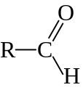
- Ketone: 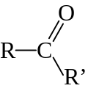
- R– : Alkyl group or Aryl group
- C : Carbonyl carbon, sp² hybridized
- Trigonal planar structure w/bond angle ≈ 120°
- In 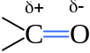, electrons in the σ and π bonds are drawn towards the more electronegative O atom
- Carbonyl oxygen: Bears a substantial partial negative charge
- Carbonyl carbon: Bears a substantial partial positive charge
- Carbonyl group is strongly polarized

Reactions

Nucleophilic addition:
- Carbonyl carbon is readily attacked by an electron-rich nucleophile:
- 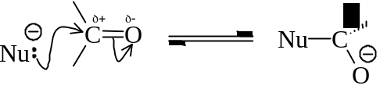
- The nucleophile should bear a pair of electrons for coordinating w/carbonyl carbon
- Nucleophile may be neutral or negatively charged
- After the addition of a nucleophile, the carbonyl oxygen gains a pair of lone pair electrons
- Oxygen becomes electron rich
- O transfer its electron pair to a proton to complete the reaction
- 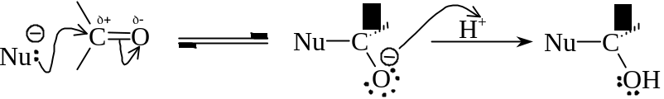
- The nucleophilic attack of the C=O bond may come from above or below the trigonal planar
- Aimed at minimize the steric hindrance
- Usually, a racemic mixture of products formed

- C=O bond addition is differ from C=C bond addition by:
- C=O bond is highly polarized and act as an electron-deficient site, while the
C=C bond is non-polar and act as an electron-rich center
- C=O perform nucleophilic addition whereas C=C perform electrophilic addition
- C=O bond addition is initiate by the attack of electron rich species, while the
C=C bond addition is initiate by the attack of electron-deficient species

- The reactivity of the carbonyl compounds toward nucleophilic addition depends on:
- Electronic influence of the groups attached to the carbonyl carbon
- The more electron-releasing group decreases the degree of e– deficient of carbonyl carbon
- The carbonyl group becomes less polarized, and reactivity decrease
- Steric bulkiness of the groups
- The C=O group flanked by two alkyl / aryl groups are less reactive than aldehydes in general
- 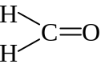 > 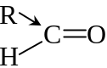 > 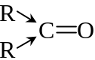 > 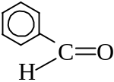 > 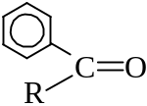 > 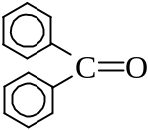
- The aryl group (benzene ring) reduces the electron deficiency of carbonyl carbon

Nucleophilic addition of HCN:
- Hydrogen cyanide adds to carbonyl groups of aldehydes and ketones
- Forms 2-hydroxynitriles
- 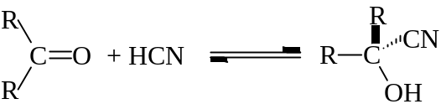
- In actual practice, HCN is not used because:
- HCN is a dangerous toxic gas in room temperature
- Liquid HCN in low temperature is very toxic and volatile
- HCN is a weak acid and therefore a poor nucleophile (poor ionization)
- Usually, NaCN or KCN is used instead:
- 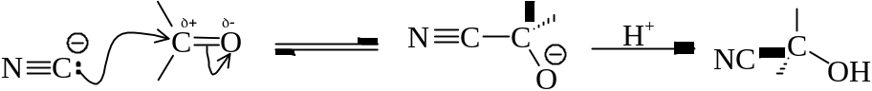
- Addition of HCN is useful to prepare α-hydroxacids or α, β-unsaturated acids
- Hydrolyse the –CN group to –COOH by refluxing w/70% H₂SO₄ or dil. alkaline solution
- 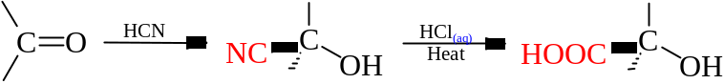
- 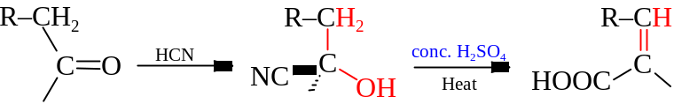
- Important in making molecules w/two functional groups or lengthen the carbon chain

Nucleophilic addition of NaHSO₃:
- Reacts aldehyde / ketone with excess 40% NaHSO₃
- 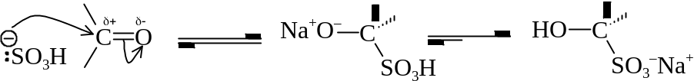
- Gives Colorless crystal of Bisulphite adducts
- Reaction is limited to aliphatic aldehydes & sterically unhindered ketones only
- The rxn is very sensitive to steric hindrance
- Aldehydes / Ketones can be regenerated by treating the adducts w/aqueous alkali or dil acids
- Shifts the equilibria to the left
- It can be served as a separation & purification of aldehyde & ketone from other cpds

Addition-elimination (Condensation):
- Addition of two molecules to carbonyl cpd to form an unstable intermediate and then rapidly eliminates a water molecule
- 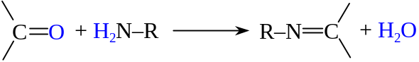

- Reaction w/Hydroxylamine (NH₂OH)
- Reacts carbonyl cpds w/NH₂OH to form oximes
- Aldehyde → Aldoxime; Ketone → Ketoxime
- Crystalline solids
- 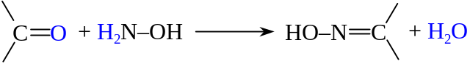

- Reaction w/2,4-Dinitrophenylhydrazine (2,4-DNP)
- 2,4-Dinitrophenylhydrazine: 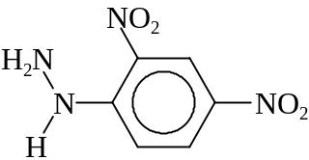
- Carbonyl cpds react w/2,4-dinitrophenylhydrazine to form 2,4-dinitrophenylhydrazones
- 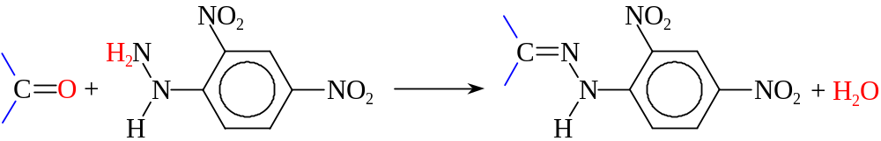
- A orange-yellow solid is formed
- The solid is purified by recrystallization
- The reaction is used to identify the aldehyde / ketone by MP of the solid

Iodoform test:
- Reacts iodine in NaOH_{(aq)} w/ethanal or methyl ketones contains 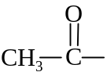 group
- 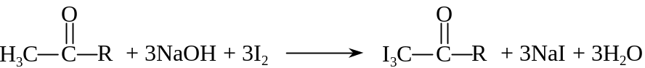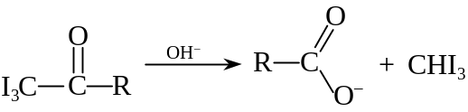
- Pale yellow crystalline precipitates of triiodomethane appears

Redox reations:
- Aldehydes are readily oxidized to carboxylic acids even by mild oxidizing agent
- 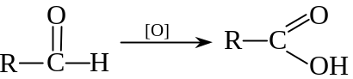
- [O] can be KMnO₄ or K₂Cr₂O₇
- Ketones requires more drastic conditions to convert to carboxylic acids
- To bring about the cleavage of C–C bond
- 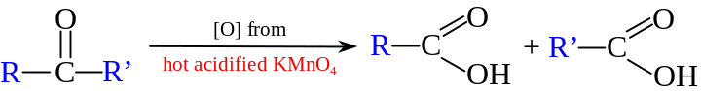

- Silver mirror test:
- Tollen’s reagent: aqueous Silver nitrate(V) + aqueous Ammonia
- A weak oxidizing agent
- Contains Ag(NH₃)₂OH or [Ag(NH₃)₂]⁺ as active ingredients
- Aldehydes can be oxidized by Tollen’s reagent to give carboxylate ions (RCOO–)
- The Ag reduced becomes a silver mirror on test tube
- Tollen’s reagent only give silver mirror to aldehydes and negative result on ketones

- Fehling’s test:
- Fehling’s solution: Copper(II) Sulphate(VI) + Sodium Potassium Tartrate + excess NaOH
- A weak oxidizing agent
- Clear royal blue in color
- Fehling’s solution oxidizes aldehydes to give carboxylate ions (RCOO–)
- The Cu²⁺ ion in Fehling’s solution is reduced by the aliphatic aldehydes to Cu₂O
- Gives a reddish-brown precipitate
- 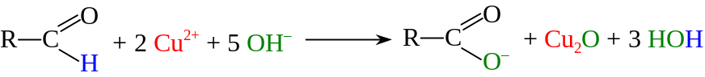
- Aromatic aldehydes and ketones give a negative result

- Reduction
- Aldehyde and ketone undergo reduction to give 1° and 2° alcohols respectively
- 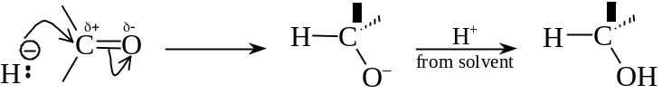
- Reducing agent: Lithium tetrahydridoaluminate(III) (LiAlH₄) in ethoxyethane (dry ether)
Sodium tetrahydridoborate(III) (NaBH₄) in aq or methanol
- Generates a nucleophile H–, the hydride ion
- LiAlH₄: A stronger and versatile reducing agent
NaBH₄: A milder but convenient reducing agent
- Only LiAlH₄ can reduce Carboxylic acid, Acid chloride, Acid anhydride and Ester to Alcohol
- Neither LiAlH₄ nor NaBH₄ can reduce C≡C or C=C to full saturation
- H– is repelled by the π cloud

2-Hydroxynitriles = Cynohydrins
NaHSO₃ = Sodium Hydrogensulphate(IV) = Sodium Bisulphite
LiAlH₄ = Lithium tetrahydridoaluminate(III) = Lithium aluminum hydride

