OrgChem – Carboxylic Acid

Carboxylic Acid

Structure & Formation:
- Carboxylic acid contains Carboxyl group: 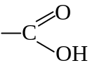
- Carboxyl group = Carbonyl group + Hydroxyl group
= 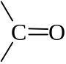 + –OH
- Behavior of the carbonyl group and hydroxyl group modified by each other

- α-Hydroxycarboxylic acid can be prepared by hydrolysis of α-hydroxynitriles
- 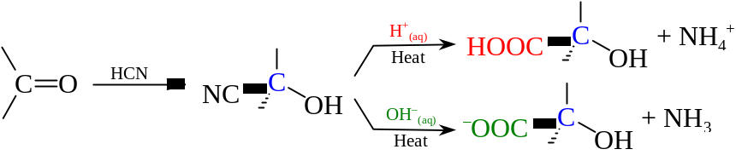
- Hydrolysis of nitriles by alkali gives carboxylate ion
- Carboxylic acid can be recovered by addition of acid to the solution
- If 2° or 3° haloalkanes are used instead of 1° haloalkane, alkene is formed
- CN– is a strong base and leads to elimination rather than substitution

- Oxidation of 1° alcohols by strong oxidizing agents can give carboxylic acid
- 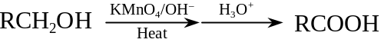
- Aldehydes are formed as an intermediate
- The oxidation of aldehyde can undergo in even milder condition to carboxylic acid

- Oxidation of alkylbenzenes by strong oxidizing agents
- 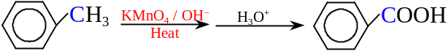
- Oxidation takes place at phenylmethyl carbon
- Oxidation requires the abstraction of a phenylmethyl hydrogen
- 2-Methyl-2-phenylpropane have no phenylmethyl H and resistant to side chain oxidation
- Any alkylbenzene will become Benzoic acid
- If the side chain contains aldehydic or ketone group, strength of the oxidizing agent determines the product
- The KMnO₄ / OH– is the strongest oxidizing agent

- Oxidation of methyl ketone & alcohol
- Methyl ketone w/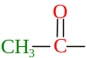 or alcohol w/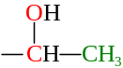 are liable to undergo triiodomethane reaction
- 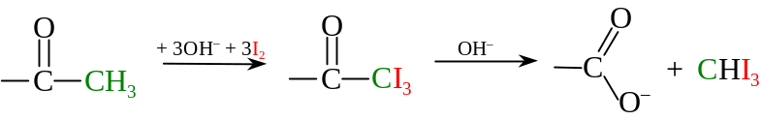
- Resulting carboxylate is one carbon less than the original carbon skeleton

Acidity:
- Carboxylic acids are weak acids w/carboxyl group responsible for the acidity
- Carboxylic acid molecule in water will dissociate into ions: 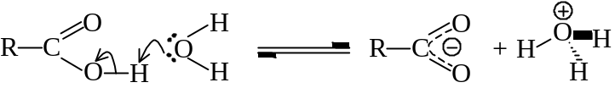
- The carboxylate ion is energetically stabilized by the spreading of the negative charge over a C and two O
- Acidity: [Mineral acids] 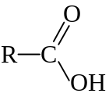 > H₂CO₃ > 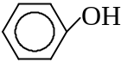 > Η₂Ο > R–OH
- R–COO– ion is stabilized by spreading of negative charge to two highly electronegative O
- 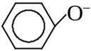 ion is stabilized by the delocalization of charge of the benzene ring
- Stability of conjugate anion: [Mineral acids] 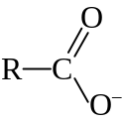 > CO₃^{2–} > > Η⁺ > R–O–
- Acidity of carboxylic acid is affected by the group attached to –COOH
- Electron attracting / withdrawing groups (e.g. Cl) increase the acidity
- 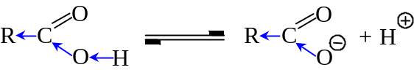
- O–H bond of RCOOH is weakened
- Stabilized conjugate anion by spreading out negative charge on RCOO– ion
- Electron releasing groups (e.g. CH₃–) reduce the acid strength
- Pushing electrons to electron-deficient carbonyl C will strengthening the O–H bond
- The electron-donating substituent will push e– toward the electron-rich COO– group to intensify to negative charge
- Destabilizes the resulting anion

Reactions

Salt formation:
- RCOOH is able to react w/metal carbonates, metal hydrogencarbonates, and some reactive metal
- Acids liberate CO₂ from carbonates and hydrogencarbonates as effervescence
- Phenols have no reaction w/CO₃^{2–} or HCO₃–
- Acids react w/reactive metals and give off H₂
- Carboxylic acid reacts with ammonia to give ammonium salts
- Strong heating dehydrates the ammonium salt and gives amide
- 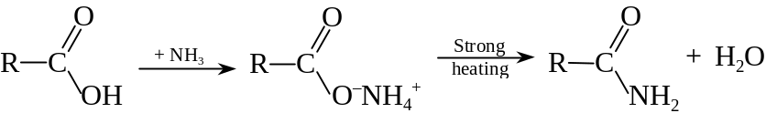
- The carboxylic acid salt can be displaced by stronger acids:
- RCOO–Na⁺ + HCl ⎯→ RCOOH + NaCl

Reduction:
- Carboxylic acid resistant to ordinary reducing agents
- Carboxylic acid can be reduced to alcohol by lithium tetrahydridoaluminate
- Primary alcohols is directly formed
- 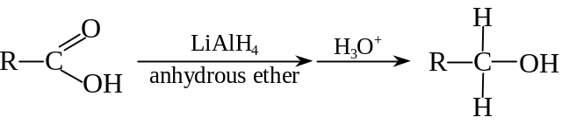
- The C=C, C≡C or 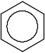 parts are unaffected

Acid Derivatives

Acyl Chloride:
- Acyl chloride (Alkanoyl chloride): 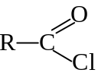
- Reacting RCOOH w/reagents PCl₅, PCl₃ or SOCl₂:
- 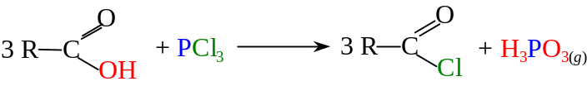
- 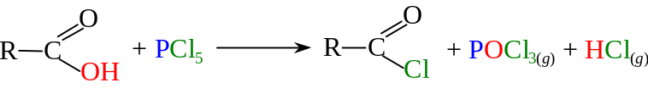
- 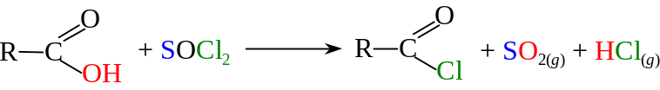
- If the Acyl Chloride has a high boiling point, PCl₅ is used
- B.P. of PCl₅ = 107°C
- Using fractional distillation, PCl₅ given out first, then acyl chloride
- If the Acyl Chloride has a low boiling point, PCl₃ is used
- B.P. of PCl₅ = 200°C
- Acyl chloride can be obtained by distillation
- If the Acyl Chloride has a intermediate boiling point, SOCl₂ is used
- Gaseous SO₂ & HCl pass off first

- The Cl is readily substituted by other nucleophiles like OH, OR, NH₂, etc.
- The carbonyl carbon has δ+ charge that can be attacked by the nucleophiles

- Acyl chloride can be hydrolyzed rapidly by cold water:
- 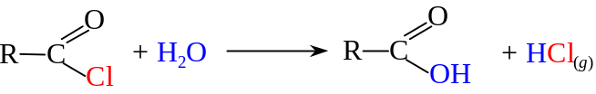
- Aromatic alkanoyl chlorides is hydrolyzed much more slowly
- The carbonyl carbon is less susceptible to nucleophilic attack
- The acyl chloride is less soluble
- Hydrolysis is faster w/alkali as OH is a stronger nucleophile

- Acyl chlorides react w/alcohols and phenols to form esters
- 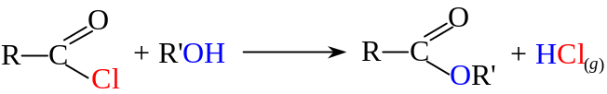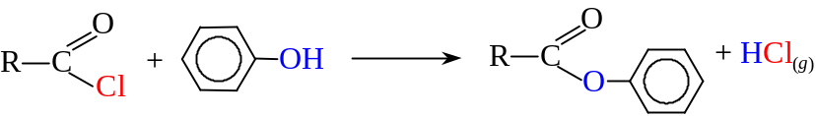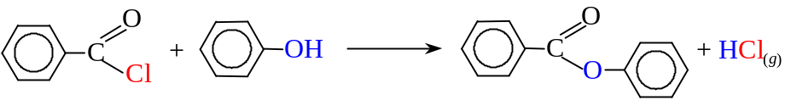
- A base catalyst is required for phenol to react w/aromatic alkanoyl chlorides
- Basic medium can provide a more powerful nucleophile 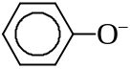

- Acyl chlorides react w/ammonia to give amides
- Ammonolysis:
- 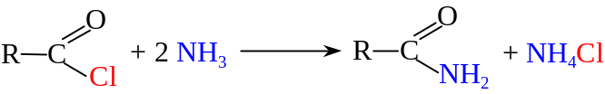
- Alkanamide formed
- Low temperature and large excess of ammonia solution is required
- To moderate the reaction
- To prevent the formation of side product

- Reaction of acyl chlorides w/amines gives amides
- 1° amine gives N-substituted amides
2° amine gives N,N-disubstituted amides
- 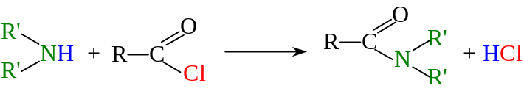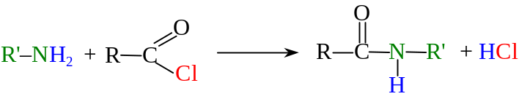

- Acyl chlorides react w/anhydrous sodium salts of acids to give acid anhydrides
- 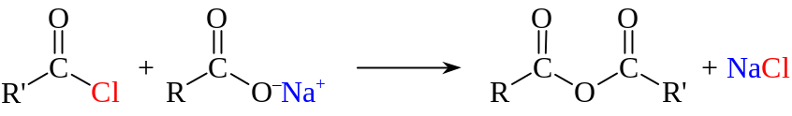

Alkanolyation is the process of replacing a H in –OH or –NH₂ group by an alkanoyl group 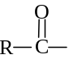
Benzoylation or Benzenecarbonylation is the process of replacing a H in –OH or –NH₂ group by an alkanoyl group 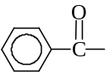
Acetylation: Alkanolyation or benzoylation

Acid anhydrides:
- Acid anhydrides: 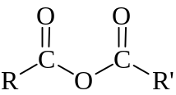
- Reacting RCOOH w/alkanoyl chlorides in presence of pyridine
- 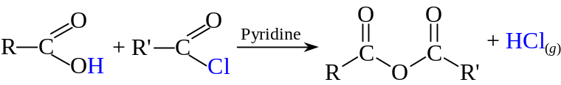
- Pyridine is used to remove the HCl formed
- Shifts the equilibrium toward the product side
- It can also be formed by refluxing alkanoyl chloride w/sodium salt of carboxylic acid

- Reaction similar to that of acyl chlorides but w/lower reactivity
- Reaction of acid anhydrides often gives carboxylic acids as products
- It can be hydrolyzed by water slowly to give carboxylic acids:
(RCO)₂O + H₂O ⎯→ 2 RCOOH
- It reacts w/alcohols & phenols to give esters
- (RCO)₂O + R'OH ⎯→ RCOOR' + RCOOH
- Heating is usually required
- A more powerful phenoxide ion is provided if reacting w/phenols in the alkaline medium
- It reacts w/ammonia & amines to give amides
- (RCO)₂O + 2 NH₃ ⎯→ RCONH₃ + RCOONH₄

Amides:
- Acid anhydrides: 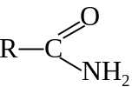
- Reacting RCOOH w/aqueous ammonia
- Ammonium carboxylate is form as an intermediate
- Heating gives primary amides
- The water formed will hydrolyze the RCOO–NH₄⁺ back to RCOOH
- excess RCOOH is added to shift the equilibrium to the product side

- It is readily hydrolyzed on refluxing w/dil acid or alkali
- 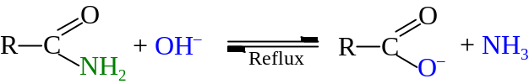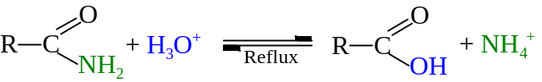
- Can be served as a test between amine and amide
- Only amide reacts w/caustic soda and liberates ammonia gas
- Heating amides w/dehydrating agent leads to the formation of nitrile
- Dehydrating agent: Phosphorus(V) oxide, P₂O₅
- 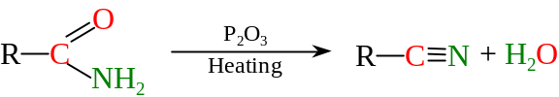
- Amides react w/KOH_{(aq)} and Br₂ to give 1° amines
- Hofmann degradation
- The amine product is one carbon less
- Amides can be reduced to 1° amines
- By lithium tetrahydridoaluminate (LiAlH₄) or sodium in ethanol (RO–Na⁺)
- 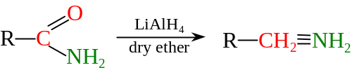

Esters:
- Ester: 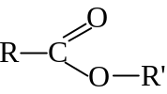
- Reacting RCOOH w/alcohols in the presence of acid catalyst
- The reaction is called esterification
- 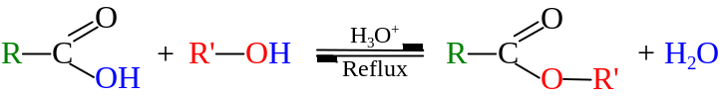
- Ester often has a lower BP than alcohol or acid
- Ester can be distilled out of the reaction mixture
- High activation energy required for esterification
- Reaction is too slow without the acid catalysis

- Ester can be hydrolyzed in acidic medium
- 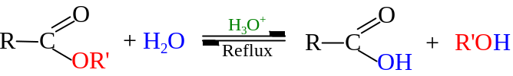
- Reverse of esterification, excess water is required to shift the equilibrium
- If in alkaline medium, the hydrolysis also occur
- The carboxylic acid formed will be reacted w/OH– immediately
- The equilibrium will shift to product side w/higher extend
- Alkaline hydrolysis is much faster
- Ester can be reduced by LiAlH₄
- Primary alcohols formed:
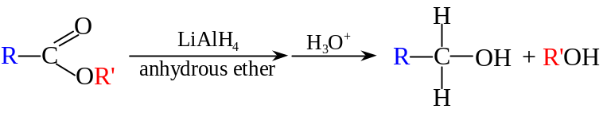

Alkaline hydrolysis = Saponification

