OrgChem – Nitrogenous Compound

Amine

Structure:
- Amine: Organic derivative of ammonia w/H replaced by alkyl or aryl groups
- Classified as 1°, 2° and 3° amines
- According to the number of alkyl or aryl groups attached to the nitrogen atom
- R–NH₂ Primary Amine
R–NH–R Se-condary Amine
NR₃ Tertiary Amine
[ NR₄]⁺ Quaternary Ammonium ion

Formation:
- Amines can be formed by alkylation of halogenoalkanes
- By heating halogenoalkanes w/NH₃ under pressure
- R–Br + NH₃ ⎯→ R–NH₂ + HBr
- R–Br + R₃N ⎯→ R₄N Br
- Reaction by nucleophilic attack by the LP e– of N on the slightly pos. C of the halogenoalkane
- 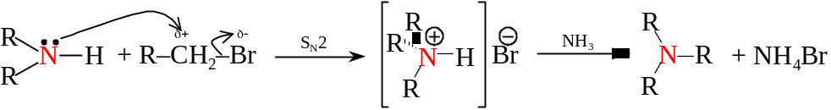
- A mixture of product given out due to multiple alkylation
- Can be minimized by using large excess ammonia

- Amines can also be formed by reduction of nitro group
- Using the method of:
- Catalytic hydrogenation
- LiAlH₄ / H₃O⁺
- Treating nitro compound w/acid and Fe, Zn, Sn or SnCl₂
- 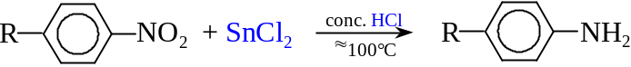
- To reduce aromatic nitro compound, Sn w/hydrochloric acid can be used
- 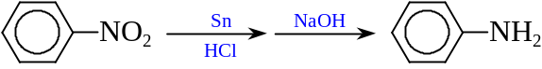

- Reduction of nitriles and amides becomes amine
- Reduction by:
- Catalytic hydrogenation
- LiAlH₄ in anhydrous ethoxyethane than by treatment w/H₂O
- R–C≡N + 4[H] ⎯→ R–CH₂–NH₂
- 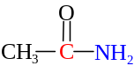 + 4[H] ⎯→ R–CH₂–NH₂

- Hofmann degradation of amides forms primary amine
- Reacting amide w/KOH_{(aq)} and Br_{(aq)} in a rearrangement reaction
- Primary amines given and can be distilled off
- The 1° amine formed by Hofmann degradation is one carbon less
- 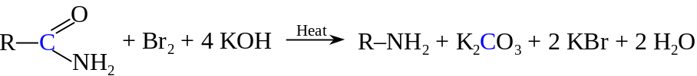

Reactions of Amine

Salt formation:
- All amines are basic
- LP e– on nitrogen atom attracts a proton from an acid
- Ionic salt products formed if reacted w/acid
- The amine can be regenerated when the ammonium salt react w/stronger bases
- R–NH₃Cl + NaOH ⎯→ R–NH₂ + NaCl + H₂
- Basicity: RO–Na⁺ > NaOH > 2° > 1° > 3° amine > NH₃ > Aromatic amine > Amide

Acylation:
- Amine group is readily react w/acyl chloride
- The LP e– in N atom undergoes nucleophilic attack on the electron-deficient carbonyl carbon
- 1° and 2° amines react readily w/ethanoyl chloride
- Ethanoylation
- 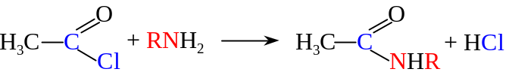
- N-substituted amides formed
- The reaction occur readily in cold
- 3° amines cannot be acylated as there is no hydrogen on the nitrogen
- Form salts w/acid chloride instead
- 1° and 2° amines can also react w/benzoyl chloride in the presence of excess alkali
- Benzoylation / Schotten-Baumann reaction
- 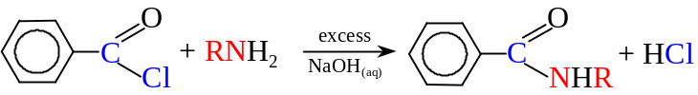
- N-substituted amides formed
- The reaction is used to get the benzoyl derivatives for identification of the amines
- The purified benzoyl derivatives are having sharp MP

Reaction w/HNO_{2(aq)}
- 1° amines can react w/nitric(III) acid
- Nitric(III) acid is prepared in situ by reacting ice cold dil. HCl with cold NaNO₂
- NaNO_{2(aq)} + HCl_{(aq)} NaCl_{(aq)} + H–O–N=O_{(aq)}
- The nitric(III) acid decomposes easily
- Primary aliphatic amines + HNO₂ ⎯→ Aliphatic diazonium salts (Alkyldiazonium salts)
- The HNO₂ is usually replaced by adding NaNO₂ and mineral acid
- The diazonium salt formed is unstable and it will decompose spontaneously
- Nitrogen formed as effervescence
- Carbocation formed to produce a mixture of alcohols, alkenes and halogenoalkanes
- The reaction served as a test for the primary aliphatic amine
- Primary aromatic amines + HNO₂ ⎯→ Aryldiazonium salts
- The diazonium salt formed is more stable than aliphatic ones
- It do not decompose at an appreciable rate when the reaction is kept below 5°C
- The stability is due to the positive charge distributed about the aromatic ring
- If the aryldiazonium salt is above 5°C, it begins to breakdown as the alkyldiazonium salt
- The reaction is known as diazotization:

Coupling reaction
- Benzenediazonium ions can react w/naphthalen-2-ol in alkaline solution
- Under the ice cold condition
- Reaction take place at the 2-position
- Bright red crystalline precipitate formed
- 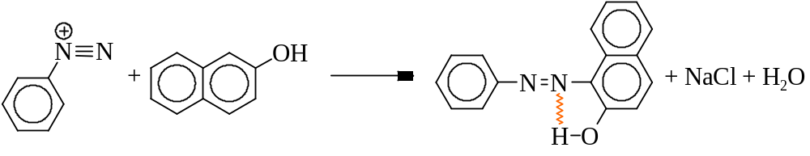
- There is a hydrogen bond present in the ppt inhibits the reaction of phenolic –OH group
- The ppt is insoluble as no intermolecular H-bond can be formed
- Nitrogen of the diazonium group retained in the product
- The reaction is used to characterize primary aromatic amines

Amino acids

Structure:
- Amino acids are bifunctional organic compounds
- Contains both basic amino groups (–NH₂) and acidic carboxyl groups (–COOH)
- Amino acid: 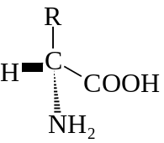
- Amino acids may have different number of amino and carboxyl groups
- If there are equal number of amino and carboxyl groups, it is called neutral amino acids
- If there are more amino than carboxyl groups, it is called basic amino acids
- If there are less amino than carboxyl groups, it is called acidic amino acids
- Most α-amino acids contain asymmetric carbon atoms
- The natural amino acids usually shows optical activity
- Synthesized amino acids are usually optically inactive as they are racemic mixtures

Properties:
- Amino acids are non-volatile, crystalline organic compounds w/high melting points
- Due to the formation of zwitterion
- Amino acid is neither very strong acids nor very strong bases
- Intramolecular migration of the acidic proton occurs in amino acid solutions
- Carboxyl group neutralizes the amino group
- 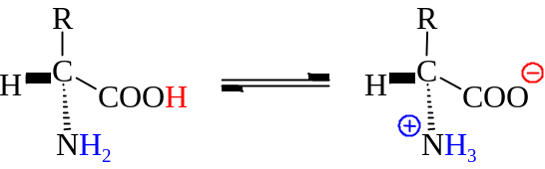
- Dipolar ion (zwitterion) formed
- Except the zwitterion, amino acid may also form conjugate acid and conjugate base with water
- 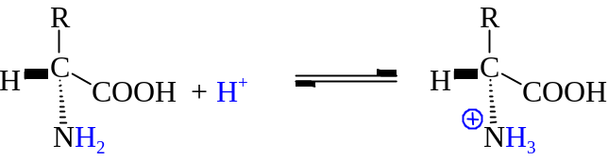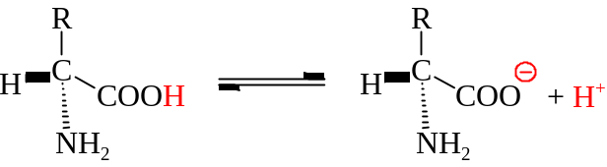
- Many species given when dissolving amino acids into water
- Due to the ionic properties, amino acids have low solubility in organic solvents and highly soluble in polar solvents
- Amino acids are white solids at RTP resembling other ionic salts in many other properties

Nitric(III) Acid = Nitrous Acid = HNO₂
The precipitate is 1-(phenylazo) naphthalen-2-ol

