OrgChem – Synthesis & Interconversion

Redox of Organic Cpds

Oxidation
- Oxidation involves the removal of e–
- Oxidizing agents in org chem: KMnO₄, K₂Cr₂O₇, H₂CrO₄, CrO₂,
O₂, Tollen’s reagent, Fehling’s reagent, O₃, etc.

- Mild oxidation by Potassium manganate(VII)
- Carried out at RTP w/o heating in either acidic, neutral or alkaline medium
- Sufficient to oxidize various types of double & triple bonds
- 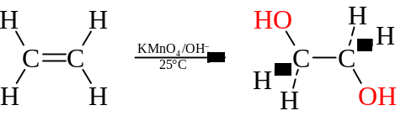

- Vigorous oxidation by Potassium manganate(VII)
- In acidic or alkaline medium w/heating
- Can lead to cleavage of C=C or C≡C bonds
- 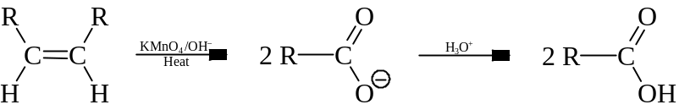
- Alkaline medium is often employed then by acidification as KMnO₄ is unstable in strong acid
- If there is a =CH₂ or ≡CH₃ group as termination, the group is often oxidized to CO₂
- 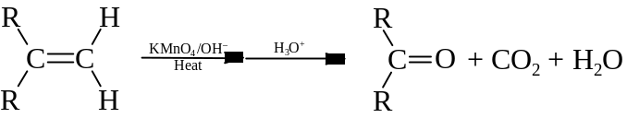
- This vigorous oxidation can also break down aromatic side chains w/phenylmethyl hydrogen
- 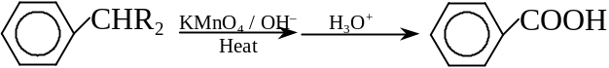
- This can convert 1° alcohol to carboxylic acid and 2° alcohol to ketone
- 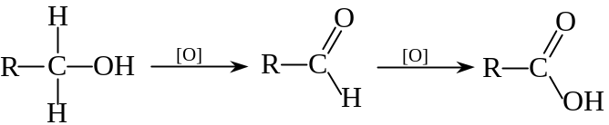
- 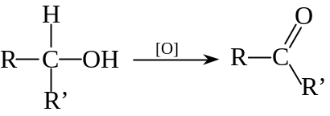

- Oxidation by Potassium / Sodium dichromate(VI) or Chromium(VI) oxide
- Oxidation is milder than KMnO₄
- Active oxidizing agent: Chromic(VI) acid, H₂CrO₄
- Generated in the situ by Cr₂O₇^{2–} in acidic medium
- The oxidation is same by K₂Cr₂O₇, NaCr₂O₇ or CrO₃ as both generates H₂CrO₄ in acid
- Oxidation is strong enough to convert aliphatic 1° alcohol and aromatic side chain to aldehyde
- 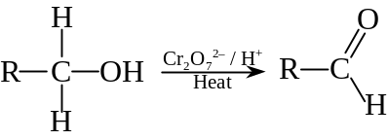
- 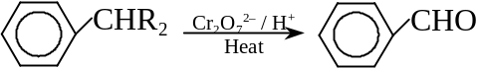
- In vigorous conditions, it can convert aromatic aldehyde to carboxylic acid
- 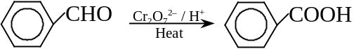
- It is usually used to oxidize 2° alcohol to ketones
- Oxidation by Ozone
- Ozonolysis is used to determine the position of double bond in unknown alkene
- 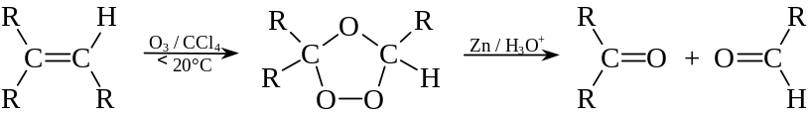
- Reaction should be kept below 20°C to permit the formation of the intermediate, ozonide

- Oxidation by Tollen’s or Fehling’s reagent
- Weak oxidizing agents
- Useful in oxidation of aldehyde to carboxylate but no reation w/ketone

Reduction
- Reverse of oxidation: H atoms are added to organic cpd
- Common reducing agents: H_{2(g)} w/transition metal catalyst, LiAlH₄, NaBH₄

- Hydrogenation w/Transition metal catalyst
- Used to reduce unsaturated hydrocarbons or other unsaturation centers
- It can convert alkene & alkyne to alkane in RTP
- 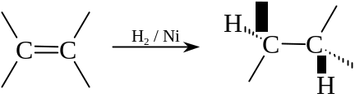
- 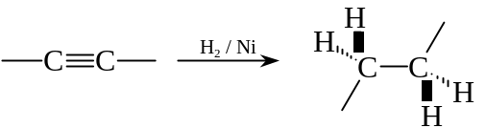
- It can reduce benzene to cyclohexane at high temperature (300°C)
- 
- It can also reduce nitriles to amines
- R–C≡Ν ⎯→ R–CH₂–NH₂

- Lithium tetrahydridoaluminate / Sodium tetrahydridoborate
- Used in dry solvent like anhydrous ether
- LiAlH₄ and NaBH₄ are unstable in polar solvents and may react violently
- LiAlH₄ + 4 H₂O ⎯→ Li⁺ + Al³⁺ + 4 OH– + 4 H₂
- Reduction done by transfer of hydride ion (H–) to unsaturation centers
- Ease of reduction: 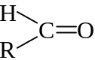 > 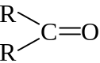 > 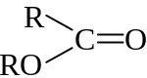 > 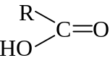 > 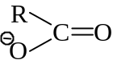
- It can reduce the carbonyl oxygen to hydroxy group
- 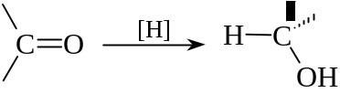
- It can reduce carboxylic acid and amide to alcohol and amine
- 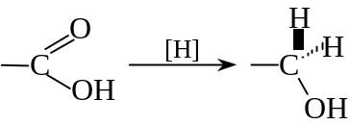
- 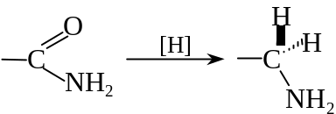
- It can reduce nitrile or nitro cpds to amine
- R–C≡N ⎯→ R–CH₂–NH₂
- R–NO₂ ⎯→ R–NH₂
- It can cleavage ester during reduction
- 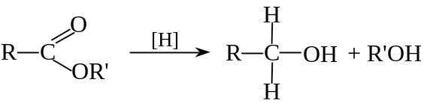
- NaBH₄ is a milder reducing agent than LiAlH₄
- It can only reduce aldehydes and ketones but not acids and esters

- Zinc, Iron, Tin in Hydrochloric acid
- Useful in reducing aromatic nitro groups to amino groups
- 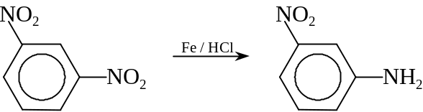
- For more than one nitro gp is present, it can be reduced by tin(II) chloride in HCl
- 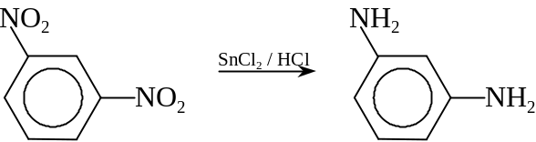

Carbon skeleton

Chain lengthening
- 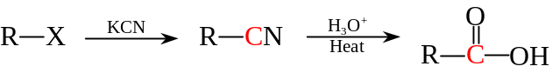
- 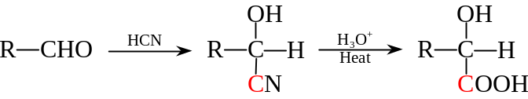

Chain degradation
- Hofmann degradation: 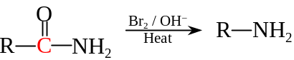
- Iodoform formation reaction: 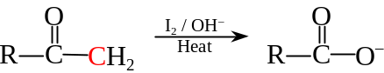
- Ozonolysis: 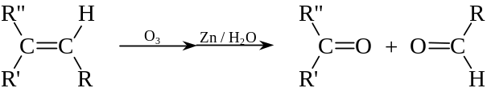

Interconversion of Functional Groups

Aromatic compounds

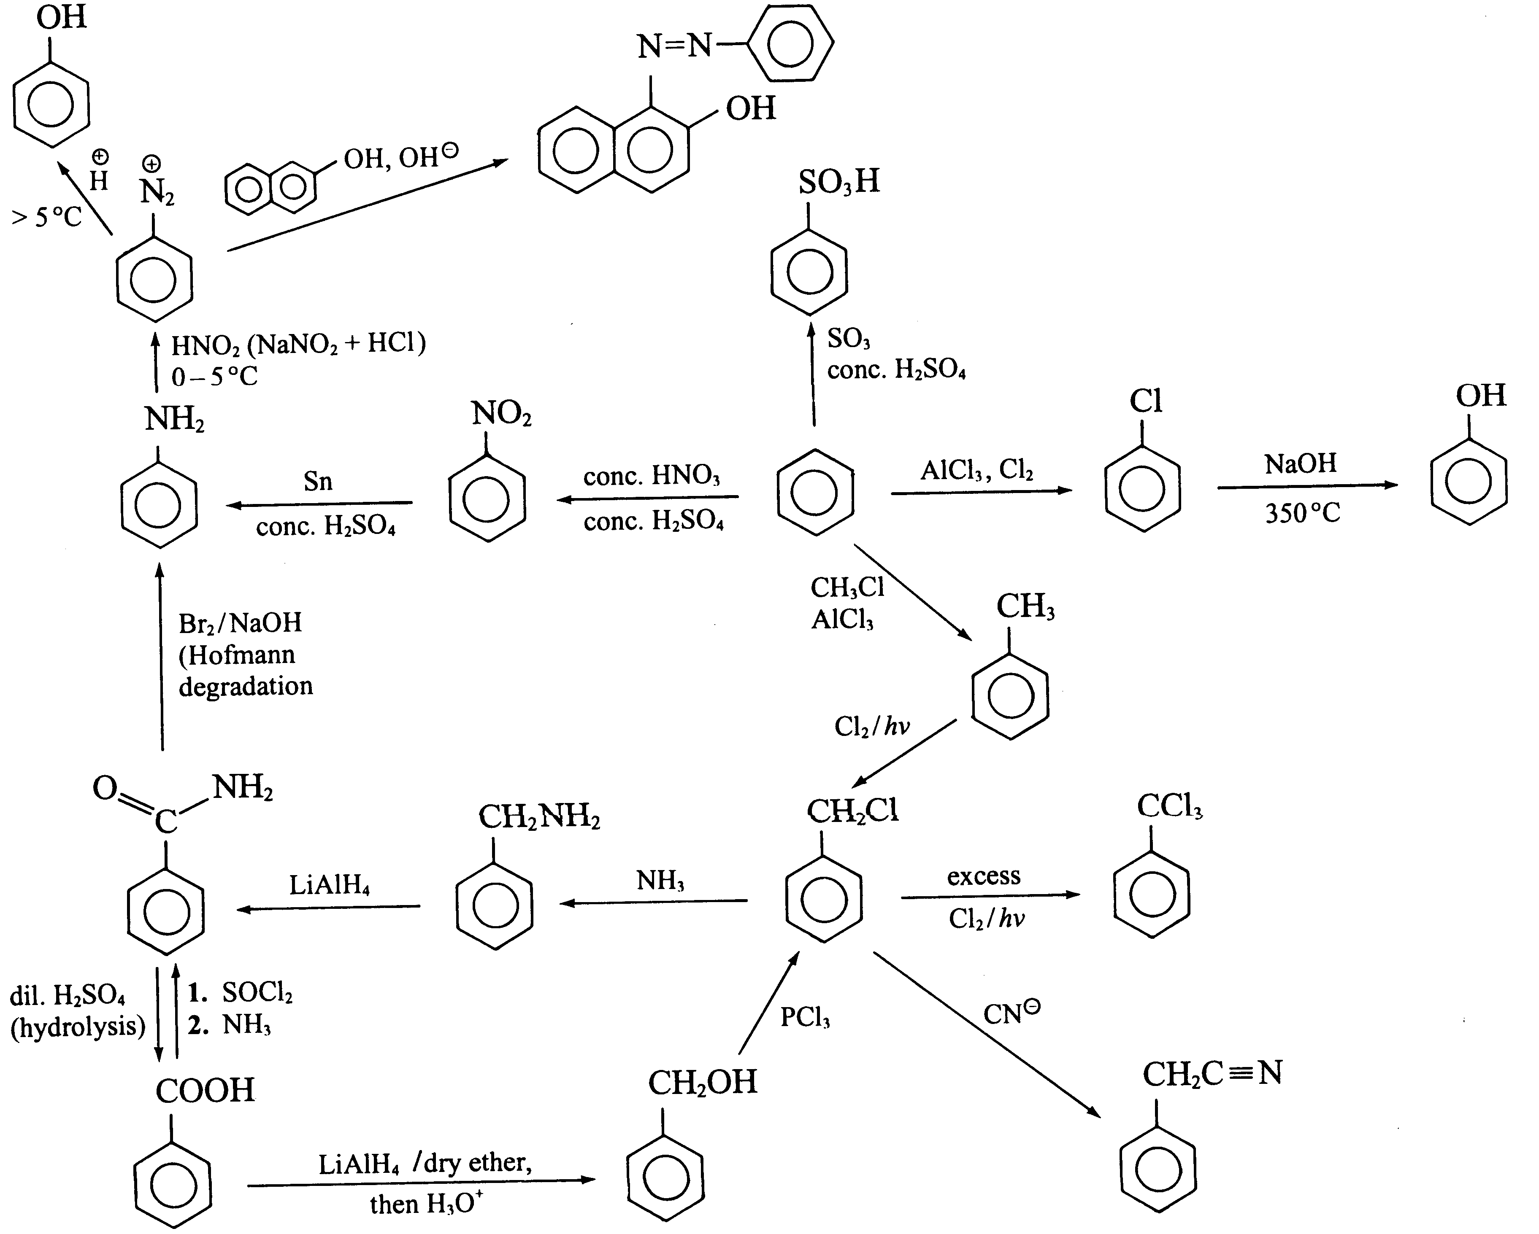

Aliphatic compounds
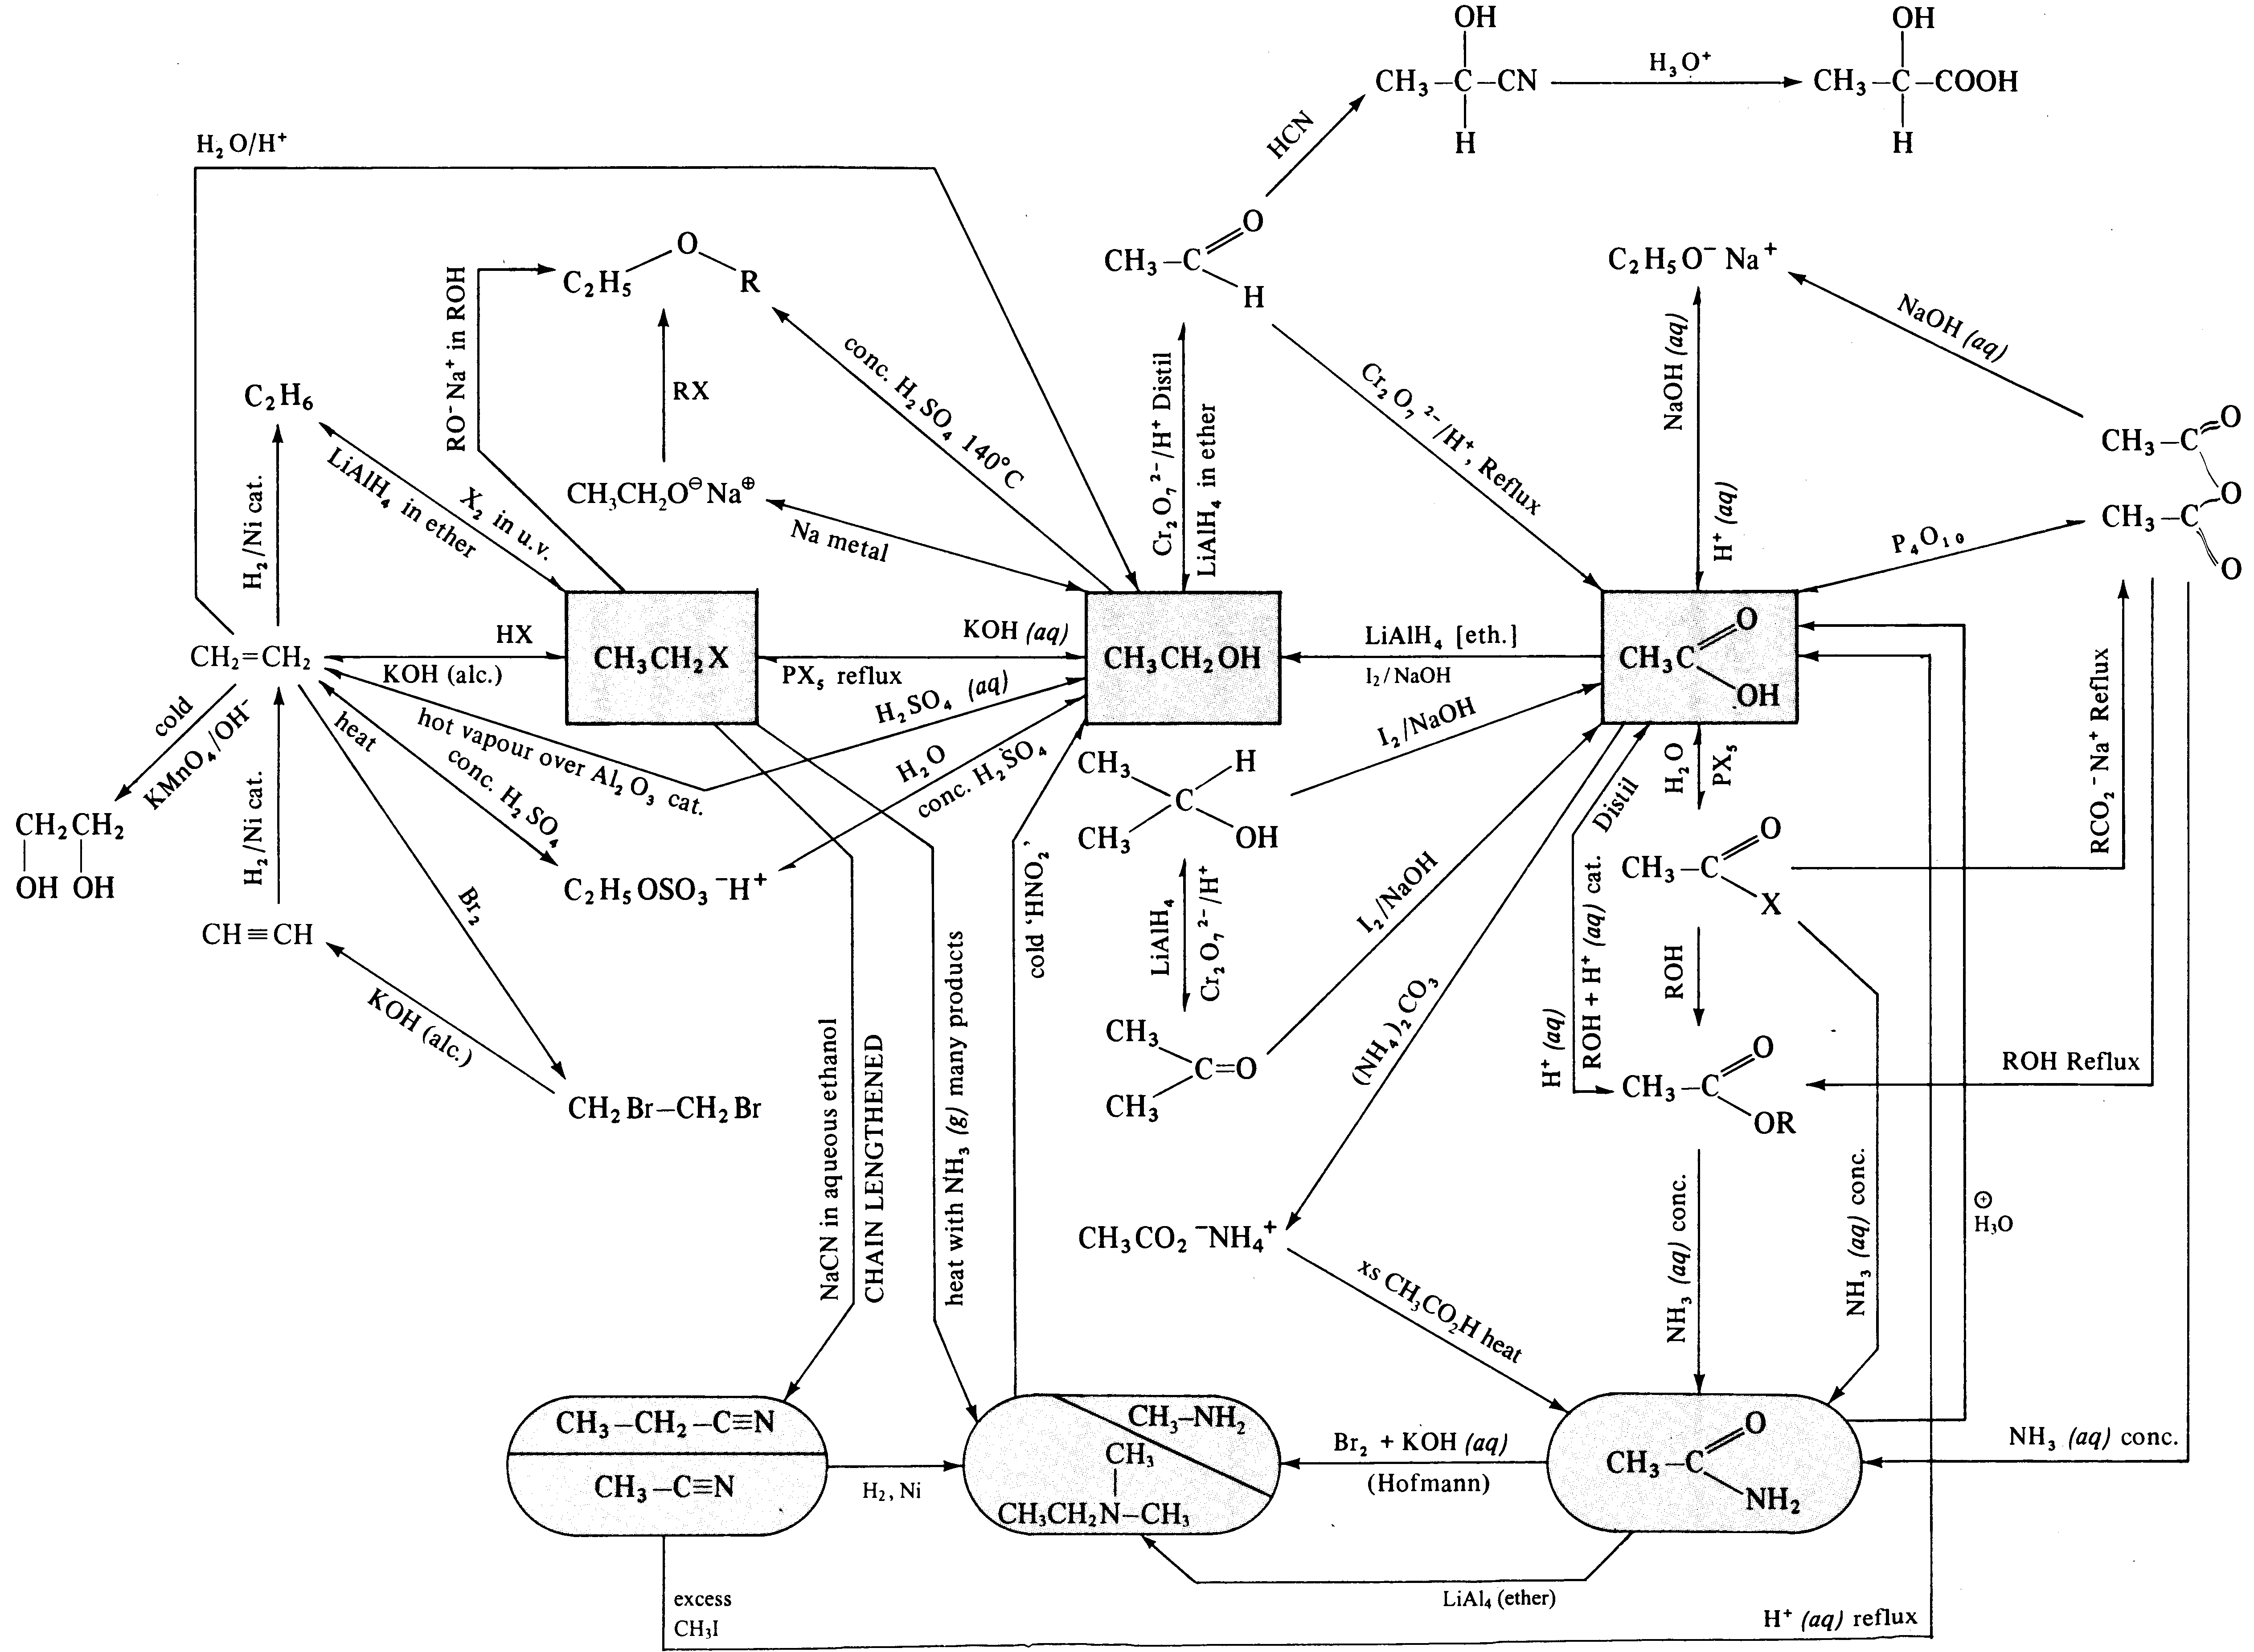

Transition metal catalyst: Pt, Pd, Ni, etc.

