PhyChem – Atomic Structure

Atomic Structure
Fundamental particals:
Particles | Charge (Coulomb) | Relative charge | Mass (Kilogram) | Mass (a.m.u.)
Proton | +1.6022 × 10^{–19} | +1 | 1.6726 × 10^{–27} | 1.0073
Neutron | 0 | 0 | 1.6750 × 10^{–27} | 1.0087
Electron | –1.6022 × 10^{–19} | -1 | 9.1095 × 10^{–31} | 5.4858 × 10^{–4}

Nucleon: A collective name of protons and neutrons (Nucleon number = Mass number)
Nuclide: An atomic species of which the proton number and nucleon number are specified
■ Nuclides are written as: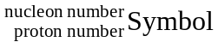

Isotopes: Atoms with the same number of protons but different numbers of neutrons
Atomic mass unit: An unit of mass which 1 unit =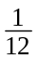of the mass of ¹²C nuclide = 1.661 × 10^{–27} kg
Relative isotopic mass: The ratio of the mass of a particular atom toof the mass of ¹²C nuclide
■ RIM =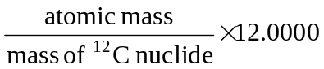
Relative atomic mass: The weighted average mass of the relative isotopic masses of an element
■ RAM (A_{r}) =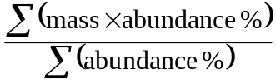

Radioactivity
Radioactive decay: The unstable nuclei of some atoms break down/disintegrate into smaller atoms
Radioactivity: Particles and energy emitted during radioactive decay

Radiation:
Radiation | Nature | Symbol
Alpha | Helium nucleus | α or 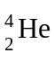
Beta | Electron | β or 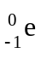
Gamma | Electromagnetic wave | γ

Alpha radiation: Positively charged helium nucleus
■ Highly ionizing, short range & low penetrating power
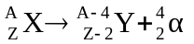

Beta radiation: A stream of electrons moving at nearly light speed
■ Created by the unstable nuclei which release energy in the decay process
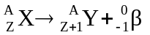

Gamma radiation (Gamma rays): High-energy electromagnetic radiation (photons)
■ Released by nuclei with excess energy
■ High energy, short wavelength
■ Long range, high penetrating power, low ionizing power
■ Not deflected by electric & magnetic fields
 The angle deflected,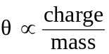

Radioisotope: Radioactive isotope

Mass Spectrometer
Mass spectrometer: Most accurate instrument for comparing the masses of atoms and molecules
■ Responds to the mass/charge ratio of ionized species

Vaporization chamber: Samples vaporized by a heater into gaseous atoms or molecules
Ionization chamber: High speed electrons from the electron gun knock off a electron from the samples: X_{(g)} + fast e– ⎯→ X⁺_{(g)} + 2 slow e–
Acceleration chamber: Negatively charged grids produce an electric field to accelerate the sample
Vacuum pump: Make the spectrometer tube at extremely low pressure to prevent ionic collisions
Electromagnet: Deflect the sample along a circular path by a magnetic field: 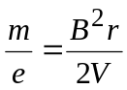
Ion detector & recorder: Recorder record the ions hit the ion detector plate which have a specific 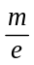 ratio and give the corresponding intensity.

a.m.u. = Atomic Mass Unit
Atoms with unstable nuclei = Radioactive atoms
