PhyChem – Stiochiometry

Mole Concept
Mole (mol): The number equal to the number of atoms in exactly 12.0000 grams of pure ¹²C isotope
Avogadro constant: Number of particles in 1 mole of substance, has units mol^{–1}.
■ Avogadro constant =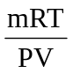=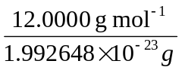= 6.022137×10²³ mol^{–1}

Molar mass: Mass of 1 mol substance with specified elementary particles
Molar volume: Volume occupied by 1 mol substance
■ Molar volume of gas: 24 dm³ at RTP; 22.414 dm³ at STP

Number of mole = Molarity×Volume =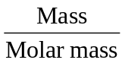=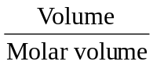=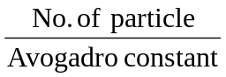

Ideal Gas Equation
Avogadro’s Law: Equal volume of all gases at the same temperature and pressure, contain the same number of molecules.
➢ Volume ∝ Number of mole (V ∝ n)

Ideal gas law:
Boyle’s Law: V ∝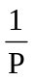 (T, n constant)
Charles’ Law: V ∝ T (P, n constant)
Pressure Law: T ∝ P (V, n constant)
Avogadro’s Law: V ∝ n (T, P constant)

Ideal Gas Law: PV = nRT =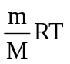
Where: P: Pressure V: Volume M: Molar mass R: Gas constant
T: Temperature m: Mass n: Number of mole ρ: Density
■ Gas constant = 8.314 J mol^{–1} K^{–1}
➢ Other forms: M =; PM =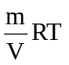= ρRT; ρ =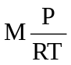
➢ Under same temperature and pressure, Molar mass ∝ Density (M ∝ ρ)

Dalton’s Law: The total pressure in a mixture of gases is equal to the sum of the partial pressure of the individual gases.
The partial pressures are the pressures that individual gases will exert if each was present alone in the volume previous occupied by the whole mixture at the same temperature. It is equal to the total pressure times the mole fraction of the gas.
➢ P _{total} = Σ P _{individual} =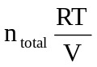; P _{individual} = P _{total} χ_{individual}
■ Gas laws hold on the partial pressures of individual gases

Formulae
Empirical Formula: Shows the simplest whole number ratio of the atoms or ions present
Molecular Formula: Shows the actual number of each kind of atom in a molecule of a substance
■ Molecular formula = (Empirical formula) _{n} Where n =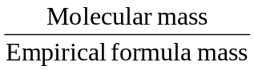
Structural Formula: Shows how the constituent atoms are joined up in a molecule of a substance

Volumetric Analysis - Titration
Standard solution: A solution of known concentration (make up by dissolving solid chemical).
Aliquot: The volume of solution delivered by the pipette.
Titrant: The solution filled in the burette.
Titre: The volume of solution titrated from the beginning to reach the end point.

Primary standard (Standardizing agent):
A pure compound that a standard solution of known concentration can be prepared from it directly, without any further standardization is needed,
■ Criteria of a standardizing agent: i Pure;
ii Can dissolve in water easily;
iii Stable: not easy to decompose or attacked by O₂ or moist;
iv Generally be solid, not volatile;
v Fairly high molar mass – reduce the weighing error.

Equivalence point: The point in the titration at which enough standard solution has been added to react exactly with the substance being determined (i.e. Theoretical).
End point: The point at which the indicator give a sharp clear change (i.e. Experimental).
■ In ideal case, End point = Equivalence point

* Disadvantages of filling burette with strong alkali:
- Erosion of the glass by the alkali
- Alkali will absorb CO₂ in atmosphere to form compound
 Compound may block the jet of the burette

Faraday
■ Q = It, where: Q = Quantity of electricity, in coulombs, C
I = Current, in amperes, A
t = Time, in seconds, s

Faraday: The quantity of charge, or electricity of one mole of electrons.
 Faraday’s constant: 1 F = 96485 C mol^{–1}

Faraday’s 1st Law of Electrolysis:
The mass of a substance liberated at an electrode during electrolysis is proportional to the quantity of electricity passed.

Faraday’s 2nd Law of Electrolysis:
The quantity of electricity required to produce a mole of a substance from its ions is proportional to the charge on the ions.
 X^{n+}_{(aq)} + ne– → X_{(s)} nF:M = It:m; m =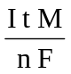
Where: m = Mass of substance deposited; M = Molar mass of the substance;
n = Charge of the ion carried; F = Faraday’s constant

Elementary particles: Atoms, ions, molecules, etc.
χ_{A} = Mole fraction of gas A in the mixture of gases =