PhyChem – Shapes & Hybridization

Shapes of Covalent molecules
VSEPR Theory: Valence Shell Electron Pair Repulsion Theory
- Covalent bonding is directional and leads to molecules with specific shapes.
- The number of electron pairs in the valence shell of the central atom in a covalent molecule largely determines the geometry of the molecule.
- Electron pairs in the central atom tend to rearrange themselves in space so as to get as far apart as possible to minimize the electrostatic repulsions.
- Multiple bonds are regarded to eqv. to a single bond as only the molecular shape is concerned.
- Distortion occurs because the repulsions between electron pairs are different in strength.
 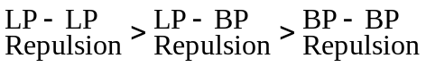and 
■ VSEPR model is suitable for making qualitative predictions of bond angles but not for quantitative predictions with accurate numerical details.

Shapes of simple molecules:
# of e– pair | Shape |  | Bond angles | Examples
2 | 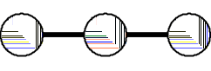 | Linear | 180 º | CO₂
3 | 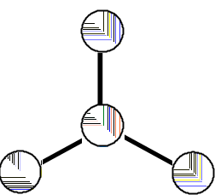 | Triangular plane | 120 º | BF₃
4 | 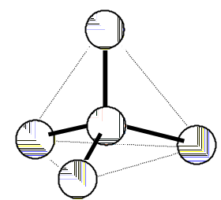 | Tetrahedron  1 LP: Trigonal pyramid;  2 LP: V-Shape | 109.5 º | CH₄
5 | 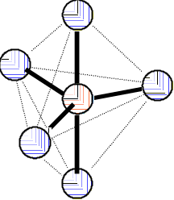 | Trigonal-bipyramid | 180 º  120 º  90 º | PCl₅
6 | 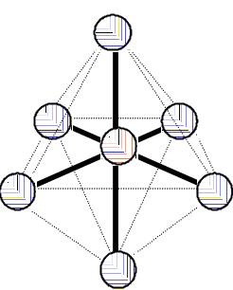 | Octahedron | 180 º  90 º | SF₆

■ Distortion: The greater the repulsion between electron pairs, the greater the angle between them
⇒ LP requires more room than bond pairs  Presence of LP compress the angles between BP  (LP–LP) > (LP–BP) > (BP–BP)
Distortion:  Interactions between lone pairs and bond pairs leading to different molecular shapes.
■ Presence of lone pairs leads to greater repulsive effect to other electron pairs
■ Lone pair electrons is attracted by 1 nucleus only 
Greater electron density around the central atom  More diffuse 
Repel other electron pairs from a bigger region of space
■ Repelling power:
■
■ Bond pairs tend to move as far apart as possible from lone pairs, though this might result in their moving slightly closer to other bonding pairs.
■ No. of lone pair = (No. of e– in valence shell – No. of electrons in bond pairs)

Multiple bonds:  Multiple bonds have more shared electrons in between the bonded atoms
 Stronger electrostatic attraction between the nuclei and electrons.
■ Shorter, stronger and having higher bond enthalpies then single bonds
■ Rigid to rotation, i.e. cannot be twisted

Hybridization
Valence bond theory:
■ Covalent bonds will be formed when the orbitals of two atoms overlap and the electrons can move into the overlapping orbitals.
■ The direction of the bond formed will be in the direction in which the orbitals are overlapped.

Types of overlapping:
■ -bond: The two bonding orbitals are in same axis, and overlap along the internuclear axis.
■ -bond: The two bonding orbitals are parallel, and overlap above and below the internuclear axis.
■ -bond is weaker than the -bond since the less effective overlapping.
■ -bond formation:  s–s overlapping: 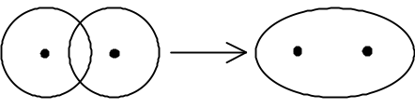
⧫ s–p overlapping: 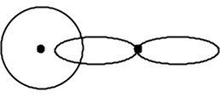
⧫ p–p overlapping: 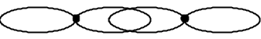
■ -bond formation:  p–p side overlapping: 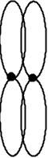

Hybridization: Mixing of pure orbitals (s, p, d, etc.) in the separated atom and form a new set of hybrid orbitals for bonding. It can account for:
1. The number of bond in resulting molecules
2. The observed shape of the molecule.

Steps of Hybridization:
■ Ground state  Excited state
➢Unpairing electrons  Promotion of the electrons to orbitals of higher energy,
e.g. 2s²2p_{x}¹2p_{y}¹  2s¹2p_{x}¹2p_{y}¹2p_{z}¹
■ Excited state  Hybridized
➢Pure orbitals in excited atom are hybridized to form equivalent orbitals (i.e. hybrid orbitals) that have definite orientations in space
⧫ Energy used in excitation of atom is compensated by the greater overlap of hybridized orbitals
Types of Hybridization:
■ sp hybridization: 1 pure s orbital + 1 pure p orbital  2 sp hybrid orbitals in linear
■ sp² hybridization: 1 pure s orbital + 2 pure p orbital  3 sp² hybrid orbitals in trigonal planar
■ sp³ hybridization: 1 pure s orbital + 3 pure p orbital  4 sp² hybrid orbitals in tetrahedral
■ Ethene (CH₂=CH₂) molecules:
⧫ Formation of -bond:  Each C atom forms 3 sp² hybrid orbitals in a plane
 1 of the sp² orbitals in each C atom overlaps each other
 2 of the sp² orbitals in C atom overlap s orbital of H atoms
⧫ Formation of -bond:  p_{x}, p_{y} orbitals in C atom are hybridized and p_{z} orbital remains
 The p_{z} orbitals remain is perpendicular to the plane of sp² orbitals
 The p_{z} orbitals in the two C atoms are parallel
 The two parallel p_{z} orbitals overlap and forms -bond
⧫ Double bond always consists of a -bond and a -bond.
⧫ Double bond is rigid to rotation because rotation makes the p_{z} orbitals cannot overlap in parallel fashion and breaks the -bond.

Distortion: Deviation from regular shape.
The difference in repulsive force is small
Energy used in excitation is known as the activation energy

