PhyChem – Solid Crystal Structures

Metallic Crystals
Unit cell: Smallest part of the crystal that contains all the characteristics of the structure
■ Repeating the unit cell in 3 directions can generate whole structure.
 As a building block of the solid structure

Coordination number: Number of neighboring atoms an atom is in direct contact with.

Structures of Metallic Crystals:
■ Atoms: Hard incompressible spheres of equal size
■ Packing: Adjacent atoms touch one another
■ Hexagonal Close-Packed Structure (h.c.p.):
⧫ Close packed structures (74% efficiency)
 Occupied the minimum volume and attained the maximum lattice stability
⧫ Third layer of spheres is placed above the first layer  “abab…” structure pattern
⧫ Every sphere is in contact w/6 sphere in the same layer, 3 in the layer above and 3 in the layer below
 Coordination number = 12
■ Cubic Close-Packed Structure (c.c.p.):
⧫ Close packed structures (74% efficiency)
⧫ Repeats itself every fourth layer  “abcabc…” structure pattern
⧫ Every sphere is in contact w/6 sphere in the same layer, 3 in the layer above and 3 in the layer below
 Coordination number = 12
■ Body-centered Cubic Packing (b.c.c.):
⧫ Open structures: Less efficient mode of packing in alkali metals (68% efficiency)
⧫ 8 atoms at the corners of a cube and 1 atom at the center
⧫ Repeats itself every third layer  “abab…” structure pattern
⧫ Every sphere is in contact w/4 sphere in the layer above and 4 in the layer below
 Coordination number = 8
■ Simple Cubic Structure (s.c.p.):
⧫ Open structure (52% efficiency)
⧫ 8 atoms at the corners of a cube
⧫ Repeats itself every layer  “aaa…” structure pattern
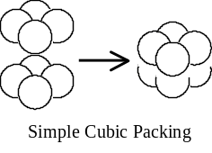 Every sphere is in contact w/4 sphere in the same layer, 1 in the layer above and 1 in the layer below
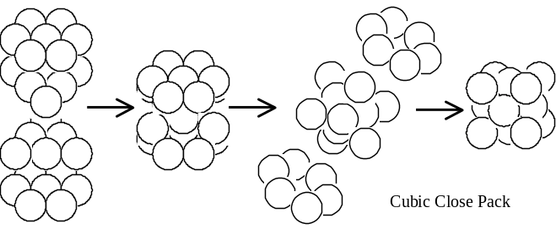 Coordination number = 6
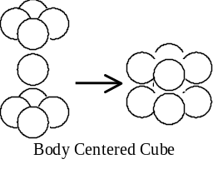
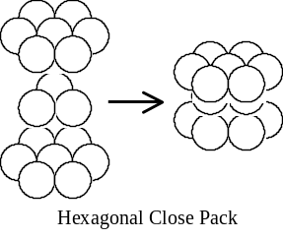
Metallic Radius:
■ Metallic radius: Half the internuclear distance between the atoms in a metallic crystal
■ Metallic radius > Corresponding covalent radii
 Bonding in metallic crystal is weaker than covalent bonding.
■ Radius increases down the group as more electron shells are occupied
■ Radius decreases across the period as higher E.N.C. attracts the outershell electrons closer
Ionic Crystals
Ionic Crystals:
■ Factors affecting the arrangement of ions within an ionic lattice (i.e. the type of crystal):
⬥ The number of ions and the charges on them
⬥ Relative sizes of ions
⬥ Stoichiometric ratio of cations and anions
■ The ions are packed in an orderly manner for stability in the lattice
⧫ Each ion tends to have the maximum number of neighbors of unlike charge ions
⧫ The lattice is electrically neutral
⧫ Maximum lattice enthalpy is attained
■ The coordination number of an ion in a crystal of ionic cpd is the number of oppositely charged ions immediately surrounding that ion.
■ The maximum coordination number of an ion in a ionic compound = 8

Structure of Ionic Crystal:
■ Ionic structure: Interpenetrating lattices of cations and anions.
■ Formula of the compound M_{m}X_{x}: Coordination no. of X : Coordination no. of M = m : x
 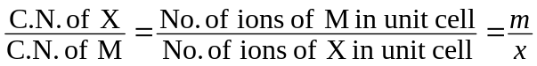
■ Structure of Sodium chloride
⧫ Close packed.
⧫ Consists of two penetrating face-centered cubic lattices of cations and anions.
⧫ C.N. of sodium = C.N. of chloride = 6.
 NaCl exhibits 6:6 Coordination
■ Structure of Caesium chloride
⧫ Not closely packed.
★ As Cs ions are larger than Na ions, CsCl has to adopt an open structure
⧫ Consists of two penetrating simple cubic lattices.
⧫ C.N. of sodium = C.N. of chloride = 8.
 NaCl exhibits 6:6 Coordination

Ionic Radii:
■ The ionic radius is the approximate radius of the spherical space occupied by the electron cloud in all direction in an ionic lattice.
■ Internuclear distance = Cationic radius + Anionic radius
 Internuclear distance is measured by X-ray diffraction
■ Cations have smaller radii than the corresponding atoms
★ Cations in lattice is formed by losing electrons  Has 1 less filled shell than the atom
★ Nuclear charge outweighs the electronic charge  Electron cloud contracts
 For metals, Atomic radius > Ionic radius
■ Anions have larger radii than the corresponding atoms
★ Protons exceeded by the electrons  Greater electronic repulsion leads to greater ionic size
■ Generally, Cationic radius < Anionic radius
■ In an isoelectronic series, more protons leads to smaller radius
■ Factors governing the ionic radius:
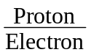 ratio: Higher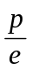ratio  Higher E.N.C.  Contraction of electron cloud of the ion
⬥ Presence of other ions:
⧫ Charge cloud of an ion would tend to expand to fill up the atmosphere until it is repelled
⧫ If the ion is present in close vicinity to other ions, its size is very much reduced owing to electron repulsion.
Molecular Crystals
Molecular Crystals:
■ Discrete molecules or noble gases atoms held by intermolecular forces in lattice sites
⬥ Atoms in individual molecules are boned by intramolecular covalent bond
⬥ Molecules tend to pack together as efficiently as possible
■ Intermolecular forces involved in molecular crystals:
⬥ Induced dipole-induced dipole interactions: Iodine, Carbon dioxide
⬥ Dipole- dipole interactions: Sulfur dioxide
⬥ Hydrogen bonds: Ice
■ The coordination number of an ion in a crystal of ionic cp. is the number of oppositely charged ions immediately surrounding that ion.

Giant Covalent Crystals
Giant Covalent Crystals:
■ Atoms are bonded by strong covalent bonds only.
⧫ Properties are governed by geometry and strength of bonds

Structure of Diamond:
■ An allotrope of carbon.
■ Each C atom is bonded tetrahedrally to 4 neighboring C atoms.
⧫ Atoms are bonded by identical and directional C–C covalent bonds
 Forms a three dimensional covalent network structure

Structure of Graphite:
■ An allotrope of carbon.
■ Each C atom is bonded trigonally to 3 other C atom in the same layer
⧫ Atoms are bonded by identical and directional C–C covalent bonds
 Gives a layer of planar structure of hexagonal rings.
⧫ C–C bond in graphite has some double bond character due to the delocalized electrons
■ Weak van der Waals’ forces attract planes / layers of carbon atoms together
⧫ Layers are widely spaced since the weak attraction  Lubricating properties
⧫ Electrons delocalized inn between the layers  Electrical conductivity

Structure of Quartz:
■ Quartz = Silicon(IV) oxide, i.e. SiO₂
■ Each silicon atom is tetrahedrally bonded to 4 oxygen atoms
⧫ Atoms are bonded by strong identical and directional Si–O covalent bonds
■ Each oxygen atom is bonded to 2 silicon atoms
⧫ Coordination no. of Si = 4; Coordination no. of O = 2
 Gives a tetrahedral diamond-like structure.

Efficiency = Percentage volume of the unit cell occupied / utilized by the atoms.
Cubic Close-Pack = Face-centered Cubic Packing (f.c.p.)
Isoelectronic ions = ions having the same number of electrons

