PhyChem – Rate Equations

Rate Equation

Rate Equation:
- Reaction are reversible to a certain extent
- If the condition chosen can neglect the reverse reaction, the reaction will depend on conc. of reactants only
- For reaction: a A + b B ⎯→ Product,
- Rate ∝ [A]^{x}[B]^{y}
- Rate = k[A]^{x}[B]^{y}
- Differential rate equation

Differential Rate Equation:
- Rate = k[A]^{x}[B]^{y}
- Shows how rate depends on conc. of reactants
- Express rate as a function of concentration
- k = Proportionality constant = Rate constant
- x = Order of reaction w.r.t. reactant A
- x + y = Overall order of the reaction
- [A] = Concentration of reactant A, unit: mol dm^{–3}
- Unit of rate: mol dm^{–3} s^{–1}
- Unit of rate constant:
Overall order | Unit of k
0th order | mol dm^{–3} s^{–1}
1st order | s^{–1}
2nd order | dm³ mol^{–1} s^{–1}
3rd order | dm⁶ mol^{–2} s^{–1}

Determination of Rate Equations:
- Rate equation is determined by experiments
- Determine rate eqn by the method of initial rates
- Several experiments are carried out w/different initial conc.
- Measure the rate for each at time close to t=0
- Rate law is obtained by comparison of data
- Determine rate eqn by the method of excess reactant
- Choosing condition that the conc. of only one reactant varies
- Done by using reactant w/relatively small conc.
- Rate = k[A]^{x}[B]^{y}[C]^{z} becomes Rate = k' [A]^{x}
where k' = k[B]^{y}[C]^{z}
- Rate law determined by:
- Taking logarithm on both sides and plotting log(Rate) vs log[A], slope = x
- Performing experiment w/different conc. of B & C to find the values of k' and also k, y, z

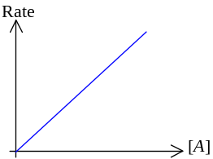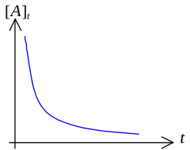

Integrated Rate Equation:
- First order reaction
- Example: Radioactive decay
- Rate = k[A]
- Integrated rate law: [A]_{t} = [A]₀e^{–kt}
- 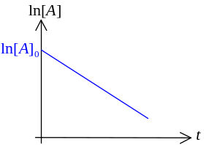Conc. of reactant depends on the time after reaction
- [A]_{t} = Conc. at time t
- [A]₀ = Initial concentration
- Usual form of integrated first order rate law: ln[A]_{t} = ln[A]₀ – kt
- The rxn is 1st order iff plotting ln[A] against time gives a straight line
- Slope = –k
- As [A]_{t} performs exponential decay, it has half life
- Half life: 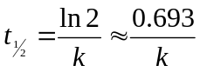

- Second order reaction
- 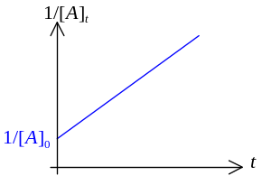Rate = k[A]²
- Integrated 2nd order rate law: 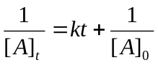
- Plotting 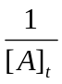 against time gives a straight line
- Slope = Rate constant k

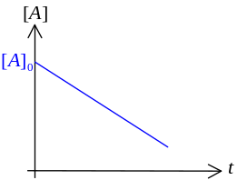
- Zeroth order reaction
- Rate = k = constant
- Integrated rate law: [A] = –kt +[A]₀
- Plotting [A] vs time gives a straight line
- Slope = –k
- 0th order rxns are most often encountered when a substance such as a metal surface or enzyme is req’d for the rxn to occur

