PhyChem – Collision Theory

Gaseous Matters

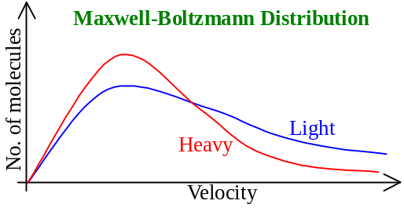Matter of gaseous states:
- Comprises of molecules in continuous, chaotic motion
- Widely separated
- Possess energy and collide randomly
- Distribution of molecules of different energy follows the Maxwell-Boltzmann distribution
- 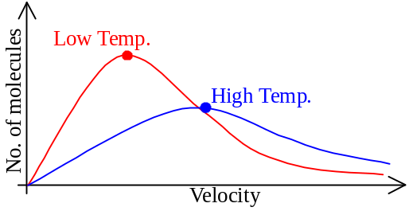At same temperature, lighter molecules tend to have a wider spread of speeds than that of heavy molecules
- Raising temperature, the distribution generally shift to higher velocity
- Same area, as total no. of molecules not changed
- Curve flattened as there is a considerable inc. in no. of molecules having higher velocity

Collision theory:
- Major postulates of collision theory:
- Chemical rxn in the gas phase are due to the collision of reactant particles
- A collision only results in a rxn if a certain threshold energy is exceeded
- The energy come from molecular kinetic energy
- The threshold energy is called activation energy, E_{A}
- A collision only results in a rxn if the colliding particles are correctly orientated to one another
- Rate ↑ as conc. of reactant ↑
- Since Freq. of collision ↑ as conc. ↑
- Probability of a collision having sufficient conditions for a rxn to occur also ↑
- Rate ↑ as temperature ↑
- At any time, only a fraction of molecules has sufficient large KE to effect fruitful collision
- Inc. temperature can inc. the fraction of effective collision
- Increment is exponential
- No. of collision w/activation energy = (Total no. of collision) ×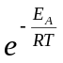
- E_{A} = Activation energy
- R = Universal gas constant = 8.314 JK^{–1}mol^{–1}
- T = Absolute temperature
- = Fraction of molecules w/energy greater than E_{A}
- 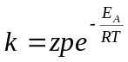
- k = Rate constant
- z = Collision frequency
- p = Steric factor (Fraction of collision w/effective orientation)
- Arrhenius equation: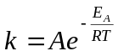 where A = Arrhenius factor
- 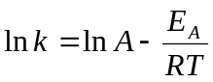

Activation energy

Determination of E_{A} of a reaction:
- 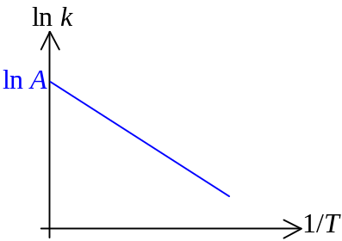Arrhenius equation: ⇒
- Plot of ln k against 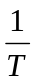 gives a straight line
- Slope of graph = 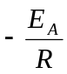
- ln k-intercept = ln A
- E_{A} = –R × Slope = (–8.314 JK^{–1}mol^{–1}) × Slope

Energy Profile:
- Chemical reaction: Molecular kinetic energy is converted into potential energy thou’ the collision
- During the rxn carrying out, some highly energetic & unstable chemical species exist briefly
- Possess maximum potential energy
- Called activated complex or transition state
- Energy gap btw reactants and transition state = Activation energy, E_{A}
- If reactant possess energy < E_{A} , it cannot convert to transition state
- 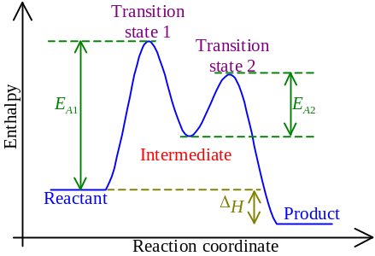Cannot react
- Sometimes, before the transition state converted to product, an intermediate formed
- Intermediates are energetically more stable
- Rarely can be isolated
- The intermediate will be changed to another transition state and then finally becomes product

Rate Determining Step:
- Reaction mechanism: A series of steps or stages occur when a reaction proceeds
- Molecularity: No. of species that must collide to produce the reaction of a step
- A reaction may have many stages
- Elementary steps
- The rate law of the rxn in each elementary step can be written directly from its equation’s molecularity
- The elementary step involving 1, 2 and 3 molecules are called unimolecular, bimolecular and termolecular steps respectively
- Rate law of a elementary step follows directly from the molecularity of that stage:
Elementary step | Molecularity | Rate law
A ⎯→ Product | Unimolecular | Rate = k[A]
A + A ⎯→ Product | Bimolecular | Rate = k[A]²
A + B ⎯→ Product | Bimolecular | Rate = k[A][B]
A + A + B ⎯→ Product | Termolecular | Rate = k[A]²[B]
A + B + C ⎯→ Product | Termolecular | Rate = k[A][B][C]
- Sum of elementary steps must give the overall balanced equation
- In multistage reaction, there must be a stage be the slowest
- Rate determining step
- The overall rxn cannot be faster than the rate determining step
- Usually, the rate law of the rate determining step is the overall rate law of the rxn

Catalyst

Catalyst:
- Reaction can be speeded up by increasing the fraction of molecules that have energies > E_{A}
- Lowering the E_{A} , the fraction will also increased
- Reaction speeded up
- Catalyst can direct the reaction into a new pathway that with lower E_{A}
- By providing an alternative pathway (catalytic pathway) of lower E_{A}
- The catalyst is usually reacted in one step and then regenerated in subsequent steps
- Catalyst is chemically unchanged, but it may have physical change after rxn
- 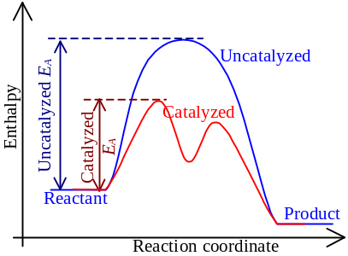If a catalyst can speed up a rxn, it is called a positive catalyst
- Providing an alternative pathway w/lower E_{A}
- If a catalyst can slow down a rxn, it is called a negative catalyst
- Blocks out the original pathway

Heterogeneous Catalysis:
- Catalytic process occurs in more than one phase
- Catalyst in a different phase from both the reactant & product
- Catalytic process occurs in the interface btw phases
- Reactants are absorbed on the rxn surface, then react via a new rxn pathway w/lower E_{A}
- Example: 2H₂O_{2(aq)} ⎯→ 2H₂O_{()} + O_{2(g)} Catalyst: MnO_{2(s)}

Homogeneous Catalysis:
- Whole rxn occurs in a single phase only
- Catalyst, reactants, products are uniformly distributed in the same phase
- Catalysis occur by the catalyst forming some unstable intermediates w/the reagents
- To allow ready rxn w/lower E_{A} followed by regeneration of catalyst
- Example: Esterification, RCOOH_{(aq)} + ROH_{(aq)} ⎯→ RCOOR_{(aq)} + H₂O_{()} Catalyst:H⁺_{(aq)}

Autocatalysis:
- Reaction is catalyzed by the product formed
- The product responsible for the catalytic action is called autocatalyst
- The rate is slow at the beginning but increases with time
- 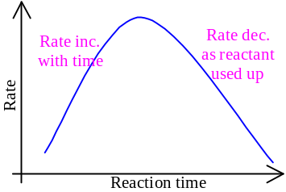Example: 2MnO₄– + 16H⁺ + 5C₂O₄^{2–} ⎯→ 2Mn²⁺ + 8H₂O + 10CO₂ Catalyst: Mn²⁺ ion

