PhyChem – Acid-Base Equilibria

Dynamic Equilibrium
Dynamic equilibrium: Two reversible or opposing changes are continually take place on the molecular level but that they are balanced
Phase equilibria: The equilibria existing btw phases of a system
- Example: X_{(g)} X_{()}
Chemical equilibrium: Rate of forward reaction is equal to the rate of the reverse reaction

Characteristics of Dynamic equilibrium:
- A stable state of dynamic equilibrium can only be achieved in a closed system
- i.e. No matter exchange with the surroundings
- Equilibrium can be achieved from either forward or reversed direction
- At a given temp., the overall properties does not changes with time for a system in dyn. eq.
- Equilibrium is a stationary but dynamic condition in which forward & backward reaction are occurring at a rate which balanced on a molecular level all the time

Equilibrium Law:
- If the concentration of one or more reacting substances in a reversible equation is changed, then the equilibrium will shift in such a way as to preserve the constancy of the relative concentration of the products & reactants
- 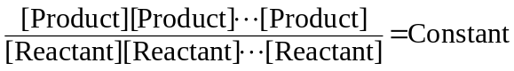
- The constant value is specific for a particular temperature
- For a reaction αA + βB γC + δD in equilibrium,
Equilibrium law: 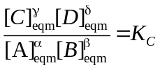
- K_{C} = Molar concentration equilibrium constant
- [ ]_{eqm} = Molar concentration at equilibrium
- Equilibrium law = Equilibrium constant expression for the reaction
- In equilibrium constant expression,
- The expression used for K_{C} must be consistent w/the corresponding balanced equation
- K_{C} is specific for a equation
- Same reaction but in two balanced equation that of different coefficient, K_{C} is different
- Equations that the coefficient are multiplied by a certain factor, KC raised to the corresponding power
- If the equation is reversed, K_{C} is inverted (reciprocal)
- Unit of K_{C} is depended on the equation being considered
- Equilibrium constant for gaseous systems are often be expressed in terms of partial pressure of gases rather than concentration
- Partial pressure equilibrium constant, K_{P}, is used instead
- 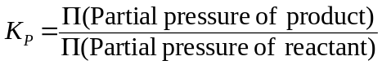
- For any equilibrium constant K,
- Large K ⇒ The reaction mixture will have larger proportion of product
⇒ The reaction has a large extent to the right (product side)
- Small K ⇒ The reaction give low yield of products at equilibrium
- Equilibrium constant K is fixed at a constant temperature

Acid & Base

Definitions:
- Anhenius: Acid produces H⁺_{(aq)} ions
Base produces OH–_{(aq)} ions
- Limitation: Do not account for basic properties of some insoluble / not water-miscible bases
- Brönsted-Lowery theory: Acid is a proton (H⁺) donor
Base is a proton acceptor
- Conjugate acid: The substance that a base received a proton
- Conjugate base: The remains after an acid lost a proton
- Example: HCl + H₂O H₃O⁺ + Cl–

- HCl = Acid
- H₂O = Base
- H₃O⁺ = Hydronium ion = Conjugate acid
- Cl– = Conjugate base

- Whether a substance is a Brönsted acid or base depends on the other substance present

Dissociation of water:
- 2H₂O_{()} H₃O⁺_{(aq)} + OH–_{(aq)}
- H₂O_{()} is both Brönsted acid and base
- One H₂O furnishing a proton and forms OH– (conjugate base)
- Another H₂O accepting a proton and forms H₃O⁺ (conjugate acid)
- Equilibrium constant: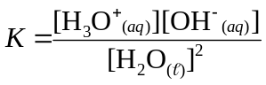
- If simplified equation H₂O_{()} H⁺_{(aq)} + OH–_{(aq)} is used, 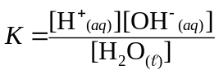
- Ionic product of water: K_{W} = K[H₂O] = [H⁺][OH–]
- Unit: mol²dm^{–6}
- At 25°C, K_{W} = 1.0×10¹⁴ mol²dm^{–6}
- K_{W} is constant for any aqueous solution, no matter what is dissolved
- In neutral solution, [H⁺] = [OH–]
- In acidic solution, [H⁺] > [OH–]
- In alkaline solution, [H⁺] < [OH–]
- pH scale: 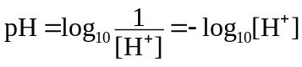
- pH is a common logarithmic scale
- pH changes by 1 for every 10 times change in [H₃O⁺]
- pH decreases as [H⁺] increases and vice versa
- pOH = –log₁₀[OH–]
- pH + pOH = 14 for any solution in 25°C

Acid strength:
- Strength of acid is depended on its equilibrium of dissociation
- HA_{(aq)} + H₂O_{()} H₃O⁺_{(aq)} + A–_{(aq)}
- Strong acid: Equilibrium lies far to right
- Almost completely dissociated
- Weak acid: Equilibrium lies far to left
- Only dissociate to a small extent
- In particularly high concentration, those generally strong acids do not dissociate
- Acid strength considers the dilution instead of concentration
- If dilution cause a proportionate increase in pH, the acid is completely dissociated
- Strong acid
- If pH variation is not proportionate to dilution, the acid is not completely dissociated
- Weak acid

Strong Acid
- Common strong acid: Sulphuric(VI) acid H₂SO₄; Hydrochloric acid HCl;
Nitric(V) acid HNO₃; Chloric(VII) acid HClO₄
- In H₂SO₄, HNO₃, HClO₄, the displaceable H atom is bonded to oxygen atom
- Called oxyacids
- More sensible to write in SO₂(OH)₂; NO₂(OH); ClO₃(OH)
- In oxyacid of the form H–O–X, if X has high EN, O–X bond is very strong and covalent
- When H–O–X dissolved in water, O–X bond will remain intact, the relatively weak & polar H–O bond will break readily
- Strong acid
- HCl is hydrohalic acid in the form H–X
- Acidity depends on strength & polarity of H–X bond
- HCl is strong acid as H–Cl bond is weak and polar
- Readily dissociates when dissolved in water
- HF is weak acid even it is very polar as the H–F bond is very strong

Acid dissociation constant:
- When weak acid HA dissolved, an equilibrium set up: HA_{(aq)} H⁺_{(aq)} + A–_{(aq)}
- Equilibrium constant is called acid dissociation constant, K_{a}
- 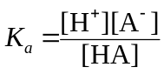
- Degree of dissociation = Percentage of acid dissociated
- Degree of dissociation =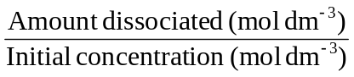
- Larger K_{a} ⇔ Stronger acid
- Stronger acid gives a weaker conjugate base and vice versa
- Strong acid is completely dissociated and [HA]=0
- No K_{a} value

Bases:
- Strong base are hydroxide salts that dissociate completely in water
- In molecule H–O–X, if X has low EN, O–X bond tend to be ionic and weakened
- OH– ion forms when dissolved
- General reaction btw a weak base and water: B_{(aq)} + H₂O_{()} BH⁺_{(aq)} + OH–_{(aq)}
- Equilibrium constant: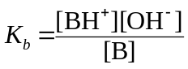
- In reaction B_{(aq)} + H⁺_{(aq)} BH⁺_{(aq)}, the equilibrium constant 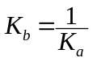
where K_{a} is the acid dissociation constant of conjugate acid BH⁺
- 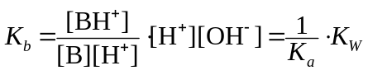
- K_{W} = K_{a} ⋅ K_{b}

Lewis Acid & Bases:
- More general definition of acids & bases
- Lewis acid: An electron pair acceptor
- Lewis base: An electron pair donor
- Only a qualitative theory

Buffer:
- Buffer solution: Resist the change of pH on addition of small amount of strong acid/alkali or dilution
- Buffer at acidic pH: Dissolving approx. equal conc. of weak acid and its salt w/strong base in same aqueous solution
- Buffer at alkaline pH: Dissolving approx. equal conc. of weak base and its salt w/strong acid in same aqueous solution
- pH of buffer is determined by its components
- In acidic buffer, HA_{(aq)} + H₂O_{()} H₃O⁺_{(aq)} + A–_{(aq)} where K_{a} is small
- If small amt of acid added, H⁺_{(aq)} + A–_{(aq)} HA_{(aq)}
- [H₃O⁺] has not much change
- If small amt of alkali added, OH–_{(aq)} + HA_{(aq)} H₂O_{()} + A–_{(aq)}
- OH– ion cannot accumulate
- In alkaline buffer, B_{(aq)} + H₂O_{()} BH⁺_{(aq)} + OH–_{(aq)} where K_{b} is small
- If small amt of acid added, H⁺_{(aq)} + B_{(aq)} BH⁺_{(aq)}
- If small amt of alkali added, OH–_{(aq)} + BH⁺_{(aq)} B_{(aq)} + H₂O_{()}
- pH of buffer remains largely unchanged after the addition of moderate amt of acid/alkali

Essence of Buffering:
- In buffer: HA_{(aq)} H⁺_{(aq)} + A–_{(aq)} ; 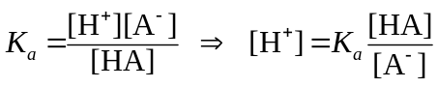
- Therefore pH is determined by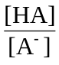
- Buffer has its effect since [HA] and [A–] are large
- Any OH– or H⁺ added, change in is small and [H⁺] is virtually constant
- 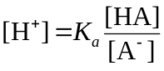; 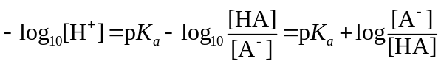
- Henderson-Hasselbach equation: 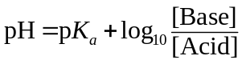

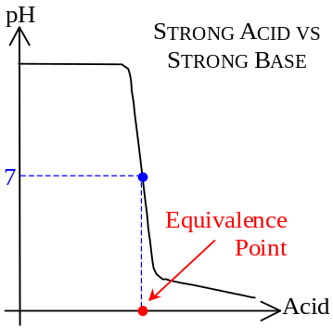Acid-Base Titration

Titration curve:
- Strong Acid vs Strong Base
- Curve start off with almost horizontal section
- A lot of acid could be added w/o changing much the pH
- Then the curve becomes very steep
- pH drop rapidly from 11 to 3
- Sharp fall of pH allows easy detection of equivalence point
- Equivalence point: The point which original acid/base in solution is completely consumed
- 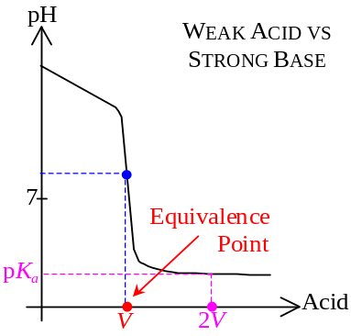pH 7 in Strong acid – Strong base titration
- Weak Acid vs Strong Base
- Initially, the curve falls slowly
- pH at equivalence point > 7
- Due to the basicity of conjugate base of the weak acid
- Finally the titration curve decrease slowly & levels off
- Buffering effect of the weak acid and salt mixture
- Strong Acid vs Weak Base
- pH at equivalence point < 7
- Due to acidity of conjugate acid of the weak base
- Before equivalence point: Buffering range
- 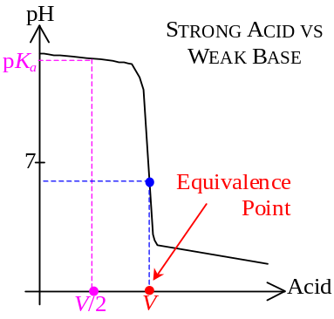Beyond equivalence point: pH drop significantly as excess H⁺ present
- 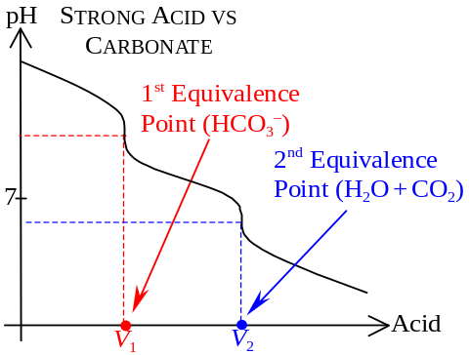Strong Acid vs Carbonate
- CO₃^{2–}_{(aq)} + H⁺_{(aq)} ⎯→ HCO₃–_{(aq)}
HCO₃–_{(aq)} + H⁺_{(aq)} ⎯→ H₂O_{()} + CO_{2(g)}
- Reaction proceed in two stages
- Titration process is essentially made up of two separate acid-base reaction
- Titration curve has two kinks

Acid-Base Indicators:
- End point: The point which change in color of the indicator
- Equivalence point: A stoichiometry state
- Acid-base indicators: Substance that changes color w/pH of the environment
- Usually complex molecules of weak acids
- It exhibit a color in HIn acid form and exhibit another color in In– basic form
- Considering indicator HIn, HIn_{(aq)} H⁺_{(aq)} + In–_{(aq)}
- 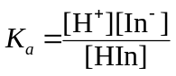, 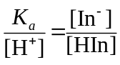
- If H⁺ in solution is abundant, HIn dominates
- If H⁺ is rare, In– dominates
- For most indicators, the major form to minor form ratio shoud grater than 10:1 fir aooearabt cikir change to human eye
- In acidic environment: 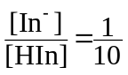
- By Henderson-Hesselbach equation, when color changes: pH = pK_{a} – 1
- In basic environment: 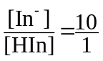
- By Henderson-Hesselbach equation, when color changes: pH = pK_{a} + 1
- pH range for color change of an indicator: pH = pK_{a} ± 1

Choice of Indicator:
- Strong Acid – Strong Base titration:
- Equivalence point = pH 7, ∴pK_{a} = 7±1 = 8 to 6
- Due to the dramatic change of pH near the end point (pH 5.3 ~ pH 8.7), a large variety of indicator can be used
- Weal Acid – Strong Base titration:
- Range for sharp change of pH is narrow
- Equivalence point = pH 8.7
- Phenolphthalein as indicator
- Two stage neutralization of Carbonate + Strong Acid:
- Two equivalence point at pH 5 and pH 9 respectively
- Use phenolphthalein & methyl orange
- Double indicator method

