PhyChem – Phase Equilibria

One Component System

Phase:
- Phase is any part of a system which is physically distinct from the rest of the system
- A phase can be solid, liquid, gas or solution
- Any part of a phase must be the same, i.e. homogeneous
- Equal temperature, pressure, concentration, etc.
- Any phase is separated from other phases of the system by a distinct boundary
- Example: Surface of solid, liquid surface
- One component system: A system containing one pure substance in some phases only
- The substance may exist in different phases when under different conditions (temperature & pressure)
- 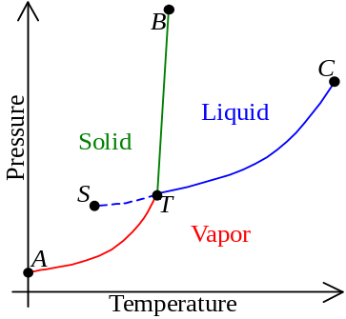Summarized by a phase diagram
- In a phase diagram of a pure substance,
- AT = Sublimation curve
- Solid and vapor has a dynamic equilibrium
- BT = Melting point curve
- Solid and liquid has a dynamic equilibrium
- CT = Vapor pressure curve
- Liquid and vapor has a dynamic equilibrium
- ST = Supercooling curve
- Liquid & vapor in metastable state
- Point T = Triple point
- Solid, liquid and vapor has a dynamic equilibrium
- Point C = Critical point
- The substance is in an indistinguishable phase
- When a liquid is supercooled, it remain in liquid state below the triple point
- It is supercooled because the liquid cannot achieve the degree of organization necessary to become a solid
- Some small and more ordered particles, or suspended dust, are required for crystallization
- The supercooled condition is unstable / metastable state
- When the melting point curve has a positive slope, inc. in pressure will inc. the MP
- Example: Carbon dioxide, as the solid density is higher than water
- When the melting point curve has a positive slope, inc. in pressure will dec. the MP
- Example: Water, as the solid density is lower than water

Two Component System

Two component system:
- A mixture of two miscible liquids form a two component system at a single phase
- The two liquids can be miscible in any proportions
- Individual components are free to diffuse throughout the solution
- No boundary of separation of the two liquids
- Mole fraction is the ratio of no. of moles of a given component to total no. of moles of soln
- Mole fraction of component A: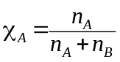

Ideal system:
- Raoult’s law states that the partial vapor pressure of a component in a mixture is equal to the vapor pressure of the pure component multiplied by its mole fraction in the liquid
- A mixture of two miscible liquids is said to be ideal solution if it obeys Raoult’s law
- P_{A} = χ_{A}P⁰_{A} where P⁰_{A} is the vapor pressure of A in pure component
- By Dalton’s Law, P_{total} = P_{A} + P_{B} = χ_{A}P⁰_{A} + χ_{B}P⁰_{B}
- A solution is ideal if the escaping tendency of a liquid into vapor is proportional to the vapor pressure
- 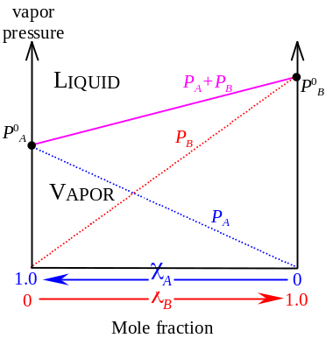In mixture of A & B, interactions btw A & A, A & B or B & B are same as those btw A & A in pure A or B & B in pure B
- No enthalpy change nor volume change in mixing the liquids
- In the vapor pressure – composition curve,
- The graph illustrates the vapor pressure of an ideal solution at constant temperature at all concentration
- Curves P_{A}, P_{B} & P_{A}+P_{B} are straight lines as the soln is ideal
- At any composition and pressure, if the pt reps the mixture is:
- Above the curve, it is in liquid state;
- Decreasing pressure would make it boil
- Below the curve, it is in vapor state;
- Increasing pressure would make it condense
- 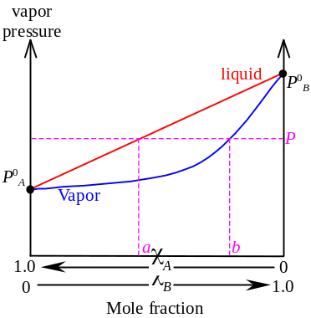On the curve, it attained an equilibrium btw liquid & vapor
- It is boiling
- P⁰_{B} > P⁰_{A} ⇒ BP of B < BP of A
⇒ B is more volatile (B has greater escape tendency)
- Since B has greater escaping tendency, when the liquid is boiling at pressure P, χ_{B} in vapor > χ_{B} in liquid
- Plotting pressure against vapor composition is an increasing curve under the liquid composition curve
- At vapor pressure P, when the equilibrium attained, the liquid has the composition a and the gas has the composition b
- When temperature increases, the pressure – liquid composition curve shifts up and slopes increases
- P⁰_{B} increases more than P⁰_{A} when temperature increases
- At particular pressure, when temp. inc., the boiling composition shifts to less volatile liquid
- 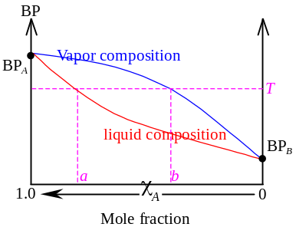When plotting BP against composition,
- Any composition of liquid a or composition of vapor b has the BP at T
- The points under the BP curve is in liquid state;
The points above the BP curve is in vapor state
- The vapor composition curve is above the liquid composition curve as the more volatile component is richer in vapor

Fractional distillation:
- 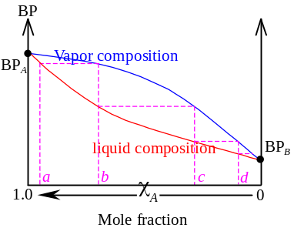Let a mixture of A & B at composition a is boiled
- Composition of vapor is b, where B is richer in the vapor
- The boiled vapor is then collected and condensed, a liquid of composition b is obtained
- Repeat boiling and condensing, a series of liquid of composition c and d is obtained
- The liquid obtained is having richer and richer composition of B
- Each step further, the BP required is lower
- Theoretically, after infinitely many boil & condense process, a absolutely pure B can be obtained
- The principle of fractional distillation
- In practice, a fractionating column is used to give a series of condensation and evaporation

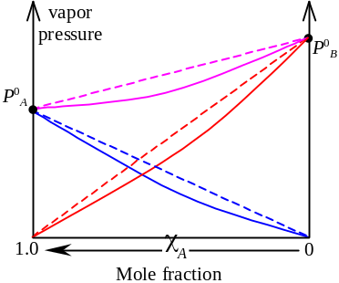Non-ideal systems

Negative deviation from Raoult’s Law:
- If a mixture has vapor pressure lower than predicted for an ideal solution, it is said to have a negative deviation from Raoult’s Law
- The neg. deviation happens  interaction of A-B > A-A or B-B
- Example: Hydrogen bond formed btw two liquid
- Usually heat is evolved as the interaction is stronger
- Small deviation would not give a minimum, but large deviation can give a minimum
- 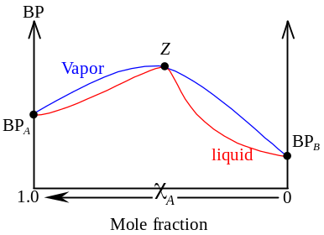For some non-ideal systems, the BP – composition curve has a point Z where the liquid composition and vapor composition curves touches
- This composition is called azeotrope
- The azeotrope always occur in extreme points
- At this point, the liquid composition and vapor composition are the same
- No composition change in boiling, just like a pure substance

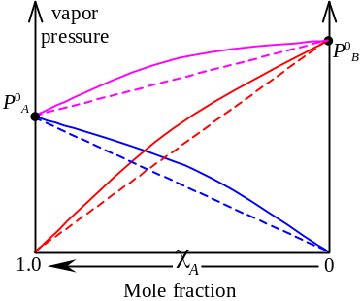Positive deviation from Raoult’s Law:
- If a mixture has vapor pressure higher than predicted for an ideal solution, it is said to have a positive deviation from Raoult’s Law
- The neg. deviation happens  interaction of A-B < A-A or B-B
- Example: Hydrogen bonds in pure liquid are broken
- The mixture has a higher escape tendency than in pure
- Usually mixing the liquid is endothermic
- Small deviation would not give a maximum, but large deviation can give a maximum
- Azeotrope also occurs in positive deviation
- In any deviation, the liquid composition is below the vapor composition curve
- 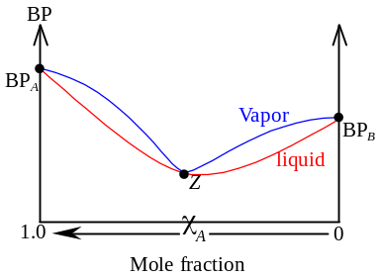Higher vapor pressure correspond to lower BP,
- In negative deviation, the BP curve is convex;
In positive deviation, the BP curve is concave
- Azeotrope in positive deviation: Minimum boiling azeotrope
Azeotrope in negative deviation: Maximum boiling azeotrope

Fractional distillation of non-ideal system:
- A mixture has high vapor pressure means the escape tendency is high (volatile)
- Intermolecular attraction btw molecules in liquid is weak
- Boiling point is low
- When mixing liquids gives a neg. deviation, the intermolecular attraction is stronger and BP ↑
- When mixing liquids gives a pos. deviation, the intermolecular attraction is weaker and BP ↓
- When deviation from Raoult’s law is very small, the pure lower-BP substance can be obtained by fractional distillation
- Same as those in ideal system as no azeotrope on the BP-composition curve
- 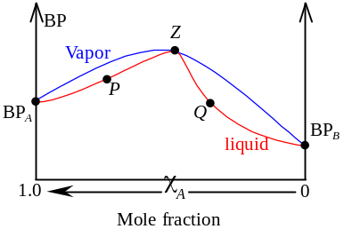When there is a large neg. deviation, the max pt on BP-composition curve represents azeotrope
- If azeotropic mixture Z is distillated, no separation can be given
- If mixture P, which lies btw Z and pure A in the BP-composition curve, is distillated, it will finally gives pure A
- If mixture Q, which lies btw Z and pure B in the BP-composition curve, is distillated, it will finally gives pure B
- When there is a large pos. deviation, the min pt on BP-composition curve represents azeotrope
- If azeotropic mixture is distillated, no separation can be given
- If non-azeotropic mixture is distillated, it will give a azeotropic mixture finally

Partition of a Solute

Solvents
- Polar solvents and non-polar solvents are immiscible
- When they mix, two distinct layers with a definite boundary formed
- Forms two distinct phase at same physical state (liquid)
- When a solute is dissolved in the immiscible solvents, it may dissolve to different extents in the two phases
- Forms a system of three components
- The solute at the interface btw the two solvents can move from one liquid from another
- Equilibrium set up when rate of solute moving from solvent 1 to 2 is equal to that moving from solvent 2 to 1
- 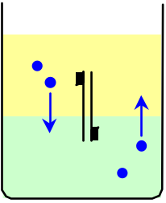The ratio of distributing solute btw two solvents is constant at particular temperature, regardless the amount dissolved
- Distribution law
- Distribution is described by partition coefficient: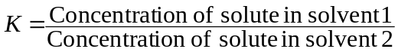
- Partition coefficient is constant at a fixed temperature
- The distribution law holds only in dilute solutions
- No association or dissociation of solute can take place in both solvents
- If a solute A in solvent α exists as A_{2(α)} but in solvent β exists as A_{(β)}, then the partition coefficient is: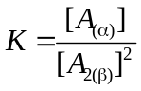
- Due to A_{2(α)} 2A_{(β)}, the coefficient of becomes the index

Solvent Extraction:
- Since organic products are more soluble in organic solvent than water, we can use organic solvent to extract organic product from its aqueous solution
- The two solvents is separated by separating funnel
- The extracted organic products can be purified by distillation
- By the distribution law, the solvent extraction is more efficient to be used in smaller portions
- It is more efficient to use 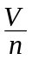 volume organic solvent in n times than V volume in one time

Paper chromatography:
- Chromatography: Analytical techniques depends on the relative adherence of a sample btw a stationary phase and a mobile phase
- In paper chromatography,
- The paper is soaked w/water to holds a thin film of water which forms a stationary phase
- A spot of sample solution is placed near the bottom of the strip of paper
- The paper strip is then dipped into a suitable solvent, which forms the mobile phase
- The solvent (mobile phase) is moving up as the result of capillary action
- The substance in sample is then distribute btw the mobile and stationary phases
- As different substances have different partition coefficients btw the mobile and stationary phases, they would be carried forward to different extents
- Those more soluble in the mobile phase than water film is carried more rapidly
- Those more soluble in water tends to move more slowly
- Different spots given respect to different substances in the sample
- Retardation factor for each spot: 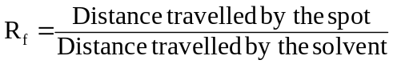
- R_{f} value is identical for each substance under same condition (temp., solvent, etc.)
- The substance in the sample is identified

Azeotrope = Azeotropic mixture = Constant boiling point mixture

