Chem&Soc – Chemistry & Food

Components of Food
Principal components of food: Proteins, Carbohydrates, Fats
- For normal functioning of body

Protein:
- Essential for the maintenance of structure & proper functioning of living organisms
- Proteins are macromolecules of relative molecular mass 5000 to 600000
- Proteins are made up of α-amino acids linked up by peptide bonds:
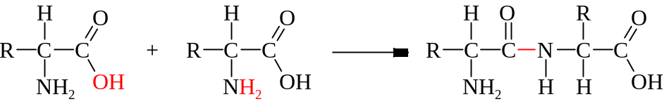
Peptide bond
- There are totally 20 amino acids found in proteins
- 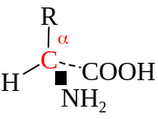All with the structure 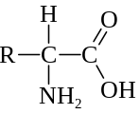 but with different side chain R
- They are called the 20 essential amino acids
- Except glycine (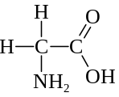), all amino acids are optically active w/α-carbon as chiral center
- Amino acids exists as zwitterion in solution: 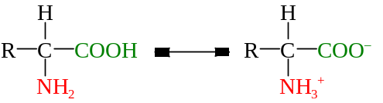
- Amphoteric: 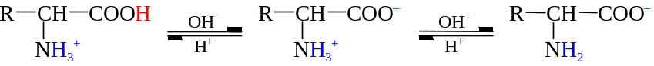
- Proteins could be broken down to amino acids by the hydrolysis of peptide bond:
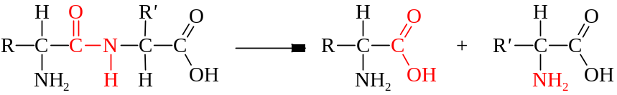

Carbohydrates:
- Source of energy in diet, with the formula C_{x}H_{2y}O_{y}
- Carbohydrates are polyhydroxyl aldehydes / ketones
- Monosaccharides: Simple sugars with formula C₆H₁₂O₆
- Disaccharides: Consist of two monosaccharide joined by glycosidic bond (Formula: C₁₂H₂₂O₁₁)
- Polysaccharides: Condensation polymers of monosaccharides w/formula (C₆H₁₀O₅)_{n}
- 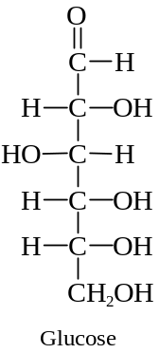Monosaccharides, glucose & fructose, have six carbon atoms
- Hexose
- Glucose: Dextrose or grape sugar
- It ca exist in acyclic or cyclic forms
- It is an aldohexose which contains an aldehyde group in open chain structure
- 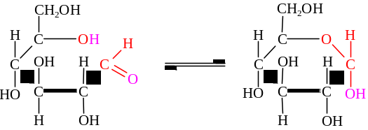
- Fructose: Levulose or fruit sugar
- 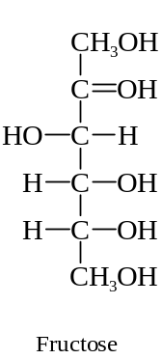It can exist in acyclic or cyclic forms
- It is an ketohexose which contains a keto group in open chain structure
- 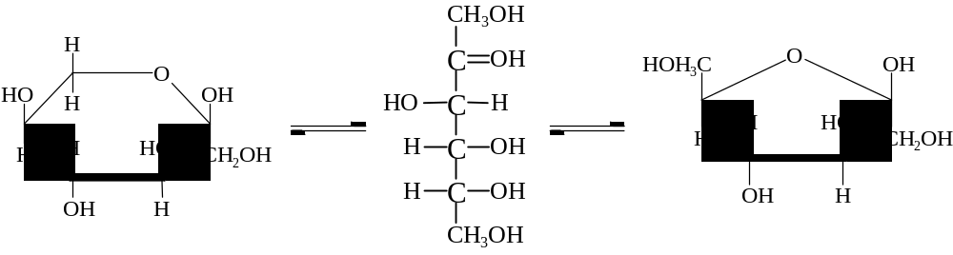
- Two monosaccharides can be linked to become a disaccharides by glycosidic linkage
- A condensation reaction between two –OH groups
- 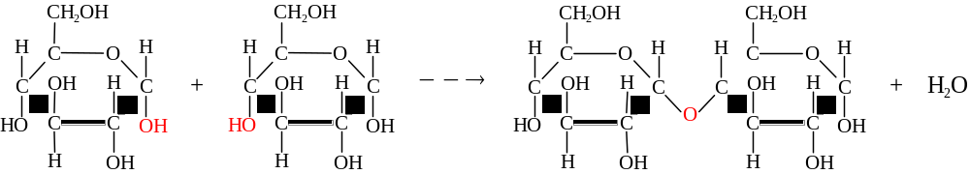
- By the repetition of condensation, monosaccharides are linked up by glycosidic linkage to form a polysaccharide
- All disaccharides can be hydrolyzed w/dil mineral acids into two monosaccharides:
C₁₂H₂₂O₁₁ + H₂O ⎯→ C₆H₁₂O₆ + C₆H₁₂O₆
- Starch can be completely hydrolyzed into glucose when boiling w/dil acid:
(C₆H₁₀O₅)_{n} + nH₂O ⎯→ nC₆H₁₂O₆
- If enzyme amylase is used, starch is broken down into maltose
- Monosaccharides, sucrose & lactose are reducing sugar which possess a reducing keto or aldehyde group
- Can be detected by Fehling’s test: Cu²⁺ + [O] ⎯→ Cu₂O

Fat & Oils:
- Fats are obtained by combining propane-1,2,3-triol with fatty acids:
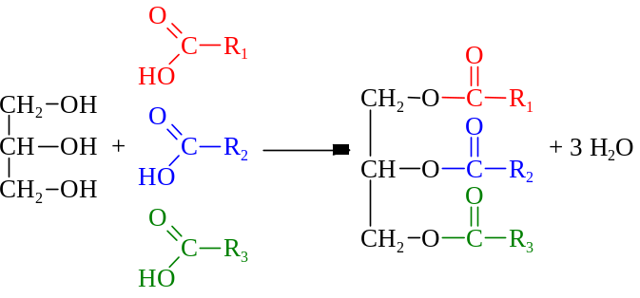
- R₁, R₂, R₃ are long fatty acid side chains
- The fatty acids are usually unbranched but may contain C=C double bond
- Saturated / unsaturated fatty acids
- Saturated fatty acids are closely packed due to the regular structure, ∴ in solid state
- Unsaturated fatty acids are not efficient to pack as the structure is irregular, ∴in liquid state
- Fats & oils can be hydrolyzed into carboxylic acids & glycerol:
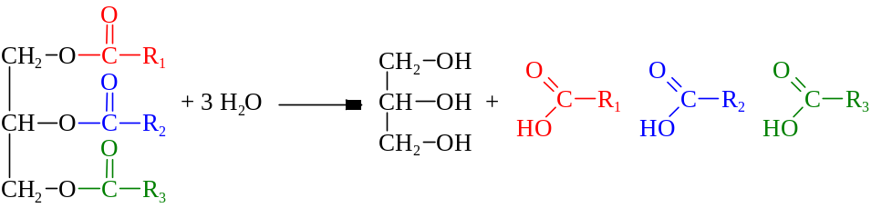
- The reaction is catalyzed by enzyme in body:
- The hydrolyze in laboratory can be catalyzed by acids or bases
- Use NaOH to break down fats is more practical & complete:
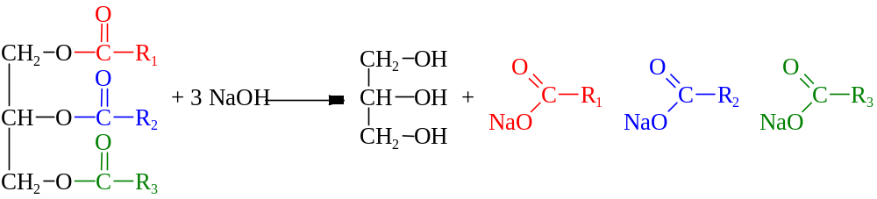
- Saponification process
- Iodine value is a measure of the degree of unsaturation in fat
- 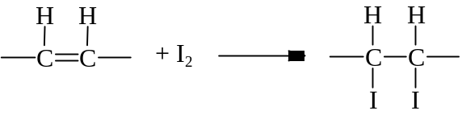
- More unsaturated fat will react with more iodine
- Iodine value is defined to be the no. of grams of I₂ that reacts with 100g fat or oil
- The vegetable oil w/high unsaturation is hardened by hydrogenation
- Used in the manufacture of margarine
- Lipid stand in air for long time will develop unpleasant odor & taste
- Rancidity caused by hydrolytic or oxidative reactions
- Hydrolytic rancidity: The moisture hydrolyze oil,
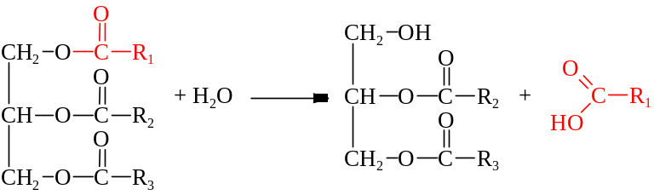
- The fatty acid produced is volatile and has unpleasant odor
- Oxidative rancidity: Oxidation of double bond by O₂
- O₂ reacts w/C=C double bond to form organic peroxides which then becomes foul smelling carbonyl cpds
- The rancid flavor formed

Food Preservation

Food Spoilage:
- Food preservation is aimed to store & transport food w/o deterioration in quality
- Food spoilage is due to microbial activities & chemical reactions in food
- Most deterioration is due to microbial spoilage caused by yeasts, fungi or bacteria
- Example: Bread mould on bread; Lactic acid bacteria in milk
- The micro-organisms spoil the attractiveness, palatability and nourishment of food
- Some micro-organisms may produce toxic chemicals when they act on food
- Food poisoning
- Some cases of food spoilage is owing to chemical changes
- Example: Rancidity of oils; Browning of apple
- Browning of apple is due to oxidation of phenols into diquinones which will be polymerized into a brown polymer
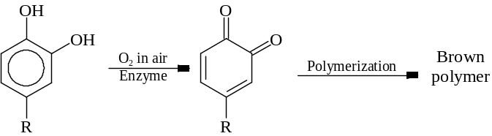

Food Preservation:
- Food preservation is base on three main principles: Killing micro-organisms, Inhibition of microbial growth, Retardation of chemical/biochemical changes
- Killing: Prevent the microbial reproduction in the damp & warm environment of food
- Inhibition: Keep food in tough condition for micro-organisms to grow to have activities
- Retardation: Retard changes in food by removing air or water and inhibit enzyme activities
- Preservation principles:
- Removal of moisture: Slow down the growth rate of micro-org. and prevent hydrolytic rxns
- Altering temperature: Retard microbial growth at low temp. or kill micro-org. by high temp.
- Changing pH: Providing unfavorable pH condition for microbial growth
- Osmotic process: Use a concentrated solution to preserve food and use the osmotic potential difference btw food & micro-org. to inhibit microbial activities
- Chemical additives: Inhibit microbial activity or slow down biochemical changes by chemical
- Example: NO₂– & NO– in meat curing;
- Example: BHA in cooking oil
- Preservation techniques:
- Heat treatment: Kill micro-organisms, Alter protein structures, Destroy enzyme activities
- Example: Cooking, Sterilization of milk by UHT
- Drying & Dehydration: Made water unavailable to prevent chemical rxns and microbial growth
- Example: Coffee powder, Milk powder
- Irradiation: Expose food to ionizing radiation to destroy enzymes and micro-organisms
- Example: Peaches, Strawberries
- Refrigeration:
- Chilling keeps food at 0°C ~ 4°C to slow down microbial & enzymatic activities, chemical & biochemical changes to retard spoilage
- Allow short term storage only
- Example: Meat, fruit, vegetables kept chilled in refrigerator
- Freezing keeps food at –20°C to turn water into ice and prevents hydrolytic rxns to occur or for micro-organisms to grow
- Example: Frozen meat, ice-cream
- Sugaring: Preserve food in concentrated sugar solution which water in food is lost by osmosis
- Water is unavailable for enzymatic action and microbial growth
- Example: Jam, Fruits in heavy syrup
- Salting: Treating food in salt or concentrated salt solution to remove water by osmosis
- Example: Bacon, Salt fish, Soy sauce
- Canning: Place food in cans and heated in steam or in boiling water bath
- The cooking destroys enzymes and kills micro-organisms in food
- Sealed can prevents air to enter or contamination with micro-organisms
- Example: Tinned foods
- Chemical preservation:
- Meat-curing by adding salt to meat or treating meat w/conc. salt solutions containing NaNO₃ or KNO₃.
- Salt ties up water to prevent micro-organisms multiply
- Nitrates inhibit microbial growth
- Example: Sausages, Luncheon meat, Corned beef, Salted fish, Ham
- Picking by preserving food in vinegar which microbial growth is inhibited at low pH
- Example: Sauces, Pickled onions
- Use of food additives to inhibit microbial & chemical activities
- Example: Benzoates & sulphites in fruit juices, SO₂ in wine, BHA/BHT in oils

Food Additives

Use for Food additives:
- Maintain palatability & wholesomeness: As preservatives to prevent spoilage & rancidity, i.e. maintains the taste
- Enhance flavor or impart desired color: As spices and natural/synthetic flavors to enhance the taste or appearance
- Maintain product consistency: As emulsifiers, stabilizers and thickeners to ensure consistent food texture and characteristics
- Provide leavening: Leavening agents to kelp cakes or biscuits to rise during baking
- Control pH: Modify the acidity & alkalinity of food for proper flavor, taste and color
- Improve or maintain nutritional value: Restore or enrich nutrients in food which is lost during processing

Additives:
- Preservatives:
- Nitrates(III) & nitrates(V) of Na & K can slow down microbial growth, maintain the pink color of meat & prevent botulism in canned foods
- Flavoring agents:
- Spices like cinnamon and ginger to stimulate the taste buds
- Monosodium glutamate (MSG) enhances flavor / bring out flavor of food, especially in meat
- Esters bring a sweet smell to food
- Saccharin is a sweetener and used as a sugar substitute or diet sugar to intense sweetness
- Aspartame is a dipeptide to intense sweetness in food
- Coloring agents:
- Natural colorings: Dye extracted from plants or animals
- Caramel is a brown dye in oyster sauce
- Carotene is a yellow dye from carrots used in butter & margarine
- Chlorophyll is a green dye from plants used in edible oils
- Synthetic colorings: Artificial organic compounds
- Indigo carmine is a purple blue dye used with yellow coloring for candies & liqueurs
- Tartrazine is a yellow azo dye in pudding powders, candies, pop drinks
- Sunset yellow is an orange azo dye in candies, sea salmons
- Emulsifier / Stabilizer / Thickener
- Prevent the oil-water mixture separates
- Example: Carboxymethylcellulose, Xanthan gum, Pectin, Dextrins, Sodium alginate
- Nutrients: Minerals & vitamins
- Antioxidants
- Reduces the amount of O₂ dissolved in food and prevent rancidity
- Ascorbic acid / Ascorbates are antioxidants for water soluble fatty products
- Due to their reducing property
- BHA, BHT donate H atom to hydroperoxide radical ROO⋅ to stop the oxidative spoilage
ROO⋅ + AH ⎯→ ROOH + A⋅

Harmful Effects of Food Additives:
- There are hazards associated with the use of food additives
- Allergies: Some people are allergic to certain additives like MSG & tartrazine, which may cause rashes, stomach upsets, asthma
- Hyperactivity: Food additives may cause hyperactivity, ADD in children
- Long-term illnesses: Some additives like NaNO are suspected to be carcinogenic
- BHT in large amount can cause cancer in laboratory animals
- Other alternative antioxidants like vit.C & vit.E are available
- Use of BHA & BHT are unnecessary & risky
- MSG is naturally occur in fresh meats & vegetables but also being questioned its safety
- People allergic to MSG may have dizziness, thirst, headache, chest pain, sweating, and abnormal discomfort
- Chinese Restaurant Syndrome
- Evident that MSG may have harmful effects on brain development esp. during infant stage
- The use of nitrates(III) is controversial:
- NO– is shown to be caused a decrease in hemoglobin in blood
- Long term ingestion of NO– may lead to Malnutrition, Growth retardation, Impairment of reproductive capacity, Reduced life span
- NO– are believed to be converted into carcinogens ‘nitrosamines’: 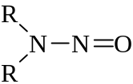
- In stomach, NaNO_{2(aq)} + HCl_{(aq)} ⎯→ HNO_{2(aq)} + NaCl_{(aq)}
- HNO₂ then react with 2° amines released during the digestion of proteins,
HNO_{2(aq)} + 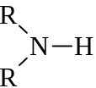_{(aq)} ⎯→ _{(aq)} + H₂O_{()}
- SO_{2(g)}, SO₄^{2–}, HSO₄–, S₂O₄ are commonly used to preserve food that can prevent discoloration in dried fruits and freshly cut vegetables, also inhibit bacterial growth and fermentation
- SO₄^{2–} can destroy vitamin and thiamin in foods
- The S(IV) salts are thought to cause reactions like tightness of chest, hives, abdominal cramps, diarrhea & lower blood pressure
- SO₄^{2–} can produce severe asthma attacks in sulphate-sensitive asthmatics
- Saccharin is a sweetener and as a substitute for sugar but carcinogenic to laboratory animals
- Saccharin is usually replaced by aspartame nowadays
- The safety of food additives is monitored by scientific research to look for the potent effects on humans
- The use of food additives is governed by legislation to control the permissible additives and the limits of additives in particular food

α-amino acid is the amino acid with amino group attached to the α-carbon of the related carboxylic acid
Propane-1,2,3-triol = Glycerol
UHT = Ultra High Temperature or Ultra Heat Treatment
Ascorbic acid is the chemical name of vitamin C
BHA = Butylated Hydroxyanisole
BHT = Butylated Hydroxytoluene
ADD = Attention Deficient Disease, a learning disability

