Physics – Atomic Physics

Electrons

Thermionic Emission:
- A glass tube contains a gas in 10Pa (low pressure of 10^{–4} atm)
- Wires C & A are fused into the tube
- Wire C is connected to a current supply to make it hot
- 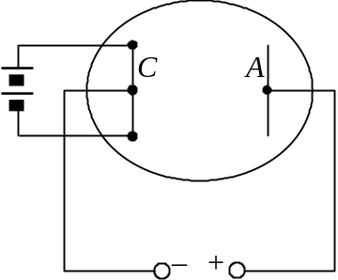A battery is connected across C & A to provide a p.d.
- A current will flows from wire A to C if:
- Gas pressure is sufficiently low or vacuum
- A hot C wire
- C is at lower potential than A
- Wire C: Cathode
- Wire A: Anode
- Current flow as the result of thermionic emission
- There are randomly-moving free electrons inside the metal
- If the electron possess enough energy, it can escape from the surface
- Minimum energy required to leave the metal surface = Work function
- At high temp. (heated cathode), more e– get the energy > Work function
- More e– can escape
- If no electric force provided, the metal surface becomes pos. charged as e– leaves
- The electron is pulled back as the result of electrostatic attraction
- If anode is in much higher potential, a E-force is provided to the e– when it leaves
- The electron will be accelerated toward the anode
- Cathode ray
- The current I across C & A & their p.d. V follows the relation 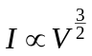 approximately
- By using the thermionic emission, a vacuum diode is made
- 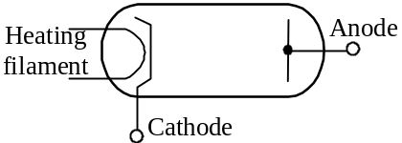Evacuated tube w/2 electrodes
- If cathode is in lower potential, current flows
- Forward bias
- If cathode is in higher potential, no current flows
- Reversed bias

Cathode rays:
- Maltese cross tube
- Consists of hot cathode and a hollow cylindrical anode in a evacuated glass bulb
- Has a coating of fluorescent material on the inside and a metal cross at the center
- The hot cathode and cylindrical anode make up an electron gun
- It shoots electrons to the bulb when the electrodes are maintained at high p.d.
- 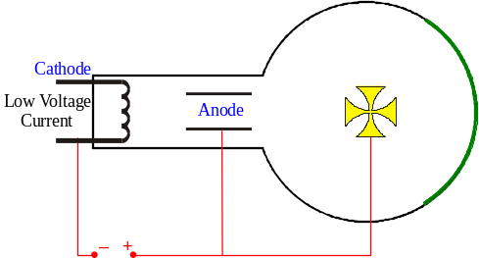When p.d. above 1kV, the electron causes the fluorescent material grows
- The metal cross make a shadow on the fluorescent screen
- If e– shot into the bulb, the shadow does not grow
- Electrons are blocked by the metal cross
- If a magnet bring near the tube, the shadow displaces
- The cathode ray possess neg. charge
- Cathode ray: Rapidly moving electrons with high velocity of about 10⁷ms^{–1}
- Deflection tube
- A Maltese cross tube with a narrow horizontal slit at one end of the cylindrical anode
- 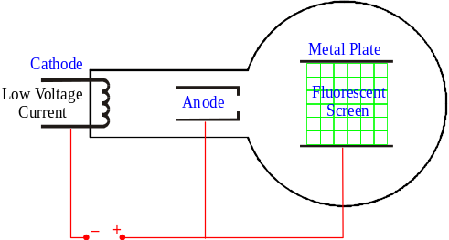The electron gun produces a flat narrow beam
- A pair of metal plates installed instead of the Maltese cross
- A fluorescent screen is situated vertically btw the plates
- When the p.d. of the two metal plates are different the luminous trace on the screen is different
- Trajectory looks like a parabola when the plates are not equipotential
- Trajectory is straight when the plates in same potential
- The beam always deflect towards the relatively positive plate
- Instead of adjusting the p.d. of the plates, produce a B-field parallel to the metal plates can also produce the same effect
- When applying a suitable B-field and p.d. across plates simultaneously, undeflected e– beam could be produced

Electron dynamics:
- Velocity
- When electron is boiled off from the cathode, it moves toward anode
- Assume the e– moves with velocity v and p.d. across electrodes is V₀
- K.E. = Electric P.E.: 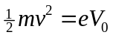
- 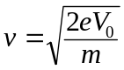
- Electric deflection
- When the electron entering the space btw two metal plates in the deflection tube,
- The plates have a potential difference, i.e. the space have an electric field
- The electron experiences an electric force toward the positive plate
- Assume the e– accelerates vertically with acceleration a_{y}; p.d. across the plate is V; separation btw the plates is d,
- 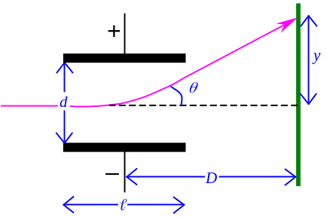Electric force F =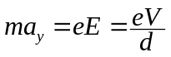
- In time t,
- Horizontal displacement s_{x} = vt = 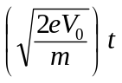
- Vertical displacement s_{y} =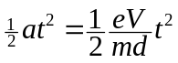
- 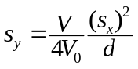
-  s_{y} ∝ (s_{x})², ∴ Trajectory is parabolic and independent of mass & charge of e–
- Suppose the plates are having a length , ∴ Time for the e– in the E-field is 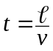
- Vertical displacement of the e– on emerging =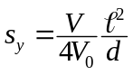
- Vertical component of velocity =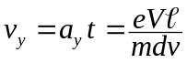
- Angular deflection θ satisfies: 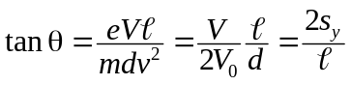
- If the e– caught by a screen at D from the center of the plate, linear deflection: y = D tanθ
- Magnetic deflection
- When e– entering a magnetic field, its path deflected
- The B-field is usually built by installing a pair of Helmholtz coils aside the deflection bulb
- 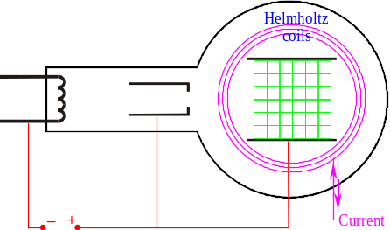If the coils’ radius is R, consist of N turns and having a current I flows in,
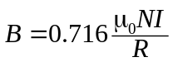
- The electron experiences a constant magnetic force F = evB
- The deflected path is circular as F always ⊥ motion
- Centripetal force: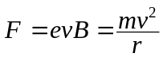
⇒ 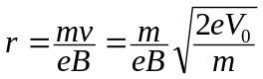
- Charge-mass ratio: 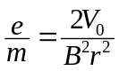
- 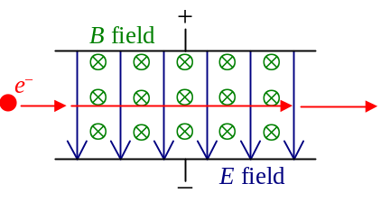Since the B-force by Helmholtz coils is in opposite dir. of E-force by metal plates, the electron move straight when the forces cancelled out each other
- eE = evB ⇒ 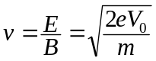
- Charge-mass ratio: 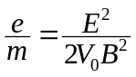

Cathode Ray Oscilloscope:
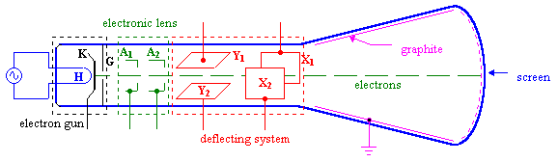
- Application of CRT to produce a visual image of electrical signals
- Structure of CRO:
- Electrons are emitted by thermionic emission at the cathode K & H
- A grid G is kept at lower potential then K to control the proportion of emitted e– reaching A₁
- Controlling the intensity of the light spot on the screen
- Anodes A₁, A₂ are kept at higher potential than C to accelerate the electrons forward
- Also converge the electrons to a fine beam and give a sharp spot on screen
- Y₁, Y₂ are deflecting plates for controlling the vertical deflection of the beam
- X₁, X₂ are deflecting plates for controlling the horizontal deflection of the beam
- A fluorescent screen makes the electron beam become visible as light spot
- 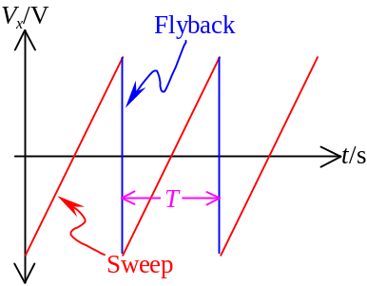Graphite coating on sides walls to provide a conducting return path for the electrons
- When a time base is used, the X-plates are connected to a built-in circuit that generates a saw-tooth waveform
- The external signal is connected to a input selector
- A circuit w/3 selections
- 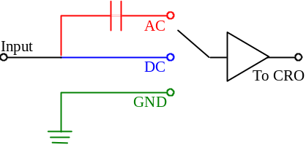GND: Connect the amplifier to ground and no signal received by CRO
- Use for setting the 0V line on the screen
- D.C. (Direct coupling): Entire signal is connected to CRO
- A.C.: Filter for AC component of the signal only
- The DC component is cut off by the blocking capacitor
- Advantages of using CRO as a voltmeter:
- Fast response of signal display
- Both AC or DC can be measured
- Very large internal resistance (very large due the OpAmp)
- CRO will not be damaged by overloading

Lissajous Figures
- 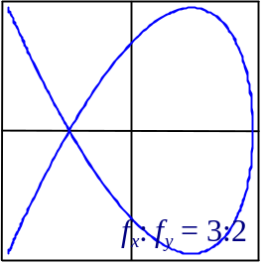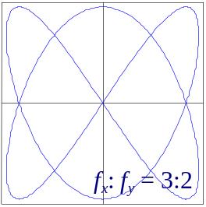When 2 AC signals are connected to the X- and Y-input with time-base off, a Lissajous pattern is observed
- Frequency ration of signals: 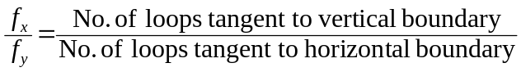
- Broken lines are treated as half-loops

- If two sinusoidal signals w/same amplitude & freq. applied to X- & Y-input, the Lissajous Figure is a straight line, circle, or ellipse according to the phase difference φ
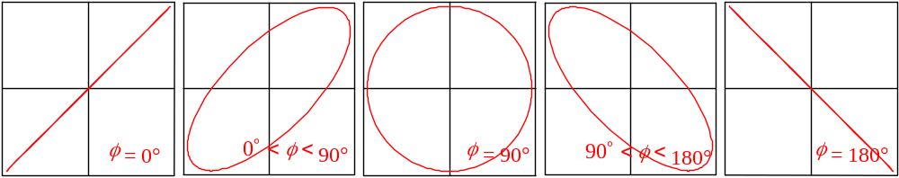

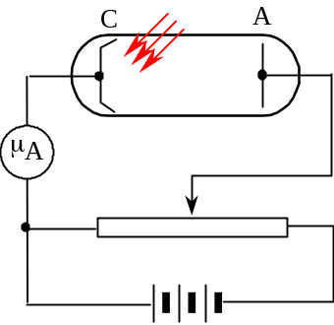Photoelectricity & Atomic structure

Photoelectric effect:
- A photosensitive metal C is placed in an evacuated tube as cathode
- When light falls on the cathode, photoelectrons emitted
- Photoelectric emission
- Current I_{P}, called photocurrent, flows in the circuit
- There would be no photocurrent when the light is of the frequency ν below ν₀
- ν₀ = Threshold frequency
- 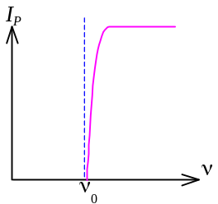The photocurrent above the threshold frequency is directly proportional to the intensity of the radiation
- If C is in negative electrode, I_{P} will decrease until voltage at C equals to V_{S}
- At V_{S}, KE of e– is zero, ∴PE of e– is its max. energy
- 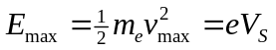
- If C is in positive electrode, I_{P} saturates soon
- 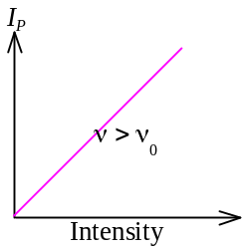No. of photoelectrons emitted is independent of the applied voltage
- Inc. the intensity would inc. the saturation current but no change to V_{S}
- 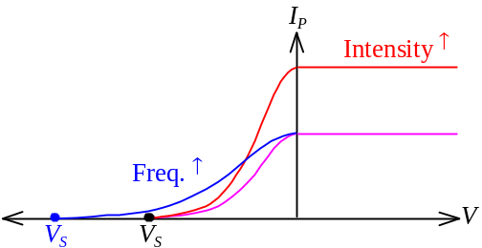Inc. light frequency make V_{S} more negative but don’t alter the saturation current
- Properties of photoelectric emission
- Emission occurs only if the freq. of the incident radiation > Threshold frequency
- Emission commences at the instant the surface starts to be irradiated
- No. of electrons emitted ∝ Intensity of radiation
- Emitted electrons have KE ranging from 0 to some max. value
- Inc. freq. → Inc. max KE
- Intensity of radiation have no effect on the KE of emitted electrons

Einstein’s Photoelectric Equation:
- Einstein suggested that light have dual properties:
- When light is in transmission, it behaves as waves
- When light is in emission or absorption, it behaves as particles
- EM radiation consist of lumps of energy (wave packets)
- Photons
- Energy of photon: E = hν where h = Plank’s constant = 6.63×10^{–34} Js
- When EM radiation falls onto the metal surface, the energy of photon is absorbed by e–
- The electron gained KE by a huge factor
- The gain of KE causes it shoot out though the surface when the direction is proper
- Minimum energy required to escape from the metal surface = Work function Φ
- Work function Φ is specific for a particular metal
- The threshold frequency satisfies: Φ = hν₀
- If ν <ν₀, no emission as the energy gained cannot outweigh the work function required
- If ν >ν₀, energy of photon is greater than Φ and the electron can escape with some KE
- Max. KE of photoelectron: U_{k} =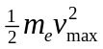= U – Φ = hν – hν₀
- Einstein’s photoelectric equation: = hν – Φ

Stopping potential:
- 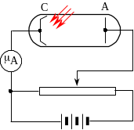Let the p.d. of C w.r.t. A be V
- 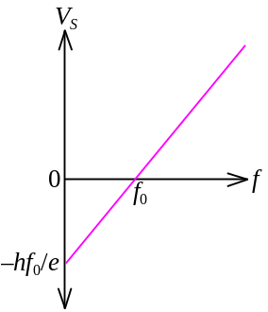When e– emitted from C reached A, its PE gained for eV and the KE also dropped for eV
- KE of e– reaching A: U_{k} = hν – hν₀ – eV
- If KE = 0 when the electron reaches A,
- Current of the circuit I_{P} = 0 (Photocurrent cease to flow)
- V is called the stopping potential V_{S}
- hν – hν₀ – eV_{S} = 0 ⇒ 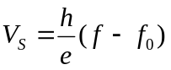

Ionization:
- 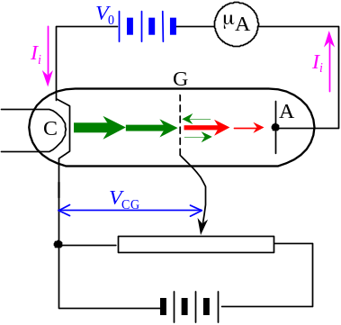There is a gas at low pressure inside the sealed glass tube
- Anode A is maintained at negative potential V₀ relative to C
- Electrons emitted from C cannot reach A
- The grid G is placed mid-way btw A and C and maintained at a variable potential V_{CG} above C
- Thermionic electrons are attracted by G from C
- P.d. btw G and A = V₀ + V_{CG}
- The potential barrier to prevent thermionic electrons reaches A
- Even some e– may pass thou’ the grid, it has not enough energy to overcome the potential barrier to reach A
- All thermionic electrons are attracted by G and no currents detected by microammeter
- When V_{CG} increased to enough high,
- 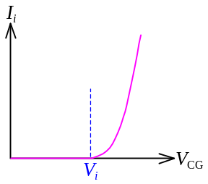When e– travels from C to G, it gains KE: U_{k} = eV_{CG}
- If the KE is high enough, it can ionize the gas atoms btw G & A
- Positive ions produced and attracted toward A
- Current detected by microammeter
- The least value of V_{CG} that gives current is called the ionization potential of the gas
- For hydrogen, the ionization potential = 13.6 V
- Ionization energy of hydrogen = 13.6 eV
- When V_{CG} > ionization potential, the tube grows
- Due to the excited atom return to the ground state or the ionized atom recapture electrons

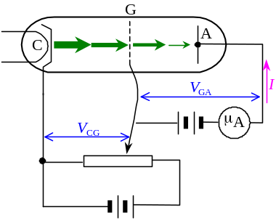Excitation:
- Excitation: Atoms absorb energy without ionization
- Franck and Hertz apparatus is used to study the excitation energy of gas
- The sealed glass tube contains gas at low pressure
- Grid G is positive relative to A
- Electrons reaching A must have KE > eV_{GA}
- When V_{CG} < V_{GA}, electron have not enough energy to reach A
- No current I is detected
- When V_{CG} = V_{GA}, current is just detected
- Further increase of V_{CG} cause more and more electrons shoot thou’ the grid to reach anode A
- 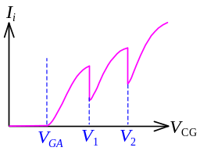Raising the current
- There are some drops in current when V_{CG} increases
- Some electrons lose their KE due to inelastic collision
- When V_{CG} increases, energy of e– increases
- When V_{CG} reaches V₁, e– possess energy eV₁
- The energy eV₁ = Exactly the energy enough to excite the atom to one energy level higher
- During collision, the energy of e– transferred to the gas atoms to excite them
- Energy lost, Current drops
- Relative minimum of current attained
- At V₁, energy of some e– is used to raise the gas atom to its first excitation state
- V₁ is known as the excitation potential
- Above V₁, inelastic collision still occurs and same amt of energy lost for excitation
- At V₂, more energy lost due to further raise atom to second excitation state
- Subsequent drops in current
- When the excited atoms return to their ground state, EM radiation is emitted

Spectra:
- Atoms of a substance can be excited when they are Heated, Bombarded by electrons or Illuminated w/radiation
- When the excited atoms return to lower energy states, there are emission of EM radiation
- When the radiation disperses out, a spectrum is obtained
- Line spectrum: The radiation comprising discrete frequencies
- Produced by exciting gaseous atoms
- Continuous spectrum: The radiation comprising continuous frequencies
- Produced by incandescent solids, liquids and compressed gas
- Band spectrum: Consists of closely grouped bands of lines
- Each band corresponding to a transition btw a high and low energy state
- Produced by molecular gases or chemical compounds
- Radiation is emitted by an excited atom at higher energy level returns to a lower level
- Radiation is absorbed when an atom having transition from a lower energy level to a higher level
- Energy involved during transition btw energy levels m and n: E = | E_{m} – E_{n} | = hν

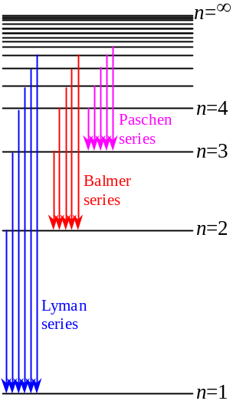Hydrogen Spectrum:
- Hydrogen spectrum is the emission spectrum when hydrogen discharges
- Discrete lines are observed corresponding to a specific transition
- The frequencies of the lines in hydrogen spectrum satisfies:
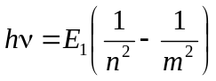 where E₁ = Ionization energy = 13.6 eV
- m, n are integers indicating the H atom jumps from level m to level n and emitting radiation of frequency ν
- Energy of H at n^{th} level: 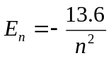
- Ground state energy of H = E₁ = –13.6 eV
- Ionization level energy of H = E∞ = 0 eV
- Lyman series: 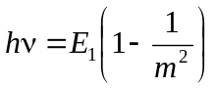 m = 2, 3, 4, …
Balmer series: 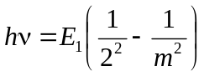 m = 3, 4, 5, …
Paschen series: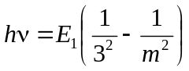 m = 4, 5, 6, …

Absorption Spectrum:
- When a light source w/all frequencies passing thou’ some colored material like KMnO₄ solution, the some of the frequencies are absorbed
- Absorption spectrum
- The absorbed frequencies correspond to the energy absorbed for excitation
- The absorbed energy is used to excite the species to a higher energy level
- Then the energy is released as the species returns to its ground state
- EM radiation of the same frequencies emitted at all directions
- The intensity at that freq. is weaker, i.e. some lines are darken
- The dark lines are in exactly the same position of the lines in emission spectrum as the transition is the same
- Absorption spectra can be used to identify elements
- Dark lines in solar spectrum: Fraunhofer lines

Laser:
- Laser: Light Amplification by Stimulated Emission of Radiation
- A monochromatic, coherent EM radiation
- Parallel beam of lights (Unidirectional)
- High intensity
- Normally,
- Most atoms are in ground state and a photon incident would cause stimulated absorption
- The excited atoms undergoes spontaneous emission randomly in all directions
- The atoms will stay in excited state for only 10^{–8} to 10^{–9} s
- EM radiation emitted is in short burst
- Procedure to produce Laser:
- Population inversion: Pump majority of atoms to a excited state instead of ground state
- Then the atoms should be metastable which the excited state can stand for long lifetime
- A photon of suitable freq. incident and stimulates a chain of emission of metastable atoms
- The emitted photon should be confined in the system by mirrors to allow further stimulate emission from other excited atoms
- At one end, a full mirror is installed to reflect all photons; At another end, a slightly transparent mirror is installed to allow the laser beam to escape

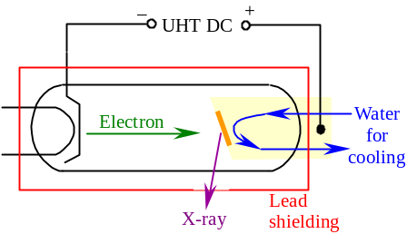X-rays:
- X-ray: EM radiation of λ=10^{–12} to 10^{–15} m
- X-rays are produced by X-ray tube
- A beam of focused electrons accelerated towards the target
- Produced by thermionic emission at cathode
- When e– collide w/the target, they decelerate rapidly
- X-rays produced
- The tube is vacuum (very low pressure of ≈10^{–3} Pa)
- The target is a high-MP metal such as tungsten or molybdenum embedded in a copper rod
- There are waters circulating thou’ the copper rod to conduct heat away
- ~ 99.5% KE of electron goes into heat
- Efficiency of producing X-ray: ~ 0.5%
- When the operating voltage (10³-10⁶ V) of X-ray tube ↑, the quality of X-ray ↑
- Properties of X-ray:
- Travel in straight lines at velocity c
- Uncharged
- Penetrate matters (Penetration is weaker in denser materials)
- 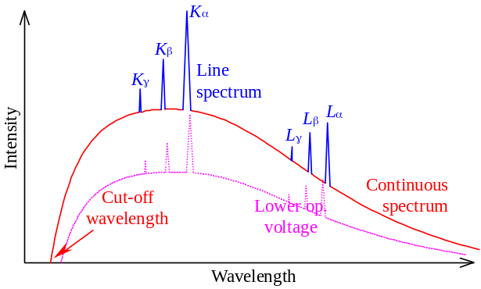Can be reflected at large angles of incidence
- Little banding occurs when X-ray refracts
- Cannot be focused by lenses
- Can be diffracted
- Ionize gases
- Affect photographic film
- Produce fluorescence
- Produce photoelectric emission

X-ray Emission Spectrum:
- The emission spectrum of X-ray have two distinct components: Continuous & Line spectra
- Continuous background spectrum:
- Given by electrons lost energy during one or several collisions w/target
- When e– give up all energy at one collision, most energetic X-ray is produced
- λ is minimum / frequency is maximum
- Cut-off wavelength / Cut-off frequency
- λ_{min} or f_{max} depends on the operation voltage of X-ray tube only
- Independent of the target metal
- Energy at cut-off freq.: 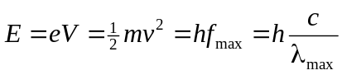
- When e– lost energy in many collisions, smaller amt of energy gave up each time
- X-ray of longer λ
- The shape of continuous spectrum is same for all metal targets
- Discrete line spectrum:
- 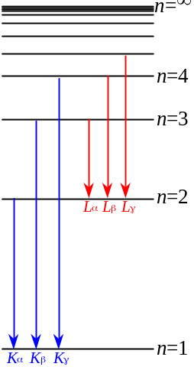Given by the electron transitions within the atoms of the target metal
- The colliding e– is energetic (~10⁵ eV) and may knock out some electrons in deep-lying / inner quantum shell
- The outer shell e– fall into the vacancy and release a large amt of energy
- Produces X-rays
- Energy evolved in the transition: E₂ – E₁ = hν
- The line spectra are the characteristics of the target metal

Radioactivity

Radioactive radiations:
- Radioactive radiations: α-particles, β-particles, γ-rays
- α-Particles:
- Fast moving, positively charged ⁴He nucleus
- Can be easily absorbed by a sheet of paper
- β-Particles:
- Fast moving, negatively charged electrons
- Can be absorbed by aluminum plates of several mm thick
- γ-Rays:
- EM radiation w/λ of the order 10^{–10} m
- Uncharged and intensity 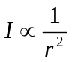
- Intensity of γ-ray can be halved by several cm thick of lead

Properties:
 | α-particles | β-particles | γ-rays
Nature | Fast moving ⁴He | Fast moving electrons | EM waves
Charge | +2e | –e | 0
Rest mass | 4 u | 1/1840 u | 0
Speed | 0.1 c | 0.3 c | c
Energy | Same for a given source | Varies up to a max. depends on source | Same for a given source
Range in air | Fixed range of several cm | Varies up to a meter | Follow the inverse sq. law
Penetrating power | Stopped by paper | Stopped by several mm of aluminum | Reduced by lead
Ionizing power | Strong  (10³-10⁴ ions per mm in air) | Weak  (100 ions per mm in air) | Very week
Effect of B-/E-field | Bent slightly | Bent strongly | No deflection

Detectors:
- Ionization chamber:
- Consists of two electrodes (Cylindrical metal anode & Thin brass rod cathode) at high p.d.
- A strong radial electric field directs inward
- When a source emitting radiation into the ionization chamber, gas along the track is ionized
- Ions in the cylinder travel according to the E-field
- Ionization current set up and there is a p.d. across R
- Detected by the electrometer
- R should be large to give a appreciable voltage for a small ionization current
- The applied voltage should be high enough to make the ionization current in saturation
- The saturation voltage / current depends on the rate of production of ions by the radiation
- Applied voltage V would be higher for a stronger radiation
- 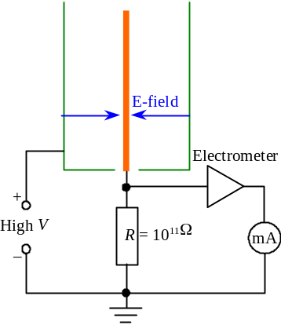Ionization chamber is suitable for α-particle and strong β-particle which gives appreciable amount of ion pairs
- 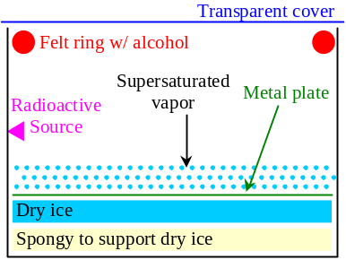Cloud chamber:
- Shows the tracks of radiation
- Structure:
- A felt ring soaked w/alcohol is placed round the top of chamber
- Air in the chamber is saturated w/alcohol
- The dry ice at the bottom cool the air and a super saturated vapor layer formed
- When the radioactive source emits radiation, there are ions left along the path
- The ions becomes condensation nuclei and the supersaturated vapor condenses on it
- Tracks of radiations
- In cloud chamber, if the radioactive source emits:
- α-particle: Thick, straight tracks of well-defined length are shown
- Due to its strongest ionization power
- β-particle: Fainter, twisted tracks
- As β-particles can be easily deflected by air molecules
- γ-ray: No clear tracks can be observed
- Geiger-Müller tube:
- GM tube consists of a Cylindrical metal tube as cathode & a Central stiff wire as anode
- The two electrodes have a p.d. of ~ 450V
- A large E-field is created inside the tube
- The tube is sealed and filled w/argon at low pressure (0.1 atm)
- 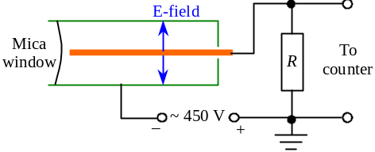The mica window allows radiations to enter from outside
- When radiation enters the tube,
- Gas molecules inside are ionized
- The free e– produced is accelerated by E-field
- Fast-moving e– further ionize other atoms and produce more e–
- Avalanche of electrons
- The avalanche of e– carries a large quantity of charge and arrives the anode
- Produce a pulse of current
- The large amt of cations then move slowly to the cathode
- In order to prevent the cations on their way to cathode emit secondary e– and produce another avalanche, Br_{2(g)} is added to the GM tube to absorb energy from the cations
- Bromine gas is used as a quenching agent
- Dead time is the time interval during which the GM tube is insensitive to further radiation
- The time required for the cations travel to the cathode
- During the travel, the E–field is cancelled out by the positive charges
- The dead time determines the upper limit of detection, i.e. the max. rate of radiation detected
- Typical dead time: 200μs, eqv. 5000 radiation per second
- GM tube can detect α- or β-particles penetrated into the tube w/efficiency 100%, but only ~ 1% for γ-radiation as its ionization power is low
- GM tube can be connected to a counter to register for the activity:
- A loudspeaker to heard an audible click for each pulse
- A scalar to record the exact number of pulses
- A ratemeter to record the count rate

Radioactive decay:
- Every radioactive atoms have the equal chance of being decayed in each unit time
- All radioactive decay obey the decay equation 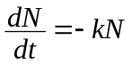 or N = N₀e^{–kt}
where N is the no. of decays and k is the decay constant, unit s^{–1}
- Activity A of a radioactive sample is the rate of disintegration / decay
- 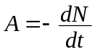, unit: becquerel, Bq (decay s^{–1})
- Activity at any time: A = A₀e^{–kt}
- Half-life is the time taken for the no. of a radioactive nuclide decrease by half
- 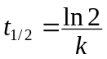
- 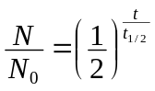 and 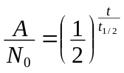
- When a nucleus decays,
- Total mass number and proton number is conserved
- α-decay: 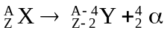
- Occurs for a large, heavy nucleus
- β-decay: 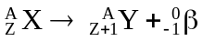
- A neutron in the nucleus decays into a proton and a electron: 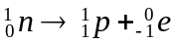
- Actually a neutrino ν w/no rest mass and carries energy travelling in speed c is also emitted
- γ-decay: 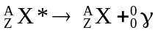
- The nucleus get rid of excess energy
- A nucleus is unstable when it has incorrect balance of protons & neutrons
- Stable nucleus: N:Z ≈ 1:1 for small nucleus and N:Z ≈ 1:1.6 for heavy nucleus
- If a nucleus w/too few neutrons, it would has an α-decay
If a nucleus w/too much neutrons, it would has a β-decay
- A nuclide with A>230 is unstable and would undergo a series of transformation (radioactive decay) until became some stable nuclide
- Stable nuclide: ²⁰⁶Pb, ²⁰⁷Pb, ²⁰⁸Pb, ²⁰⁹Bi

Radiation Dose:
- Radiation dose is a measure of the extent to which matter has been exposed to ionizing radiation
- Absorbed dose D: The energy imparted to unit mass of a body
- 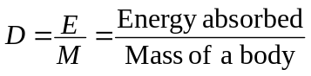, unit: gray, Gy, J kg^{–1}
- A physical quantity only
- Dose equivalent H: The product of absorbed dose D and the relative biological effectiveness (r.b.e.) Q
Radiation | R.B.E., Q
α-particles | 20
Neutrons,  Protons | 10
β-particles,  γ-ray  X-ray | 1

- H = DQ, unit: Sievert, Sv
- Over-dose of radiation may lead to Somatic effect, Cancer, or Genetic effects

Nucleus

Rutherford’s model:
- Proposed by Sir Ernest Rutherford in 1910-1911
- Most of the mass of the atom and all the positive charges are concentrated in a tiny region at the center of the atom
- Nucleus
- Size of atom: In the order of 10^{–10}m
- Size of nucleus: 10^{–14}m ~ 10^{–15}m
- Outside the nucleus, there are mostly empty space
- The negatively-charged electrons carry negligible mass are orbiting around the nucleus

Binding Energy:
- Einstein’s mass-energy relationship equation: E = mc²
- c = Speed of light
- The unified atomic mass unit (a.m.u.) u is defined to be 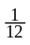 of the mass of the carbon-12 atom
- Molar mass of carbon-12 is exactly 12g
- 1 u = 1.660559×10^{–27} kg
- Mass of proton: m_{p} = 1.0072765 u
Mass of neutron: m_{n} = 1.0086649 u
Mass of electron: m_{e} = 0.0005485799 u
- 1 u ⇔ 1.49×10^{–10} J = 931.5 MeV (1 eV = 1.6×10^{–19} J)
- 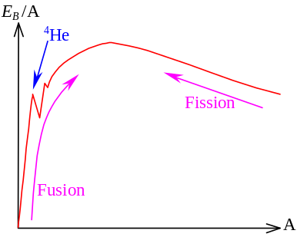Binding energy E_{B} of a nucleus is defined to be the energy required to completely separate the individual components of the nucleus
- Mass defect: The E_{B} released when the nucleus is formed by the comprising nucleons
- Mass defect = Mass equivalent of binding energy
- Mass of an atom is always less than the total mass of the nucleons
- The discrepancy goes to binding energy
- Binding energy per nucleon Is used to measure the stability of a nucleus
- Most nuclei have the binding energy per nucleon btw 7 MeV ~ 9 MeV
- Highest binding energy per nucleon, most stable nucleus
- Appears at middle of the periodic table such as Fe, Ni, Co (E_{B} /A ≈ 8.8 MeV, A = 62)
- Small nuclei tend to have nuclear fusion to become a larger nucleus w/greater E_{B} per nucleon
- Large nuclei tend to have nuclear fission to split into smaller nuclei w/greater E_{B} per nucleon
- There is a spike at A=4 (E_{B} /A ≈ 7 MeV) shows the unusual stability of α-particle

Nuclear reactions:
- Nuclear reactions: Rearrangement of nuclei components
- Charge, momentum, angular momentum, energy & no. of nucleons are conserved
- There are reaction energy released as the defect btw rest masses before and after reaction
- In reaction A + B ⎯→ C + D or written as A(B,D)C
Reaction energy Q = (m_{A} + m_{B} – m_{C} – m_{D})c²
- Q is usually positive as the total mass decreases in most nuclear rxn
- Positive Q ≠ Feasible as initial KE of nuclei is required to overcome electrostatic repulsion
- Natural radioactive transformation: Unstable nucleus undergoes radioactive decay to emit α-, β- or γ-raidations
- Nuclear fusion:
- Small nuclei combine to form larger nucleus
- e.g. 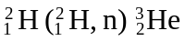
- Deuterium and tritium come close together will carry out fusion and produces helium
- Mass defect per fusion ≈ 3-4 MeV
- In fusion, two nucleus need to bring together in the range of nuclear force (10^{–15} m) and against the electrostatic repulsion
- Very high temperature of 10⁸K is required
- Thermonuclear reaction
- Uncontrolled fusion: Hydrogen bomb & Sun
- Controlled fusion is not yet practical as it is difficult to:
- Achieve the high temperature for a sufficient long time
- Prevent the hot reacting gas (plasma) from touching the container holding it
- Nuclear fission:
- Unstable nucleus splits up into smaller pieces of fragment nuclei
- e.g. 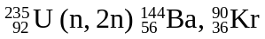
- Uranium-235 capturing a neutron will carry out fission and produces different pairs of fragments
- Mass defect per fission ≈ 200 MeV
- The energy released is in the form of KE of the product nuclei fragments
- As the ²³⁵U releases neutrons which may induce further fission, a chain reaction can be occurred
- Controlled chain reaction: Nuclear reactors for the generation of electricity
- Uncontrolled chain reaction: Atomic bomb
- Bombardment of particle:
- A nucleus is bombarded by a particle and undergoes transformation
- e.g.: 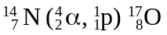; 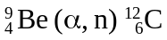;
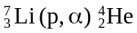; 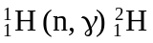

Pressurized water reactor:
- The pressurized water reactor generates energy under controlled nuclear fission
- Heat evolved produces steam which drives the turbine of the generator
- Control rod: Controls the rate of the nuclear reaction
- Absorbs neutrons when inserted into the reactor vessel
- Made of boron-steel and cadmium
- Moderator: Slow down the neutrons which are going to bombard with ²³⁵U
- Fission occurs only when slow neutrons bombarded with ²³⁵U to produce ²³⁶U
- The moderator (water) extracts the KE of neutrons
- Coolant: Carry energy away from the fuel rods to heat up water in heat exchanger
- High pressure water is used as coolant
- Can still be in liquid state at 300°C
- The coolant is insulated from outside world as it contains highly radioactive fall-outs
- Nuclear plants produce nuclear wastes
- Low / intermediate level of activity: Stored in metallic concrete drum in shallow land disposal or ground surface repositories for about 300 years
- High level activity: Spent fuel which U-235 in the fuel rod is below a specified level
- Re-process the rods to enrich the content of U-235 and use again

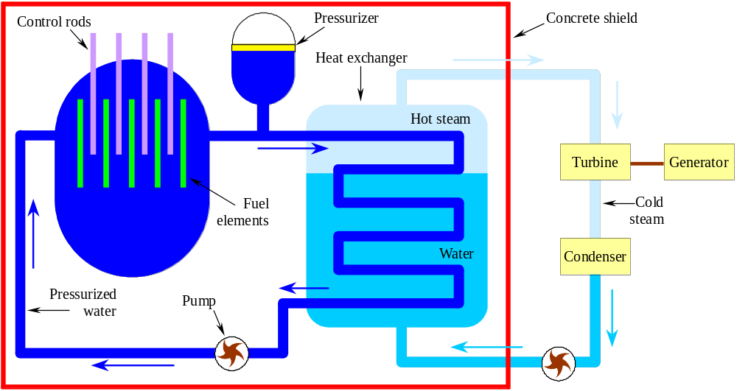

This method for finding the e/m ratio is used by J.J. Thomson in 1897
CRT = Cathode Ray Tube
Threshold frequency for a given metal is defined as the minimum frequency of electromagnetic radiation for which photoelectric emission occurs
Quality of X-ray = Penetrating power of X-ray. Higher quality X-ray has a shorter wavelength and higher frequency.
When calculating the mass defect, the mass of electrons is also taking into account
Deuterium: Hydrogen-2 isotope, Heavy hydrogen
Tritium: Hydrogen-3 isotope, Very heavy hydrogen

