Physics - Matters

Solid

Structures:
- Crystalline solids
- Atoms and molecules are arranged in a regular manner
- Crystal consists of a basic structure that repeated many times to form the whole crystal
- Unit cell
- Example: Ionic salt, metallic lattice, graphite
- Amorphous solids
- Atoms arranged in no order
- Have no long range order which the crystalline solids have

Extension & length:
- When an external force is applied to a wire, it extended / has deformation
- When the force vanished, the wire return to the original state
- Elastic
- The tension force F applied to the wire is proportional to its extension δ
- Tension required to produce the extension δ ∝ Cross-sectional area A of the wire
- Under a particular tension, extension δ ∝ Length of the wire 
- 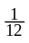
- 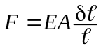, the proportionality constant E is called Young modulus
- 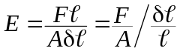
- A measure of stiffness

Stress & strain:
- Stress: Tension per unit cross-sectional area
- Tensile stress: 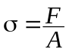, unit: Pa
- Strain: Extension per unit length of wire, i.e. fractional elongation
- 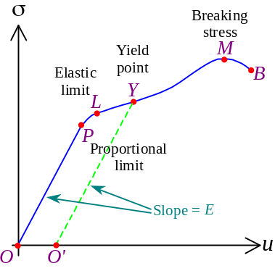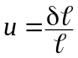
- Stress ∝ Strain: 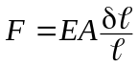 ⇒ 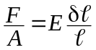 ⇒ 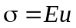
- Hooke’s Law
- Stress-strain curve:
- σ ∝ u only if stress is small
- Material deforms elastically and obeys Hooke’s law
- Btw proportional limit P and elastic limit L, stress-strain relation is not linear but still in elastic deformation
- Usually, smaller stress causes a larger strain than usual
- The material is less stiff
- Exceeds elastic limit, the material undergoes plastic deformation
- When stress removed, the material does not return to the original state
- Permanent deformation
- Before Y, the material return to O' instead of O when stress removed
- Beyond yield point Y, The material stays where it is when the stress is removed
- Thinning
- Breaking stress M is the maximum stress a material can withstand
- Tensile strength
- 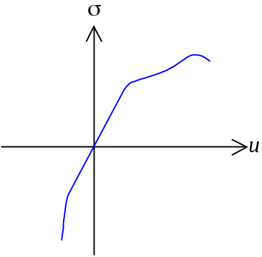Compression: Negative stress
- Hooke’s law holds for small compression
- For large compression, the material is stiffer than tension

Mechanical Properties:
- Stiffness: Resistance to deformation under the application of forces
- Stiff material has a higher Young modulus than a soft material
- Strength: Ability to withstand forces without breaking
- Strong material has a higher breaking stress than a weak material
- Ductility: A ductile material elongates appreciably before it breaks
- Displays a large among of plastic deformation
- Brittleness: A brittle material breaks soon after the yield point is reached
- Can withstand only small deformations
- Stiff but not strong

Energy:
- Material at its natural state has the lowest energy
- When material is stretched / compressed, it possess a higher PE U
- Increased PE ΔU = Work done W to deform the object
- Work done: 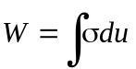
- A solid of unit length and unit cross-sectional area, 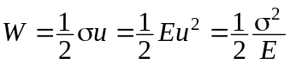
- PE stored per unit volume
- A solid of length  & cross-sectional area A, total PE stored: 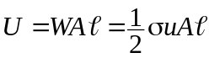
- 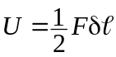; 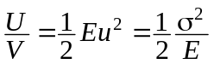
- Elastic deformation: The PE absorbed is released completely when stress removed
- Plastic deformation: The PE absorbed is partially released when stress removed, but partially used to deform the object to other shape

Elastic Hysteresis:
- Stress-strain behavior of rubber is different from other crystalline solid:
- Has a large range of elasticity
- Does not obey Hooke’s law within elastic limit
- Soft at small strains but stiff at large strains
- In microscopic view, rubber comprising molecular chains coil up and tangle with one another
- 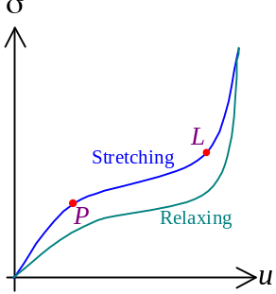Small stress → Straighten the chains
- Further strain after straightened out → Much greater stress required
- Stress removed → Coil up again
- In stress-strain curve, stretching & relaxing behavior differs
- The curves for stretching & relaxing does not coincide
- Elastic hysteresis
- The area bounded by hysteresis loop is the energy absorbed by rubber
- Energy absorbed as heat (internal fiction of molecular chains)

Intermolecular forces & potential:
- In a solid, atoms are held together by inter-atomic forces
- When atoms are too close, the inter-penetration of electron shells produce a repulsive force
- When atoms are close, bonding formed by inter-atomic electrostatic attraction
- When atoms are too far apart, the inter-atomic forces are negligible
- 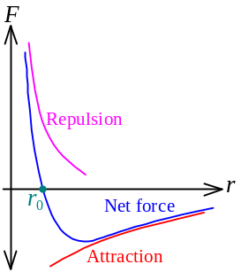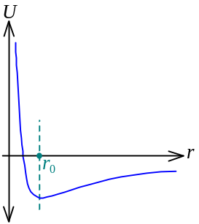Distance btw neighboring atoms = r
- The PE U btw two atoms depends on r
- U is minimum at the equilibrium separation r₀
- Not squeezed nor extended
- U_{min} is the bond energy
- Force: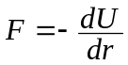
- F > 0: Net repulsion, r < r₀
- F < 0: Net attraction, r > r₀
- Near r₀, the F-r graph is approx. linear
- For small stress, Force ∝ Extension or compression

Interpretation of Young’s modulus:
- Consider an analog model of solid: Particles linked by springs in a cubic array
- Cross-sectional area = A
- Length of a side = 
- Equilibrium separation btw atoms = x
- Force constant of each spring = k
- When the cubic array is stretched for an extension δ,
- No. of atoms stretched = No. of atoms on cross-sectional surface =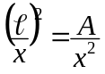
- Extension on each spring = δx
- 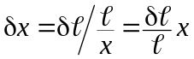
- Total stretching force required: 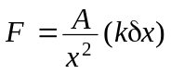
- Stress: 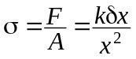
- Strain: 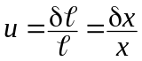
- Young’s modulus: 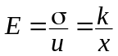

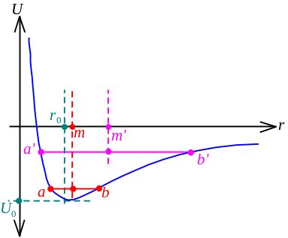Thermal expansion:
- The U-r graph is asymmetric about r₀
- Steeper for compression and flatter for stretching
- Let U = –U₀ when r = r₀
- At 0K, atoms in a material are stationary at r₀
- KE = 0; PE = –U₀
- Above 0K, there is some thermal energy in the material
- KE > 0; Atoms oscillate about the equilibrium position r₀
- Some molecular KE will turn to molecular PE during oscillation
- Conservation of energy
- U rose, the atoms oscillating btw r = a & r = b
- Mean interatomic separation = m
- Raising temperature, U rose as more thermal energy in the material
- The atoms oscillating btw r = a' & r = b'
- Mean interatomic separation = m'
- Since m' > m, the average distance btw atoms increased, the solid expanded

Fluids in Motion

Flow of fluid:
- Turbulent flow: The fluid flows in irregular paths
- Eddies may form
- Depriving energy from the system
- Streamlined flow: The fluid flows in layers without fluctuations or turbulence
- Flow velocity at a fixed pt is constant and independent of time
- Turbulence occur or not depends on the flow velocity and shape of the objects
- If an fluid flowing in a tube,
- Volume of fluid in the tube is fixed
- In same time interval δt, Mass of fluid flowing into the tube = Mass flowing out of the tube
- 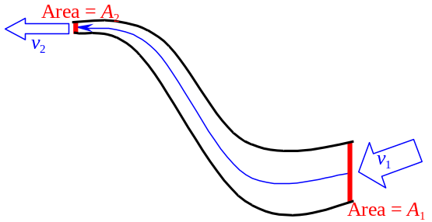ρ₁A₁v₁δt = ρ₂A₂v₂δt ⇒ ρ₁A₁v₁ = ρ₂A₂v₂
- Equation of continuity: ρAv = Constant
- If the fluid is incompressible, A₁v₁ = A₂v₂
- Speed of flow at smaller cross-sectional area is higher

Bernoulli’s Principle:
- Ideal fluids:
- Non-viscous: No mechanical energy can be converted into internal energy
- Incompressible: Density ρ of the fluid is constant
- Fluid is moving with streamlined flow / steady flow: No turbulence
- Irrotational flow: Fluid has tranlational motion only
- When a ideal fluid is flowing in a tube:
- 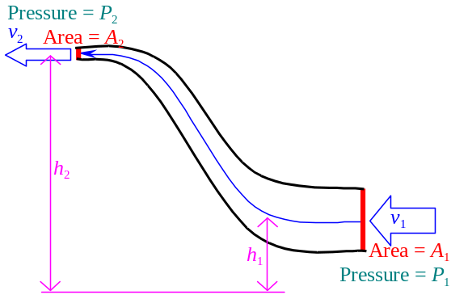In time interval δt, mass of fluid transferred in:
m = ρA₁v₁δt
- Mass of fluid transferred out: m = ρA₂v₂δt
- The fluid flows up as there is a pressure difference
- Net force pushes the fluid up = P₁A₁ – P₂A₂
⇒ Total work done: P₁A₁v₁δt – P₂A₂v₂δt =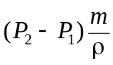
- ΔE_{k} =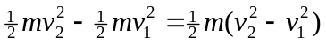
- ΔE_{p} = mgh₂ – mgh₁ = mg(h₂ – h₁)
- Total work done = ΔE_{k} + ΔE_{p}
⇒ 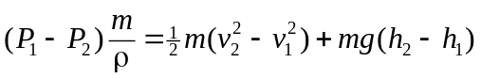
⇒ 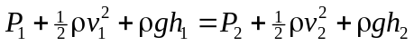
- Bernoulli’s equation: 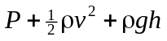= Constant
- As the speed of fluid flow increases, fluid pressure reduces
- If there is a flow speed difference round an object, pressure difference would be created
- 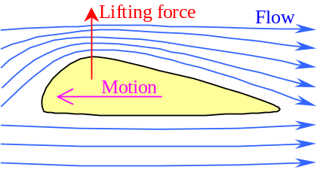Pushing the object towards the side w/lower pressure (higher speed)

Application of Bernoulli’s principle:
- Airfoil
- Upper side has a more curved surface than lower side
- The upper side increases the speed of air flow
- 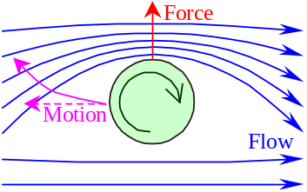The pressure difference set up to create a net lifting force
- Spinning golf ball
- When a ball spin through the air, air is dragged by the spinning motion
- The spinning cause an increase of air flow on one side and decrease on other side due to the viscous force
- Unequal pressure set up on opposite sides
- 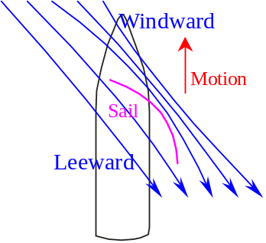Curve in flight (Magnus effect)
- Yacht sailing
- The sail of a yacht has the shape of airfoil
- When a yacht sailing against the wind, its sail is rotated
- On the windward side, it has a faster flow
- On the leeward side, it has a slower flow
- A force causing the yacht to move
- Jets & Nozzles
- 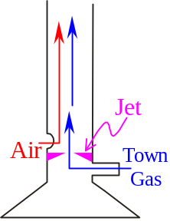When a fluid flow through a horizontal pipe from a large cross-section to a smaller cross-section, its velocity increases
- The jets & nozzles are having a constriction to produce the effect
- Example: Bunsen burner, Filter pump, Spray, Carburetors
- Bunsen burner:
- The town gas is injected to the Bunsen burner thou’ a jet
- Faster flow & lower pressure
- The lower pressure inside causes sucking of air from air hole
- Higher oxygen-town gas ratio, better combustion
- 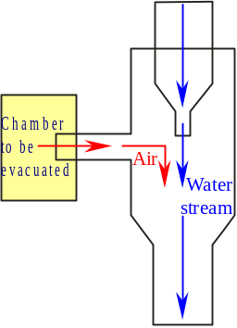Filter pump:
- When water passing thou’ the jet in filter pump, pressure dec.
- The dec. in pressure sucks air from the chamber
- The chamber is evacuated

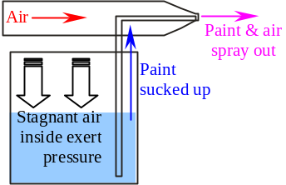
- Paint sprayer:
- When air blown thou’ the nozzle, pressure at nozzle dec.
- 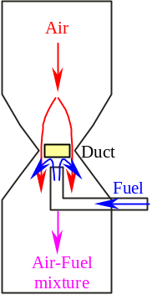The dec. in pressure causes stagnant air inside exert pressure to push the paint out
- Carburetor:
- Carburetor is used to mix air w/fuel to prepare for the engine
- When air is drawn thou’ the narrow duct, its pressure dec.
- The reduced pressure sucks up fuel and mix w/air
- The proportion of air & fuel is controlled by the pressure, i.e. size of duct

Measuring devices:
- Venturi meter:
- Venturi meter is a horizontal pipe w/a constriction
- Cross-sectional area of the pipe = A₁; Fluid speed = v₁
- Cross-sectional area of the constriction = A₂; Fluid speed = v₂
- 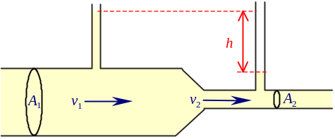Since A₁v₁ = A₂v₂ and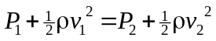,
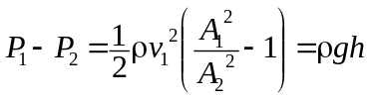
- Liquid level ∝ Pressure
- 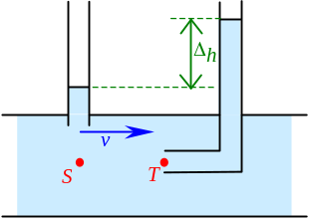Flow speed of fluid 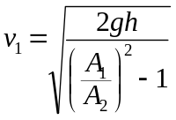
- Pitot Tube:
- Pitot tube is a manometer w/two tubes, namely the total tube & static tube
- At the mouth of total tube T, the fluid stagnates, fluid speed v_{t}=0
- At the mouth of static tube S, the fluid moves at speed v_{s} = v
- Flows at undisturbed flow speed
- At points S & T, the pressures can be related by: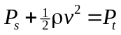 or 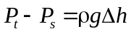
- Speed of flow: 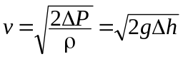

Gases

Gas Law:
- Boyle’s Law: For a fixed mass m of gas at constant temperature T, the pressure P of the gas is inversely proportional to its volume V
- PV = Constant
- Gases that obey Boyle’s law exactly is called ideal gas
- Most gases obey Boyle’s law well at low pressure and high temperature
- Pressure Law: At fixed m and V, P ∝ T
- Charles’ Law: At fixed m and P, V ∝ T
- Ideal gas equation: PV = n R T
- R = Universal molar gas constant = 8.3145 J K^{–1}mol^{–1}

Avogardro’s Law:
- Under same V, T & P; two ideal gases contain equal number of molecules
- In P_{a}V_{a} = n_{a}RT_{a} and P_{b}V_{b} = n_{b}RT_{b} , if P_{a}=P_{b}; V_{a} = V_{b}; T_{a} = T_{b}, then n_{a} = n_{b}
- 1 mol ideal gas in std T (273.15K) & P (1.013×10⁵ Pa) has a vol. 22.4 dm³

Microscopic Definition of Ideal Gas:
- Large separation btw molecules w.r.t. their size
- Gas molecules occupy negligible volume
- Gas molecules are point masses
- Molecules are in random motion & obey Newton’s Laws
- Molecules move in all directions with equal probability
- Constant distribution of various molecular speeds
- Gas molecules undergo perfectly elastic collision
- Molecular kinetic energy is conserved
- Intermolecular forces / interactions are short-range and negligible
- Intermolecular attraction / repulsion would not alter the volume

Kinetic Theory Model:
- Assume a gas comprising N molecules each of mass m trapped in a cubic box of vol. ³
- For a molecule moving with velocity 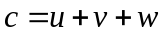, consider its x-direction component
- When it collides with the wall of the cubic box, it undergoes perfectly elastic collision
- The molecule rebounds in reversed direction with same speed
- Momentum change Δp = mu – m(–u) = 2mu
- After it rebounds, it moves toward the opposite wall
- It collides with the wall on opposite side after time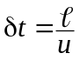
- Period for the molecule collides on the same wall: 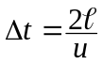
- Force exerted by the gas molecule over a long period: 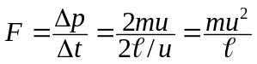
- Total force exerted by N molecules: 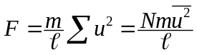
- 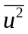is the mean square speed of molecules
- Pressure experienced by the wall: 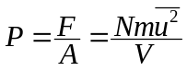
- Since , 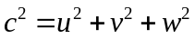 and 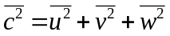
- 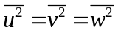 as gases are in random motion
- 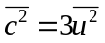
- 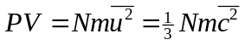
- 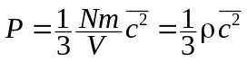
- By defining the root-mean-square speed 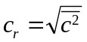
- 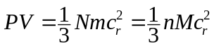 where n = no. of mole of gas; M = molar mass of gas
- 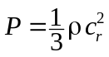

Temperature & Energy:
- 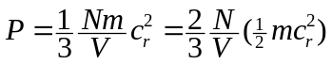 ∴ Pressure ∝ Molecular translational K.E. of the gas
- 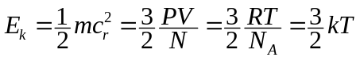
- Total internal energy of a gas: 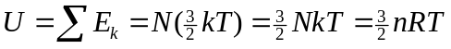
- 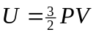
- 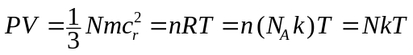
- Boltzmann’s constant =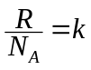= 1.3806 × 10^{–23} JK^{–1}
- Avogardro’s number = N_{A} = 6.022 × 10^{–23} mol^{–1}
- 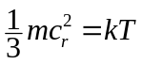 ⇒ 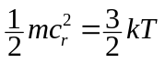
- Avg K.E. of gas molecule ∝ Absolute temperature of gas

Distribution of molecular speeds:
- 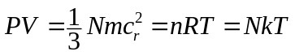 and
- 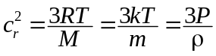
- R.m.s. Speed of gas molecule: 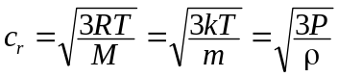
- As the temperature inc., the rms speed of gas inc.
- The various speed of gas follows the Maxwell-Boltzmann distribution
- When temperature inc., the peak of the curve shift to right
- Area under the curve = No. of molecules = Constant
- 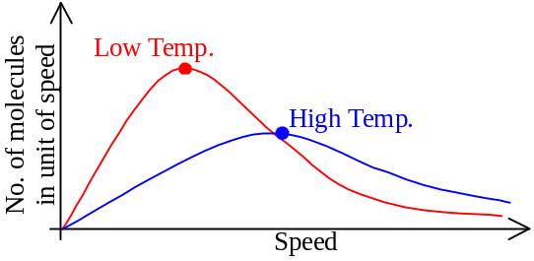Amplitude of curve falls as temperature inc.
- The curve is spread out as temperature inc.

Real Gases:
- Real gases differ ideal gases as:
- Have a finite size
- Possess intermolecular interaction
- Dipole-dipole interaction at most times
- Electron cloud repulsion when collides
- Due to the differences, the ideal gas equation PV = nRT is not applicable:
- Pressure is less: When gas molecules strike on the wall, attraction retarded the effect
- Volume is greater: Repulsive force reduces the space where a molecule can move
- The gas molecules occupies spaces makes the measured volume > actual free volume
- 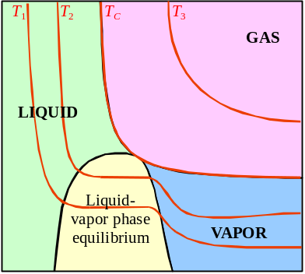For pressure, a positive correction k is added
- Pressure = P + k where 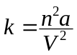
- Fore volume, a negative correction nb is made
- Increase in volume ∝ Amount of gas molecules
- Volume = V – nb
- Van der Waals’ equation of state: 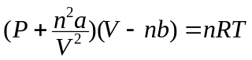
for some constants a and b w.r.t. to a particular gas
- 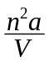 is the correction for the pressure affected by intermolecular attraction
- nb is the correction for the volume affected by the volume occupied by molecular size
- The van der Waals’ eqn accurately describing the behavior of real gas at high temperature
- On or above the critical temperature
- Above the critical temp., the P-V curve (isotherm) shows a rectangular hyperbola
- At critical temp., the isotherm has a pt of inflexion C representing the critical point
- At the critical point, gas, vapor & liquid exists in equilibrium
- Below the critical temp., the isotherm has a part of flat curves
- At the flat part of the curve, it is in liquid-vapor phase equilibrium

Thermodynamics
Energy: The capacity to do work
Internal Energy: Total energy possessed by a substance or a system
- Includes molecular kinetic energy and molecular potential energy

Heat & Energy:
- Matters possess internal energy due to its internal state
- Molecular KE due to molecular motion
- Measured by absolute temperature
- Intermolecular PE due to intermolecular interactions
- More separated molecules, greater PE
- Internal energy U of an object may change by:
- Work done W by the object
- Heating the object to give it energy Q
- By convection, conduction or radiation from one body to another

Laws of Thermodynamics:
- Zeroth law of thermodynamics states that when each of two systems is in equilibrium with a third, the first two systems must be in equilibrium with each other
- First law of thermodynamics states that an object gains internal energy due to heat transfer and work done on it
- ΔU = ΔQ – ΔW
- ΔU = Change of internal energy
- + : Gain of internal energy
– : Loss of internal energy
- ΔQ = Energy transferred during heating
- + : Energy transferred to the system
– : Energy transferred out of the system
- ΔW = Work done
- + : Work done by the system on another
– : Work done on the system by another
- Second law of thermodynamics states that the entropy of an isolated system can never decrease
- Heat-engine version: No continually working heat engine can take heat from a source and convert it completely into work
- An isolated system is the one which ΔU = ΔQ = ΔW = 0 (Internal energy keeps constant)
- Maximum efficiency of a heat engine: 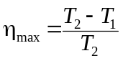
- T₂ = Source temperature in K
- T₁ = Sink temperature in K
- Third law of thermodynamics states that the temperature of 0K can be approached arbitrarily closely, but it can never be reached

Gas System:
- A gas under pressure P and has a definite volume V, when it expands for δV,
Work done by the gas = PδV =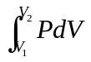
- When it expands, δV > 0, work done by the gas, ΔW > 0, temperature dec.
- When it compresses, δV < 0, work done on the gas, ΔW < 0, temperature inc.
- In isovolumetric process, keeping ΔV = 0
- ΔW = 0, ΔQ = ΔU
- In isobaric process, keeping ΔP = 0
- 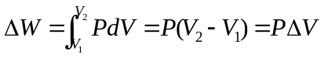
- In isothermal process, keeping ΔT = 0
- The process is slow to allow heat exchange to maintain constant T
- It is held in a thin-walled, highly conducting vessel surrounding by a constant temperature bath
- 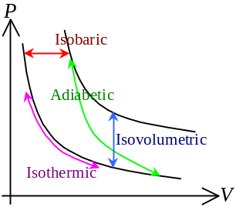As ΔU ∝ ΔT, ΔU = 0
- ΔQ = ΔW
- 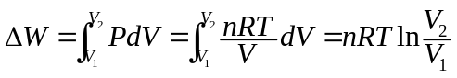
- In adiabatic process, ΔQ = 0
- No heat exchange occurred
- The process is rapid to prevent heat exchange
- It is held in a thick-walled, highly insulated vessel
- ΔU = –ΔW
- PV ^{γ} = constant where 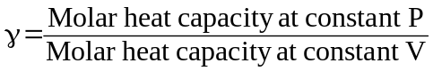
- γ = 1.67 for monoatomic gas; γ = 1.40 for diatomic gas; γ = 1.30 for polyatomic gas

Degradation of energy:
- The nature has a tendency to move toward a state of disorder
- A higher grade energy can change to a lower grade energy completely;
a lower grade energy transform to a higher grade energy can never complete
- Higher grade energy can be transformed w/higher efficiency
- All the energy ultimately becomes internal energy of the surroundings thou’ being used to overcome friction, in which the internal energy is an useless energy
- Energy is degraded
- Primary energy resources: Naturally occurring fuels (e.g. coal, gas)
- Secondary fuels: Electricity, petrol, etc.
- Renewable sources: Energy sources that can be replenished naturally and thus inexhaustible
- Example: Solar energy, wind, tidal, geothermal, wave

Tensile stress is the stress to produce longitudinal elongation or compression
Streamlined flow = Steady flow
The critical temperature is the temperature above which a gas cannot be liquefied by applying high pressure
When gas above the critical temp., it is called as ‘gas’; when it is below the critical temp., it is called as ‘vapor’
Molecular motion cans be translational, rotational or vibrational motions
Work is a process to transfer energy from one body to another by means of application of a force for a distance
Heat is a process to transfer energy from one body to another by means of temperature difference

