Physics – Mechanics

Linear Motion
Mechanics is a study of the relationship between force, mass and motion.
Kinematics is a description of the motion using the concepts of space and time.

Instantaneous Velocity: v =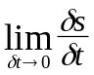=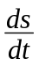
Instantaneous Acceleration: a =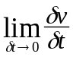=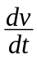=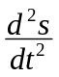=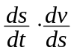=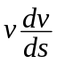
Displacement: s =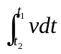
Change in Velocity: Δv =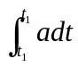

Equation of rectilinear motion in constant acceleration:
⬥ v = u + at
⬥ v² = u² + 2as
⬥ s = u t +at²

Equation of free falling:
⬥ v = g t
⬥ v² = 2gh
⬥ h =gt²
■ Objects moving freely under the influence of gravity only
■ Constant downward acceleration g
■ Regardless the initial motion, mass and shape

Terminal velocity: The velocity when upward air resistance and the upthrust is balanced by the downward gravitational force during the free fall motion.
■ Depends on size, shape and weight
■ Lighter and boarder objects give a lower terminal velocity
 F = m g – k v

Projectile Motion
■ Conditions:  Gravitational acceleration keeps constant and downward over the range of motion
⬥ Air resistance is negligible.
⬥ Rotation of earth does not affect the motion.
■ Motion of superposition of two independent vertical and horizontal motions.
⧫ Vertical motion: Motion of freely falling body.
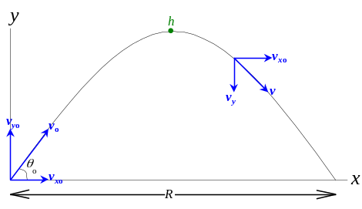 Horizontal motion: Uniform velocity.
 a _{x} = 0 a _{y} = – g
⧫ Initial speed is v_{o} makes an angle θ _{o} with the horizontal:
 Initial horizontal velocity: v_{xo} = v_{o} cos θ _{o}
 Initial vertical velocity: v_{yo} = v_{o} sin θ _{o}
 Horizontal velocity at time = t: v_{x} = v_{o} cos θ _{o}
 Vertical velocity at time = t: v_{y} = v_{o} sin θ _{o} t – g t
 Horizontal displacement at t: x = v_{o} cos θ _{o} t
 Vertical displacement at t: y = v_{o} sin θ _{o} –g t²
■ Equation of motion: 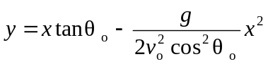
 Equation of parabola in the form: y = a x – b x²
■ Range of flight: 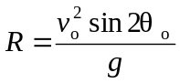 Time of flight: 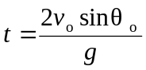
 Maximum range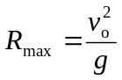 when launch angle θ _{o} = 45°
■ Maximum height: 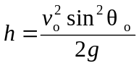 when time 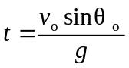
■ If g is not constant, the path of motion is non-parabolic, e.g.: Long range missiles
■ The effect air resistance causes the velocity decreases
 Cause: Asymmetric path, Reduced maximum height, Shortened range
⧫ The effect of air resistance depends on the mass and the size of the object.

Newton’s Laws of Motion
Newton’s laws of motion:
⬥ A body will remain at rest or a body in uniform motion in a straight line will maintain that motion unless an external resultant force acts on it.
⬥ The time rate of change of momentum of a particle is proportional to the resultant external force acting on the particle.
⬥ If two bodies interact, the force of body A on body B is equal to and opposite the force of body B on body A.

Force is something that changes the state of rest or uniform motion of a body (unit: kg m s^{–2}, N).
Inertia is the reluctance of a body to change in its state of motion.
Mass is the measure of inertia (unit: kg).
True Weight is the force exerted by the earth on a body toward the center of the earth
➢ W = mg (Independent of the motion of the body)
Apparent Weight is the force acting on the support by the body.

Momentum is the amount motion and defined as the product of mass and velocity (unit: kg m s^{–1}, Ns).
➢ 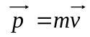
 Newton’s 2nd Law: 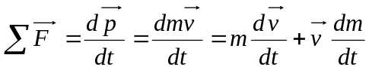
➢ For a constant mass, F = ma

Equilibrium is a state of the body where sum of force and sum of moments are both 0.
➢ 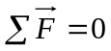 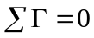

Force of friction:
■ The force of static friction between any two surfaces in contact is opposite the applied force.
■ The force of kinetic / dynamic friction is opposite the direction of motion
■ Static friction is related to the normal reaction of the body on the surface
 f_{s} ≤ μ_{s} N
➢ μ_{s} = coefficient of static friction N = normal reaction
➢ Limiting friction: f_{s, max} = μ_{s} N ∴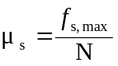
■ Kinetic friction f_{s} = μ_{k} N
➢ μ_{k} = coefficient of kinetic friction, nearly independent of the velocity
■ Coefficient of friction:
⧫ Dependent on the nature / material of the contact surfaces.
⧫ Independent of the surface area of contact.
⧫ f_{k} f_{s, max}

Tension:
■ Tension in a flexible rope/string/chain at a point is the size of the force which one part of the rope cut at that point exerts on the other part.
■ Tension along the rope is constant if the rope is light.
■ Hooke’s Law: The extension of an elastic body is directly proportional to the force that produces it, providing that the extension is small.
 Stretching force ∝ Extension ⇒ F = k x
➢ k = Force constant, unit: N m^{–1}

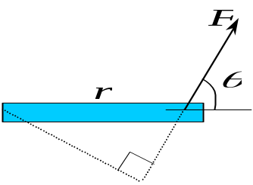Moments
Torque:
■ Torque ≡ Turning moment τ ≡ Γ
■ Torque = Force × Moment arm = Fr sin θ
 Vector cross product: 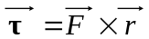

■ Principle of moment: For a body in equilibrium, total moment about any axis is zero.
■ Resultant of parallel forces: Parallel forces F_{k} (k=1… n) at positions x_{k} from the axis of rotation can be replaced by a force F ' at a position x’ from the same axis of rotation, where:
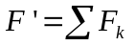 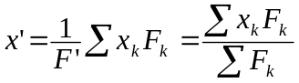

Center of gravity:
■ Weight of an extended body = Resultant of the forces of gravity acting on each particle of the body.
 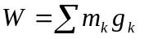
■ The center of gravity of a body is the point where its weight is considered to act.
 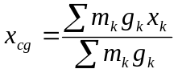 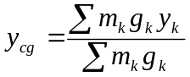 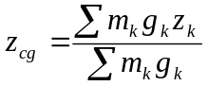
■ For small object, the gravitational acceleration g is constant:
 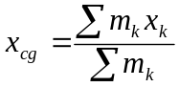 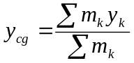 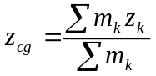

Couple of force:
■ Couple: A pair of equal but opposite forces acting on a body along different parallel lines of action.
 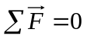 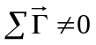
■ (Moment of a couple) = (Force) × (Perpendicular distance between their lines of action)
 τ = F d
➢ Moment of a couple is independent of the axis
■ A couple only changes the rotational motion of the body
➢ No ways alters the translational motion.

Work & Energy
Work:
■ Work is done when:
⬥ The object undergoes a displacement
⬥ The force has a non-zero component in the direction of the displacement
■ Work = (Force) · (Displacement)
 Vector dot product: 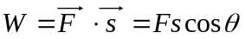
 Scalar quantity, unit in N m or joule (J)
➢ For a variable force, the work done, 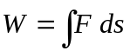
■ Conservative force: Work done by the force is independent of the path of the motion
⧫ Example: Gravitational force
⧫ Work done: W = F s cos θ
■ Non-conservative force: Work done by the force is depended on the path of the motion
⧫ Example: Frictional force
⧫ Work done: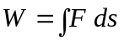
■ ΔW can be regarded as the transfer of mechanical energy of the system
⬥ ΔW > 0 Energy is transferred to the system through the force
⬥ ΔW = 0 No energy is exchanged through the force
⬥ ΔW < 0 Energy is released from the system through the force

Power:
■ Power is the time rate of doing work.
 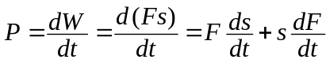
➢ For constant force, P = F v
■ Unit in Nms^{–1}, kgm²s^{–3}, watt (W)
⧫ 1 horsepower = 746.0 watt

Energy:
■ Kinetic energy is the energy a body has because of its motion
■ Kinetic energy (E_{k}, k.e.) =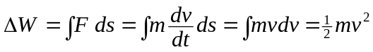
■ Potential enersgy is the energy a system of bodies has because of the relative positions of its parts
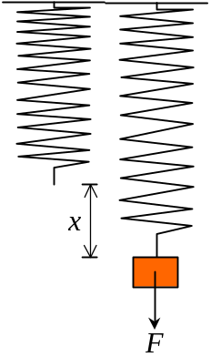 Energy by virtue of position and stored in the system
■ Potential energy (E_{p}, p.e., U) is defined for conservative force only.
➢ e.g.: Gravitational P.E., Elastic P.E., Electric P.E.
⧫ Gravitational P.E.: ΔU = ΔW = FΔs = mgΔh
➢ ΔU = mgΔh ∴ Gravitational force 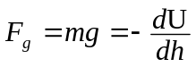
⧫ Elastic P.E.: ΔU =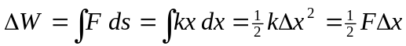
➢ ΔU =kΔx² ∴ Elastic force 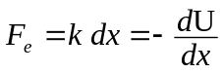
■ For a body in a system undergoes an infinitesimal displacement dx, the change in p.e. dU = – F dx
➢ F = Gravitational force, Elastic force, etc.
⧫ The force F is pointed to the direction of lower p.e.
⧫ In the U-x graph, the minimum U attains when the corresponding F = 0

Conservation of energy: Energy is never created or destroyed.
 Thus the total energy content of an isolated system remains constant.

Mechanical energy:
■ Mechanical Energy is the sum of total kinetic energy and total potential energy.
 Mechanical energy = E_{k} + E_{p}
■ The total mechanical energy of a system is conserved if the forces that do work are conservative.
 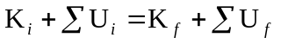
■ Work done by all non-conservative force = Change in mechanical energy

Linear Momentum
Linear momentum:
■ Linear momentum is the quantity of motion and defined as the product of mass and velocity
➢
■ Impulse is the change in linear momentum, Δp
➢ By Newton’s 2nd Law, 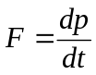 ∴ Δp =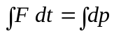
 For a constant force over a period Δt, the impulse Δp = F Δt
■ Conservation of linear momentum: For a system of interacting particles that are isolated from their surroundings, their total momentum is conserved, regardless of the nature of the forces between them.
➢ 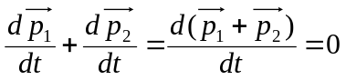

Collision:
■ Particles collide inside an isolated system, their total momentum conserves.
➢ ∑ m_{k} u_{k} = ∑ m_{k} v_{k}
■ Impulsive force during collision is assumed to be much larger than any external forces such as friction and gravitational force.
■ The total energy of the whole system is conserved.
■ Kinetic energy is generally converted into:
⬥ Heat or sound energy
⬥ Internal elastic potential energy when the bodies are deformed
■ Inelastic collision:
⧫ ∑ E_{k, before} > ∑ E_{k, after}
⧫ m₁u₁ + m₂u₂ = m₁v₁ + m₂v₂
■ Perfectly inelastic collision:
⧫ ∑ E_{k, before} > ∑ E_{k, after}
⧫ Particles stick together after collision.
⧫ m₁u₁ + m₂u₂ = m₁v + m₂v
■ Elastic collision:
⧫ ∑ E_{k, before} = ∑ E_{k, after}
⧫ m₁u₁ + m₂u₂ = m₁v₁ + m₂v₂
 m₁ = m₂ ⇒ velocity exchanges, v₁ = u₂ v₂ = u₁
 m₁ = m₂ u₁=0 ⇒ v₁ = u₂ v₂ = 0
 m₁ m₂ u₂=0 ⇒ v₁ ≈ u₁ v₂ ≈ 2u₁
 m₁ m₂ u₂=0 ⇒ v₁ ≈ –u₁ v₂ ≈ 0
⧫ If u₁=0 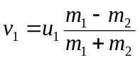 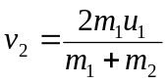

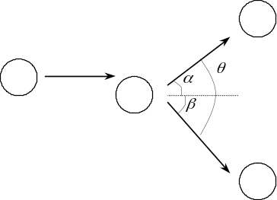Collision in Plane:
■ Oblique collision (not head-on) between a moving particle of mass m₁ and a stationary particle of mass m₂:
➢ 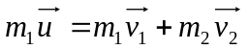
 m₁u = m₁v₁cosα + m₂v₂cosβ
 m₁v₁sinα + m₂v₂sinβ = 0
■ For a elastic collision,
⬥ m₁ = m₂ ⇒ θ = 90°
⬥ m₁ > m₂ ⇒ θ < 90°
⬥ m₁ < m₂ ⇒ θ > 90°

Circular Motion
Circular motion:
■ Angular position (θ ): Dimension less quantity, in radian
■ Angular displacement: Δθ = θ₁ – θ₂
■ Linear distance travelled: Δs = r Δθ
■ Angular velocity: 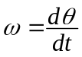 unit in rad s^{–1}
■ Linear velocity: 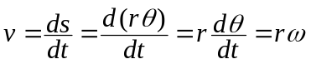, it is tangential to the circle
■ Angular acceleration: 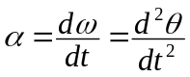 unit in rad s^{–2}
■ Linear acceleration: 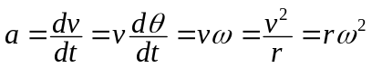, it is center seeking
 Centripetal acceleration
■ Period: Time to complete one revolution. 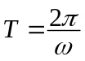
■ Frequency: Number of revolutions completed per second. 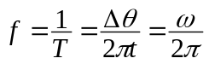
■ Angular frequency: ω = 2πf
■ Uniform circular motion: The motion along a circle with the angular acceleration α = 0

Equation of circular motion in constant angular acceleration:
⬥ ω_{f} = ω_{i} + αt
⬥ ω_{f}² = ω_{i}² + 2αθ
⬥ θ = ω_{i} t +αt²

Centripetal force: The force giving centripetal acceleration.
 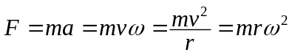
⧫ Centrifugal force: Imaginary, fictitious force
⧫ Work done by centripetal / centrifugal force = 0

Rounding at flat road:
■ Static friction btw the tyres and the road provides the centripetal force
■ Rounding a bend of radius r at speed v, limiting friction should larger than the centripetal force
➢ 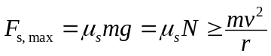
 ∴ Maximum speed of rounding: 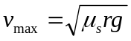
 ∴ Minimum coefficient of static friction required: 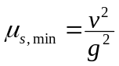

Rounding at banked road:
■ The horizontal component of normal reaction provides (some of) the centripetal force.
■ Rounding on a banked road w/o the help of friction:
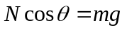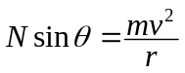
 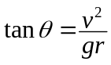 ∴ The maximum speed: 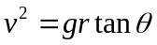

Vertical circular motion:
■ For a body moving inside a frictionless circular track,
⧫ Minimum speed at the highest point: 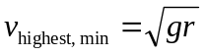
⧫ Minimum speed at the lowest point: 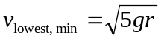
⧫ v _{lowest, min} > 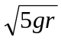 : The body can maintain its circular motion
⧫ v _{lowest, min} = : The body having a circular motion until the highest point and than falls down in a projectile motion.
⧫ 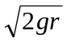< v _{lowest, min}< : The body having a circular motion until somewhere below the highest point and than falls down in a projectile motion.
⧫ v _{lowest, min} < : The body is in a motion of a pendulum
■ For a body moving outside a frictionless circular track, it will maintain its circular motion until it’s at the angular position 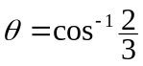 and then falls down as a projectile motion.
■ Vertical circular motion is non-uniform circular motion as the linear acceleration is having both tangential and centripetal components
Simple Harmonic Motion
Oscillatory motion:
■ The displacement, velocity and acceleration vary periodically in both magnitude and direction.
■ Period (T): Time for completing one cycle of oscillation.
■ Frequency: Number of cycles completed per second. 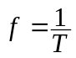
■ Angular frequency: ω = 2π f
■ Amplitude (A): The maximum displacement from the equilibrium / undisturbed position.

Isochronous motion: The period of an oscillatory motion is independent of its amplitude.

Simple harmonic motion:
■ The displacement (x), velocity (v) and acceleration (a) vary sinusoidally with time.
■ Acceleration ∝ Distance away from the equilibrium point (i.e. displacement)
■ The acceleration in SHM is always directed toward the equilibrium point
➢ 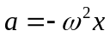
■ Displacement: 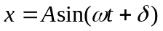 or 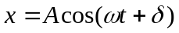
➢ A = Amplitude δ = Initial phase ω = Angular frequency ω t + δ = Phase of motion
 The motion is periodic, repeats when the phase of motion increased by 2π rad.
➢ 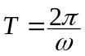
■ Velocity: 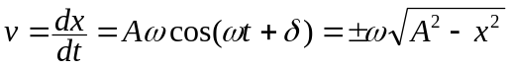
 v _{max} = Aω at the equilibrium position (phase of motion = 0)
■ Acceleration: 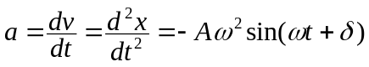
 a _{max} = Aω² at the position w/max displacement (phase of motion =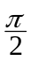, 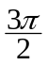)
■ v leads x by and lags a by.
■ Initial values: x_{o} = A sinδ v_{o} = Aω cosδ a_{o} = – Aω²sinδ
➢ 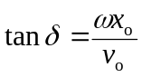 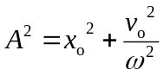

Horizontal mass-spring system:
■ Net force acting on the mass: F = – k x
➢ 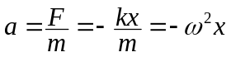 where 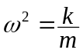
 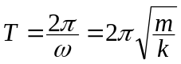 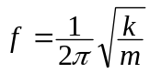
➢ T and f depend on m and k only ⇒ Independent of amplitude
 Stiffer spring, smaller mass (↑k, ↓m) ⇒ ↑f

Simple pendulum:
■ The tangential restoring force: F_{t} = –mg sinθ
⧫ The restoring force makes the object, which is in SHM, returns to its equilibrium position.
⧫ The negative sign in –mg sinθ means the force is directed to the equilibrium position.
■ For small amplitude, sinθ ≈ θ ⇒ 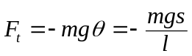
➢ 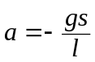 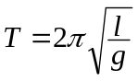 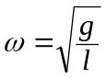
■ For a small amplitude, 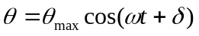
➢ θ_{max} is the maximum angular displacement
 It is an angular SHM

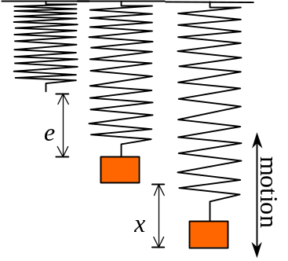Vertical mass-spring system:
■ At equilibrium position, mg=T₀=ke
■ While the body at a displacement x from the equilibrium:
⧫ Tension: T = k (x+e)
⧫ Net force: F _{net} = mg – k (x+e) = –kx
■ Period of motion: 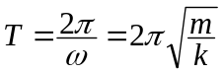
 Period is independent of amplitude A and gravity g

Energy of a Body in Simple Harmonic Oscillation:
■ In a simple harmonic oscillator, there is a continuous interchange of E_{P} and E_{K}
■ In a mass-spring system:
⧫ U _{elastic} =kx² =kA² sin²(ωt+δ)
➢ U _{elastic, max} =kA² at x=A (maximum displacement)
⧫ E_{k} =mv² =mω²(A²–x²) =mω²A² cos²(ωt+δ)
➢ E_{k, max} =mv_{max}² =mω²A² at x=0 (equilibrium)
⧫ Total mechanical energy E_{total} =kx² +mv² =kA²
 Total energy is a constant, E_{total} ∝ A²
 E_{total} =kx² +mv² =kA² 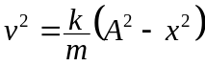

Damped oscillation:
■ Free oscillation: No damping / external influences
⧫ Constant amplitude throughout the motion
⧫ Natural frequency:
 Depends on the inertia m and elastic constant k only
■ Damped oscillation: A retarding force is acting against the motion of the system
⧫ Mechanical energy of the oscillator is dissipated to the resistive medium
⧫ Amplitude decreases with time
⧫ Net force on the oscillator = Restoring force + Damping force
⧫ If the oscillator is small enough and spherical, then: Air Resistance ∝ Velocity
➢ Damping force =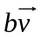 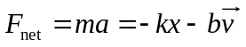 where b is a constant
■ Damping can be increased by:
⬥ Increasing air resistance by making the oscillator broader
⬥ Increasing viscous force by immerse the oscillator in liquid
⬥ Induce an opposing force by electromagnetic induction
■ Light damping / Underdamped motion
⧫ Dissipative force < Restoring force
⧫ Oscillatory character of the motion is preserved
⧫ Frequency is lower, Period is longer
⧫ The amplitude decays exponentially with time
 Equation of motion: 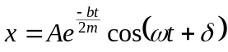
➢ 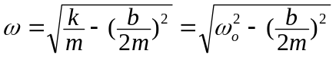
➢ 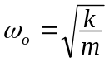= Angular frequency at free oscillation
⧫ The ratio between the amplitudes at consecutive period of time is constant
■ Critical damping
⧫ Dissipative force = Restoring force
⧫ No oscillation occurred
⧫ b = 2mω_{o} or b²=4mk
⧫ The system returns to equilibrium in period of free oscillation
⧫ Mechanical energy of the system loss exponentially with time
■ Heavy damping / Overdamping
⧫ Dissipative force > Restoring force
⧫ No oscillation occurred
⧫ b > 2mω_{o} or b² > 4mk
⧫ The system returns to equilibrium very slowly

Forced oscillation:
■ A sinusoidal external driving force acts on the system.
⧫ Net force = Restoring force + Damping force + Driving force
⧫ A steady-state condition is achieved after a sufficiently long time:
 Freq. of the system = Freq. of the driving force
 Energy loss of the system in each cycle = Energy input by the driving force in each cycle
 Oscillation proceed a constant amplitude
■ For a harmonically-varied force:
⧫ F = F_{o} cos ω t
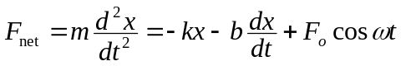
⧫ Motion: 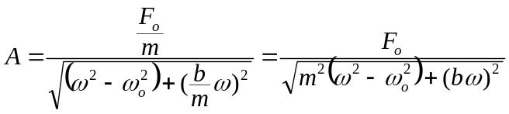
➢ Amplitude attained its maximum when Driving freq. = Natural freq.
➢ A = A _{max} ⇒ ω = ω_{o}
 Driving force in ω = ω_{o} is called resonance.
 ω_{o} is called the resonance frequency.
■ Resonance:
⧫ Applied force is in phase with v
⧫ Power transference is the maximum.
⧫ For a light damping, resonance frequency  natural frequency

Rotational Dynamics
Rigid body: The separations between all pairs of particles remain constant
 Non-deformable.

Rotation of a rigid body:
■ Each particle in a rotating rigid body has the same ω and same α
■ Tangential acceleration of a particle a_{t} = rα
■ Radial (centripetal) acceleration of a particle a_{r} = rω²
 Total acceleration 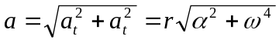

Torque (Moment of a force):
■ τ = Fr sin θ
■ For a small particle of mass m rotating in a circle of radius r,
the tangential force F_{t} = ma_{t}
 τ = F_{t}r = ma_{t}r = mr²α = Iα where I=mr² is the moment of inertia of a particle
■ For a rigid body rotating about an axis at angular acc. α,
⧫ Torque on a particle = τ_{i} = m _{i} r _{i}²α
⧫ Total torque on whole body: 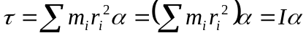 where 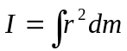

Rotational K.E.:
■ K.E. of a rotating particle: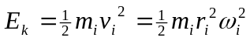
■ Total K.E. of a rotating rigid body: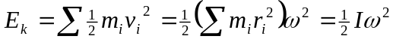

Moments of inertia:
■ 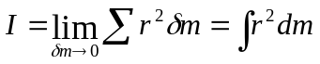
■ United in kgm²
■ Factors affecting the value of moment of inertia I:
⬥ Mass of the rigid body
⬥ Distribution of mass (e.g. density)
⬥ Position of the rotating axis

Object and axis | Moment of inertia
Ring about cylindrical axis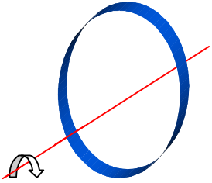 | 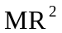
Ring about diameter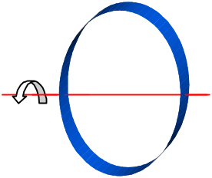 | 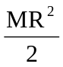
Cylinder/Disc about cylindrical axis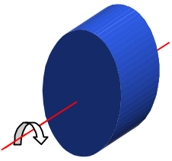
Cylinder/Disc about central diameter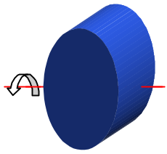 | 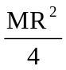
Rod about axis thou’ center  to length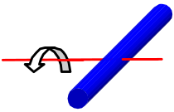 | 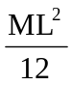
Rod about axis thou’ one end  to length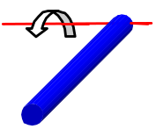 | 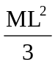
Solid sphere about diameter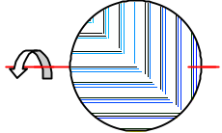 | 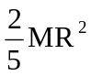
Hollow sphere about diameter | 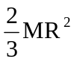

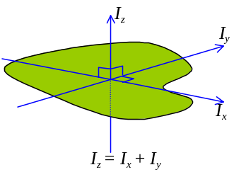 Parallel axis theorem: The moment of inertia about any axis that is parallel to and a distance d away from the axis that passes though the center of mass is given by I = I_{c}+ Md²
■ Perpendicular axis theorem: The moment of inertia of a lamina about an axis perpendicular to it is the sum of moment of inertia about any two mutually perpendicular axes.

Work and Energy:
■ Work done by tangential components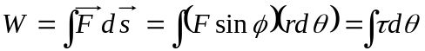
■ For a constant τ, W = τθ
■ As 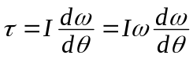, 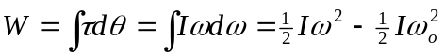
■ Work done by external forces in rotating = Change in rotational K.E.
■ Power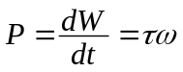

Angular Momentum (Moment of Momentum):
■ Angular momentum of a particle: The moment of the linear momentum of a particle about the axis of rotation.
■ Angular momentum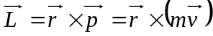
 L = mvr sinθ = mvr = mr²ω
■ United in Nms or kgm²s^{–1}
■ Newton’s 2nd Law for Rotation: The torque acting on a rotating body is equal to the time rate of change of the angular momentum of that body.
➢ 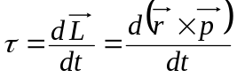
■ Angular momentum of rigid body: The sum of angular momentum of its particle.
■ Angular momentum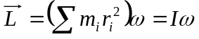
■ 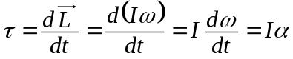
■ Conservation of angular momentum: If the resultant external torque acting on a system is zero, the total angular momentum of the system is constant.
■ Analogy between translational and rotational motion:
 | Translational (Linear) | Rotational (Angular)
Displacement | s | θ
Velocity | 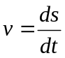 | 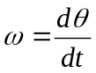
Acceleration | 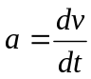 | 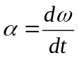
Constant a / α | 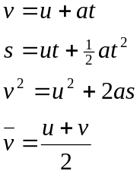 | 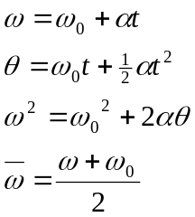
Mass /  Moment of inertia | m | 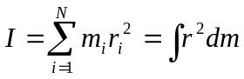
Force / Torque | F | Γ
Momentum | p = mv | L = Iω
Newton’s 2nd Law | 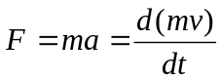 | 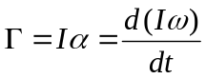
Work Done | 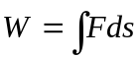 | 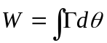
Power | P = Fv | P = Γω
Kinetic Energy | 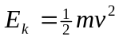 | 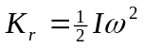
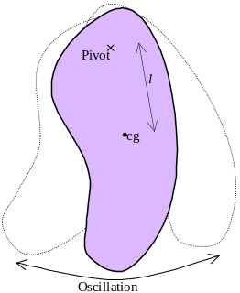Oscillation:
■ A rigid body freely pivoted at a position l from the center of mass:
⧫ When having a small angular displacement θ from the vertical:
torque 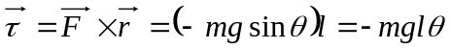
⧫ Since τ = Iα, Iα = –mglθ
 A (angular) simple harmonic motion
 Period of motion 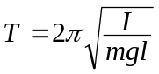

■ An object suspended from a torsion wire and set to rotate in a horizontal plane:
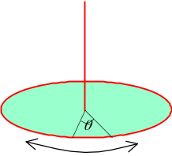 When it at an angular displacement θ from equilibrium,
restoring torque τ = – cθ where c is a torsional constant
⧫ Factors affecting the torsional constant c:
⬥ Cross-sectional area or the torsion wire
⬥ Length of the wire
⬥ Material that made of the wire
⧫ Since τ = Iα, Iα = –cθ
 A (angular) simple harmonic motion
 Period of motion 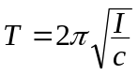

Rolling motion:
■ For an object rolling down an incline plane of height h with speed v,
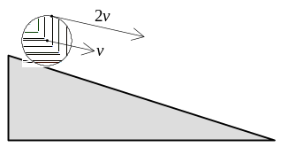 Angular velocity about the center of mass 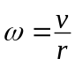
⧫ Translational K.E. =mv²
⧫ Rotational K.E. =Iω²
⧫ Speed of the center of mass = v
⧫ Speed of the surface = 2v
■ If the object is rolling without slipping, mgh =mv² +Iω²
 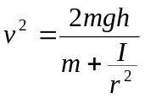 ➢ The smaller the I, the greater the linear speed v attained.

Gravitation
Kepler’s Laws:
■ Nicolaus Copernicus: Heliocentric hypothesis, planets are revolved in circular orbits about the sun.
■ Tycho Brache: Provided the data of astronomic measurements over a period of 20 years.
■ Johhannes Kepler: Deduced a mathematical model from Brache’s data for the motion of planets.
■ Kepler’s 1st Law: All planets move in elliptical orbits having the sum at one focus
■ Kepler’s 2nd Law: The radius vector joining the planet and the sun sweeps out equal areas in equal times.
■ Kepler’s 3rd Law: The square of the orbital period of any planet is proportional to the cube of the mean distance from it to the sun.

Gravity:
■ Newton: Attractive gravitational force causes gravitational acceleration g
■ Newton: Centripetal acceleration of the moon is caused by gravitational force between moon and Earth.
■ Gravitational force ∝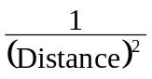.
■ Newton’s law of universal gravitation: Every particle in the universe attracts every other particle with a force that is directly proportional to the product of their masses and inversely proportional to the square of their separation.
➢ For particles of masses m₁ and m₂ which are separated by a distance r, the gravitational force:
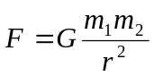 where G is the universal gravitational constant and in Nm²kg^{–2} or m²kg^{–1}s^{–2}
■ The gravitational force exerted by a finite-size, spherically symmetric mass on a particle outside the sphere is the same as if the entire mass of the sphere were concentrated at its center.

Gravitational force btw a particle & a spherical mass:
■ For a spherical shell of mass M and radius R:
⧫ r ≥ R: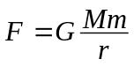
⧫ r ≤ R: F = 0
■ For a solid sphere of mass M and radius R:
⧫ r ≥ R:
⧫ r ≤ R: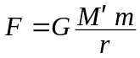 where M’ is the mass of the sphere within the radius r from center

Gravitational field:
■ Gravitational field is a region in which any mass will experience a gravitational force.
■ Gravitational field strength = Gravitational intensity = Gravitational force per unit mass
➢ 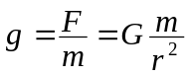
⧫ Vector quantity, unit: Nkg^{–1} or ms^{–2}
■ If rotation of planet is ignored, Gravitational acceleration = Gravitational field strength
■ Density: Relative gravitational field strength
■ Tangent: Direction of the gravitational force exerted on a mass
➢ Radially inward for a planet
■ For an object of mass m on the surface of a planet, gravitational force = weight: 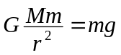
■ For an spherical planet of uniform density ρ, and radius r_{p},
⧫ When 0 ≤ r < r_{p}, 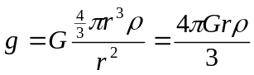
➢ g ∝ r
⧫ At depth h, 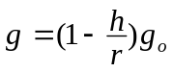 where g_{o} is the gravitational acceleration on the surface
■ Effects causing variation of g with latitude on the Earth:
⬥ Slightly flattened sphere (i.e. ellipsoid) shape of the Earth
⬥ Rotation of the Earth (part of the gravitational force is used to provide the centripetal force)

Gravitational P.E.:
■ Gravitational force is a conservative force
■ Change in E_{p} = – (Work done by F_{g})
➢ 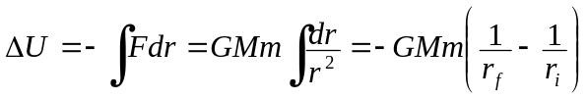
 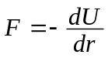, 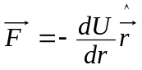
■ Reference point: Customary, taking U = 0 at r = ∞, so that 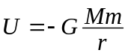
■ When a mass m raised to a height h above the Earth’s surface, change in P.E.=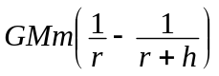
Gravitational potential:
■ Gravitational potential: Gravitational P.E. per unit mass
➢ 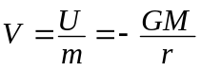
⧫ Scalar quantity, unit: Jkg^{–1}
■ Gravitational potential difference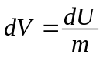
➢  and 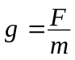, 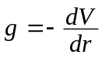
➢ g is the negative  Field strength points to the direction of decreasing potential
■ Equipotential: Lines/Surfaces having the same gravitational potential
⧫ Equipotentials are perpendicular to field lines
⧫ Equipotentials are circular around the planets
⧫ Equipotentials are uniformly spaced near the surface of the planet
⧫ The closer the equipotentials are, the stronger the field is.

Satellites:
■ The centripetal force for satellite moving around a planet is provided by the gravitational force.
➢ 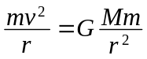, 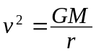
■ If the field strength at the Earth’s surface is g_{o},
⧫ 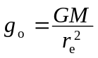, 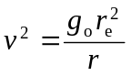
⧫ For a motion at low height, r ≈ r_{e}, v² = g_{o} r
■ Total energy of a satellite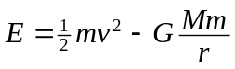
⧫ , ∴K.E. = –P.E., 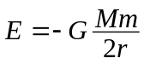
➢ In case of circular orbits, total energy must be negative
⧫ The satellite moves faster if it’s nearer to the Earth
⧫ For a synchronous / geostationary satellites used for worldwide comm., it is at 35800 km above the Earth’s surface to attain the period of exactly 1 day.

Escape velocity:
■ Escape velocity: The minimum speed that an object must have at the earth’s surface in order to escape from the influence of the earth’s gravitational field
 Loss in K.E. = Gain in gravitational P.E.
➢ 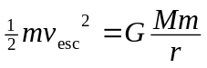, 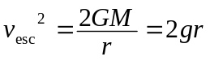
■ When a satellite is in a speed v,
⬥ 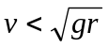, Elliptical path to the surface of the Earth
⬥ 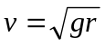, Circular orbit
⬥ 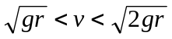, Elliptical orbit
⬥ 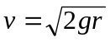, Parabolic orbit
⬥ 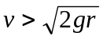, Hyperbolic orbit

Weight and mass:
■ True weight: The total F_{g} exerted on the body by all other bodies in the universe
■ Apparent weight: The supporting force (e.g. reaction from the floor) acting on the body
■ True weightlessness: Net gravitational force = 0
■ Inertial mass: Measures how fast an object will accelerate when a given force acts on it.
➢ F = m_{i}a
■ Gravitational mass: Measures the gravitational force btw two bodies.
➢ 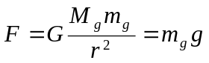

Non-conservative force = Dissipative force
Isolated system: The system where no energy can go into or escape from it.
Retarding force = Dissipative force
The equation of motion is derived by solving the equation “F = ma = kx – bv” for a small b
The equation of motion is derived by solving the equation “ma = – kx – bv – F cos ωt”
G = (6.67259±0.00085) × 10^{–11} Nm²kg^{–2}
The total energy of a satellite should be negative so that it can be bound by the Earth. If its total energy is positive, than it will tend to give up energy to attain a more stable state and escape to infinite separation apart from the Earth.

