Physics - Waves

Waves

Waves:
- Periodic disturbance in a property travels thou’ a material medium or thou’ space
- Wave motion is the motion of disturbance
- Wave energy converts between internal energy of the medium and the amplitude of wave

Types of waves:
- Mechanical waves:
- Involve mechanical energy
- Transmit energy thou’ a deformable / elastic medium
- Disturbance: Physical displacement of particles
- Electromagnetic waves:
- Disturbance: Variation of E-field & B-field
- No medium required for transmission
- Travelling & Stationary waves:
 | Travelling waves | Stationary waves
Energy | Transferred | Stored
Amplitude | Constant | Fluctuating
Motion | Moves w/a wave speed | Waveform stays at the same position
- Transverse waves: Disturbance is perpendicular to the direction of propagation
- Longitudinal wave: Disturbance is along the direction of propagation
- Some waves, like water surface waves is neither purely transverse nor longitudinal
- Water molecules at the surface moves in a nearly circular paths
- The wave has both transverse and longitudinal components

Wave motion:
- Pulse: Disturbance of relatively short time duration
- Succession of disturbances: Creates a continuous train of waves
- Wave-train
- Point of maximum pos. displacement = Crest
Point of maximum neg. displacement = Trough
- Amplitude, A: Maximum variation from the equilibrium value as caused by the disturbance
- Phase difference, φ : The fraction of a cycle by which the variation at a position behind the variation at another position
- Particles are in phase iff the are in same motion
- Wavelength, λ: The minimum distance btw any two pts on a wave that behave identically
- The min. distance btw two pts of the same phase
- The particles separated by a whole no. of wavelength is in phase
- Frequency, f : The rate at which the disturbance repeats
- Frequency of wave = Frequency of source
- Period, T : Time for a complete cycle of wave to pass any point
- Time for the variation to complete a cycle
- 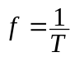
- Wave velocity, v: The velocity of propagation of a wave
- 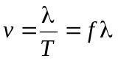
- Intensity, I : The amt of energy that passes thou’ unit area perpendicular to the direction of propagation in unit time
- Intensity ∝ (Amplitude)², 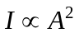
- Unit: Js^{–1}m^{–2}, Wm^{–2}
- Wavefront: A line or surface on shows the pts of the same phase disturbance
- Ray: A line shows the direction of travel
- A ray is perpendicular to the wavefront

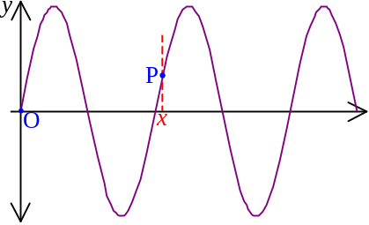Wave equation:
- Wave equation: For pt O: 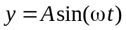
- y: Disturbance, e.g. displacement of particles
- A: Amplitude
- ω: Angular frequency
- t: Time
- If a pt P lags behind O by the phase angle 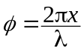, wave eqn: 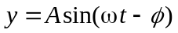
- If a pt P leads O by the phase angle , wave eqn: 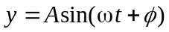
- By defining 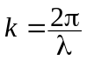, wave equation: 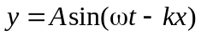
- k is called wave number
- x is the distance of P from O
- Wave velocity: 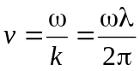
- Defining the initial phase angle θ ₀, wave equation becomes: 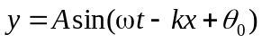
- Velocity of a particle of a plane-progressive wave: 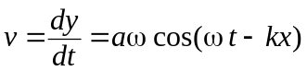
- Velocity of a particle of the wave is independent of the wave frequency
- If the wave equation represents a longitudinal wave, 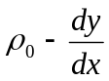 represents the density ρ
- 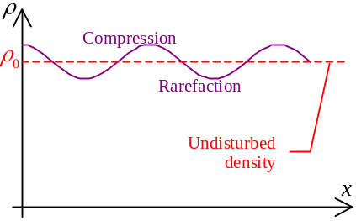If y increases with x means there is a rarefaction
- If y decreases with x means there is a compression
- Change of y is leading ρ by ¼ cycle

Speed of mechanical waves:
- Speed of mechanical waves is determined by the mass and elasticity of the material
- Mechanical waves are transmitted by the oscillation of the particles in the medium
- Oscillation is more effective if the medium is stiff and the particles are light in mass
- Generally, wave velocity, 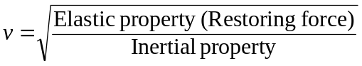
- Transverse waves on a taut string / spring: 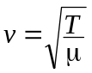
- T = Tension
- μ = Mass per unit length of the string / spring
- Longitudinal waves along masses linked by springs: 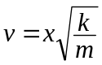
- x = Spacing btw mass centers
- k = Spring constant
- m = One mass
- Sound waves in gas: 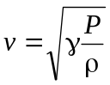
- P = Pressure
- ρ = Density of gas
- γ = A number depended on the type of gas molecules (monoatomic = ⁵/₃; diatomic = ⁷/₅)
- Short wavelength ripples in deep waves: 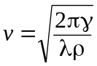
- γ = Surface tension
- λ = Wavelength
- ρ = Density

Reflection and Refraction
Huygen’s Principle states that every point on a wavefront acts as a source of secondary wavelets which travel in the forward direction. The new wavefront is formed by the surface tangent to these wavelets.
- Can be used to determine the position of a new wavefront at some instant from the knowledge of an earlier wavefront

Reflection:
- Laws of reflection:
- The incident ray, the normal and the reflected ray always lie in the same plane
- 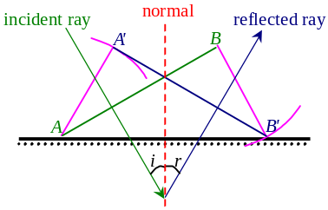Angle of incidence = Angle of reflection
- Wave reflection:
- The reflected wavefront A'B' is formed from the line tangent to the wavelets (of radius AA' or BB') originating from the incident wavefront AB
- Angle of incidence i = Angle of reflection r

Reflection of mechanical wave at normal incidence:
- Consider a slinky spring transmitting a transverse wave and with one end fixed on rigid support
- When incident pulse met the fixed end, a reflected pulse is produced and travels back in the opposite direction
- The reflected pulse has a speed same as incident pulse
- The frequency is unchanged
- Reflected pulse is inverted, i.e. has a phase change of π
- Phase change occurs only if the pulse hitting a denser medium
- If the slinky spring is fixed to a thread, no pulse inversion
- Thread is a less dense medium
- If the slinky spring is fixed on a rigid support and propagating longitudinal wave,
- Compression is reflected as compression
- Rarefaction is reflected as rarefaction
- If a less dense medium is attached,
- Compression is reflected as rarefaction
- Rarefaction is reflected as compression
- If the wave equation, y = A cos(ωt + kx), is considered
- Incident wave hits a denser medium, the reflected wave is: y = –A cos(ωt – kx)
- –A: Reversal of displacement
- Phase change of π or ½λ in transverse wave
- In longitudinal wave, 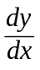 is same for both incident and reflected wave,
i.e. no change in phase
- –k: Reversed direction of propagation
- Incident wave hits a less dense medium, the reflected wave is: y = A cos(ωt – kx)
- Reversed direction of propagation only
- For transverse wave, no phase change
- For longitudinal wave, compression and rarefaction is reversed

Refraction:
- Normal incidence:
- Wavefronts are parallel to the boundary btw mediums
- Ray / Direction of propagation is normal to the boundary,
i.e. no change in direction of propagation
- Frequencies of wave in either medium is the same
- Wavelengths and velocities are different
- In ripple tank exp’t velocity is larger and wavelength is longer in deeper water
- 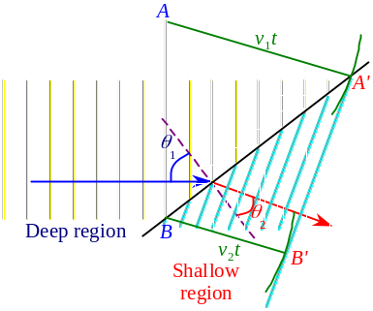Oblique incidence
- In ripple tank exp’t, v and λ are larger in deeper region
- Wavefront AB, incident from region 1 to region 2
- In region 1, wave velocity = v₁
- In region 2, wave velocity = v₂
- Pts A and B will be sources of secondary wavelet, after time t,
- The wavelet from A traveled v₁t and approached the pt A'
- The wavelet from B traveled v₂t and approached the pt B'
- Refracted wavefront = A'B'
- Angle of incidence and refraction satisfies: 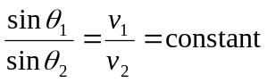
- The ratio of wave velocity in medium 1 and medium 2 is called relative refractive index
- A constant, denoted by ₁n₂
- 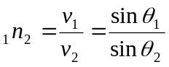 (Snell’s law)
- In case of light the relative refractive index ₀n₁ of medium 1 w.r.t. vacuum is called absolute refractive index or simply refractive index, denoted by n₁
- 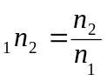
- Speed of light in a medium w/refractive index n is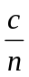
- Snell’s law: 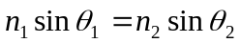

Polarization
Polarization: Selection of one direction of disturbance from two or more choice
- For transverse wave only

Polarization by Selective Absorption:
- A wave is polarized such that only the component along one direction is allowed to transmit and its corresponding complementary component is absorbed
- The device that carry out the process is called Linear polarizer
- Analyzer: The second polarizer that use to analyze the wave coming out from a polarizer w/unknown polarization direction

Polarization by Reflection:
- If an EM wave incident to dielectric material, the electrons in the material are set into vibration
- Electrons are oscillating along the direction of the electric field
- Oscillating electron will radiate EM wave
- The radiation is maximum for those propagating perpendicular to the oscillating direction
- No radiation along the direction of oscillation
- In a Cartesian space, if a wave is incident from –x toward origin and the E-field is on xy-plane
- The electron at origin is oscillating along the y-axis
- 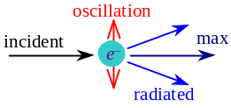Radiation is maximum on the xz-plane and no radiation along the y-axis
- If the maximum radiation is of amplitude E,
the radiation at direction that makes an angle θ with the xz-plane is E cosθ
- If an EM wave incident at a pt A, it will be partially reflected and partially refracted
- 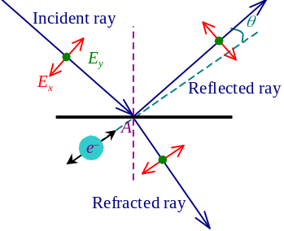The incident ray is unpolarized, the E-field can be resolved into two component, one is parallel to the reflective plane (E_{y}), and another is perpendicular to this (E_{x})
- Assume the wave with E_{x} component only, when the ray incident at A, the e– oscillate along the direction of E_{x} component of the refracted ray
- Reflected ray is produced with E_{x} polarization
- If the refracted ray makes an angle θ with the oscillating direction of the electron, the amplitude of the EM wave ∝ sinθ
- Since θ is small, the component of E_{x} polarization of the reflected ray is weak
- Assume the wave with E_{y} component only, when the ray incident at A, the e– oscillate along the direction of E_{y} component of the refracted way
- Reflected ray is produced with E_{y} polarization
- If the refracted ray makes an angle θ with the oscillating direction of the electron, the amplitude of the EM wave ∝ cosθ
- Since θ is small, the component of E_{y} polarization of the reflected ray is strong
- 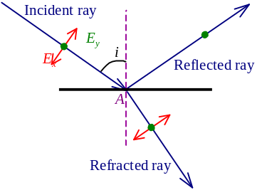Due to the different strength in reflected wave in E_{x} & E_{y} polarization, the reflected wave is partially polarized
- In some direction of incidence, the reflected ray and refracted ray is perpendicular
- θ = 0
- The reflected wave’s E_{x} polarization is zero and the E_{y} polarization is strongest
- The wave is completely plane polarized
- The angle of incidence i is called Brewster’s angle
- If the ray incident from a medium of refractive index n₁ to another medium of refractive index n₂, the Brewster’s angle θ _{b} satisfies: 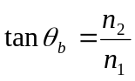

Polarization by Scattering:
- In water or gas medium, if a ray is incident from –x to +x direction thou’ the origin
- Electron will oscillate along the E-field and emit radiation
- If the scattered light is viewed on the direction parallel to the yz-plane, the radiation is completely plane polarized
- If the scattered light is viewed at an oblique angle with the yz-plane, the radiation is partially polarized only

Superposition

Principle of superposition:
- When two wave disturbances meet, the resultant disturbance is simple the sum of the two
- If the two disturbances travel in different directions, then when they separate, each moves on as if nothing has occurred

Interference:
- For two waves that are of same frequencies, a stable interference pattern is observed
- Constructive interference: Pts that the two waves are always met in phase
- Destructive interference: Pts that the two waves are always met completely out of phase
- Factors affecting the result of interference:
- Phase difference of the waves when they meet
- If the wave sources are of an initial phase diff. θ ₀, there is also a phase diff. θ ₀ when they met
- The propagation of one wave thou’ a distance x caused a phase delay θ_{x} = kx
- k = Wave number
- If there is a path difference Δx when two waves met, phase difference kx is raised
- Total phase difference = Δθ = θ ₀ + θ _{x}
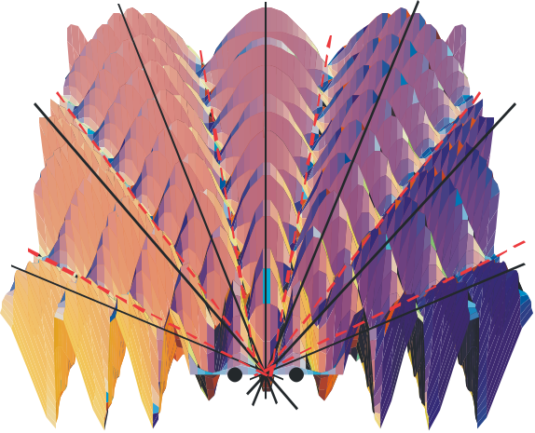
- If Δθ = 2mπ, m∈ ℤ
- Constructive interference occur
- Maximum amplitude attained
- If Δθ = 2(m+½)π, m∈ ℤ
- Destructive interference occur
- Minimum amplitude attained

Interference of Light:
- When light wave incident on double slit,
- Wave split into two
- Division of wavefront
- The double slit act as two secondary sources
- The secondary sources emitting light waves and interference occur
- If a screen is installed, the interference pattern is got
- Parallel bright and dark fringes
- Assume the screen and the double slit are very far away,
- Separation btw slits = a
- 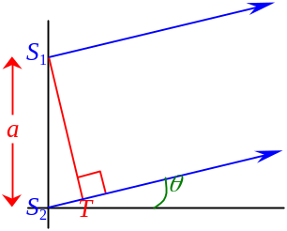Separation btw slits & screen = D
- At direction θ to the normal of dbl slits, wave from S₁ and S₂ met at the screen with path difference S₂T
- Path difference = asinθ
- If constructive interference occur: asinθ = mλ
- If destructive interference occur: asinθ = (m+½)λ
- Assume the central bright fringe be O and mid-pt btw S₁S₂ is M,
- If the m^{th} constructive int. (bright fringe) from central bright fringe occur at X and OX = y_{m},
y_{m} = D tanθ ≈ D sinθ
- 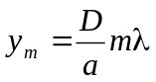 where m = 0, 1, 2, …
- Path difference: 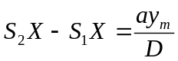
- If the m^{th} destructive int. (dark fringe) form at X' and OX' = y'_{m},
y'_{m} = 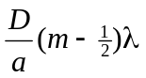 where m = 1, 2, 3, …
- Separations btw two adjacent bright/dark fringes: 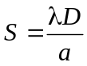
- 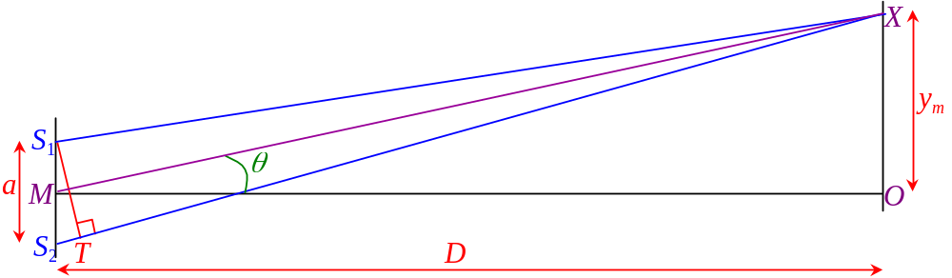The interference at or y'_{m} = is called the m^{th} order of interference
- Zeroth order of constructive interference = Central bright fringe

Intensity of Wave:
- In Young’s double slits experiment,
- Phase diff.: 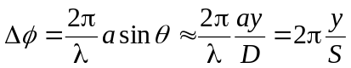 as θ is small
- If the waves are of same amplitude A₀, due to Δφ, resultant amplitude of the pt is: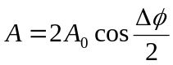
- If the original intensity = I₀, resultant intensity at the pt is: 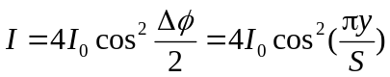
- Maximum intensity = 4I₀ at y = nS, n∈ℤ
- The variation btw neighboring maxima are smooth

Multiple Slits:
- Instead of double slit, if multiple slit w/equal separation is used
- Positions of maxima are unchanged
- Bright fringes are narrower
- Width of bright fringe <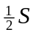
- If N slits are used, width =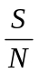
- Between bright fringes, there are more minima
- If n slits are used,
no. of minima btw neighboring bright fringe = (N – 1)
- Every minima is separated by secondary maxima
- Separation btw neighboring minima =
- At minima, Δφ of wave from neighboring
2° source =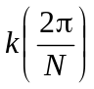 where k = 1, 2, …, (N–1)
- Intensity of each bright fringes is very high
- Maximum intensity ∝ N²

Diffraction Grating:
- Diffraction grating: A n-slit (where n is very large) for performing interference
- If a parallel beam is having a normal incidence to the diffraction grating, angular position of maxima satisfies asinθ = mλ
- For oblique incidence, phase difference of source should take into account
- By asinθ = mλ, max. no of order could be seen is governed by: 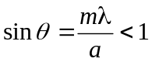
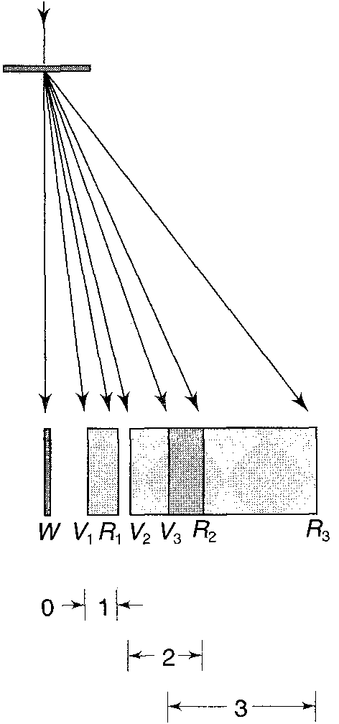
- The equation is invalid as θ not small

White light analysis
- White light consists of all colors from violet to red (λ = 0.4μm to 0.7μm)
- When white light incident normally on diffraction grating light spectra formed as different λ comprising the light
- At zeroth order (m = 0) central white band formed as all λ coincide
- At first order, diffraction pattern enclosed by first order diffraction of violet & red light
- All colors are spread out in the range
- The 2nd order diff band is wider than 1st order and 3rd order is wider than 2nd order
- Dispersion of grating = Change of angular position per unit wavelength change
- Dispersion =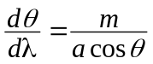
- Dispersion ↑ as order ↑ and a ↓
- High resolution pattern can be obtained if the higher order is view thou’ a fine grating
- Neighboring bands are overlap if asinθ = m₁λ₁ = m₂λ₂
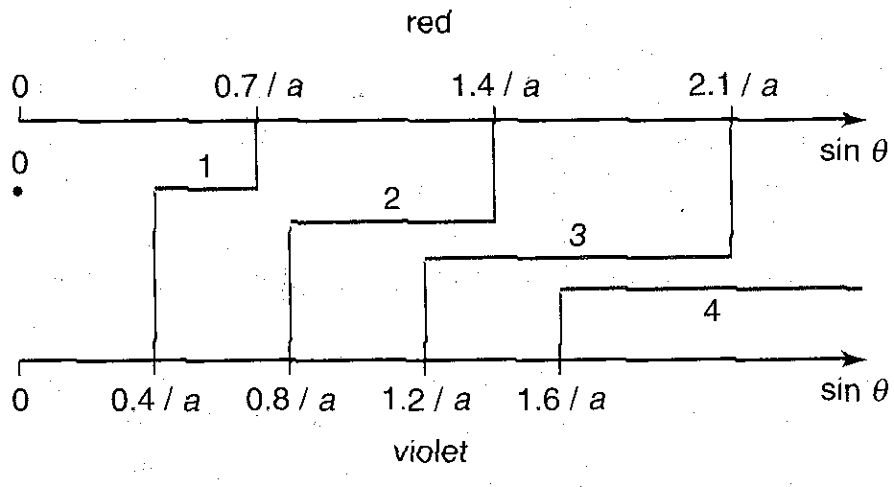
- No. of order observed is depended on the grating spacing

Conditions of Observable Interference:
- Two waves must be of same polarization
- Two waves must have constant phase difference
- Two waves must have same frequency
- Path difference must not be too large
- Coherent Source: Source of waves of definite phase difference & same frequency

Beats:
- Beats occurs when frequencies of two waves are slightly differ
- Constructive & destructive interference occur successively
- Amplitude & intensity change periodically
- Beat frequency: 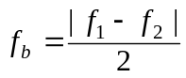
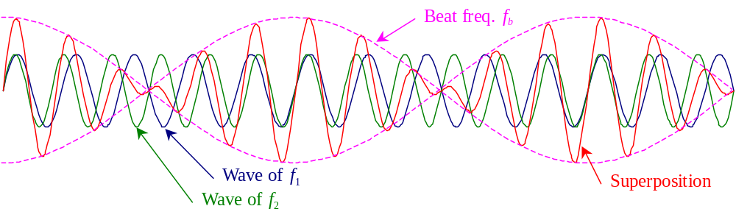

Application of Interference

Booming of lenses:
- A glass of refractive index n coated w/very thin larger of another material of refractive index n'
- 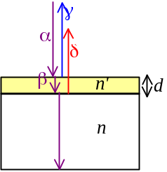n' < n
- Thickness of the n' material = d
- When a light α incident normally on the surface,
- The incident wave is split into two
- Division of amplitude
- Partially reflected (γ) and partially penetrated the coating (β)
- The reflected wave γ suffers a phase change of π
- The ray β penetrates the coating and met the surface btw the coating & glass
- Division of amplitude
- Partially reflected (δ) and partially penetrates the glass (ε)
- Reflected wave δ suffers a phase change of π
- To minimize the reflection effect of the glass, γ and δ should have destructive interference
- Phase difference btw γ & δ = 0
- δ travels an extra distance of 2d
- 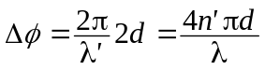
- λ' = wavelength in the coating
- λ = wavelength in vacuum
- If destructive interference occurs, Δφ = π
- 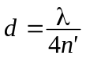
- Quarter-wave non-reflective coating
- Precautions:
- n' should be suitable so that γ & δ are of similar amplitude for complete cancellation
- Complete cancellation occurs only for a particular wavelength λ
- Longer or shorter wavelengths would be slightly reflected
- Usually l is chosen to be in the yellow-green portion of visible light
- Exact cancellation is for normal incidence only, if incident at oblique angle, Δφ < π

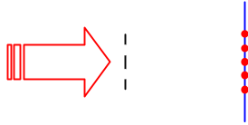Estimation of Wavelength of Monochromatic Light:
- When a monochromatic light passes a double slit, an interference pattern can be caught by a screen
- The separation between neighboring fringes is
- When the separation between the slits (a) and the slit-screen distance (D) is known, λ can be calculated

Thin films:
- 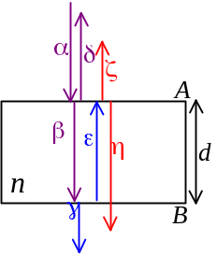A film of thickness d and refractive index n in vacuum
- Wavelength in film: 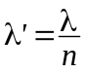
- Ray α incident normally on surface A
- Division of amplitude
- Reflected as δ and penetrated into the film as β
- Ray β incident normally at surface B
- Reflected as ε and penetrated as γ
- Ray ε incident normally at surface A
- Reflected as η and penetrated as ζ
- Total phase difference btw δ & ζ: 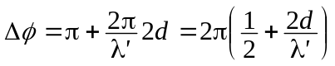
- Constructive interference if: 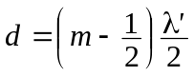
- Destructive interference if: 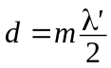
- Total phase difference btw γ & η: 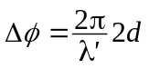
- Constructive interference if:
- Destructive interference if:
- If ray α is incident at an oblique angle θ,
- Partially reflected as β and partially refracted thou’ AB w/an angle θ'
- Light ΑΒ is reflected at the bottom surface and then refracted at the top surface as γ
- 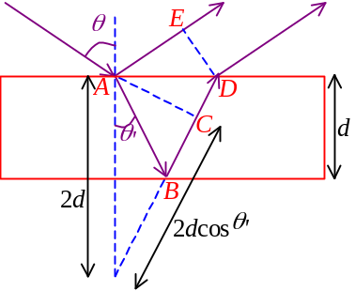Geometrical path difference: AB + BD – AE
- Optical path difference: AB + BD – CD = AB + BC = 2dcosθ'
- 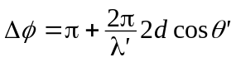
- Constructive interference if: 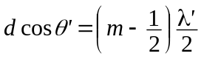
- Destructive interference if: 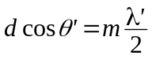

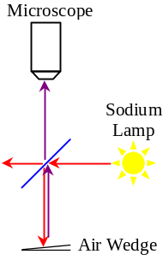Wedge-shaped Thin Films:
- When the thin wedge of air of variable thickness is viewed by microscope, a series of alternating bright and dark parallel fringes is observed
- At the line of contact, a dark fringe is formed
- The lower glass plate reflect the light with a phase change of π
- At any pt P of the air wedge, where the air wedge has the thickness 
- 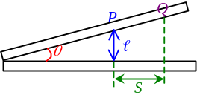Optical path difference = 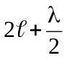
- The n^{th} bright fringe satisfies: 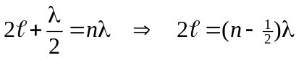
- The (n–1)^{th} dark fringe satisfies: 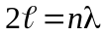
- If the microscope moves horizontally for a distance S to move the focus from P to Q, and there are k bright/dark fringes across PQ,
- Angle of the wedge θ =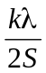
- The spacing of the wedge ∝ Wavelength
- Red fringes are further apart than blue fringes
- If the two glasses are not flat, in some line parallel to the line of contact, the thickness of the wedge is not constant
- The fringe would not be equal thickness & parallel

Newton’s Ring:
- 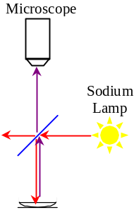A plano-convex lens touches a flat glass plate
- The thickness of the air film gradually inc. outwards from the pt of contact
- At the pt of contact, the thickness of the air film = 0
- The thickness is the same at all pts on any circle w/center at pt of contact
- There are interference due to the monochromatic light is reflected by the curved surface of the lens and the upper surface of the plate
- The interference pattern is a series of concentric rings
- Newton’s Ring
- The fringe-fringe separation decreases as the radius increases
- At the point of contact, there is a dark spot because the flat glass plate reflect the light with a phase change of π
- Let the thickness of air film at some radius be ,
- 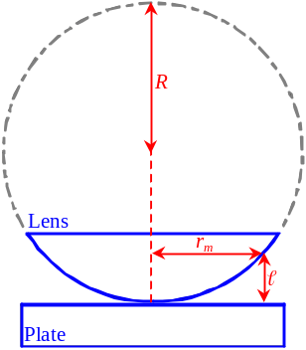It is a bright fringe (constructive interference) if: 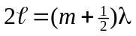 ∃m∈ℤ
- It is a dark fringe (destructive interference) if: 2 = mλ ∃m∈ℤ
- Let the radius of curvature of the lens be R, radius of m^{th} dark fringe is r_{m},
the thickness of air film at m^{th} dark fringe is , refractive index of air is n
- 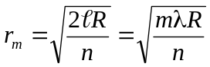

Sound

Sound:
- Generated by a vibrating source
- Propagated thou’ a material medium

Resonance in Air column / Closed tube
- An air column of length  and a tuning fork of freq. f
- The tuning fork makes a note and creates a compression at the mouth of the air column
- The compression travels thou’ the air column and reflects back at the bottom
- 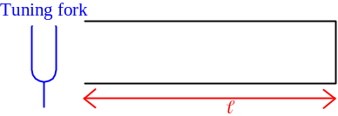If the compression reaches the mouth when the prong of tuning fork is moving away from the air column, the vibration is helped
- Resonance of sound
- Enhanced the intensity
- At resonance
- Time of travel t of the compression: 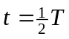
- Distance traveled = 2 = vt =vT
-  =vT =λ
- Condition for resonance: 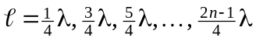
- If the tuning fork giving out notes continuously,
- The sound wave from tuning fork and reflected wave superposed
- 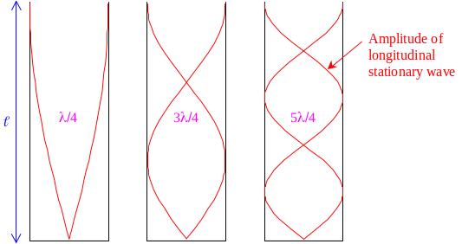Longitudinal stationary wave formed
- Node at the closed end
- Antinode at the mouth
- Forced the air at the mouth vibrate
- A loud sound produced
- Wavelength of stationary wave = 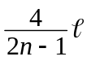
- Since resonance occur when 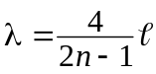
- Freq. of resonance: 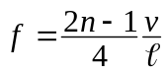
- Lowest resonant freq: 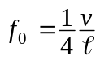
- Called the fundamental frequency or tone
- Rest frequencies are called overtones
- Overtones are 3f₀, 5f₀, …
- Fundamental freq. is strongest and overtones are weaker
- Freq. 2f₀, 3f₀, … are called 2nd, 3rd, … harmonics
- In closed tube, 3rd, 5th, … harmonics occurs only

Resonance of Open Tube:
- When a tube open at both ends brought into resonance
- 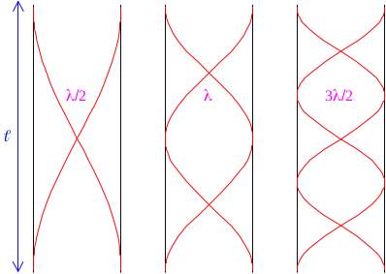Both ends are antinodes
- Resonance occurs when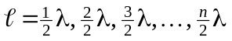
- Resonant frequency: 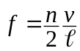
- Fundamental freq.: 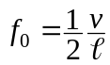
- Overtunes: 2f₀, 3f₀, 4f₀…

String vibration
- Stringed instruments produce notes by resonance of stretched strings
- If the length of string = 
- Wavelength on string: 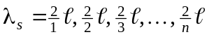
- Freq. on wave: 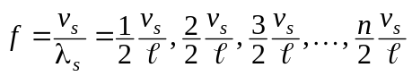
- v_{s} = Velocity of travelling waves on string
- Fundamental freq: 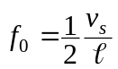
- Overtune: 2f₀, 3f₀, 4f₀…
- Since 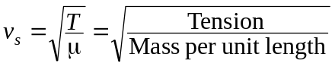, 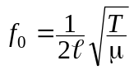
- Tightening a string causes f₀ increase
- Thicker string causes f₀ decrease

Velocity of Sound:
- Speed of wave in gas: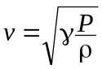
- Since density 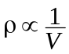, 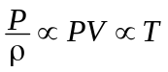
- Speed of sound 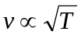 where T is absolute temperature

Doppler Effect

Moving Source:
- A sound source S is moving with constant speed u_{s}
- The source emitting sound wave of freq. f, wavelength λ, period T, wave speed v
- If the source is moving toward the observer,
- Actual wavelength = λ
- 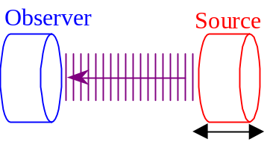Apparent wavelength by the observer = λ₀ = vT – u_{s}T = (v – u_{s})T
- Apparent frequency: 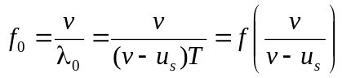
- If the source is moving away from the observer,
- Apparent wavelength by the observer = λ₀ = vT + u_{s}T = (v + u_{s})T
- Apparent frequency: 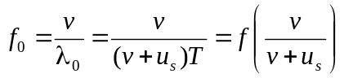
- Qualitatively, a receding source gives a lower frequency; an approaching source gives a higher frequency
- 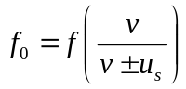
- Change in frequency: 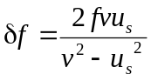

Moving Observer:
- An observer O moving with constant speed u_{o}
- A source emitting sound wave of freq. f, wavelength λ, period T, wave speed v to the receiver
- If the observer is moving toward the source,
- Actual wave speed = v
- 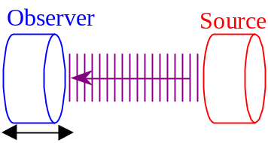Apparent wave speed = v₀ = v + u_{o}
- Apparent frequency: 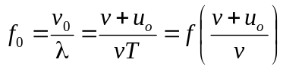
- If the observer is moving away from the source,
- Apparent wave speed = v₀ = v – u_{o}
- Apparent frequency: 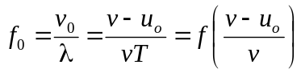
- Qualitatively, an approaching source & observer gives a higher freq.; gives a lower freq. otherwise
- 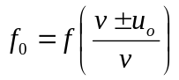
- Change in frequency: 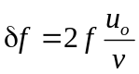
- Generally: 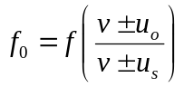 where the pos. is taken to be the dir. from O moving to S

Electromagnetic wave:
- Frequency shift is also occur in EM-waves and qualitatively follows Doppler’s effect
- Relativistic derivation of frequency shift: 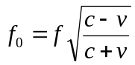
- v = Relative speed between the observer and the source
- When they are moving closer together, v is taken to be negative
- When they are moving away, v is taken to be positive
- c = Speed of light
- Change in frequency: 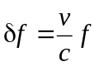
- When a shifted wave superpose with the original wave, beats w/freq 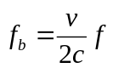 is formed
- Used in radar speed check

Human Ear

Intensity
- Power of a sound source = Acoustic energy given out per unit time
- Intensity is the energy emitted over a unit area per unit time
- When the sound traveled to a distance r from the source: 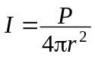
- Assumed the sound emitted in all directions equally with total power P
- Unit of intensity: Wm^{–2}
- Intensity varies over a large range
- More convenient to use in logarithm of intensity
- Intensity level
- Intensity level of an intensity I: 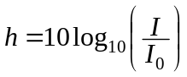
- I₀ = Reference intensity
- If I₀ = 10^{–12} Wm^{–2}, intensity level bears a unit: decibel, dB
- Intensity doubled for every 3dB increase in intensity level
- Intensity level can roughly be the scale of loudness of sound

Response of Human Ear:
- Minimum intensity level audible to a normal human ear = Threshold of audibility
- Threshold of audibility is lowest at 1-2 kHz of 0 dB
- Most sensitive freq. of human ear
- Threshold of audibility is very high outside the range of 20 Hz - 20 kHz
- Intensity level which the sound becomes painful = Threshold of feeling
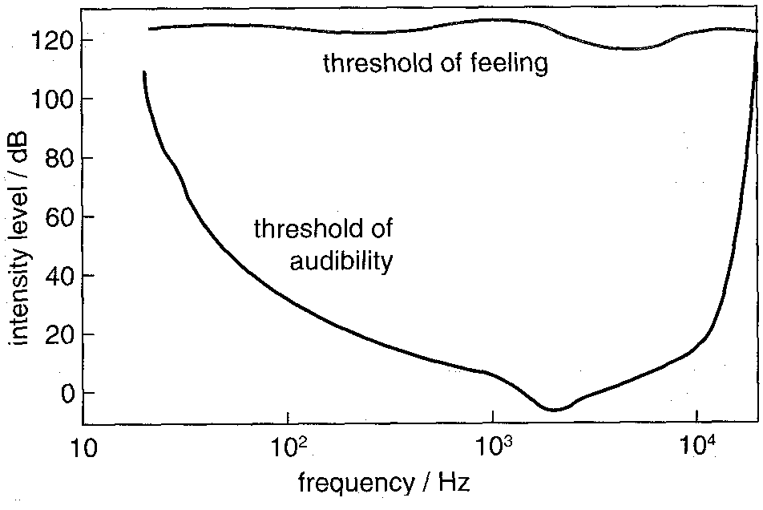
- Threshold of feeling is quite frequency-independent
- Around 120 dB at all audible frequency

Optical Instruments

Human Eyes:
- Near point: The closest position for which the lens can produce a sharp image on the retina
- Distance between the near pt & the eye = Least distance of distinct vision
- Normal eye: 25cm
- Far point: The farthest position for which the lens can be focused by the unaided eye
- 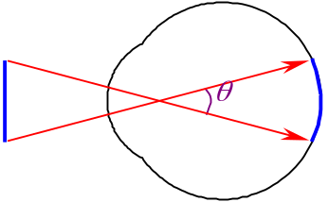Far point of the normal eye is at infinity
- The apparent size of an object is determined by the size of the image on the retina
- Depends upon the visual angle θ subtended by object at the eye
- When an object moves toward the eye, the visual angle increases and a larger image is observed
- The object situated at the near point subtends the largest possible viewing angle
- Angular size is largest
- Magnifying power:
- The ratio of apparent sizes of image and object
- Linear magnification: 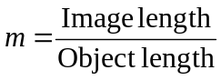
- The ratio of actual sies of image and object

Magnifying glass:
- Magnifying glass: A convex lens
- Object at the position btw the lens and the focus: Virtual, erect, enlarged image
- 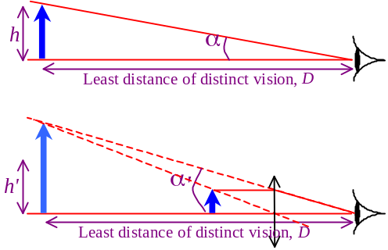Without magnifying glass, visual angle =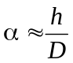
- When magnifying glass is used, visual angle =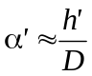
- Magnifying power: 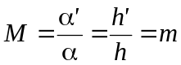
- Angular magnification = Linear magnification
- Since, 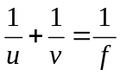, 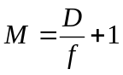
- If the image formed by the magnifying glass is at infinity, 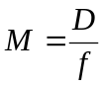
- For a particular magnifying glass w/focal length f, the image formed that can clearly seen will have an angular magnification btw 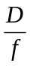 and 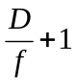

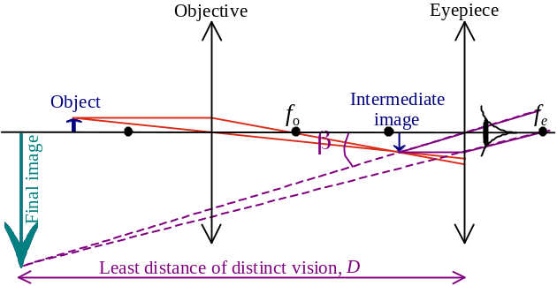Compound microscope:
- A system consists of two lenses to produce a magnified image
- It consists of two lens:
- An objective lens of very short focal length
- f_{o} < 1 cm
- An eyepiece lens of a longer focal length
- f_{e} of a few centimeters
- On using, the eye is close to the eyepiece
- The object is placed just btw f_{o} and 2f_{o} of the objective, an image is formed close to f_{e}
- The intermediate image, which act as the object of the eyepiece
- The eyepiece is a magnifier to produce a final image btw the far pt & near pt of the observer
- In normal adjustment, the final image is produced at near point and the largest angular magnification is formed
- Angular magnification: 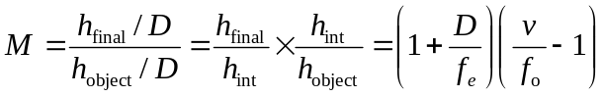
- Overall magnification = Magnification of objective × Magnification of eyepiece
- 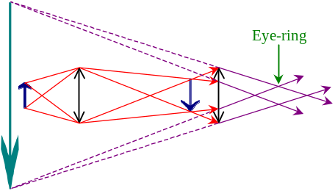If prolonged vision is preferred, the final image would be produced at infinity
- Overall magnification: 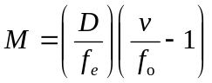
- There will be a best position to observe the image as the image is brightest and the field of view is greatest
- Eye-ring: The pos. where more refracted rays pass thou’
- Position of eye-ring
= Image position of the objective lens formed by the eyepiece
- In ideal case, the size of eye-ring = size of pupil

Refracting telescope:
- A system consists of two convex lens to produce magnified image of distant objects
- The objective forms a real, inverted image of distant object at its focus f_{o}
- The intermediate image is located very near to the focus of eyepiece f_{e}
- The final image is formed at somewhere btw the near pt and far pt of the eye
- 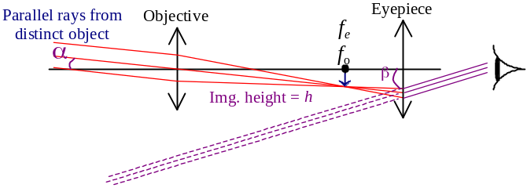In normal adjustment, the final image is produced at infinity
- Most comfortable for viewing
- The foci f_{o} & f_{e} coincides
- Distance btw two lens: f_{o} + f_{e}
- Angular magnification: 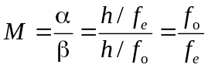
- Magnification increases for longer f_{o} and shorter f_{e}
- At eye-ring, 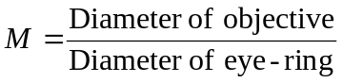

Travelling wave = Progressive wave
Stationary wave = Standing wave
Magnifying power = Angular magnification

