Pure Math - Logic & Sets

Mathematical Logic

Propositions
Simple proposition: Simple statement that has a definite meaning and either be true or false
Composite proposition: A proposition formed by connecting several simple propositions (components) with connectives

Statement calculus
Negation: ▪ ~P (not P)
▪ Truth-value is opposite to that of P

Conjunction: ▪ P ∧ Q (P and Q)
▪ True only if P and Q are both true

Disjunction: ▪ P ∨ Q (P or Q)
▪ False only if P and Q are both false

Conditional: ▪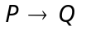(if P then Q)
▪ False only if P is true whereas Q is false
▪ P is called the antecedent (hypothesis) or sufficient condition
▪ Q is called the consequence or necessary condition
▪ Derivatives of :
1. Converse: 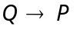
2. Inverse: 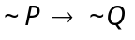
3. Contrapositivity: 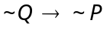
▪ If is always true, then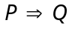(P implies Q)

Biconditional: ▪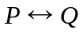(P if and only if Q)
▪ True only if P and Q have thee same truth-value
▪ If is always true, then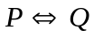(P equivalent to Q)

Equivalence: ▪ The proposition has the same truth-value for any truth-values of their components
▪ e.g. 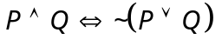
▪ Tautology: The proposition, which is always true
▪ Contradiction: The proposition, which is always false

Universal Quantifier: ∀ (for all, for each)
Existential Quantifier: ∃ (there exists, for some)

Theorems on logical operations:
Idempotent Law: 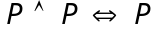
Associative Law: 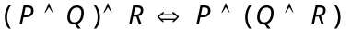 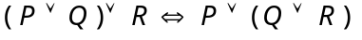
Commutative Law: 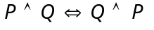 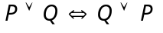
Identity Law: 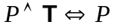 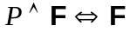 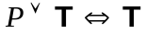 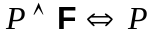
Complement Law: 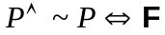 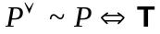 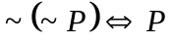  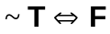
De Morgan’s Law: 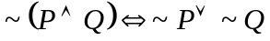 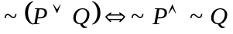
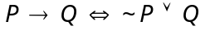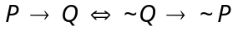
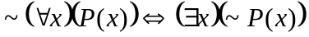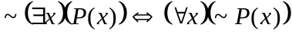
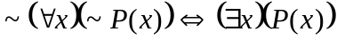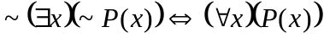
Set Theory
Set: ▪ A collection of definite, distinguishable objects known as elements
▪ Tabular form: Defining a set by listing all its elements. e.g. {1,3,5,7,9}
▪ Set-builder form: Defining a set by denoting the common property of its elements. e.g. {n: 0<n<10}

Sets of number system:
▪ ℕ = Set of natural numbers
▪ ℤ = Set of integers
▪ ℚ = Set of rational numbers
▪ ℝ = Set of real numbers
▪ ℂ = Set of complex numbers

Finite set: A set containing finite number of elements
Infinite set: A set containing infinite number of elements
Empty set: A set containing no any elements (∅)
Singleton: A set containing exactly one element
Universal set: The largest set under consideration (U)

Subset: ▪ A ⊂ B iff (∀x) (x∈A ⇒ x∈B)
♦ A ⊄ B iff (∃x) (x∈B ∧ x∉A)
▪ ∅ is a subset of all sets
▪ Power set: The collection of subsets of a particular set, {X: X ⊂ B}
♦ Every power set must contain an element: ∅
♦ For a set with n elements, the number of elements in its power set =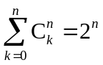
▪ Intervals: ♦ Open interval: (a, b) = {x: x∈R ∧ 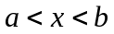}
♦ Closed interval: [a, b] = {x: x∈R ∧ 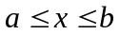}
♦ Half open-half closed interval: (a, b] = {x: x∈R ∧ 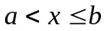}
♦ Half closed-half open interval: [a, b) = {x: x∈R ∧ 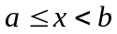}
♦ Closed ray: [a, ∞) = {x: x∈R ∧ 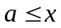} (–∞, a] = {x: x∈R ∧ 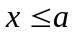}
♦ Open ray: (a, ∞) = {x: x∈R ∧ } (–∞, a) = {x: x∈R ∧ }

Axiom of extension: A = B iff (∀x) (x∈A ⇔ x∈B)

Intersection of A and B is the set A ∩ B = {x: x∈A and x∈B}
Union of A and B is the set A ∪ B = {x: x∈A or x∈B}
Absolute complement of the set A is the set A’ ={x: x∈U and x∉A}
Relative complement of the set A in the set B is the set B\A ={x: x∈B and x∉A}
Symmetric difference of A and B is the set A Δ B = (A \ B) ∪ (B \ A)

Family of sets:  A set whose elements are sets
■ For a family of sets F = {A₁, A₂, A₃, ..., A_{n}}
♦ Union: 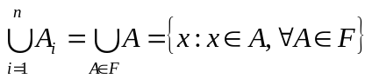= A₁ ∪ A₂ ∪ ... ∪ A_{n}
♦ Intersection: 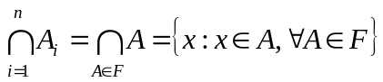= A₁ ∩ A₂ ∩ ... ∩ A_{n}

Theorems on set operations:
Idempotent law: 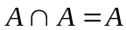 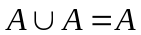
Commutative law: 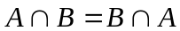  A Δ B=B Δ A
Distributive law: 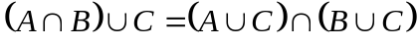 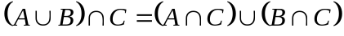
Associative law: 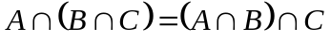 
Identity law: 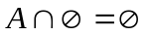 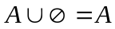 A ∪ U = U A ∩ U = A
Complement law: (A’)’ = A A ∪ A’ = U A ∩ A’ = ∅ U’ = ∅ ∅’ = U
De Morgan’s law: (A ∩ B)’ = A’ ∪ B’ (A ∪ B)’ = A’ ∩ B’
Absorbent law: if A ⊂ B, then A∪B = B if A ⊂ B, then A∩B = A

if A ⊂ C and B ⊂ D, then (A∩B) ⊂ (C∩D) and (A∪B) ⊂ (C∪D)

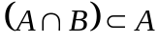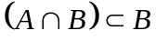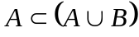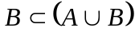
A \ A = ∅ A \ ∅ = A ∅ \ A = ∅ A \ B ⊂ A
(A \ B) ∩ (B \ A) = ∅ A ∩ (B \ A) = ∅ A \ B = ∅ ⇔ A ⊂ B A ⊂ B ⇔ B’ ⊂ A’
A \ B = A ∩ B’

Relations & Functions
Unordered pair: A set whose elements are in no order, i.e. {x, y}={y, x}
Ordered pair: A set (coordinate) whose elements are in order, i.e. (x₁, y₁)=(x₂, y₂) iff x₁=x₂ and y₁=y₂

Cartesian product: Given two sets A⊂ℝ, B⊂ℝ, A×B={(a, b): a∈A and b∈B}
Cartesian plane: The cartesian product ℝ×ℝ or written as ℝ²

Relation: A subset of a cartesian product, i.e. the relation R⊂A×B
■ First projection: Pr₁R={a: a∈A and (a, b)∈R ∃b∈B}
■ Second projection: Pr₂R={b: b∈B and (a, b)∈R ∃a∈A}

Function (mapping) f : X→Y is a relation from X into Y such that it satisfies the condition:
∀x∈X, ∃!y∈Y, s.t. (x, y)∈f
■ The function f maps x into y
■ y is called the value (image) of f at x
■ The variable x is called the pre-image of y under f
■ Domain: The first projection of function, i.e. Dom(f) = Pr₁f = A
■ Image: The second projection of function, i.e. Im(f) = Pr₂f
■ Range: The set that the image will fall on, i.e. Rang(f) = B
■ Given a subset A⊂X, B⊂Y,
♦ Direct image: f [A]={f (a) : a∈A} ⊂ Y
♦ Inverse image: f ^{–1}[B]={x : x∈X and f (x)∈B}
 x∈f ^{–1}[B] ⇔ f (x)∈B

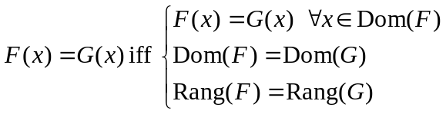

Injective function is a function f : X→Y that f (x₁)=f (x₂) ⇔ x₁=x₂ ∀x₁,x₂∈X
Surjective function is a function f : X→Y that ∀y∈Y ∃x∈X s.t. y=f (x)
Bijective function is a function that is both injective and surjective
■ Given a bijective function f : X→Y, the inverse function of f is the relation f ^{–1}={(y, x) : (x, y)∈f }
 if f is not bijective, then f ^{–1} is called an inverse relation of f

Special functions:
Constant function: f (x)=n ∀x∈ℝ
Step function: f (x)=[x]=n where n∈ℤ r∈ℝ x=n+r, n ≤ x, 0 ≤ r< 1
Identity function: f (x)=x ∀x∈ℝ
Sign function: f (x)=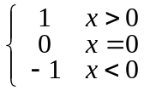
Even function: A function f : X→Y that x∈X ⇔ –x∈X and f (x) = f (–x)
■ The graph of an even function is geometrically symmetric w.r.t. the y-axis
Odd function: A function f : X→Y that x∈X ⇔ –x∈X and f (–x) = –f (x)
■ The graph of an odd function is geometrically symmetric w.r.t. the origin
Zero function: f (x)=0 ∀x∈ℝ
 The only function which behaves both even function and odd function properties
Periodic function: The function f : X→Y is a periodic function iff ∃p∈X, ∀x∈X ⇒ x+p∈X, f (x+p)=f (x)
■ Generally, f (x+np)=f (x) ∀n∈ℕ

Increasing function: A function f : ℝ→ℝ that x > y ⇒ f (x) ≥ f (y) ∀x, y∈ℝ
■ x > y ⇒ f (x)> f (y) ∀x, y∈ℝ is called a strictly increasing function
Decreasing function: A function f : ℝ→ℝ that x > y ⇒ f (x) ≤ f (y) ∀x, y∈ℝ
■ x > y ⇒ f (x)< f (y) ∀x, y∈ℝ is called a strictly increasing function
Monotone function: A function that is either increasing or decreasing
Bounded function: A function f : X→Y is bdd if ∃M∈X s.t. | f (x) | ≤ M ∀x∈X
■ A function f : X→Y is bdd above if ∃U∈X s.t. f (x) ≤ U ∀x∈X
■ A function f : X→Y is bdd below if ∃L∈X s.t. f (x) ≥ L ∀x∈X
■ g.l.b. = Greatest Lower Bound l.u.b. = Least Upper Bound

Polynomial function: A function f : ℝ→ℝ is defined by f (x) =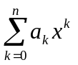
Rational function: A function defined by f (x) =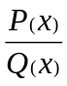 where P(x) and Q(x) are polynomial functions
Algebraic function: A function f is an algebraic function if y=f (x) and x and y satisfy an algebraic equation: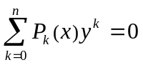 where P_{k}(x) are polynomials in x
 A function of x that is a root of y in a polynomial equation of x and y

Transcendental function: Non-algebraic, includes trigonometric, logarithmic, exponential, etc.

Functional operations:
Given two functions f : A→X, g: B→Y and a constant k
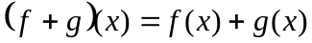 ∀x∈A∩B
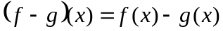 ∀x∈A∩B
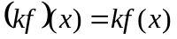 ∀x∈A
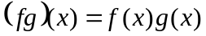 ∀x∈A∩B
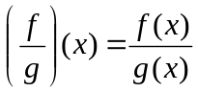 ∀x∈A∩B, g(x)≠0
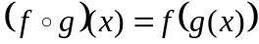 ∀x∈A∩B

Tautology = Valid Formula
Contradiction = Falsity
Injective function = Injection = One-to-one function
Surjective function = Surjection = Onto function
Bijective function = Bijection = One-one onto function

