Pure Math – Binomial Theorem

Permutations & Combinations
Factorial Notation: 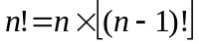, where 0!=1 is defined.

Permutations: The no. of permutations of n different items taken r =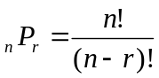

Combinations: The no. of combinations of n different items taken r =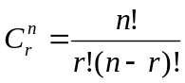=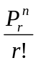
■ n, r are positive integers
■ It is defined that _{n}C₀ = _{n}C_{n} = 1
■ _{n}C_{r} = _{n}C_{n–r}
■ _{n}C_{r} + _{n}C_{r+1} = _{n+1}C_{r+1}

Binomial Theorem for Positive Integral Index
Binomial theorem: For each positive integer n,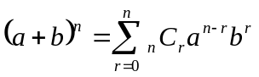
■ The expansion contains (n+1) terms
■ (r+1)^{th} term is 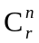a^{n–r} b^{r} which is called the general term
■ The binomial coefficients, are all integers

Properties of binomial coefficients:
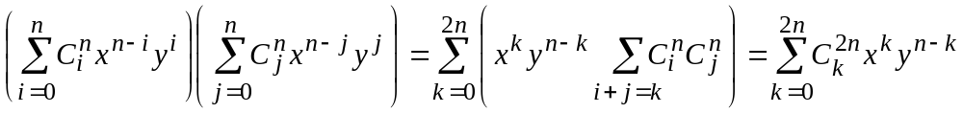*
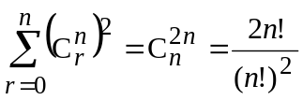; 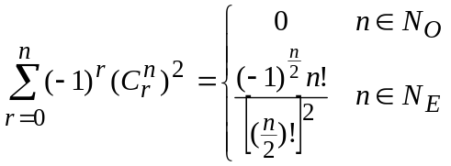
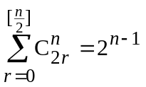; 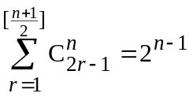; 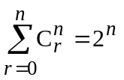
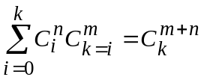; 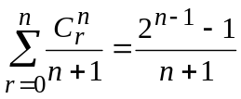
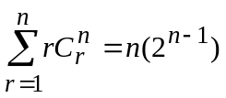; 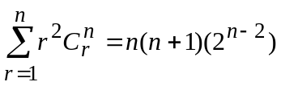; 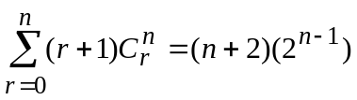

Greatest coefficient: The greatest value of 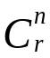 is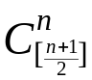 when 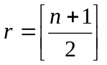
Greatest Term: Consider the expansion of (1+x)^{n}, the greatest term is:
(1) The (n+1)^{th} term: 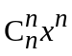 when x ≥ n
(2) The r^{th} & (r+1)^{th} term where 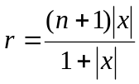 when x < n and 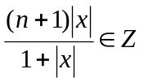
(2) The (r+1)^{th} term where 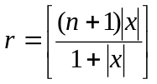 when x < n and 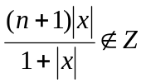
When considering the expansion of (x + y)^{n}, it will be transformed into 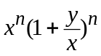

General Binomial Theorem for Real Index
General binomial theorem: For each real number n,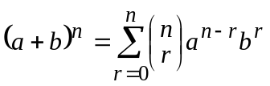
■ 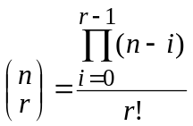 and 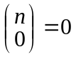
■ n is any real numbers whereas r is a non-negative integer
■ 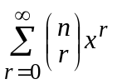converges to (1 + x)^{n} if x<1
■ The expansion of 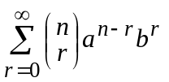is an infinite series called binomial series

Multinomial Theorem for Positive Integral Index
Multinomial theorem: For each positive integer n, 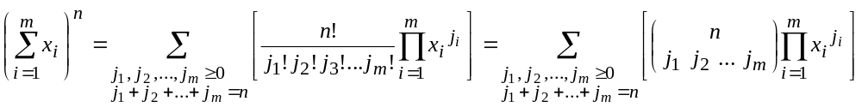
■ 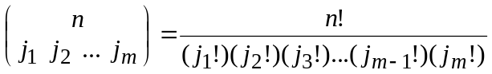

* Known as Vandermonde Theorem

