Pure Math – Limits

Absolute Values
Absolute value: 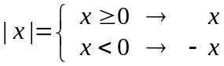 ∀x∈ℝ

Properties of absolute values:
- | x |= 0  x = 0
- x  0  | x | > 0
- | x | = | –x |
- | x | = | a | → x = ±a
- | b | ≤ a  –a ≤ b ≤ a
- | b | ≥ a  b ≥ a ∨ b ≤ –a
- | ab | = | a | | b |
- | a^{n} | = | a |^{n}
- 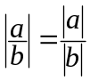 ( b  0 )
- | a + b | ≤ | a | + | b |
- | a – b | ≤ | a | + | b |
- 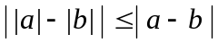

Limit of a Function
Left Hand Limit: A function f has L as left hand limit at a iff (∀ε>0)(∃δ>0) s.t.
(a<x<a+δ ⇒ | f(x)–L|<ε)
➢ Denoted by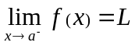 or f(x)  L as x  a–

Right Hand Limit: A function f has L as right hand limit at a iff (∀ε>0)(∃δ>0) s.t.
(a–δ<x<a ⇒ | f(x)–L|<ε)
➢ Denoted by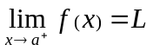 or f(x)  L as x  a⁺

Limit: A function f has L as limit at a iff (∀ε > 0)(∃δ > 0) s.t. (| x–a | < δ ⇒ | f(x) – L| < ε)
➢ Denoted by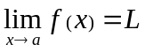 or f(x)  L as x  a
➢ iff ∧

■ If f(x) = g(x) in some deleted neighborhood of a and then 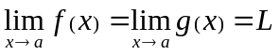
■ If then f(x) is bdd on some del’d nhd of a
■ If 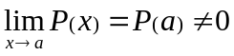 ∧ 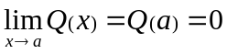 then 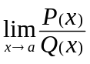 does not exist (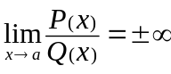)
 If 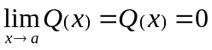 ∧ then 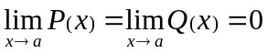

■ If f(x) < g(x) < h(x) in some del’d nhd of a and 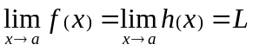 then 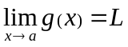
■ If g(x) is bdd in some del’d nhd of a and 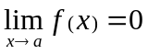 then 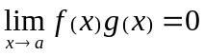

Limit at Infinity: A function f has L as limit at infinity iff ∀ε > 0, ∃δ > 0 s.t. ∀x>r ⇒ | f(x) – L| < ε
➢ Denoted by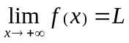 or f(x)  L as x  +∞

Limit Algebra:
■ 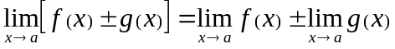
■ 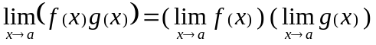
■ 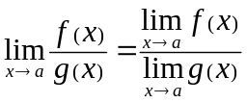 (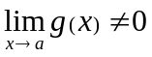)
■ 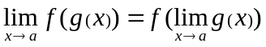
■ 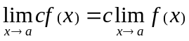
■ 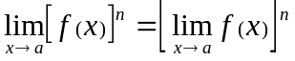

Continuity of a Function
Continuous:  A function f is continuous at a point a iff ∀ε>0, ∃δ>0 s.t. | x–a | < δ ⇒ | f(x) – f(a)| < ε
➢ f is cts iff 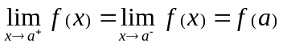
■ A function f is cts on (a, b) iff f is cts at point x ∀x ∈ (a, b)
■ A function f is cts on [a, b] iff f is cts at point x ∀x ∈ (a, b)
∧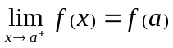 ∧ 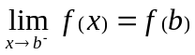

Discontinuous:  A function f is discontinuous at a point a iff it is not continuous at a
■ A function f is discontinuous on a range iff f is not continuous on that range

Discontinuity:
- Jump: A function f,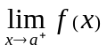 and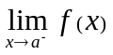exists but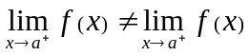
- Replaceable discontinuity: A function f,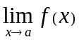 and f(a) exists but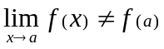
- Essential discontinuity: A function f, does not exist.

The three are known as triangle inequalities
The sandwich principle of squeeze theorem
Corollary of the sandwich principle

