Pure Math – Differentiation

Differentiability
Differentiable: A function f:(a, b)  ℝ is differentiable at x_{o}∈(a, b) iff (∃B∈ℝ)
(∀ε>0) (∃δ>0) (0<| x–x_{o} |<δ ⇒ 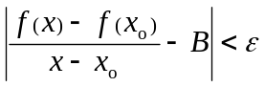)
 B is called the derivative of f at x_{o} and denoted by f’(x_{o}) or 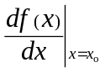
➢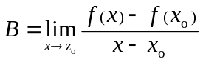
■ f:(a, b)  ℝ is a diffble function or is diffble on (a, b) iff f is diffble on x_{o} ∀x_{o}∈(a, b)
⧫ If f is diffble at x=x_{o}, f is cts at x=x_{o}
 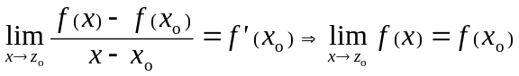

Derived function: A function f:(a, b)  R, 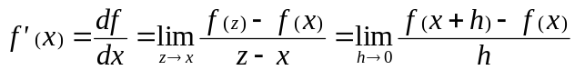 is called the derived function of f.

Differentiation
Differentiation of inverse functions:
- If f(x) and f^{–1}(x) exist, then f^{–1}□f(x) = f□f^{–1}(x) = x
- The graph of y = f(x) and y = f^{–1}(x) are symmetric about the line y = x
- 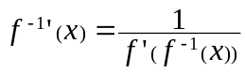 and 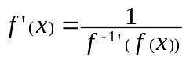
- For y = f(x), it is equivalent to 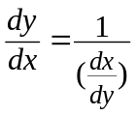 and 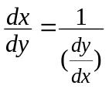

The natural number e:
- The natural number e =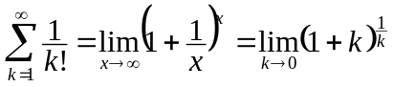 ≈ 2.718281828459045…
- e ^{x} =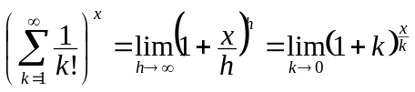
- The natural logarithm 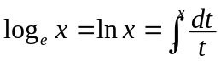
- and
The inverse trigonometric functions:
Function | Inverse function | Domain | Range
y = sin x | y = sin^{–1}x | –1  x  1 | –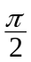 y 
y = cos x | y = cos^{–1}x | –1  x  1 | 0  y  π
y = tan x | y = tan^{–1}x | x  R | – y 
y = cot x | y = cot^{–1}x | x  R | 0 < y < π
y = sec x | y = sec^{–1}x | | x |  1 | –π  y  – or 0  y 
y = csc x | y = csc^{–1}x | | x |  1 | –π  y  – or 0  y 

- 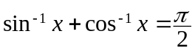
- 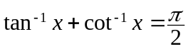
- 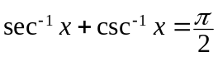
- 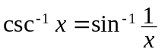
- 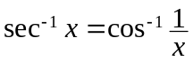
- 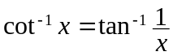
- sin^{–1}(–x) = – sin^{–1}x
- cos^{–1}(–x) = π – sin^{–1}x
- tan^{–1}(–x) = – tan^{–1}x
- cot^{–1}(–x) = π – cot^{–1}x
- sec^{–1}(–x) = π – sec^{–1}x
- csc^{–1}(–x) = – csc^{–1}x

Differentiation formulae:
- 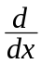c = 0
- x = 1
- x ^{n} = n x ^{n–1}
- (u ± v) =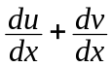
- 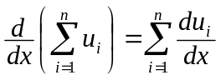
- (uv) =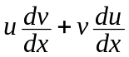
- 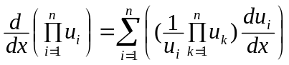
- k u = k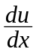
- u ^{n} = n u ^{n–1}
- 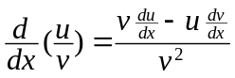
- For y = F(x) = f (u) = f (g(x)), 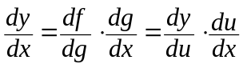
- 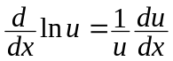
- 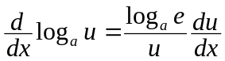

- 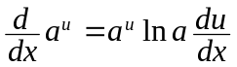
- 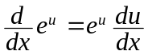
- 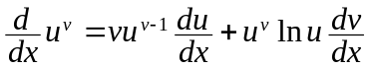
- sin u = cos u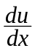
- cos u = – sin u
- tan u = sec²u
- cot u = – csc²u
- sec u = sec u tan u
- csc u = – csc u cot u
- 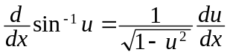
- 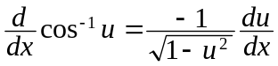
- 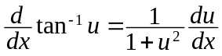
- 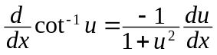
- 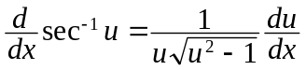
- 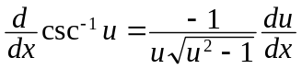

Differentiation of parametric equations:
■ For a parametric equation, 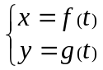, 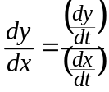

Mean Value Theorem
Extreme values:
Absolute extremum:
- A function f : A  B, x_{o}A s.t. if f (x_{o})  f (x) xA, then
f (x_{o}) is called the absolute minimum value of f at x = x_{o}
- A function f : A  B, x_{o}A s.t. if f (x_{o})  f (x) xA, then
f (x_{o}) is called the absolute maximum value of f at x = x_{o}

Relative extremum:
- A function f : A  B, x_{o}A s.t. if f (x_{o})  f (x) x in some nhd of x_{o}, then
f (x_{o}) is called the relative minimum value of f at x = x_{o}
- A function f : A  B, x_{o}A s.t. if f (x_{o})  f (x) x in some nhd of x_{o}, then
f (x_{o}) is called the relative maximum value of f at x = x_{o}
- If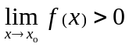 then f (x) > 0 in some del’d nhd of x_{o}
- If f (x) > g (x) in some del’d nhd of x_{o} then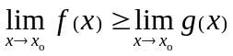
- If f is cts on [a, b] and f (a) = f (b) then there exist an extremum in the interior of [a, b]
Mean value theorem:
Fermat’s Theorem:
A function f is defined on (a, b) and diffble on x₀(a, b). If x₀ is a maximum/minimum pt of f then f ´(x₋) = 0

Rolle’s Theorem:
A function f is cts on [a, b] and diffble on (a, b). If f (a) = f (b) then x_{o}(a, b) s.t. f ´(x_{o}) = 0

Lagrange’s Mean Value Theorem:
A function f is cts on [a, b] and diffble on (a, b), then x_{o}(a, b) s.t.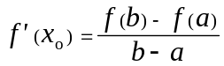

Cauchy’s Mean Value Theorem:
Functions f and g are cts on [a, b] and diffble on (a, b) and g´(x)  0 x(a, b), then
x_{o}(a, b) s.t.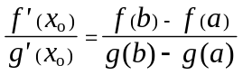

L’Hôspital’s Rule
Indeterminate form: A non-constant function f, 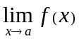is said to be an indeterminate form if:
- 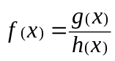 where 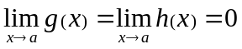, i.e. in the form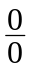
- where 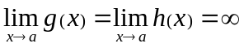, i.e. in the form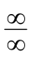
- 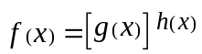 where , i.e. in the form 0 ⁰
- where 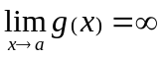and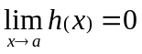, i.e. in the form  ⁰
- where 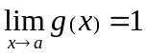 and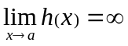, i.e. in the form 1 
- 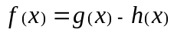 where , i.e. in the form  – 
- 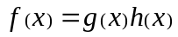 where and, i.e. in the form   0
L’Hôspital’s rule:
Functions f and g are diffble on some nhd of a, if 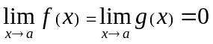 or 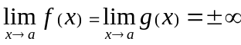, then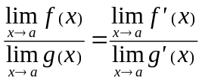

Maxima & Minima
Extreme Theorem:
A function f:[a, b]R, if x_{o}(a, b), f´(x_{o}) = 0 then f (x_{o}) is called the stationary value
➢ Extremums / Reflex points

 If f is diffble on (a, b) and cts on [a, b], then the extremums must exist at the end pts or the interior pts of [a, b] where the derivative is zero only.

Point of inflexion:
A function f:[a, b]R and x_{o}(a, b), if f" is strictly monotone in the nhd of xo and f"(x_{o}) = 0
then (x_{o}, f (x_{o})) is defined to be inflexion point of f

Monotonic functions:
- f is diffble on (a, b) and cts on [a, b], x(a, b), f´(x)  0 then f is increasing on [a, b]
- f is diffble on (a, b) and cts on [a, b], x(a, b), f´(x)  0 then f is strictly increasing on [a, b]
- f is diffble on (a, b) and cts on [a, b], x(a, b), f´(x)  0 then f is decreasing on [a, b]
- f is diffble on (a, b) and cts on [a, b], x(a, b), f´(x) < 0 then f is strictly decreasing on [a, b]

Criteria for determination of maxima & minima:
Reverse sign test:
- Function f is diffble on some (del’d) nhd of x_{o} and f'(x_{o}) = 0 or  or not exist,
if f'(x) < 0 x < x_{o} in some nhd of x_{o} and f'(x) > 0 x > x_{o} in some nhd of x_{o}
then f (x_{o}) is a minima
- Function f is diffble on some (del’d) nhd of x_{o} and f'(x_{o}) = 0 or  or not exist,
if f'(x) > 0 x < x_{o} in some nhd of x_{o} and f'(x) < 0 x > x_{o} in some nhd of x_{o}
then f (x_{o}) is a maxima

Second derivative test:
- Function f is diffble on some nhd of x_{o} and f´(x_{o}) = 0,
if f"(x_{o}) exists and f"(x_{o}) < 0 then f (x_{o}) is a maxima
- Function f is diffble on some nhd of x_{o} and f´(x_{o}) = 0,
if f"(x_{o}) exists and f"(x_{o}) > 0 then f (x_{o}) is a minima

Convexity of a function:
Convex function:
- A function is convex on (a, b) if ∀x₁, x₂∈(a, b) 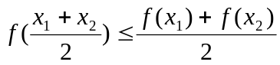
- Convex ⇔ Concave upwards
Concave function:
- A function is convex on (a, b) if ∀x₁, x₂∈(a, b) 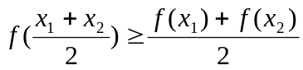
- Convex ⇔ Concave downwards

Leibniz’s formula
2nd Derivative:
The derivative of 2nd order of a function f(x) is denoted by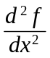, f " or f ⁽²⁾(x) and defined by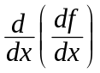

n^{th} Derivatives:
The derivative of order n of a function f(x) is denoted by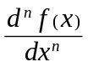 and defined by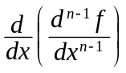
 Also denoted with f ^{(n)}(x) or simply f ^{(n)}
➢ For the sake of compactness in notation, it is defined that:
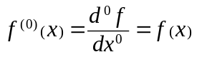 and 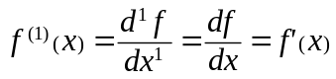
Leibniz’s formula:
If f(x) and g(x) are n-times differentiable, then: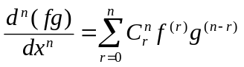
- 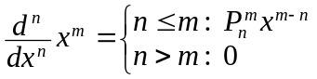 m, n ∈ℕ
- 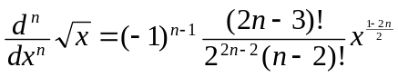 n ≥ 2
- 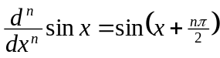
- 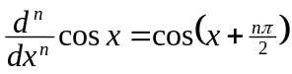
- 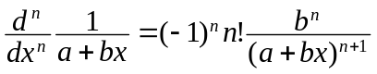

Asymptotes
Vertical asymptotes:
- A vertical line x = a is a vertical asymptote to the right of the curve y = f(x) if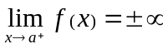 or 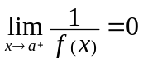
- A vertical line x = a is a vertical asymptote to the left of the curve y = f(x) if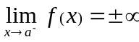 or 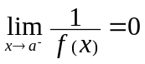

Horizontal asymptotes:
- A horizontal line y = a is a horizontal asymptote to the right of the curve y = f(x) if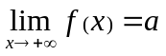
- A horizontal line y = a is a horizontal asymptote to the left of the curve y = f(x) if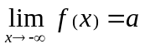

Oblique asymptotes:
- A straight line y = mx+c is a oblique asymptote to the right of the curve y = f(x) if 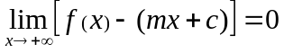
- A straight line y = mx+c is a oblique asymptote to the left of the curve y = f(x) if 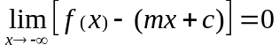

Derivative = Differential coefficient = Differential quotient
Natural logarithm = Napierian logarithm
Inverse trigonometric functions = Inverse circular functions
Extremum: Extreme values, i.e. maximums and minimums
Relative maximum = Local maximum
Interior of [a, b] = (a, b)
Stationary point/value = Critical point/value
Extremums = Turning points (The critical points excluding the reflex points)
Reflex points = Points of inflexion

