Pure Math – 2D Coordinate Geometry

Straight lines
Length btw two pts:
- The length btw P(x₁, y₁) and Q(x₂, y₂): 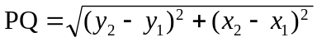

Gradient of two pts:
- The gradient m of a straight line passing thou’ P(x₁, y₁) and Q(x₂, y₂): 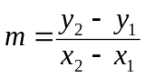

Equation of straight lines:
Two-pt form of a straight line:
- The straight line passing thou’ P(x₁, y₁) and Q(x₂, y₂):

Pt-slope form of a straight line:
- The straight line passing thou’ P(x₁, y₁) w/slope m: 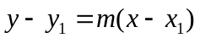

Slope-intercept form of a straight line:
■ The straight line passing thou’ P(0, c) w/slope m: 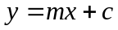

Intercept form of a straight line:
- 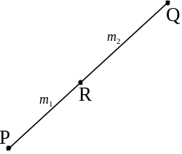 The straight line passing thou’ P(a, 0) and Q(0, b): 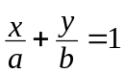

Formulae related to straight lines:
Section formula:
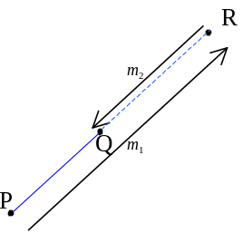 For 3 collinear pts P(x₁, y₁), Q(x₂, y₂) and R(x, y), if R divides line segment PQ in the ratio m₁:m₂ = 1:r then 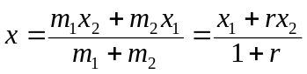; 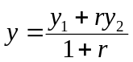
- If R is outside the line segment PQ, then m₁ and m₂ takes different signs.
- If R is the mid-point, then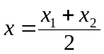, 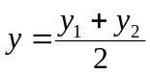.
Angle btw two straight lines:
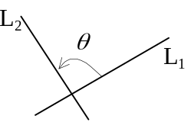 The straight lines L₁, L₂ w/slope m₁ and m₂ respectively, then the positive angle θ from L₁ to L₂ is: 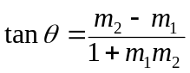
- ∴ The acute angle θ btw L₁ and L₂ is :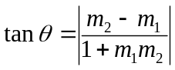

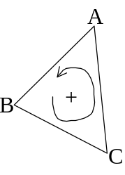Area of a triangle:
■ The area of the triangle formed by A(x_{A}, y_{A}), B(x_{B}, y_{B}) and C(x_{C}, y_{C}) is: [ABC] =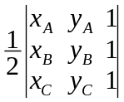=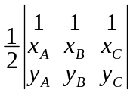
- The area is positive if ABC is in counterclockwise direction order and it is negative if in clockwise direction order.
- It can be induced to any convex polygon that its area =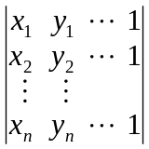

Forms of straight lines
General form:
- General form: Ax + By + C = 0
- Either A0 or B0 or both
- Slope = 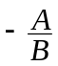
- x-intercept = 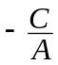
- y-intercept = 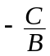
Normal form:
- Normal form: xcosθ + ysinθ – p = 0
- θ is the inclination of the normal to the line and p is the  distance from the origin to the line
- In terms of coefficients of general form, it is: 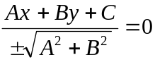
- The sq. root takes the sign to make negative constant term or positive y coefficient.
- For a pt P(x₁, y₁), the  distance from P to the line Ax + By + C = 0 is 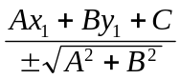
- It can also be x₁cosθ + y₁sinθ – p
- Negative if P is below the line and positive if P is above the line
- The  distance btw 2 parallel lines Ax + By + C₁ = 0 and Ax + By + C₂ = 0 is 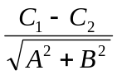
- Positive only if Ax + By + C₁ = 0 is above Ax + By + C₂ = 0
Parametric form of a straight line:
- Algebraic form: 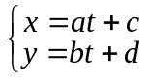 with parameter t
- Polar form: 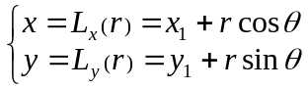
- The straight line pass thou’ P(x₁, y₁) with slope m = tan θ
- For a pt Q(L_{x}(r_{o}), L_{y}(r_{o})) on that straight line, the distance PQ is r_{o}
Intersection:
- The intersection (x, y) of two lines 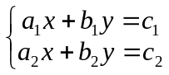 is: 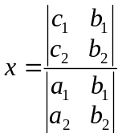 and 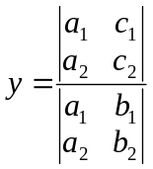
- If the 3 straight lines, L₁:A₁x + B₁y + C₁ = 0; L₂:A₂x + B₂y + C₂ = 0; L₃:A₃x + B₃y + C₃ = 0
are concurrent, then: 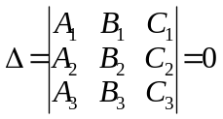
- Conversely, if Δ = 0, L₁, L₂ and L₃ are either concurrent or parallel.

Pair of straight lines
Line pairs passing thou’ origin:
- Quadratic equation in x and y: ax² + 2hxy + by² + 2gx + 2fy + c = 0
- Straight line a₁x + by₁ = 0 and a₂x + b₂y = 0 are passing thou’ the origin
- Eqn of origin-passing line pairs: (a₁x + by₁)(a₂x + b₂y) = 0
- Eqn of line pairs is in the form ax² + 2hxy + by² = 0
- Homogenous equation of 2nd order in x and y
- If h² – ab > 0, it rep. a intersecting line-pair
- If a+b=0, the intersecting lines are ⊥
- If h² – ab = 0, it rep. a coincided line-pair
- If h² – ab < 0, it rep. a point circle (viz., origin)
- The angle bisector of line-pair ax² + 2hxy + by² = 0 is 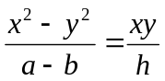

Quadratic eqn rep line-pairs:
- General form: ax² + 2hxy + by² + 2gx + 2fy + c = 0
- Necessary condition: h² – ab ≥ 0
- Equality holds only if it is a pair of coincided lines.
- Sufficient condition: 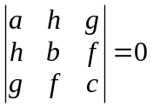
- The slope m of the lines satisfies: bm² + 2hm + a = 0
- The acute angle θ between the lines satisfies: 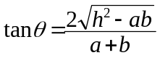

Circles
Eqn of circle:
- Standard eqn of a circle: (x – h)² + (y – k)² = r²
- Center: (h, k) Radius: r
- General eqn of a circle: x² + y² + 2gx + 2fy + c = 0
- Center: (–g, –f ) Radius: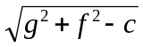
- Parametric form: 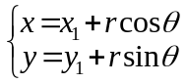 w/parameter θ
- Center: (x₁, y₁) Radius: r

Circle-related formulae:
Concyclic pts:
- For 2 pts A(x₁, y₁) and B(x₂, y₂),
the eqn of joining AB is: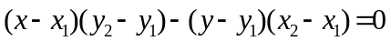
- For 2 pts A(x₁, y₁) and B(x₂, y₂),
the eqn of circle w/diameter AB is: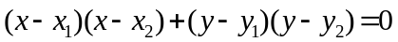
- For 3 pts A(x₁, y₁), B(x₂, y₂) and C(x₃, y₃), the eqn of circle thou’ pts A, B, C is:
- If and
then it is: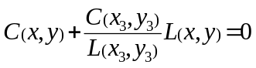

Chords:
- For 2 pts A(x₁, y₁) and B(x₂, y₂) on the circle: x² + y² + 2gx + 2fy + c = 0,
the chord AB is: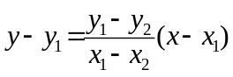 or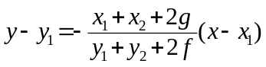
- i.e.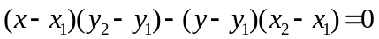 or
- The tangent at pt (x₁, y₁) is: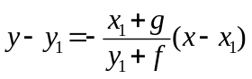 or 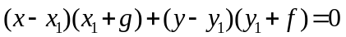
- A line L: x +my + n= 0 cuts the circle C: x² + y² + 2gx + 2fy + c = 0 iff 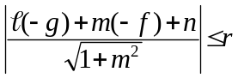
- i.e. (g–mf–n)² ≤ (g² + f ² – c²)(²+m²)
- Equality holds iff L is tangent to C
- If L intersect C at A and B, and the origin is O, then the line pair joining OA and OB is: 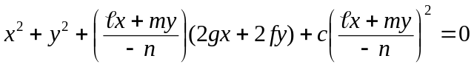
- If L and C do not intersect, it rep a pt circle at (0, 0)
- A circle C: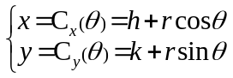 have pts P (C_{x}(θ₁), C_{y}(θ₁)) and Q (C_{x}(θ₂), C_{y}(θ₂)) on it.
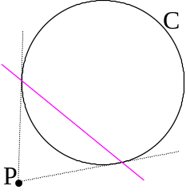The chord PQ is: 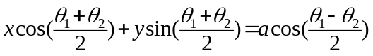
- If θ₁ = θ₂, then the tangent of C at P is: 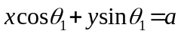
Tangents & normals:
- A pt P(x₁, y₁) on the circle C:x² + y² + 2gx + 2fy + c = 0, the tangent at P is:
x₁x + y₁y + g(x+x₁) + f (y+y₁) + c = 0
- If P is outside C, it is the line joining the 2 contact pts of tangents form P to C
- Eqn of the pair of tangents from an ext pt Q(x_{o}, y_{o}) to the circle x² + y² + 2gx + 2fy + c = 0 is:
(x² + y² + 2gx + 2fy + c)(x_{o}² + y_{o}² + 2gx_{o} + 2fy_{o} + c) = [x_{o}x + y_{o}y + g(x+x_{o}) + f (y+y_{o}) + c]²
- The length of tangent from Q to the circle is: 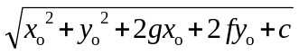
- If circles C: x² + y² + 2gx + 2fy + c = 0 and C’: x² + y² + 2g’x + 2f ’y + c’ = 0 are said to be orthogonal, the tangents at the pts of intersection are ⊥.
- C and C’ are orthogonal iff: 2gg’ + 2f f’ = c + c’
Circle-related terms:
Power:
- For a pt A(x₁, y₁) and a circle C: x² + y² + 2gx + 2fy + c = 0, the power of the point A to the circle C is defined as: P = x₁² + y₁² + 2gx₁ + 2fy₁ + c
- P > 0, then A is outside the circle and P is the square of the length of the tangent
- P = 0, then A is on the circle
- P < 0, then A is inside the circle and P is the square of the shortest length from A to C.
Pole & Polar:
- For a pt P(x₁, y₁) and a circle C: x² + y² + 2gx + 2fy + c = 0, the polar of P w.r.t. C is the locus of the pt of intersection of tangents drawn at the extremities of a variable chord passing thou’ P.
- Polar is a straight line
- If P is on the circle, the polar is the tangent at P
- If P is outside the circle, the polar is the line passing thou’ the 2 pts of contact of tangents from P and C
- P is called the pole of a polar
- Equation of polar is: x₁x + y₁y + g(x+x₁) + f (y+y₁) + c = 0
Radical axis & Coaxial circles:
- For 2 circles C: x² + y² + 2gx + 2fy + c = 0 and C’: x² + y² + 2g’x + 2f ’y + c’ = 0, the radical axis of them is the locus of pts where powers w.r.t. the circles are equal.
- The equation of radical axis is: 2(g–g’)x + 2(f–f’)y + (c–c’) = 0
- If C and C’ do not meet, the radical axis lies outside both of them
- If C and C’ intersect, the radical axis is their common chord
- If C and C’ touch, the radical axis is their common tangent
- Coaxial circles is a system of circles that any two of which have the same radical axis.
- The equation of coaxial circles is:
- (x² + y² + 2gx + 2fy + c)+k(x² + y² + 2g’x + 2f ’y + c’) = 0 k ∈ℝ and k  –1
- k = –1 leads to the eqn of the radical axis of the coaxial circles
- (x² + y² + 2gx + 2fy + c)+k(Ax +By + C) = 0 k ∈ℝ
- Radical axis is: Ax + By + C = 0
- x² + y² + 2kx + c = 0 k ∈ℝ

Conic sections
Conic: The locus of a point P in the plane such that the ratio e of its distance from a fixed point F to its distance from a given line D is constant is called a conic.
- The ratio e is called the eccentricity and essentially positive.
- The point F is called the focus.
- The line D is called the directrix.
- If F(x_{o}, y_{o}) and D:Ax+By+C=0, the eqn of a conic: 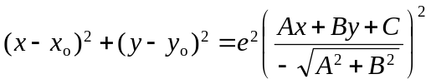
- The standard equation of conic: 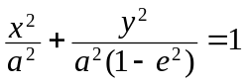
- Directrix: x + a = 0 (a > 0)
- 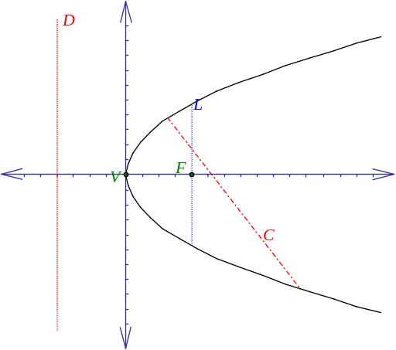Eccentricity = e

Parabola:
- Standard eqn: y² = 4ax
- Eccentricity e = 1
- Parametric form: 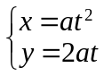 w/parameter t
- Focus: F(a, 0)
- Line y=0 is the degenerate case where a=0
- Vertex: V(0,0)
- Directrix D: x = –a

- Chord: The line joining any 2 pts on the parabola
- Chord C with end-points A(x₁, y₁) and B(x₂, y₂) is: 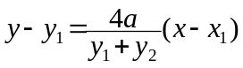 or 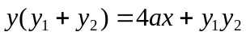
- Chord C with end-points t=t₁ and t=t₂ is: 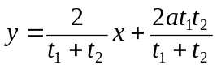
- Focal chord: The chord pass thou’ the focus F
- Focal chord C thou’ the point A(x₁, y₁) is: 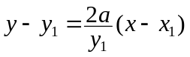
- Condition for A(x₁, y₁) and B(x₂, y₂) being end-pts of focal chord: 4a² + y₁y₂ = 0
- Condition for t=t₁ and t=t₂ being end-pts of focal chord: t₁t₂ = –1
- Tangents from the 2 end-pts of the focal ⊥ and intersects on the directrix
- Latus rectum: The focal chord ⊥ Major axis
- i.e. Focal chord // Directrix
- Length of latus rectum = 4a
- Tangent: limit of chord
- Tangents to the parabola with slope m is: 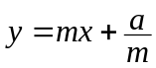
- Pt of contact: 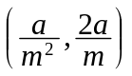
- Tangent from A(x₁, y₁) is: y₁y = 2a(x + x₁)
- At the point t=t₁, the slope of tangent is 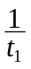
- Eqn of tangent: x – t₁y – at₁² = 0
- Pt of intersection of the tangents from t=t₁ and t=t₂ is 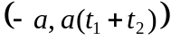
- Normal: A perpendicular to the tangent
- Normal from A(x₁, y₁) is: 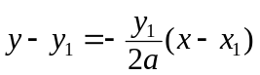
- Normal at the point t=t₁ is: y + t₁x = 2at₁ + at₁³
Ellipse:
- Standard eqn: 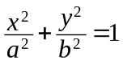
- –a ≤ x ≤ a –b ≤ y ≤ b
- 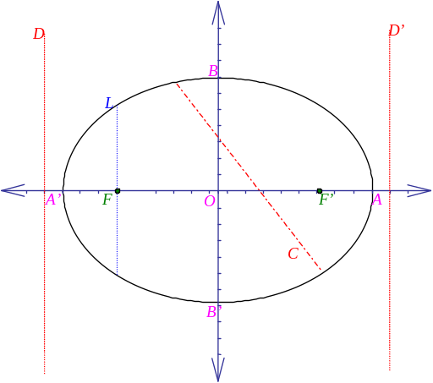Eccentricity e < 1
- Circle is the degenerate case where e = 0
- Parametric form: 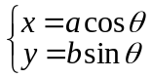 w/parameter θ
- θ = Eccentric angle
- Foci : F(c, 0) F’(–c, 0)
- a² – b² = c² c = a e
- Directrix D: 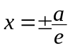 or 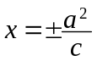
- For any pt P on ellipse, |PF| + |PF’| = 2a
- Major axis: AA’ Minor axis: BB’
- Semi-major axis = a Semi-minor axis = b

- Chords:
- Chord C with end-points A(x₁, y₁) and B(x₂, y₂) is: 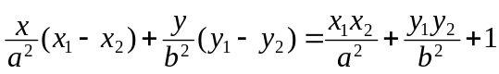
- Chord C with end-points θ=θ₁ and θ=θ₂ is: 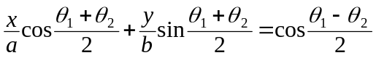
- Length of latus rectum = 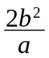
- Tangents:
- Tangents to the parabola with slope m is: 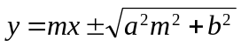
- Pt of contact: 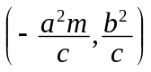 where 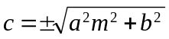
- Tangent from A(x₁, y₁) is: 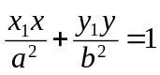
- At the point θ, the slope of tangent is 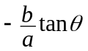
- Eqn of tangent: 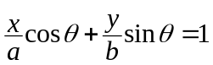
- Normal: A perpendicular to the tangent
- Normal from A(x₁, y₁) is: 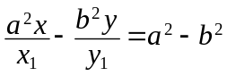
- Normal at the point θ is: 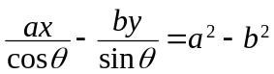
Hyperbola:
- Standard eqn: 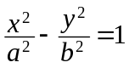
- Eccentricity e > 1
- Parametric form: 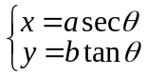 w/parameter θ
- θ = Eccentric angle
- Asymptotes: 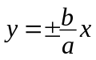 or 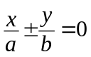
- The pair of asymptote is: 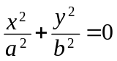
- Foci: F(c, 0) F’(–c, 0)
- 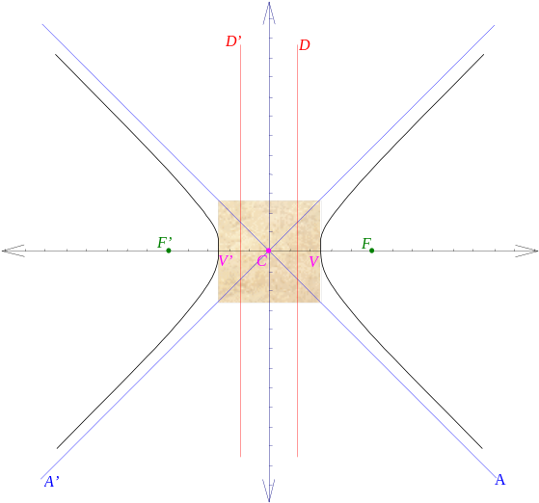a² + b² = c² c = a e
- The pair of straight lines: (e²–1) x² – y² = 1 is the degenerate case when c=0
- Vertices: V(a, 0) V’(–a, 0)
- The line VV’ is called the transverse axis
- Center: C(0,0)
- The line thou’ C and ⊥ transverse axis is called the conjugate axis
- Directrix D: or
- For any pt P on hyperbola, ||PF| – |PF’|| = 2a

- Chords:
- Chord C with end-points A(x₁, y₁) and B(x₂, y₂) is: 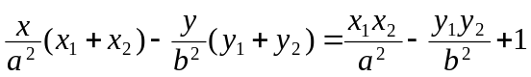
- Chord C with end-points θ=θ₁ and θ=θ₂ is: 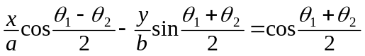
- Length of latus rectum =
- Tangents:
- Tangents to the parabola with slope m is: 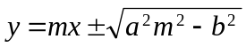
- Pt of contact: where 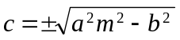
- Tangent from A(x₁, y₁) is: 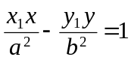
- At the point θ, the slope of tangent is 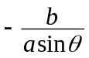
- Eqn of tangent: 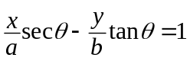
- Normal: A perpendicular to the tangent
- Normal from A(x₁, y₁) is: 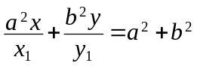
- Normal at the point θ is: 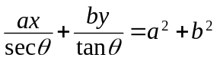

Second degree equations
Quadratic equations:
- ax² + 2hxy + by² = 0
- h² – ab > 0 : A pair of intersecting lines
- h² – ab = 0 : A single line
- h² – ab < 0 : The origin (0, 0)
- ax² + by² + c = 0
- a = b, ac < 0 : A circle
- a = b, ac = 0 : The origin (0, 0)
- ab > 0, ac < 0 : An ellipse
- ab < 0, c ≠ 0 : A hyperbola
- by² + 2gx + c = 0 : Parabola

Second degree equations w/o xy-term:
- ax² + by² + 2gx + 2fy + c = 0
- a = b,
- a(g² + f² – c) > 0 : A circle
- a(g² + f² – c) = 0 : A point-circle
- a(g² + f² – c) < 0 : Imaginary circle
- ab > 0,
- 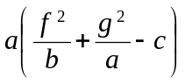 > 0 : An ellipse
- = 0 : A point
- ab < 0,
- g² + f ² – c ≠ 0 : A hyperbola
- g² + f ² – c = 0 : A pair of straight line
- ab = 0,
- fg ≠ 0 : A parabola
- either f=0 or g=0 : A pair of parallel lines
Rotation of the coordinate system to an angle θ:
- Converting the system by rotating the x- and y-axis to x’- and y’-axis over θ:
- x = x’cosθ – y’sinθ or x’ = xcosθ + ysinθ
- y = x’sinθ + y’cosθ or y’ = ycosθ – xsinθ
- After rotation, ax² + 2hxy + by² + 2gx + 2fy + c = 0 becomes
a’x’² + 2h’x’y’ + b’y’² + 2g’x’ + 2f’y’ + c’ = 0
- a’ = a cos²θ + 2h sinθ cosθ + b sin²θ
- h’ = –a sinθ cosθ + h(cos²θ – sin²θ) + b sinθ cosθ
- b’ = a sin²θ – 2h sinθ cosθ + b cos²θ
- g’ = g cosθ + f sinθ
- f’ = f cosθ – g sinθ
- c’ = c
- In rotation,
- c’ = c
- a’ + b’ = a + b
- h’² – a’b’ = h² – ab
- To cancel 2hxy term for simplification, the rotation angle θ should satisfies: 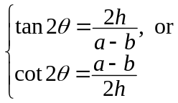

Translation of the coordinate system:
- Converting the system by translating the origin to (x₀, y₀):
- x = x’ – x₀ or x’ = x + x₀
- y = y’ –y₀ or y’ = y + y₀
- In translation, the ax², 2hxy and by² terms are invariant
- After translation, ax² + 2hxy + by² + 2gx + 2fy + c = 0 becomes a’x’² + 2h’x’y’ + b’y’² + c’ = 0
- a’ = a
- h’ = h
- b’ = b
- g’ = f’ = 0
- c’ = gx₀ + fy₀ + c
- In order to cause g’ = f ’ = 0, 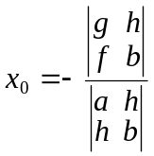 and 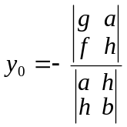
- Thus 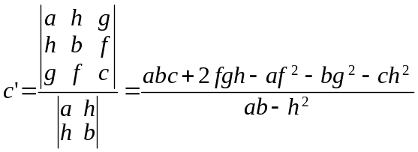

Transformation:
- After transformation,
ax² + 2hxy + by² + 2gx + 2fy + c = 0 ⇒ a’x’ ² + 2h’x’y’ + b’y’ ² + c’ = 0 ⇒ a”x’ ² + b”y’ ² + c’ = 0
- The invariant under transformation are:
- h² – ab
- a + b
- If h² – ab > 0 : (a”b” < 0)
- c’ ≠ 0 : A hyperbola
- c’ = 0 : A pair of intersecting line
- If h² – ab = 0 : (a”b” = 0)
- b” = 0, f ” ≠ 0: A parabola symmetric about the y-axis
- a” = 0, g” ≠ 0: A parabola symmetric about the x-axis
- b” = f ” = 0: Line pair parallel to y-axis
- g” ² – a”c” > 0: A pair of parallel lines
- g” ² – a”c” = 0: A pair of coincided lines
- g” ² – a”c” < 0: A pair of imaginary lines
- a” = g” = 0: Line pair parallel to x-axis
- f ”² – b”c” > 0: A pair of parallel lines
- f ”² – b”c” = 0: A pair of coincided lines
- f ”² – b”c” < 0: A pair of imaginary lines
- If h² – ab < 0 : (a”b” > 0)
- (a+b)Δ > 0: Imaginary ellipse
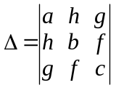
- (a+b)Δ = 0: A point ellipse
- (a+b)Δ < 0:
- a = b: A circle
- a ≠ b: An ellipse
Properties of conic sections:
 | Circle | Ellipse | Parabola | Hyperbola
Standard equation | x² + y² = a² | 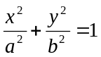 | y² = 4ax | 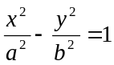
Parametric equation | 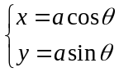 | 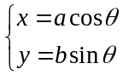 | 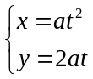 | 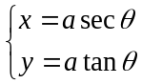
Foci (c, 0) | c = 0 | c² = a² – b² | c = a | c² = a² + b²
Eccentricity e | 0 | < 1 | 1 | > 1
Directrix | x = –∞ | 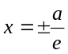 | x = –a
Tangent  at (h, k) | hx + ky = a² | 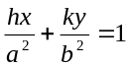 | ky = 2a(x+h) | 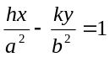
Tangent  at θ / t | xcosθ + ysinθ = 1 | 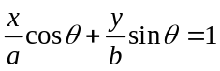 | x – ty + at² = 0 | 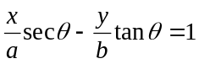
Tangent  w/slope m | 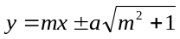 | 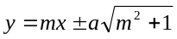 | 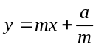 | 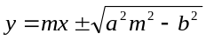
lx+my+n=0  is tangent | 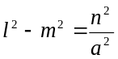 | a²l² – b²m² = n² | am² = ln | a²l² – b²m² = n²
Latus  rectum | 2a | 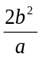 | 4a
Diameter | y = mx | 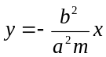 | 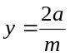 | 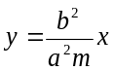
Conjugate diameters | mm' = –1 | 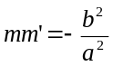 |  | 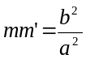
Chord w/Mid-  pt (x₀, y₀) | x₀x+y₀y=x₀²+y₀² | 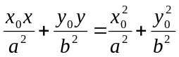 | 2ax–y₀y–2ax₀+y₀²=0 | 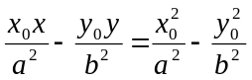

Determination of second degree equation:
δ = h² – ab  δ 0  δ < 0  δ > 0  Central conic |  | (a+b) Δ < 0 | a  b | Ellipse
 |  | (a+b) Δ < 0 | a = b | Circle
 |  | (a+b) Δ = 0 |  | Point ellipse
 |  | (a+b) Δ > 0 |  | Imaginary ellipse
 |  | Δ  0 |  | Hyperbola
 |  | Δ = 0 |  | Intersecting line
δ = 0  Non-central conic |  | Δ  0 |  | Parabola
 |  | Δ = 0 |  | Parallel / Coincided / Imaginary lines
- δ 0 is called central conics; δ =0 is called non-central conics.
- Center of a central conic, C(x, y) is given by:
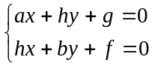 i.e. 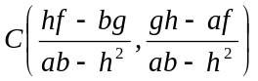

Found by using the above formula of chord with x₂x₁ and y₂y₁

