Pure Math – Polynomials & Equations

Polynomials
Polynomial in x over the set of all real numbers is a finite expression in the form 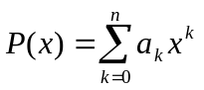 where a_{i}∈ℝ
➢ P(x) ∈ℝ[x]
■ a_{i} is called the coefficient
■ a₀ is called the constant term
■ a_{n} is called the leading coefficient
 If the leading coefficient is 1, the polynomial is a monic polynomial
■ If a_{n}≠0, n is called the degree of the polynomial P(x)
➢ deg P(x) = n
➢ deg x = 0 ∀x∈ℝ\{0}
➢ deg 0 = –∞

Properties of the degree:
- Let 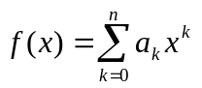 and 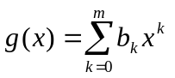
- f(x) = g(x) iff (deg f = deg g) ∧ (a_{k} = b_{k} , ∀k ≤ def f, k∈ℕ)
- 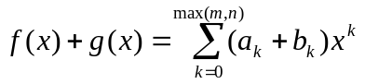
 0  deg( f + g)  max(m, n)
- 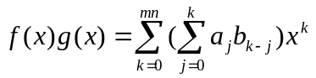
 deg( fg) = m+n

Properties of the polynomial:
- p, q ∈ℝ[x] ⇒ p+q ∈ℝ[x] (Closure property)
- p, q ∈ℝ[x] ⇒ p⋅q ∈ℝ[x] (Closure property)
- p, q, r ∈ℝ[x] ⇒ p+(q+r) = (p+q)+r (Associative law)
- p, q, r ∈ℝ[x] ⇒ p ⋅ (q ⋅ r) = (p ⋅ q) ⋅ r (Associative law)
- p+q = q+p (Commutative law)
- p ⋅ q = q ⋅ p (Commutative law)
- p+0 = 0+p = p (Existence of identity)
- p+(–p) = (–p)+p = 0 (Existence of inverse)
- 1⋅p = p (Existence of identity)
- α, β ∈ℝ, α (β p) = (αβ ) p
- α∈ℝ, α(p+q) = α p + α q (Distributive law)
- α, β ∈ℝ, (α+β )p = α p + β p (Distributive law)
- p, q, r ∈ℝ[x] ⇒ p ⋅ (q+r) = p ⋅ q + p ⋅ r (Distributive law)
- pq=0 ⇔ (p = 0) ∨ (q = 0)
- p∈ℝ[x]\{0}, pq=pr ⇔ q = r

Division
Division Algorithm:
(∀f, g ∈ℝ[x]) ∧ (f ≠ 0) ∧ (g ≠ 0) ⇒ (∃!q∈ℝ[x] ) ∧ (∃!r∈ℝ[x] ) ∧ (deg r < deg g) s.t. f ≡ qg + r

Properties of integral division:
- (a, b ∈ ℤ) (a ≠ 0) ( a | b ⇔ b = ma (∃m∈ℕ) )
- (a | b) ∧ (b | c) ⇒ (a | c)
- (a | b) ∧ (b | a) ⇔ a = ±b
- a | a ∀a∈ℤ\{0}
- a | 0 ∀a∈ℤ\{0}
- a | b ⇒ a | bc ∀c∈ℤ\{0}
- (c | a) ∧ (c | b) ⇔ c | ma+nb ∀m, n∈ℤ

Greatest Common Divisor (GCD):
∃a, b∈ℤ p is the GCD of a, b iff:
(i) (p | a) ∧ (p | b)
(ii) ∀q (q| a) ∧ (q| b) ⇒ q| p
 Denoted by (a, b) = p

Synthetic Division:
- 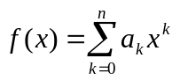 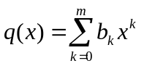 g(x)=x–a R∈ℝ
- if f(x) = g(x) q(x) + R then:
- n = m + 1
- q(x)g(x)+R = b_{m}x^{m+1}+ (b_{m–1}–ab_{m}) x^{m} + …+ (b_{k–1}–ab_{k}) x^{k} + … + (R–ab₀)
- = b_{m}x^{m+1}+ (b_{m–1}–ab_{m}) x^{m} + …+ (b_{k–1}–ab_{k}) x^{k} + … + (R–ab₀)
- a_{n} = b_{m}
- a_{k} = b_{k–1} – ab_{k}
f(x) = a_{n} a_{n–1} a_{n–2} … a₂ a₁ a₀
+ ) ab_{m} ab_{m–1} … ab₂ ab₁ ab₀

q(x) = b_{m} b_{m–1} b_{m–2} … b₁ b₀ R
- a₁ = b₀ – ab₁
- a₀ = R – ab₀

Euclidean Algorithm:
- f(x) = p(x) q(x) ⇒ p(x) | f(x) ∧ q(x) | f(x)
- g(x) = p(x) q'(x) ∧ f(x) = p(x) q(x)
⇒ p(x) | g(x) ∧ p(x) | f(x)
⇒ p(x) is the common divisor of f(x) and g(x)
- ( f, g)=d(x) iff (i) d(x) | f(x) ∧ d(x) | g(x)
(ii) d’(x) | f(x) ∧ d’(x) | g(x) ⇒ d’(x) | d(x)
- Polynomials f, g are relative prime iff deg ( f, g) = 1
➢ af + bg = 1 for some polynomials a, b
- Polynomials f, g are not relative prime iff af = bg for some polynomials a, b
- d(x) | d’(x) ∧ d’(x) | d(x) ⇒ d’(x) = k d(x) ∃k∈ℤ
- f, g, q, r∈ℝ[x] ∧ f=qg+r, ∃d∈ℝ[x] s.t. ( f, g) = (g, r) = d
Euclidean Algorithm states that for any non-zero polynomials f(x) and g(x), where
f (x)=q(x) g(x)+ r (x), over the set of real numbers, there exists a g.c.d. d(x) of f (x) and g(x) s.t.
( f (x), g(x)) = (g(x), r(x)) = d(x)

Polynomial Equations
Zero of polynomial: α is a zero of a polynomial iff P(α)=0

Factor Theorem:
- Remainder Theorem:
∀( f (x) ∈ℝ[x] ∧ deg f = n ≥ 1) ∀c∈ℝ ∃!q(x)∈ℝ[x] ∧ deg q = n–1 s.t. f (x) ≡ (x–c) q(x) + f (c)
- Factor Theorem:
∀f (x) ∈ ℝ[x] ∧ deg f = n ≥ 1, ∃c∈ℝ s.t. f (c)=0 ↔ f (x) ≡ (x–c) q(x) ∃q(x)∈ℝ[x] ∧ deg q = n–1
➢ 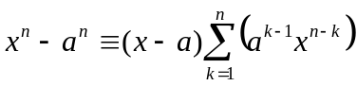 n∈ℕ
➢ 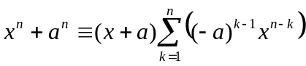 n∈ℕ_{even}
➢ n∈ℕ_{odd}
- f (x) ∈ℝ[x]. If 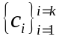∈ℂ are distinct roots of f (x)=0, then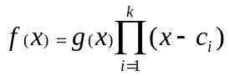 ∃g(x)∈ℂ[x]
➢ f (x) ∈ℝ[x] ∧ deg f = n, f (x)=0 has at most n distinct (complex) roots
➢= 0 for substitution of n+1 distinct values for the indeterminate x,
then a_{k} = 0 for k =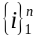
➢ f (x), g(x) ∈ ℝ[x] ∧ deg f = deg g = n, f (c) = g(c) for n+1 distinct c∈ℝ iff f (x) ≡ g(x)
➢ f (x), g(x) ∈ ℝ[x], f (c) = g(c) ∀c∈ℝ iff f (x) ≡ g(x)

Largrange’s Interpolation Formula:
For some distinct numbers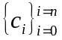∈ℝ and numbers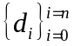∈ℝ, f (c_{i})=d_{i} 0 ≤ i ≤ n iff 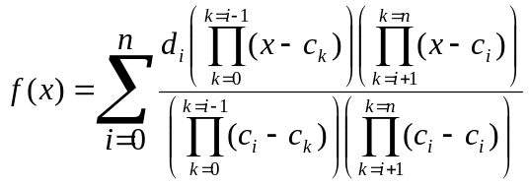

Fundamental Theorem of Algebra: f (x)  ℂ[x], λℂ s.t. f (λ) = 0
➢ 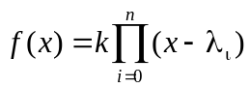 ∃λ_{i}∈ℂ

Coefficients and Roots:
- The roots of 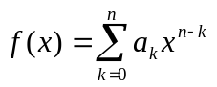= 0 are 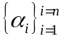
 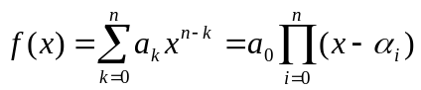
- 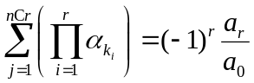
 In a n^{th} degree equation in x with 1 as leading coefficient, the coefficient of x^{n–k} is the sum of the _{n}C_{k} products of k roots in different combination, having the sign of (–1)^{k}.
- In the cubic equation, x³ + px² + qx + r = 0 :
p = –(α + β + γ )
q = αβ + βγ + αγ
r = –αβγ

Newton’s formulae for the sums of powers of roots:
- The roots of = 0 are
- Defined 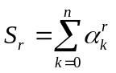
- If r < n: 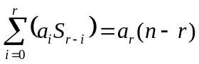 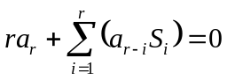
- If r ≥ n: 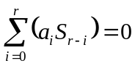

Transformation of roots:
- The roots of = 0 are
- The equation that gives x =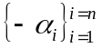 as roots is: 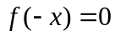
- The equation that gives x =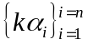 as roots is: 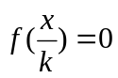
- The equation that gives x =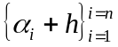 as roots is: 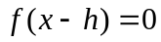
- The equation that gives x =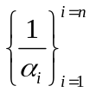 as roots is: 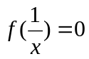

Cubic Equation:
- Std cubic eqn: x³ + px + q = 0
- Roots: 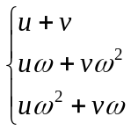 ∃u,v∈ℝ
- 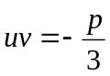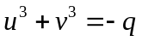
 u³, v³ are solutions of 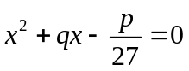
- General eqn: x³ + px² + qx + r = 0
- Roots: 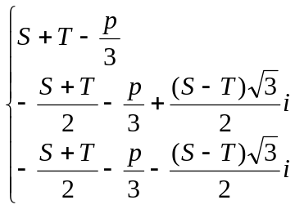
 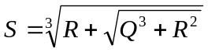 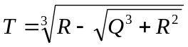
 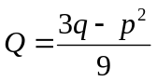 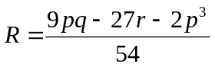

Multiple roots
Repeating Roots:
- A polynomial f(x) has α as a multiple zero iff f(x) = q(x) (x–α)^{k} ∃q(x)∈ ℝ[x], k∈ℕ, k≥2
- f(x)∈ℝ[x], f(x) has α as multiple zero iff f(α) = f’(α) = 0
- If (x–α)^{k}| f (x) ∧ (x–α)^{k+1}f (x), then α is called a zero of f (x) with multiplicity k
 f (x) = q(x) (x–α)^{k} ∃q(x)∈ℝ[x], q(α)≠0
- If (x–α)^{k}| f (x) then (x–α)^{k–1}| f ’(x)
- If (x–α)^{k–1}| f ’(x) ∧ f(α)=0 then (x–α)^{k}| f (x)
- If f (x) and f ’(x) are relative prime, f (x) have no repeated roots

Taylor’s Theorem:
- If 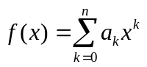, then 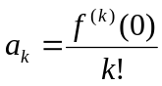
 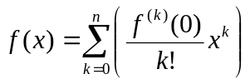
- f(x)∈ℝ[x], deg f(x)=n, h∈ℝ,
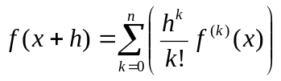 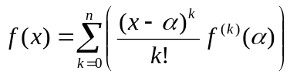
➢ Taylor’s theorem
- f(x)∈ℝ[x], deg f(x)=n, h∈ℝ, 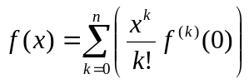
➢ Maclaurin’s theorem / Stirling’s theorem
- By Taylor’s theorem,
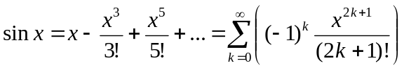
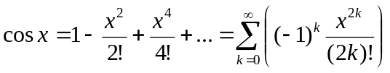
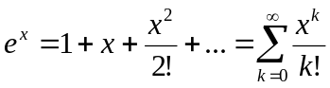

Rational, irrational & imaginary roots:
- ∀a_{k}∈ℤ,
If 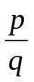, where p and q are relative prime, is a rational root of f (x) = 0 then p | a_{n} ∧ q | a₀
- ∀a_{k}∈ℚ , p, q, r∈ℚ
If 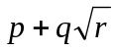 is a root of f (x) = 0 then 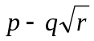 is also a root
- ∀a_{k}∈ℝ , a, b ∈ℝ
If a+bi is a root of f (x) = 0 then a–bi is also a root
 A polynomial equation with real coefficients and odd degree has at least one real root
- If 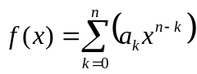 ∀a_{k}∈ℝ⁺ , f (x) = 0 has no positive roots
- If 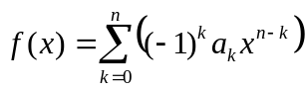 ∀a_{k}∈ℝ⁺ , f (x) = 0 has no negative roots
- f(x)∈ℝ[x], α∈ℝ⁺, if the coefficients of all terms in the quotient and remainder are positive in f(x) ÷ (x–α) , then f(x) = 0 has no roots greater than or equal to α
- f(x)∈ℝ[x], a, b∈ℝ, a<b, if f(a) and f(b) are in different signs, then there are odd number of real roots, including repeated roots, in (a, b) of the equation f(x) = 0
Partial Fractions
Algebraic fraction:
- A rational algebraic expression
- The quotient of two polynomials
 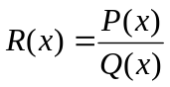 ∃P(x), Q(x)∈ℝ[x], Q(x) ≠ 0
⧫ R(x) is a proper fraction if deg P(x) < deg Q(x)
⧫ R(x) is an improper fraction if deg P(x) ≥ deg Q(x)
⧫ R(x) is called irreducible if P(x) and Q(x) have no common factor

Partial fractions:
- If 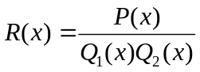 is a proper rational expression where Q₁(x), Q₂(x) are relative prime polynomials, then ∃P₁(x), P₂(x)∈ℝ[x] s.t. 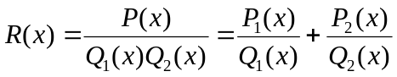
- Breaks a rational expression into an algebraic sum of several proper fractions
- If the denominator contains non-repeated linear factors only, each factor can be the denominator of one of the partial fractions, i.e.:
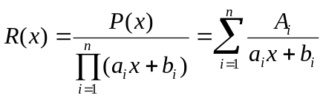 ∃P(x)∈ℝ[x], deg P(x) ≤ n, ∃a_{i}, b_{i}, A_{i}∈ℝ
- If the denominator contains non-repeated linear and quadratic prime factors, each factor can be the denominator of one of the partial fractions, i.e.:
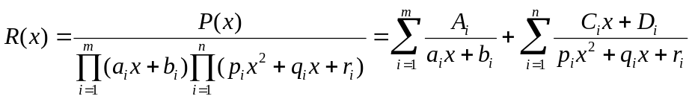
∃P(x)∈ℝ[x], deg P(x) ≤ m+2n, ∃a_{i}, b_{i}, p_{i}, q_{i}, r_{i}, A_{i}, C_{i} , D_{i} ∈ℝ
- If the denominator contains linear factors with multiplicity k_{i}≥1 only, each factor in multiplicity k≤k_{i} can be the denominator of one of the partial fractions, with all the numerator in ℝ, i.e.:
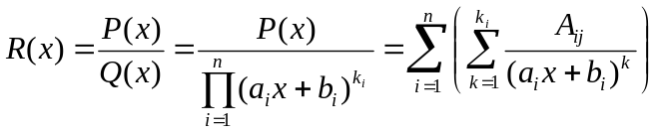
∃P(x), Q(x)∈ℝ[x], deg P(x) ≤ deg Q(x), ∃a_{i}, b_{i}, A_{ij} ∈ℝ
- If the denominator contains linear and quadratic factors with multiplicity k_{i}≥1, each factor in multiplicity k≤k_{i} can be the denominator of one of the partial fractions, which the linear ones have the numerator in ℝ and the quadratic ones with the numerator in 1st degree polynomials, i.e.:
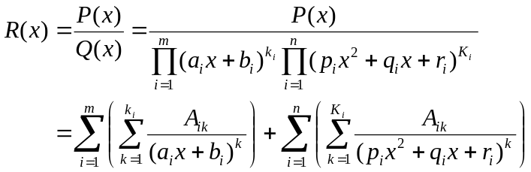
∃P(x), Q(x)∈ℝ[x], deg P(x) ≤ deg Q(x), ∃a_{i}, b_{i}, p_{i}, q_{i}, r_{i}, A_{i}, C_{i} , D_{i} ∈ℝ
- If 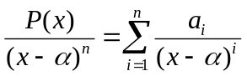, by Taylor’s theorem, 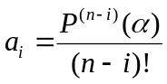
- If 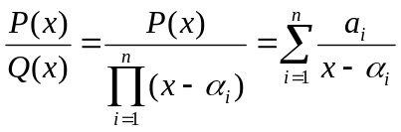, then 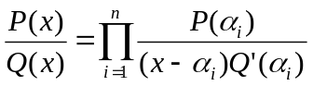

Relative prime = Coprime
Zero of f (x) with multiplicity k = k-multiple root of equation f (x) = 0
Prime polynomial = Irreducible polynomial ➢ A polynomial that cannot be expressed as the product of two polynomials of ℝ[x]

