Pure Math – Indefinite Integrals

Definitions
Primitive of a function f(x) is function F(x) such that F'(x) = f(x)
Indefinite integral of a function f(x), denoted by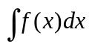, the set of all primitives of f(x)
➢ 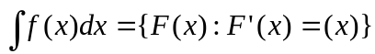
■ f(x) is called the integrand
■ x is called the variable of integration
■ ∫ is the integral sign
■ If F(x) and G(x) are primitives of the same function f(x), F(x) = G(x) + C ∃C∈ℝ
⧫ C is an arbitrary constant
⧫ C is called the constant of integration
⧫ For simplicity, the set of primitives is denoted by: 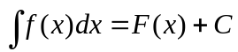

Integration Formulae
Properties:
- 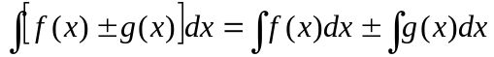
- 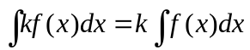 ∀k∈R

Standard integrals: (The constant of integration is omitted)

- 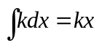
- 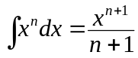
- 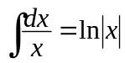
- 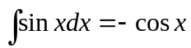
- 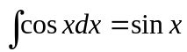
- 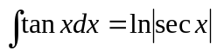
- 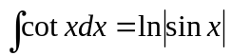
- 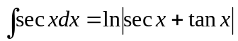
- 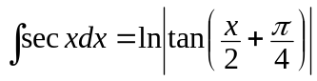
- 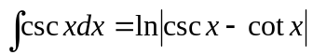
- 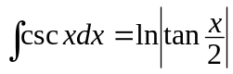
- 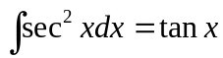
- 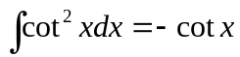
- 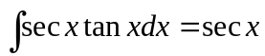
- 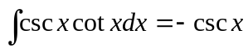
- 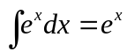
- 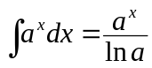
- 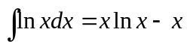
- 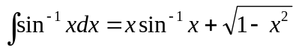
- 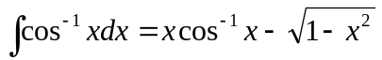
- 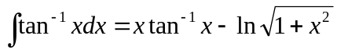
- 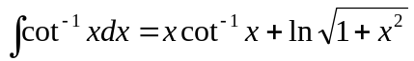
- 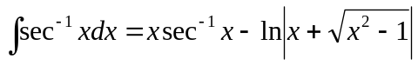
- 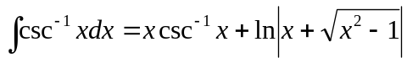
- 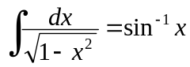
- 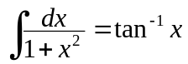
- 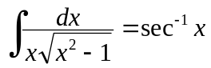
- 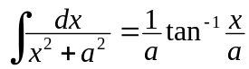
- 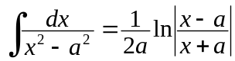
- 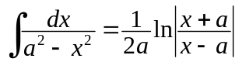

- 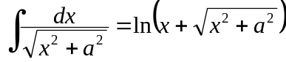
- 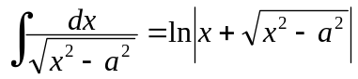
- 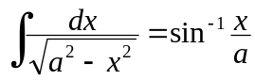
- 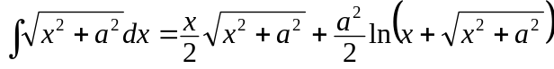
- 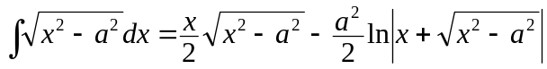
- 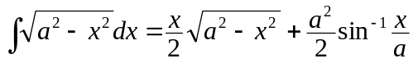

Method of Integration
Integration by Change of Variable:
- 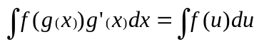 when substituting u = g(x)
➢ du = g'(x) dx

Integration by Parts:
- 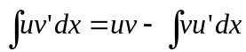
- 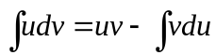
- 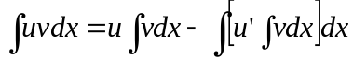

Integration by Trigonometric substitution:
- When integrand contains an expression of the form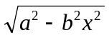, substitute 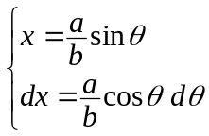
⧫ Domain of θ :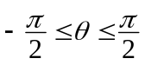
- When integrand contains an expression of the form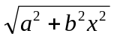, substitute 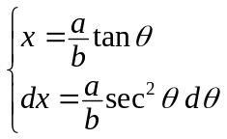
⧫ Domain of θ :
- When integrand contains an expression of the form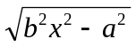, substitute 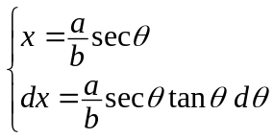
⧫ If x ≥ 1, domain of θ :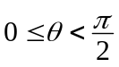
⧫ If x ≤ –1, domain of θ :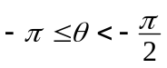

Integration of Trigonometric integrals
Integration of trigonometric products:
- Commonly used trigonometric formulae in solving trigonometric product’s integration:

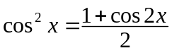
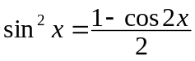
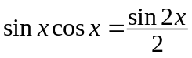
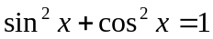
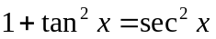
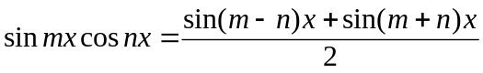
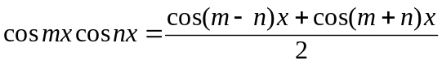
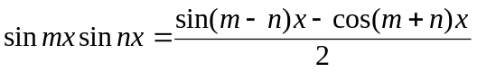

- 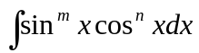:
⧫ m ∈ℕ_{odd},
⧫ n ∈ℕ_{odd},
⧫ m, n ∈ ℕ_{even}, m > n, 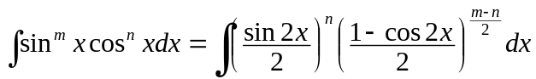
⧫ m, n ∈ ℕ_{even}, m < n, 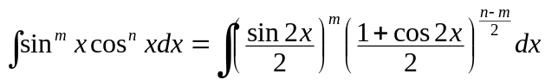
 Solve by binomial expansion of 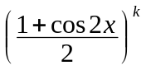

- 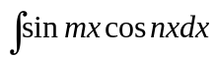, 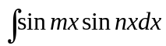, 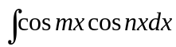:
⧫ Use , and to resolve the integral into two integrations.

- 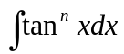, 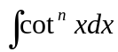:
⧫ Use and 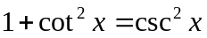 to resolve the integral into two integrations:



- 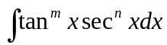:
⧫ n ∈ℕ_{even}, use 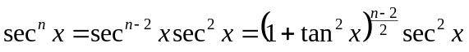 and 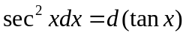 to rewrite the integral
➢ Variable of integration changed from x to tan x
⧫ m ∈ℕ_{even}, use 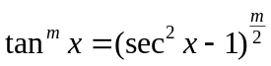 to resolve the integral into summation of several 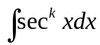
⧫ m,n ∈ℕ_{odd}, use and 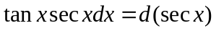 to rewrite the integral

- 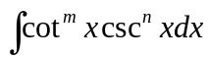:
⧫ n ∈ℕ_{even}, use 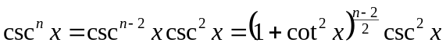 and 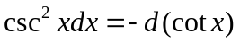 to rewrite the integral
➢ Variable of integration changed from x to cot x
⧫ m ∈ℕ_{even}, use 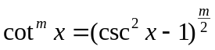 to resolve the integral into summation of several 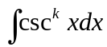
⧫ m, n ∈ ℕ_{odd}, use and 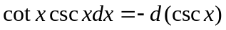 to rewrite the integral

- 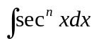, 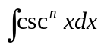:
⧫ Use 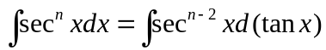 and 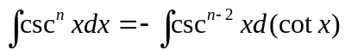 to simplify the integral and then use integration by part to solve the integration.

Integration of algebraic fractions:
- All integrands in the form 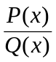 where P(x), Q(x)∈ℝ[x] can be resolved into partial fractions of the form 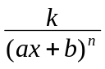, 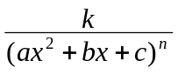 and 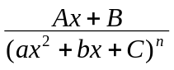
- To solve 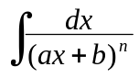, substitute ax+b by u, it will be a rational function or natural logarithm
- To solve 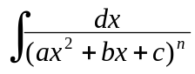, resolve ax²+bx+c into (P(x))²±Q ² then by trigonometric substitution.
- To solve 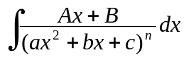, use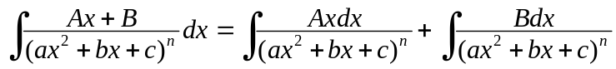 to resolve the integral into two
⧫ 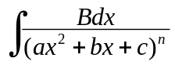 can be solved directly
⧫ 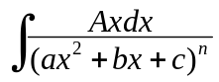 is solvable by using the formula:
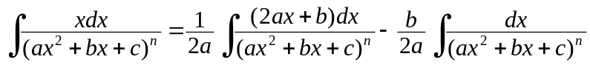
where 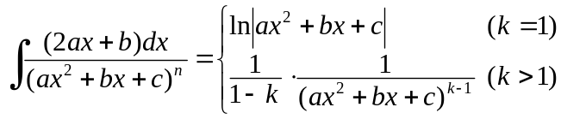
➢ f (x) ∈ ℝ[x] ∧ deg f = n, f (x)=0 has at most n distinct (complex) roots
➢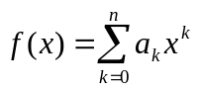= 0 for substitution of n+1 distinct values for the indeterminate x,
then a_{k} = 0 for k =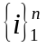
➢ f (x), g(x) ∈ ℝ[x] ∧ deg f = deg g = n, f (c) = g(c) for n+1 distinct c∈ℝ iff f (x) ≡ g(x)
➢ f (x), g(x) ∈ ℝ[x], f (c) = g(c) ∀c∈ℝ iff f (x) ≡ g(x)

Integration of rational functions of sine and cosine:
- To evaluate 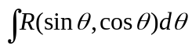, where R(sinθ, cosθ) is a rational function, we substitute:
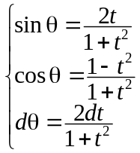 ( t = tanθ )
to give an algebraic fraction of variable t
- To solve 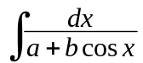, make use of 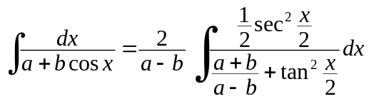, thus:
⧫ If a² > b², 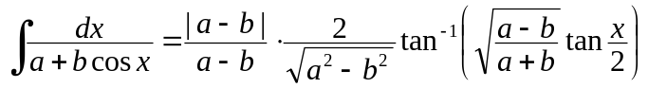
⧫ If a² < b², 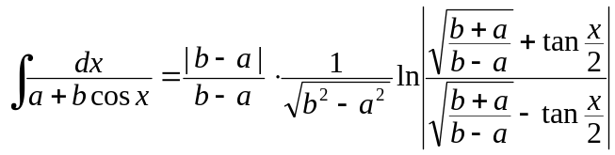
⧫ If a = b, 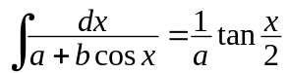
⧫ If a = –b, 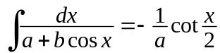

Integration of functions involving radicals:
- To evaluate 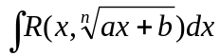 or 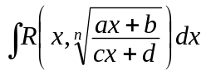, where R() is a rational function, we substitute 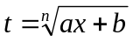 or 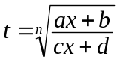 to rationalize the fraction.
- To evaluate 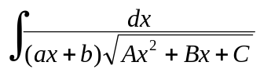, we substitute 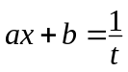, 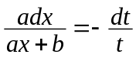 and 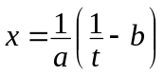 in 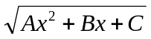 to reduce the integral in the form 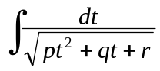
- To evaluate 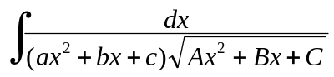, we substitute 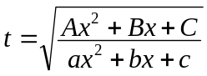

Reduction formulae
Principle of reduction formulae:
- Intended to solve the integration which involves powers of functions
 Solve by lowering the power
- Usually, the method of integration by part is used

⧫ If the integrand involves positive power, the integrand (u) can be differentiated to lower the power
⧫ If the integrand involves negative power, the integrand (v) can be integrated to raise the power

Common reduction formulae:
- 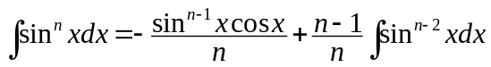
- 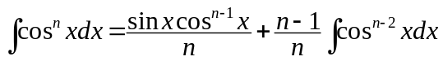
- 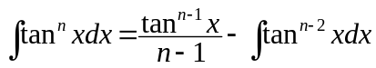
- 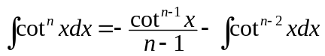
- 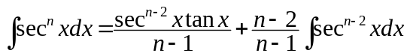
- 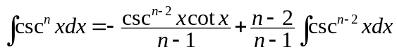
- 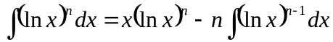

Primitive = Antiderivative

