Pure Math – Inequality

Axioms & Definitions
Absolute inequality is the inequality that is valid for all real values of its variables.
Conditional inequality is the inequality that is valid only for some real values of its variables.

Axioms:
- Positive real numbers is a set of all real numbers that greater than zero, denoted by ℝ⁺
- Negative real numbers is a set of all real numbers that less than zero, denoted by ℝ–
- ∀a∈ℝ, one of the following is uniquely satisfied: (Law of trichotomy)
- a ∈ℝ⁺
- a ∈{0}
- a ∈ℝ–
- a∈ℝ⁺ ∧ b∈ℝ⁺:
- ⇒ (a + b) ∈ℝ⁺
- ⇒ (ab) ∈ℝ⁺
- ( a∈ℝ– ∧ b∈ℝ⁺ ) ⇒ (ab) ∈ℝ–
- a∈ℝ⁺ ⇔ (–a)∈ ℝ–

Definition:
- ∀a, b∈ℝ,

⧫ a > b iff (a–b) ∈ ℝ⁺
⧫ a < b iff (a–b) ∈ ℝ–
⧫ a = b iff (a–b) ∈ {0}
⧫ a ≥ b iff (a–b) ∉ℝ– ⇔ (a > b) or (a = b)
⧫ a ≤ b iff (a–b) ∉ℝ⁺ ⇔ (a < b) or (a = b)
⧫ a ≠ b iff (a–b) ∉{0} ⇔ (a > b) or (a < b)

Properties of inequality:
■ Law of transitivity: (a > b) ∧ (b > c) ⇒ (a > c)
■ (a > b) ⇒ (a±c > b±c)
■ (a > b) ∧ (c > d) ⇒ (a+c > b+d)
■ (a > b) ∧ (c > d) ⇒ (a–d > b–c)
■ (a > b) ∧ (c > 0) ⇒ (ac > bc)
■ (a > b) ∧ (c < 0) ⇒ (ac < bc)
■ (a > b ≥ 0) ∧ (c > d ≥ 0) ⇒ (ac > bd)
■ (a > b) ∧ (c > 0) ⇒ 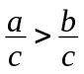
■ (a > b) ∧ (c < 0) ⇒ 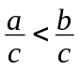
■ (a > b ≥ 0) ∧ n∈ℕ ⇒ (a^{n} > b^{n}) ∧ (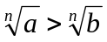)
■ (a > b) ∧ (ab > 0) ⇒ 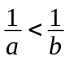
■ (a > b > 0) ∧ (c > d > 0) ⇒ 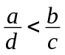
■ 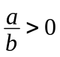 iff ab > 0, 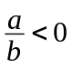 iff ab < 0
■ 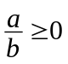 iff (ab ≥ 0) ∧ (b ≠ 0), 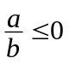 iff (ab ≤ 0) ∧ (b ≠ 0)

Absolute values
Definition:
- 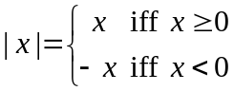
- 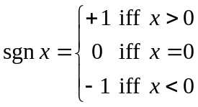

Properties of inequality:
■ | x | ≥ 0
■ | x | = max{x, –x} =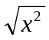= x sgn x
■ –| x | ≤ x ≤ | x |
■ | x |² = x² ≤ | –x |²
■ | –x | = | x |
■ | x | = 0 iff x = 0
■ | xy | = | x || y |, 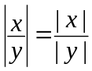
■ | x | ≤ a iff –a ≤ x ≤ a
■ | x |² ≤ a² ⇔ | x | ≤ | a |

Inequality of the means
Arithmetic, geometric, harmonic means:
- For n positive real numbers, a_{k}, k = 1, ..., n:
⧫ Arithmetic mean, A.M.=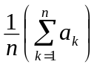
⧫ Geometric mean, G.M.=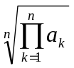
⧫ Harmonic mean, H.M.=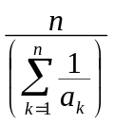

Inequality of the means:
- ∀a,b∈ℝ⁺, 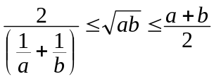
 Equality holds iff a=b
- General form: ∀a_{k}∈ℝ⁺, k = 1, ..., n, 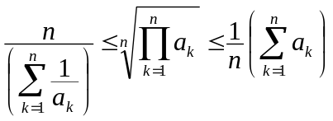
➢ H.M. ≤ G.M. ≤ A.M.
 Equality holds iff all a_{k}’s are equal.

Cauchy-Schwarz Inequality
Cauchy Inequality:
- ∀a, b, c, d ∈ℝ, 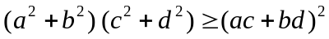
 Equality holds iff 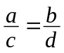
Schwarz Inequality:
- Cauchy-Lagrange identity:
∀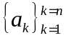, 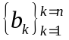 ∈ℝ, 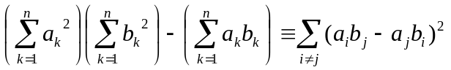
 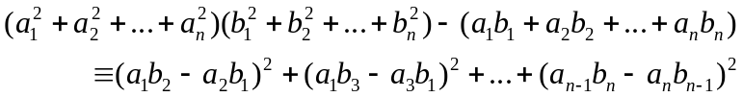
- ∀, ∈ℝ, 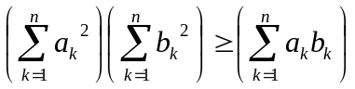
 Equality holds iff 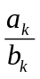 is a constant for all k = 1, ..., n

Other Inequalities
Quadratic Inequality:
- f(x)=Ax²+Bx+C
- f(x)≥0 ∀x∈ℝ ⇔ A>0 ∧ B²–4AC≤0
- f(x)≤0 ∀x∈ℝ ⇔ A<0 ∧ B²–4AC≤0
 For strictly unequal, B²–4AC<0 is required
- f(x)=0 ∀x∈ℝ ⇔ A=B=C=0

Hölder Inequality:
- ∀x>0, 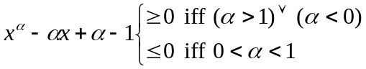
- ∀a, b>0, ∀p, q∉{0}, where 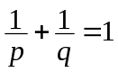,
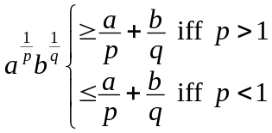
- Hölder inequality: ∀,∈ℝ⁺, ∀p, q∉{0}, where , 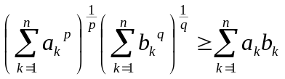
- Equality holds iff 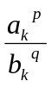 is a constant for all k = 1, ..., n
- Hölder inequality is a general form of Cauchy-Schwarz inequality
➢ If p=q=2, Hölder inequality gives the Cauchy-Schwarz inequality

Tchebychef’s Inequality:
- ∀,∈ℝ, where a_{k}≥ a_{k+1} and b_{k}≥ b_{k+1} for all k = 1, ..., n–1,
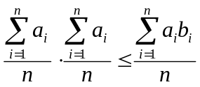
 a₁≥ a₂≥ ...≥ a_{n} and b₁≥ b₂≥ ...≥ b_{n}
- Example: If a₁≥ a₂≥ a₃ and b₁≥ b₂≥ b₃, then
3( a₁b₁+a₂b₂+a₃b₃ ) ≥ ( a₁+a₂+a₃ )( b₁+b₂+b₃ )

Minkowski Inequality:
- ∀x₁, x₂, y₁, y₂∈ℝ, p > 1,
- General forms:
⧫ ∀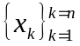,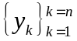∈ℝ, p > 1, 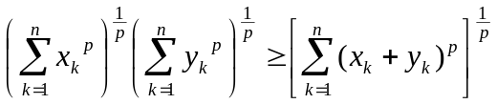
⧫ ∀,∈ℝ⁺, p < 1, p≠0, 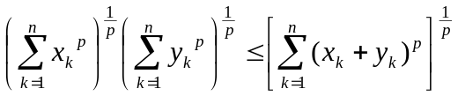
- Equality holds iff 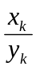 is a constant for all k = 1, ..., n
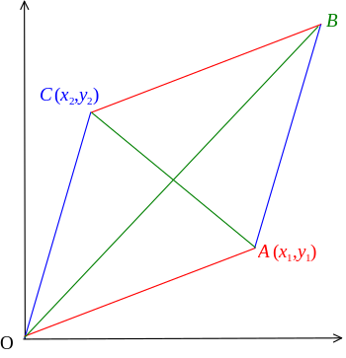

Triangle Inequality:
- ∀x₁, x₂, y₁, y₂∈ℝ,
and
 OA+OC ≥ OB and OA+OC ≥ AC

- ∀a, b∈ℝ, | a | + | b | ≥ | a+b | and
| a–b | ≥ || a | – | b ||
 Equality holds iff ab>0
➢ | a | + | b | ≥ | a+b | ≥ || a | – | b ||
- General form: ∀,∈ℝ, 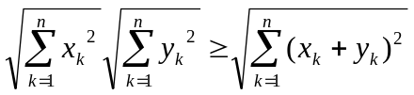

Bernoulli’s Inequality:
- If x > –1, ∀m∈ℕ m≥1, (1+x)^{m} ≥ 1+ mx

