Pure Math – Determinants

Definitions
Determinant is a square array of elements arranged in rows and columns
n^{th} Order determinant is a determinant with n rows and columns
- The n^{th} order determinant comprises n² elements

Determinant:
- Elements of a determinant is denoted by a_{ij} (i, j = 1, ..., n)
- i ^{th} row consists of elements a_{i1}, a_{i2}, ..., a_{in}
- j ^{th} row consists of elements a_{1j}, a_{2j}, ..., a_{nj}
- Determinant: 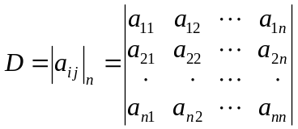

Arrangement: If (a₁, a₂, ..., a_{n}) and (b₁, b₂, ..., b_{n}) are two ordered set of same elements but with different order, then (b₁, b₂, ..., b_{n}) are called an arrangement of (a₁, a₂, ..., a_{n})
- (a₁, a₂, ..., a_{n}) = A(b₁, b₂, ..., b_{n})

Expansion:
- A determinant can be expanded into sums and products of elements
- 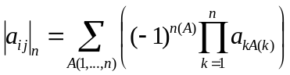
- n(A) Number of inversions of the arrangement A
- 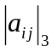= a₁₁a₂₂a₃₃ – a₁₁a₂₃a₃₂+ a₁₂a₂₃a₃₁ – a₁₂a₂₁a₃₃ + a₁₃a₂₁a₃₂ – a₁₃a₂₂a₃₁

Properties
- The rows and columns of the determinant interchanged, then the expansion of the determinant remains unchanged.
- 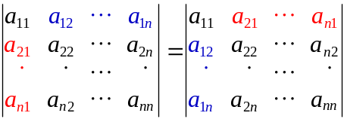
- If any two rows/columns interchanged, the sign of the determinant changed.
- 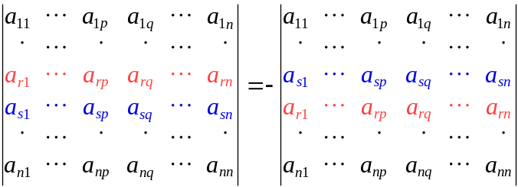
- 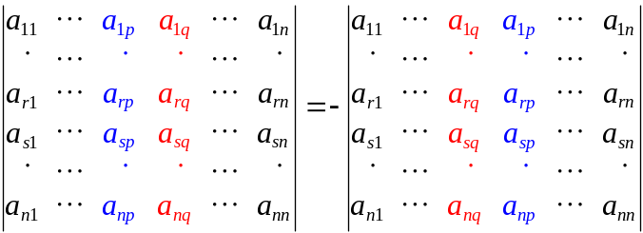
- If any two rows/columns of the determinant is identical, the determinant vanishes.
- If any one row/column of the determinant multiplied by a constant k, the value of the determinant is also multiplied by k.
- 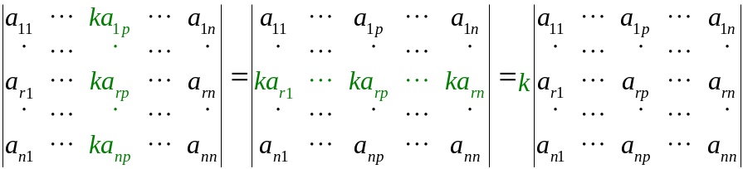
- If any row/column is added by any multiple of another row/column, the value of the determinant remains unchanged.
- 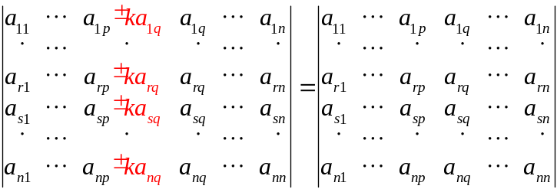
- 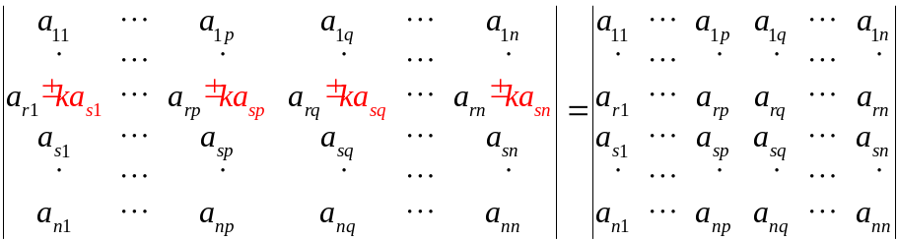
- If any row/column is a sum or difference of two elements, the determinant can be broken into two determinants.
- 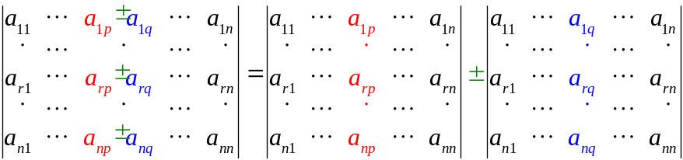

Minor & Cofactor
- The minor determinant of a_{i j} of a determinant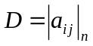 is the determinant 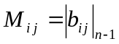 where the i ^{th} row and j ^{th} column of D are deleted.
- Minor: 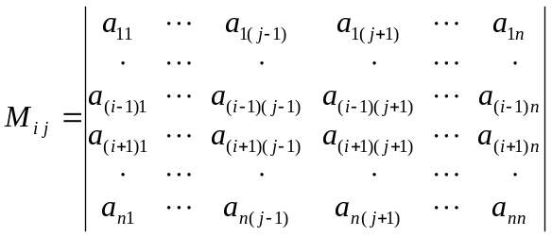
- The cofactor A_{i j} of an element a_{i j} of a determinant is the defined by 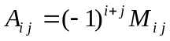

Cofactor Expansion:
- Any n^{th} order determinant can be lowered the order by expanding into the sum of its cofactors:
- 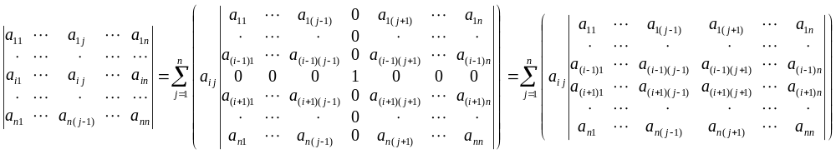
- 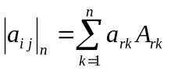 or 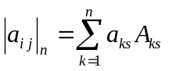
- In 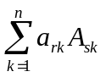or 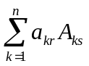where r ≠ s, the value is 0
- Forms a n^{th} order determinant r^{th} and s^{th} rows/columns identical

Multiplication of Determinants
- If the determinants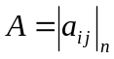, 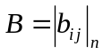, 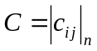have the relation A B = C or 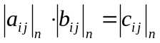, then 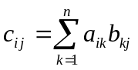
- c_{i j} = i ^{th} Row × j ^{th} Column
- 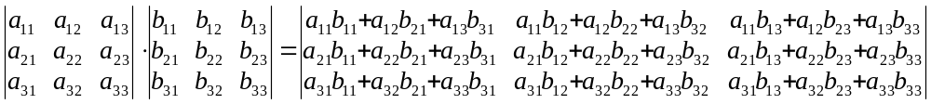

Special Determinants

Diagonal determinants:
- The determinant D = |a_{i j}|_{n} where a_{i j} = 0 if i ≠ j, i.e. D =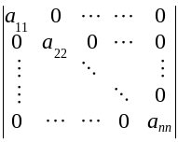
- 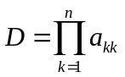

Adjacent determinant:
- For a determinant, its adjacent determinant is 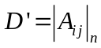 where A_{i j} is the cofactor if a_{i j} of D
- 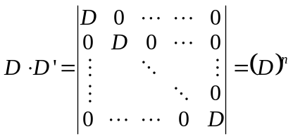
- D ' = D ^{n–1}

Symmetric determinant:
- The determinant where a_{i j} = a_{j i}
- 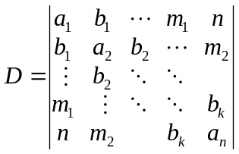

Skew-symmetric determinant:
- The determinant where a_{i j} = –a_{j i}
- 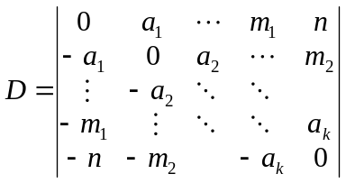
- Constituents in diagonal are all zero
- If D is an even-order determinant, it is a perfect square
- If D is an odd-order determinant, it is zero
- 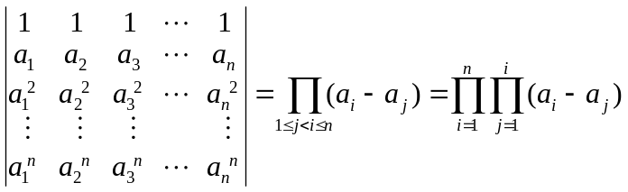
- 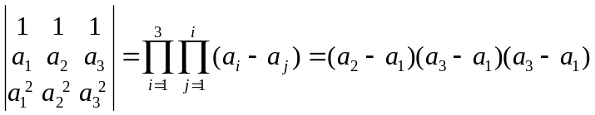

System of Linear Equations

Crammer’s Rule:
- For a system of linear equations with 3 unknowns, i.e. 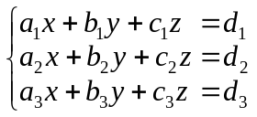, it is defined:
- 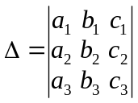
- 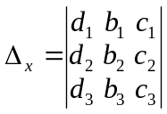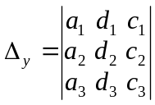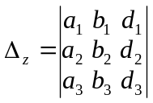
- Crammer’s Rule: 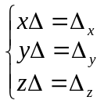 , i.e. 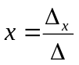, 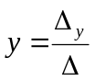, 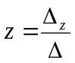
- If Δ ≠ 0, the system of linear equations is consistent and having a unique solution.
- If Δ = 0 and one or more of Δ_{x} , Δ_{y} , Δ_{z} not equal to zero, the system of linear eqn is inconsistent.
- If Δ = Δ_{x}= Δ_{y}= Δ_{z}= 0, then:
- The system of linear equations is consistent and has infinitely many solutions if:
- 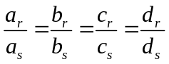 ∀r, s ∈{1, 2, 3}
- The system of linear equation has infinitely many solution iff 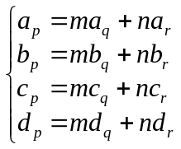
∃m, n∈ℝ, ( p, q, r) → (1, 2, 3)

System of Homogeneous Linear Equations:
- Homogeneous system: 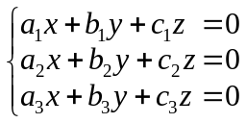
- Trivial solution: x = y = z = 0
- Let 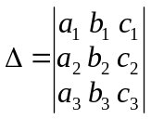,
- If Δ ≠ 0, the trivial solution is the unique solution of the homogeneous system
- If Δ = 0, there are infinitely many non-trivial solutions
- The non-trivial soln. satisfies: 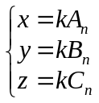
- A_{n}, B_{n}, C_{n} are cofactors of a_{n}, b_{n}, c_{n} of Δ respectively
- n ∈ {1, 2, 3} ∃k∈ℝ
- If A_{n} = B_{n} = C_{n} = 0, the three equations are in proportion.
- The homogeneous system 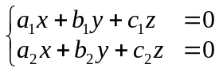 has infinitely many solutions
- Solution satisfies 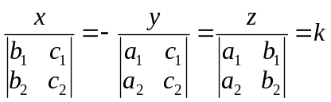 ∃k∈ℝ
- Of the determinant 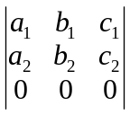, 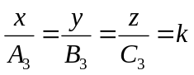

System of linear equations:
- System of linear equations.
- Defined:
- If Δ ≠ 0, the system has a unique solution: , ,
- If Δ = 0 and one or more of Δ_{x} , Δ_{y} , Δ_{z} not equal to zero, the system has no solution.
- If Δ = Δ_{x}= Δ_{y}= Δ_{z}= 0, then:
- If one or more of the cofactors of Δ is non-zero, there are infinitely many solutions.
- If all cofactors of Δ are zero and one or more of the constituents of Δ is non-zero, then the solution exists only if
- If all the constituents of Δ are zero, then there are infinitely many solution only if
d₁ = d₂ = d₃ = 0, no solution exists otherwise.

Elements = Constituents
Consistent = Solvable, i.e. has a (unnecessarily unique) solution.
Inconsistent = Unsolvable, no solution exists.

