Pure Math – Definite Integration

Definitions

Area Function:
- Let Ω be a set of bdd. region
- Area function: α: Ω → ℝ
- α(R) ≥ 0 ∀R ∈ Ω
- α(R₁) ≥ α(R₂) if R₁ ⊇ R₂
- α(R₁ ∪ R₂) = α(R₁) + α(R₂) if R₁ ∩ R₂ = ∅
- If R is a rectangle with width w and length , then α(R) = w

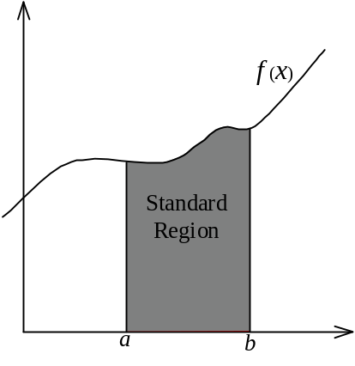Standard Region:
- For some function f: [a, b] → ℝ
- Standard region: The region under f (x) in [a, b]
- Set of pts in a std region = {(x, y) | a ≤ x ≤ b, 0 ≤ y ≤ f (x) }

Partitions:
- a = x₀ < x₁ < x₂ < ... < x_{n–1} < x_{n} = b
- Partition of [a, b] is the set Δ = { x₀, x₁ ..., x_{n} }
- The k ^{th} interval is [x_{k–1}, x_{k}]
- The width of the interval, Δ_{k}, is x_{k} – x_{k–1}

Riemann Sum

Riemann sum:
- 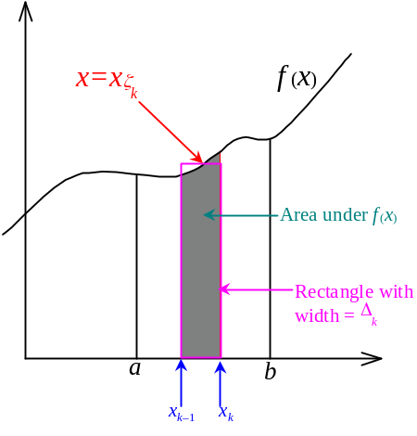Area under the curve f (x) in [a, b] is the sum of the area of all intervals in the partition.
- For some x_{ζk} ∈ [x_{k–1}, x_{k}], its functional value is f (x_{ζk}).
- The area of the rectangle with width = x_{k} – x_{k–1}= Δ_{k}, and
length = f (x_{ζk}) can act as an approximation to the area of f (x) in the k ^{th} interval.
- A_{k} = f (x_{ζk}) Δ_{k}
- The approximation to the total area in [a, b] is: 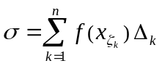
- Riemann sum
- Riemann sum is depended on the partition and the selection of x_{ζk}
- Defined: M_{k} = max{ f (x) : x ∈ [x_{k–1}, x_{k}] } and
m_{k} = min{ f (x) : x ∈ [x_{k–1}, x_{k}] }
- Upper sum is 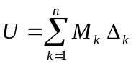 and Lower sum is 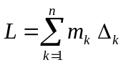
- Upper and lower sum is depended on the partition
- L ≤ σ ≤ U

Riemann integral:
- The area approximated by Riemann sum has less error if the partition is denser
- The limit of the approximated area by infinitesimally fine sub-intervals is the area under f
- Norm is defined to be 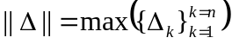
- The width of the largest interval in the partition
- Let I be the exact area under f in [a, b]:
- ∃(I∈ℝ) ∀ε >0 ∃δ >0 s.t. ||Δ|| < δ ⇒ | σ – I | < ε
- I is called the Riemann integral of f
- 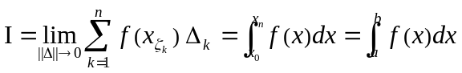
- [a, b] is called the interval of integration
- a is called the lower limit of integration
- b is called the upper limit of integration
- Riemann integral is independent of the partition and x_{ζk}
- The function that has I exists is called Riemann integrable
- As L ≤ σ ≤ U, a function is R∫ble iff 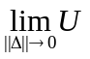 and 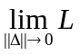 exists and equal.
- L ≤ σ ≤ U ⇒ 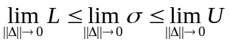, 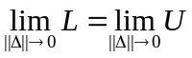⇒ 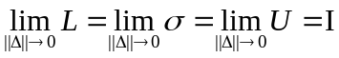

Properties

Properties:
- 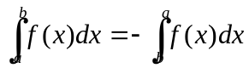
- 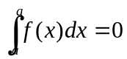
- 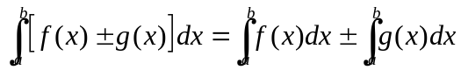
- 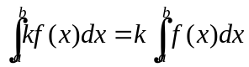
- 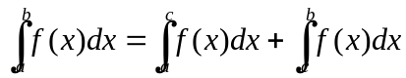
- If f (x) ≤ g (x) ∀x∈[a, b], then 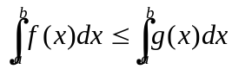
- If f(x) = g(x) ∀x∈[a, b] except a finite number of x’s, then:
- If f(x) is R∫ble on [a, b] then g(x) is also R∫ble on [a, b]
- 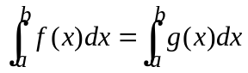

First Fundamental Theorem of Calculus:
- For some function f : [a, b] → ℝ and cts at x∈[a, b], then: 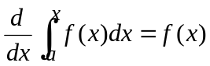
- i.e.: 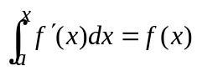

Second Fundamental Theorem of Calculus:
- 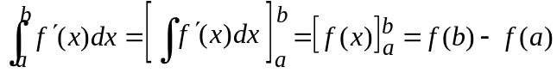

Integration Techniques

Substitution Rule:
- 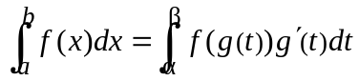
- Criteria of substitution:
- f (x) is cts on [a, b], x = g(t) is a function of real variable t
- g(α) = a, g( β ) = b
- g' (t) is cts on [a, b]
- Either g' (t) ≥ 0 or g' (t) ≤ 0 ∀t∈ [a, b]
- 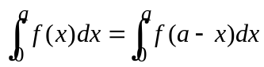

Integration of Even, Odd & Periodic Functions:
- For a continuous real-valued function f(x) defined on ℝ,
- If f is an odd function, 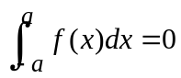 ∀a∈ℝ
- If f is an even function, 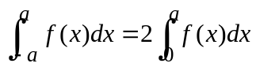 ∀a∈ℝ
- For a continuous real-valued function f(x) defined on ℝ, if f is a periodic function with period T,
- 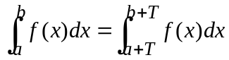 ∀a, b∈ℝ
- 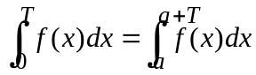 ∀a∈ℝ
- 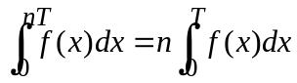 ∀n∈ℤ

Integration by Part:
- 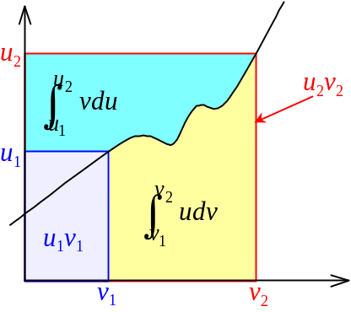 and
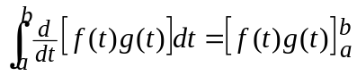
- Thus: 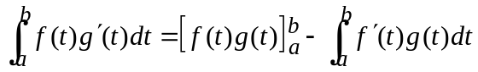
- 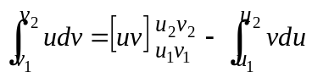

Reduction Formulae:
- If 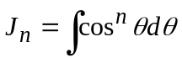, then 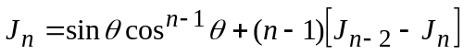
- Thus 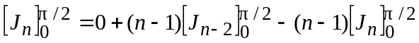
- 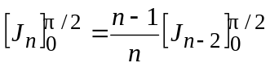
- If 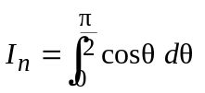, then 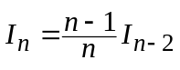
- If n is odd, 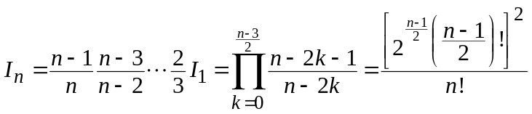
- If n is even, 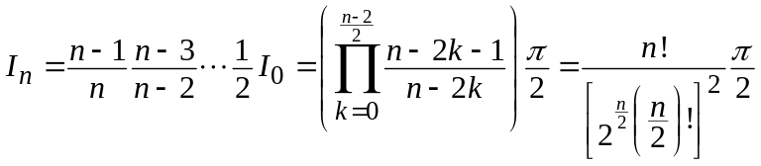

- If 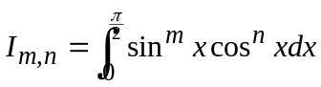, then:
- 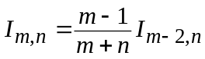
- 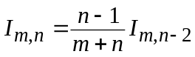
- If m is odd, 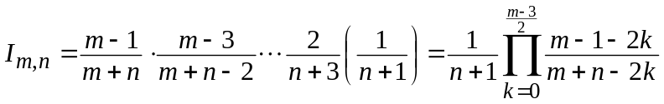
- If n is odd, 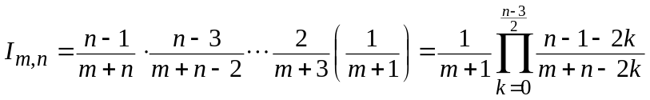
- If both m, n are even, 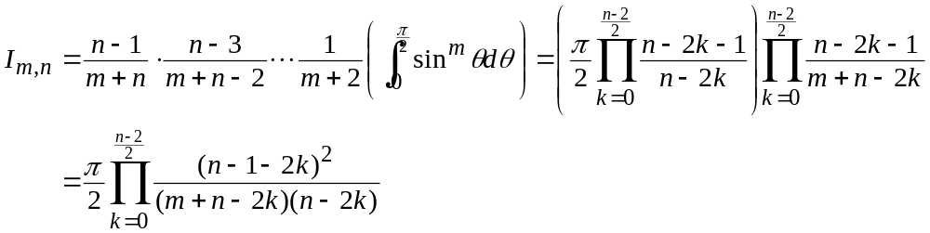

Improper Integrals
Improper integral is the integral 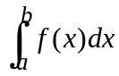 where:
- The interval of integration [a, b] is of infinite length, or
- Function f(x) is unbounded or undefined at one or more points in [a, b]

An improper integral is said to converge if the limit defining the improper integral exists.
An improper integral is said to diverge if the limit defining the improper integral does not exist.

Integrals w/Infinite Interval of Integration:
- 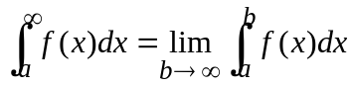
- 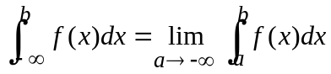
- 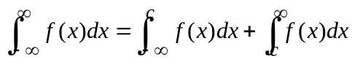
- Cauchy’s principal value: 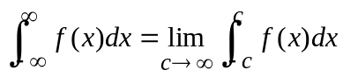

Integrals w/Singularities:
- If a is singularity, 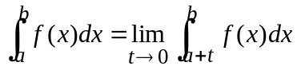
- If b is singularity, 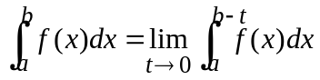
- If c∈(a, b) is singularity, 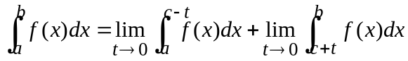
- If c∈(a, b) is singularity, Cauchy’s principal value: 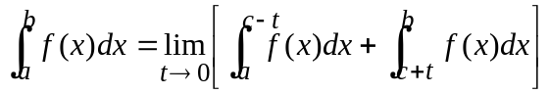

Beta & Gamma Functions
- Beta function: 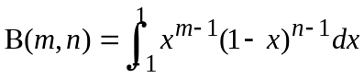
- Gamma function: 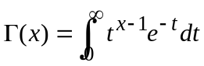
- Γ(x+1) = x Γ(x)
- Γ(x) = (x–1) !
- B(m, n) = Γ(m) Γ(n) = Γ(m+n)

Denser ≠ More / Fine
Second Fundamental Theorem of Calculus = Newton-Leibniz Formula
Those points are called singularities

