Pure Math – Matrix

Definitions

Matrix:
- Matrix is a rectangular array of numbers appears in rows and columns
- The matrix constituting m rows and n columns is called m×n
- Matrix: 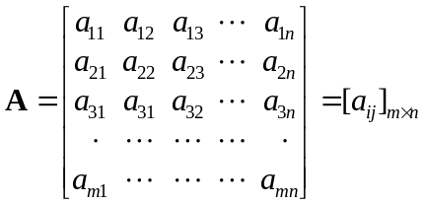
- Matrices A = [a_{ij}]_{m×n} and B = [b_{ij}]_{p×q} are equal iff:
- m = p ∧ n = q
- a_{ij} = b_{ij} ∀i∈{1,..., m}; j∈{1,..., n}
- In matrix A = [a_{ij}]_{m×n}, elements a_{ij} for i = j are called diagonal elements
- The line along the diagonal elements are called principal diagonal of the matrix

Special types of matrices:
- Square matrix
- A m×n matrix is called a square matrix iff m=n
- A n×n square matrix will usually called n^{th} order sq. matrix or sq. matrix of order n
- Row matrix & Column matrix
- A row matrix is a 1×m matrix
- A column matrix is a 1×n matrix
- Transpose of a row matrix is a column matrix and vice versa
- Diagonal matrix & Scalar matrix
- Matrix A = [a_{ij}]_{m×n} is a diagonal matrix iff it is a sq. matrix w/a_{ij}=0 when i = j
- A diagonal matrix w/all diagonal elements equal is called a scalar matrix
- Identity matrix & Zero matrix
- Identity matrix is a scalar matrix w/diagonal elements equals to one, denoted by I
- Zero matrix is a matrix w/all elements equals to zero, denoted by 0
- Triangular matrix
- Matrix A = [a_{ij}]_{m×n} is an upper triangular matrix if i > j ⇒ a_{ij} = 0
- Matrix A = [a_{ij}]_{m×n} is a lower triangular matrix if j > i ⇒ a_{ij} = 0
- Symmetric matrix
- Matrix A = [a_{ij}]_{n×n} is a symmetric matrix if a_{ij} = a_{ji} ∀i, j
- A is symmetric iff it is a sq. matrix and A = A^{T}
- Skew-symmetric matrix
- Matrix A = [a_{ij}]_{n×n} is a skew-symmetric matrix if a_{ij} = –a_{ji} ∀i, j
- Diagonal elements are necessarily zero

Matrix Algebra

Scalar multiple:
- ∃λ ∈ ℝ, A = [a_{ij}]_{m×n}, λA or Aλ is a scalar multiple of A
- λA = Aλ = [λa_{ij}]_{m×n}, i.e. every elements in A is multiplied by λ
- –A = (–1)A = [–a_{ij}]_{m×n}
- Properties:
- Distributive: λ(A + B) = λΑ + λB
- Distributive: (λ+μ)A = λA + μA
- λ(μΑ) = (λμ)Α
- (1)A = A
- (0)A = 0

Addition:
- Matrices: A = [a_{ij}]_{m×n} , B = [b_{ij}]_{m×n} , C = [c_{ij}]_{m×n}
- If A + B = C, then c_{ij} = a_{ij} + b_{ij}
- Two matrices can be added iff they are of same type
- Properties of addition:
- Commutative: A + B = B + A
- Associative: (A + B) + C = A+ (B + C)
- Exist of identity: A + 0 = 0 + A = A
- Inverse: A + B = B + A = 0  B = –A = [–a_{ij}]_{m×n}
- Subtraction: A – B = A + (–B)

Multiplication:
- Matrices: A = [a_{ij}]_{m×n} , B = [b_{jk}]_{n×p} ,
- The product AB = C = [c_{ik}]_{m×p} where 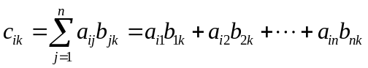
- In C = AB, matrix A is called the prefactor and B is the postfactor
- Matrices A and B is compatible for multiplication iff no. of columns of A = no. of rows of B
- Properties:
- AB ≠ BA
- A(BC) = (AB)C
- [a_{ij}]_{m×n} ( [b_{jk}]_{n×p}[c_{k}]_{p×q} ) = ( [a_{ij}]_{m×n}[b_{jk}]_{n×p} ) [c_{k}]_{p×q} = 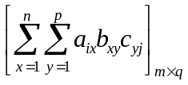
- AI = IA = A
- Right hand identity = Left hand identity
- A(B + C) = AB + AC
- AA^{n} = A^{n}A = A^{n+1}
- A^{m}A^{n} = A^{n}A^{m} = A^{n+m}

Determinant:
- Determinant of a square matrix A = [a_{ij}]_{n×n} is defined by det A = |A| = |a_{ij}|_{n}
- Minor: M_{ij}
- Cofactor A_{ij} = (–1)^{i+j}M_{ij}
- det AB = (det A)(det B)

Transpose:
- Transpose of a matrix A = [a_{ij}]_{m×n}, denoted by A^{T}, is obtained by interchanging the rows & columns
- A^{T} = [b_{ij}]_{n×m} where b_{ij} = a_{ji}
- Properties:
- (A^{T})^{T} = A^{T}
- (AB)^{T} = B^{T}A^{T}
- (A + B)^{T} = A^{T} + B^{T}
- (λA)^{T} = λ(A^{T})
- det A^{T} = det A
- For any matrix A,
- (A + A^{T}) is a symmetric matrix
- (A – A^{T}) is a skew-symmetric matrix

Cofactor & Adjoint Matrix:
- Let matrix A = [a_{ij}]_{n×n}, its cofactor be A_{ij}
- Cofactor matrix of A is: Cof A = [A_{ij}]_{n×n}
- Adjoint of A is: Adj A = (Cof A)^{T}
- A (Adj A) = (Adj A) A = (det A) I

Inverse w.r.t. multiplication:
- For any sq. matrix A, if exists another sq. matrix B such that AB = BA = I,
B is called the inverse of A, denoted by A^{–1}
- A^{–1} exists iff det A ≠ 0; Matrix A is singular iff det A = 0
- Since A (Adj A) = (det A) I, 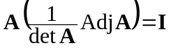
- 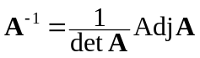
- Matrix A is said to be non-singular if its inverse exists (det A ≠ 0)
- Inverse of any invertible matrix is unique
- Matrix A is said to be singular if its inverse do not exist (det A = 0)
- Properties of inverse:
- Inverse of a particular matrix is unique
- AB = I ∧ CA = I ⇒ B = C = A^{–1}
- (A^{–1})^{–1} = A
- (AB)^{–1} = B^{–1}A^{–1}
- (A₁A₂...A_{n–1}A_{n})^{–1} = A_{n}^{–1}A_{n–1}^{–1}...A₂^{–1}A₁^{–1}
- (λA)^{–1} =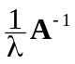
- (A^{T})^{–1} = (A^{–1})^{T}
- AB = 0 ∧ A^{–1} exists ⇒ B = 0
- AB = AC ∧ A^{–1} exists ⇒ B = C
- If A is singular, ∃ non-singular matrices X, Y s.t. AX = YA = 0
- Power of matrix:
- Positive power: A^{n} = 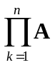
- A⁰ = I
- Negative power: A^{–n} = (A^{n})^{–1}
- A^{m}A^{n} = A^{m+n} ∀m, n∈ℤ
- A sq. matrix A is idempotent iff A² = A
- A sq. matrix A is orthogonal iff A^{T} = A^{–1}

Systems of Linear Equations

Elementary Transformations:
- Elementary operations on a matrix are:
- Interchanging (transposition) two rows/columns
- R_{α} ↔ R_{β} or C_{α} ↔ C_{β}
- Multiplying a row/column by a non-zero scalar
- kR_{α} or kC_{α}
- Add a scalar multiple of a row/column to another row/column
- R_{α} + kR_{β} or C_{α} + kC_{β}
- Elementary matrices are: (row operations only)
- 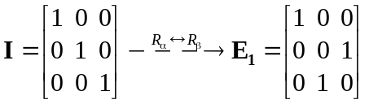
- 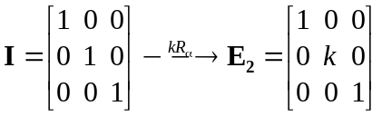
- 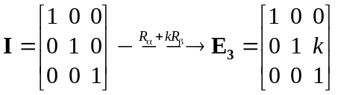
- All elementary matrices are non-singular
- Multiplying an elementary matrix E_{n} to a matrix A has the same effect as performing the elementary operation on A
- Matrix B is resulting from a succession of a finite number of elementary row transformations on a matrix A, then A & B are row-equivalent
- If A is a non-singular matrix and E_{k} (k=1, 2, ..., n) are elementary matrices s.t.
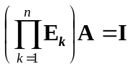 then 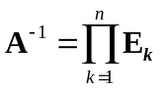
- Algorithm for finding inverse: 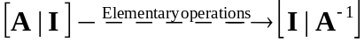

Inverse Matrix Method:
- System of linear eqn: 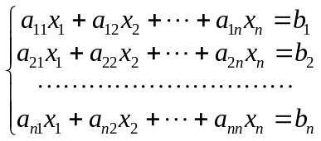
- Matrix form: 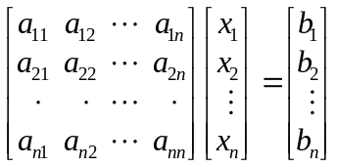, i.e. AX = B
- The matrix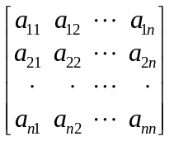 is called coefficient matrix
- The matrix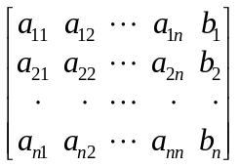 is called augmented matrix
- If matrix A is invertible, 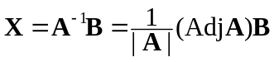
- If B = 0, the system is a system of homogeneous linear eqn
- Trivial solution is the unique soln of AX = 0 iff det A ≠ 0

Gaussian Elimination:
- Augmented matrix of a system of linear eqn: 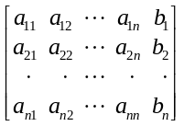
- By elementary row op., the aug. matrix can be reduced to echelon form: 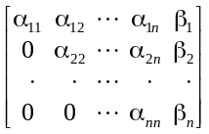,
i.e. a upper triangular matrix
- The solution of the system can be deduced from the echelon form
- If a row vector 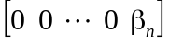 where β_{n} ≠ 0 appeared in the echelon form, it has no soln
- represents the eqn: 0 = β_{n}
- If where β_{n} = 0 appeared in the echelon form, it has infinity many soln
- If 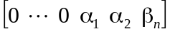 appeared in the echelon form, it has infinity many soln
- The system with n unknowns but less than n linear independent equations

Geometrical Application of Matrices

Isometric Transformation:
- In Cartesian plane, every pt (x, y) can be regarded as a column matrix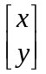
- After some transformation, the pt becomes 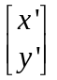, i.e. (x', y')
- Translation by α units in x-direction & β units in y direction: 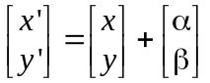
- Reflection about the line ‘y = tanθ x’ or ‘x = cotθ y’: 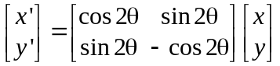
- Rotation for angle θ in counterclockwise about the origin: 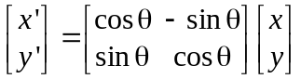
- Under isometric transformations, distances btw pts and angles btw lines are unchanged
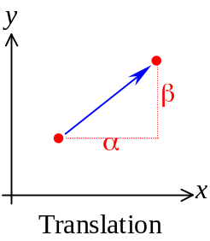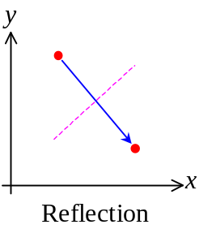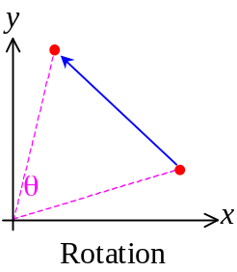

Non-isometric transformations:
- Enlargement about the origin for a factor k: 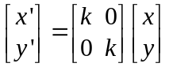
- A line is enlarged by a factor k
- An area is enlarged by a factor k²
- Shear w/x-axis as the invariant line by a factor k: 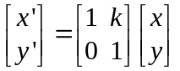
- Shear w/y-axis as the invariant line by a factor k: 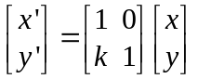
- After shearing, area is preserved
- Pts on invariant line is unchanged by the shear
- All pts are moved parallel to the invariant line by shearing
- Distance btw pts parallel to the invariant line is preserved
- General transformation: 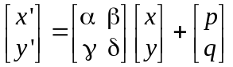
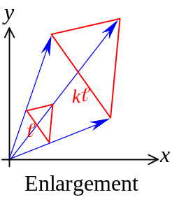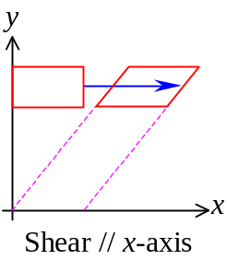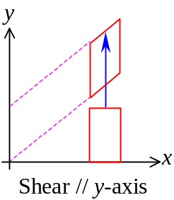

The ‘number’ in a matrix is called an element or entry
Zero matrix = Null matrix
Compatible for multiplication = Conformable for multiplication
Non-singular = Invertible

