Pure Math – Sequence & Series

Sequences

Definitions:
- Sequence is a function mapping from ℕ to ℝ
- x : ℕ → ℝ
- Graph of sequence: The set of pts of a sequence
- {(1, x(1)), (2, x(2)), (3, x(3)), ...} or
- {x(1), x(2), x(3), ...} or
- {x₁, x₂, x₃, ...} or {x_{n} : n∈ℕ}
- Graph of a sequence is discontinuous (domain = ℕ) but function is continuous (domain = ℝ)

Example of Sequences:
- Define by function: a_{n} = n(n–1) n∈ℕ
- Define by induction: a₁=1; a₂=1; a_{n}=a_{n–2}+a_{n–1} (k∈ℕ, k≥3)
- Define by words: {x_{n}: x_{n} is √2 round off to n decimal places}
⇔ {1.4, 1.41, 1.414, 1.4142, 1.14121, ...}
- {x₁, x₂, x₃, ...} ⇔ 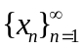 ⇔ {x_{n}}

Limit of Sequences:
- Let {x_{n}} be a sequence and L∈ℝ. If (∀ε>0)(∃n₀∈ℕ)(n>n₀ ⇒ | x_{n} – L |<ε)
then L is called the limit of the sequence
- Denoted by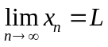 or simply lim x_{n} = L
- The sequence {x_{n}} is called a convergent sequence
- Nhd of L w/radius ε: N_{ε}(L) = {x_{n}: |x_{n} – L|<ε} = (L–ε, L+ε)
- Divergent sequence: (∃ε₀>0)(∀n∈ℕ)(∃n₀∈ℕ, n < n₀ ⇒ | x_{n}–L |≥ε)
- Properties of limit:
- lim (x_{n} ± y_{n}) = lim x_{n} ± lim y_{n}
- lim (x_{n} y_{n}) = (lim x_{n})(lim y_{n})
- 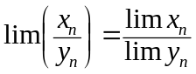 as long as the notation is defined
- lim (kx_{n}) = klim x_{n} ∃k∈ℝ
- lim (x_{n})^{m} = (lim x_{n})^{m} ∃m∈ℕ
- 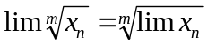 ∃m∈ℕ
- lim x_{n+m} = lim x_{n} ∃m∈ℕ
- If lim x_{n}=a and f(x) is an elementary function which f(a) is defined, then lim f(x_{n}) = f(lim x_{n})
- Predefined limits:
- 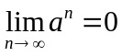 where |a|<1
- 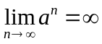 where a>1
- 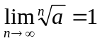 where a > 0
- 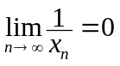 when 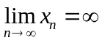; 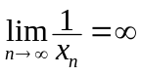 when 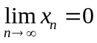
- 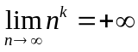 and 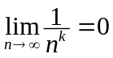 where k∈ℕ
- 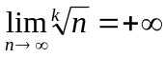 and 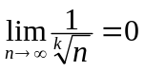 where k∈ℕ

Bounded Sequence:
- {x_{n}} is called a bdd sequence iff ∃M∈ℝ s.t. |x_{n}|≤M ∀n∈ℕ (or ∀n≥n₀)
- {x_{n}} is said to be bdd above iff ∃M∈ℝ s.t. x_{n}≤M ∀n∈ℕ (or ∀n≥n₀)
- M is called an upper bound
- {x_{n}} is said to be bdd below iff ∃M∈ℝ s.t. x_{n}≥M ∀n∈ℕ (or ∀n≥n₀)
- M is called an lower bound
- The least upper bound (l.u.b.) is called the supremum, sup{x_{n}}
The greatest lower bound (g.l.b.) is called the infimum, inf{x_{n}}
- {x_{n}} is said to be monotonic increasing iff x_{n} ≤ x_{n+1} ∀n∈ℕ
{x_{n}} is said to be monotonic decreasing iff x_{n} ≤ x_{n+1} ∀n∈ℕ
- If the equality is excluded, it is called strictly monotonic
- If a monotonic increasing sequence is bdd above, it is convergent
- If a monotonic decreasing sequence is bdd below, it is convergent
- The Bounded Convergent Theorem
- If the monotony occurs only when n≥n₀, the sequence is also convergent
- Properties of bdd sequence:
- If {x_{n}} is a convergent sequence, it is bounded
- If {x_{n}} is bdd and lim y_{n}=0, lim x_{n}y_{n}=0
- If lim x_{n}≠0 and lim y_{n}=∞, lim x_{n}y_{n}=∞; 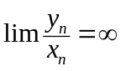

Properties of Limit of Sequences:
- x_{n} < y_{n} ∀n>n₀ ⇒ lim x_{n} ≤ lim y_{n}
lim x_{n} < lim y_{n} ⇒ x_{n} < y_{n} ∀n>n₀
- lim x_{n} > a ⇒ x_{n} > a ∀n>n₀; lim x_{n} < a ⇒ x_{n} < a ∀n>n₀
x_{n} > a ∀n>n₀ ⇒ lim x_{n} ≥ a; x_{n} < a ∀n>n₀ ⇒ lim x_{n} ≤ a
- The limit of a convergent sequence is not affected by:
- Adding finite no. of terms to the sequence
- Deleting finite no. of terms to the sequence
- Altering finite no. of terms to the sequence
- Divergence of a sequence is not affected by:
- Adding finite no. of terms to the sequence
- Deleting finite no. of terms to the sequence
- Altering finite no. of terms to the sequence
Sandwich principle: For some sequences {x_{n}}, {y_{n}}, {z_{n}}. If {x_{n}} and {z_{n}} are convergent sequences and x_{n} ≤ y_{n} ≤ z_{n} or x_{n} < y_{n} < z_{n} for all sufficient large n,
- lim x_{n} ≤ lim y_{n} ≤ lim z_{n} if the limits exist
- If lim x_{n} = lim z_{n} = ∈ℝ, {y_{n}} is also convergent and lim y_{n} = 
- Rapidity of increase of functions: ln x < x < x^{k} < a^{x} < [x]! k>1, a>1
- 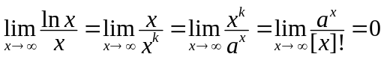
Difference equation: An equation connecting / related successive terms of a sequence

Subsequence:
- Let {x_{n}} be a sequence. 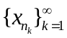is a subsequence of {x_{n}} iff:
- n_{k} ≥ k ∀k∈ℕ
- ∃α, β∈ℕ α ≥ β ⇔ n_{α} ≥ n_{β}
- A sequence converges to a limit L iff any of its subsequence also converges to the limit L
- Let {x_{n}} be a sequence, lim x_{n} = L iff lim x_{2n–1} = lim x_{2n} = L
- Limit of the sequence = Limit of even-numbered term = Limit of odd-numbered term
- Let {x_{n}} be a sequence, {x_{n}} itself is a divergent sequence if:
- There is a subsequence of {x_{n}} is divergent, or
- There is two convergent subsequence of {x_{n}} that converge to different limits
- Oscillating function has no limit even it is bounded

Series

Finite Series:
- Series is the inductive sum of terms of a sequence
- Series is individual terms connected by the ‘+’ sign
- Sequence:; Series: x₁+x₂+x₃+...+x_{N} =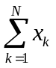
- If N is a finite natural number, the series is called a finite series
- If the series is the sum of infinite no. of terms, 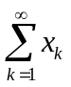, it is an infinite series
- A series may also start summing from x_{m} other than x₁, i.e.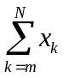
- Partial sum is the real value computed from the series’ summation
- Some common series:
- Arithmetic series: a + (a+d) + (a+2d) + ☹ + [a+(n–1)d] = 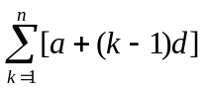
- Geometric series: a + aR + aR² + ☹ + aR^{n–1} =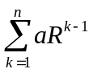
- Arithmetic-Geometric series: a + (a+d)R + ☹ + [a+(n–1)d]R^{n-1} =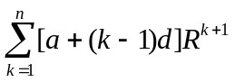
- Harmonic series: 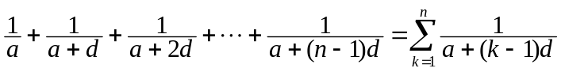
- Power series: c₀ + c₁x + c₂x² + ☹ + c_{n}x_{n} = 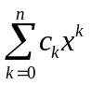
- The sum 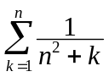is not a series as the terms varies as n varies (x_{n} is undefined)
- Method of difference:
- 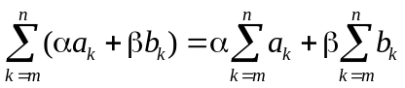
- 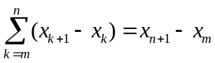
- 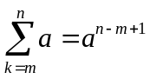

Convergence of Infinite Series:
- The sum S of the infinite series is found by the limit of partial sums: 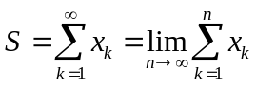
- Let 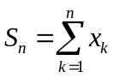; partial sum: {S_{n}}; then S = lim S_{n}
- If the limit S exists, the series is called a convergent series
If the limit S does not exist, the series is a divergent series
- The sum of divergent series will be +∞, –∞, or oscillating
- Properties of convergent series: (Σa_{n}=S, Σb_{n}=T)
- Σ(a_{n}±b_{n}) = S±T
- Σ(ca_{n}) = cS
- a_{n} ≤ b_{n} ∀n∈ℕ ⇒ S ≤ T
- If a finite no. of terms, which the sum is P, are removed from Σa_{n}, resulting series is still convergent and the sum is S–P
If a finite no. of terms, which the sum is P, are added to Σa_{n}, resulting series is still convergent and the sum is S+P

Tests for convergence & divergence:
- A series 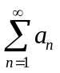 is divergent if 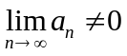; is convergent only if 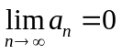
- Let & 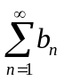 be two series, which a_{n}, b_{n}>0 ∀n∈ℕ
- a_{n} ≥ b_{n} ∀n∈ℕ, if diverges, also diverges
- a_{n} ≤ b_{n} ∀n∈ℕ, if converges, also converges
- Let & be two series, which a_{n}, b_{n}>0 ∀n∈ℕ.
If 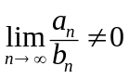, then & either both converge or diverge
- Let be a series, which a_{n}>0 ∀n∈ℕ
- If 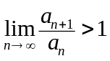, is divergent
- If 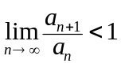, is convergent
- Let be a series, where a_{n} can be expressed as f(n) where f(x) is a continuous function that:
- f(x) > 0 ∀x≥1
- f(x) is decreasing when x≥1
- If 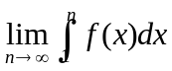 tends to a finite limit L, converges and L ≥≥ L+a₁
- If tends to +∞, diverges
- 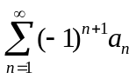 is convergent if {a_{n}} is a decreasing sequence and

Calculation of the Sum of Series:
- Let 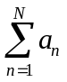be a series, where a_{n} could be expressed as: 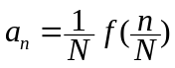 for some cts function f(x)
- 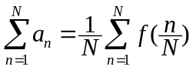
- By substituting 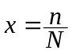, 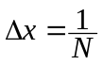,
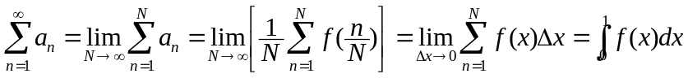

The test is known as Leibniz’s test or Alternating series test

