Pure Math – 3D Coordinate Geometry

Points in the Space

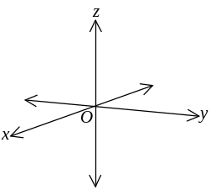3D Cartesian Rectangular Coordinate System:
- A point in the space is defined by 3 coordinates
- Ordered triple
- The coordinates are defined by x-, y- & z-axis
- Any two axes forms a coordinate plane
- xy-, yz- & xz-plane
- The three coordinate plane divides the space into 8 octants
- The octant that all the three coordinates are positive is called the 1st octant or positive octant
- Right hand coordinate system: 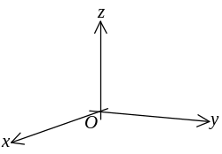
- Left hand coordinate system: 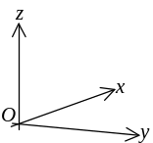

Distance Formula:
- Points in the space: P₁(x₁, y₁, z₁) P₂(x₂, y₂, z₂)
- The distance btw P₁P₂ =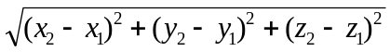

Section Formula:
- Points in the space: P₁(x₁, y₁, z₁) P₂(x₂, y₂, z₂)
- If point P(x, y, z) divides P₁P₂ in the ratio P₁P:PP₂ = m:n = 1:λ
- 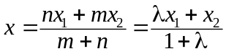
- 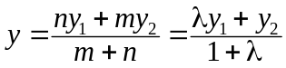
- 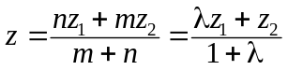

Straight Lines in the Space

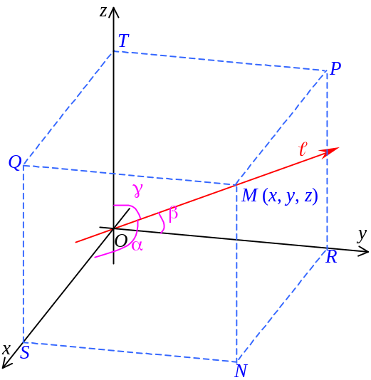Direction:
- Let a directed line  thou’ the origin
- The angle btw  and x-, y-, z-axis are α, β, γ respectively
- The angles are known as the line’s direction angles
- The values cos α, cos β, cos γ are called direction cosines of line 
- Let M(x, y, z) lies on , and OM = r
- Direction cosines:
- In ΔMSO, 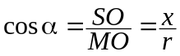
- In ΔMRO, 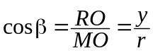
- In ΔMTO, 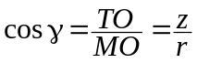
- Since x²+y²+z²=r², cos²α+cos²β+cos²γ=1
- The necessary condition for direction cosine
-  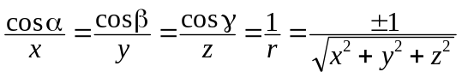; x, y, z ∝ cos α, cos β, cos γ respectively
- [x, y, z] are called a direction ratio of 
- The coordinate of any pt on  is a set of direction ratio of 
- Direction ratio of the line passing thou’ P₁(x₁, y₁, z₁) & P₂(x₂, y₂, z₂) is [x₁–x₂ : y₁–y₂ : z₁–z₂]

Equations of Straight Lines:
- Parallel lines are two straight lines that are coplanar and do not intersect
- Skew lines are two straight lines that are non-coplanar
- Let a pt P(x₀, y₀, z₀) in the space.
- The line  thou’ P and with the direction ratio [p : q : r] is given by: 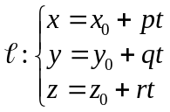
- Parametric form of the line 
- Rearrange the parametric form, 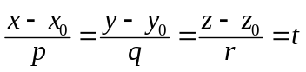 ∀t∈ℝ
- Standard form of a straight line: 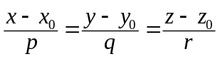
- By replacing direction ratio by direction cosine, the above eqn can be written as:
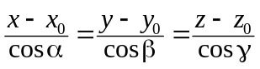
- Let pts P₁(x₁, y₁, z₁) & P₂(x₂, y₂, z₂) on the space
-  dir. ratio of the line P₁P₂ is [x₁–x₂ : y₁–y₂ : z₁–z₂], the eqn is: 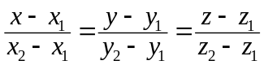
- Two-point form of a straight line
- The criteria for P₃(x₃, y₃, z₃) lies on P₁P₂ (P₁, P₂, P₃ collinear) is 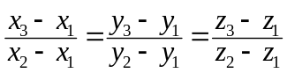
- Rearranging the std form , we get: 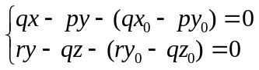
- Represent a line by the intersection of two planes
- General equation of a line: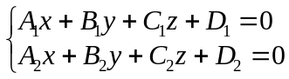
- The direction cosines satisfy: 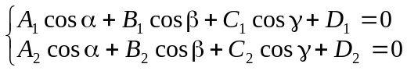
- 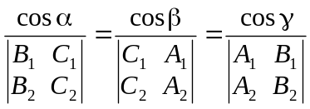

Angle btw Two Lines:
- Let two lines & their direction cosines ₁:cos α₁, cos β₁, cos γ₁; ₂:cos α₂, cos β₂, cos γ₂
- If ₁ & ₂ intersect, the angle of intersection θ is given by:
cosθ = cos α₁ cos α₂ + cos β₁ cos β₂ + cos γ₁ cos γ₂
- The lines ₁ & ₂ are orthogonal / perpendicular iff cos α₁ cos α₂ + cos β₁ cos β₂ + cos γ₁ cos γ₂ = 0
- Two lines perpendicular is not necessary to intersect
- The lines ₁ & ₂ are parallel only if cos α₁ cos α₂ + cos β₁ cos β₂ + cos γ₁ cos γ₂ = 1
- The necessary & sufficient condition for ₁ // ₂ is: 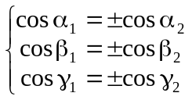
- If the direction ratios are ₁[p₁:q₁:r₁] and ₂[p₂:q₂:r₂]
- ₁ // ₂ ⇒ 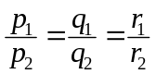
- ₁ ⊥ ₂ ⇒ p₁p₂ + q₁q₂ + r₁r₂ = 0
- 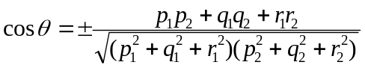

Relation btw 2 Straight Lines:
- Lines ₁: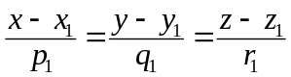 & ₂: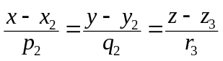
- Lines ₁ & ₂ are coplanar iff: 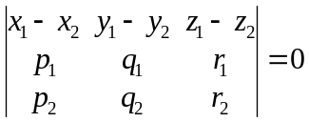
- If ₁ & ₂ are not coplanar, they are skew lines
- The shortest distance btw two skew lines is the length of their common perpendicular
- Shortest distance d btw ₁ & ₂ is: 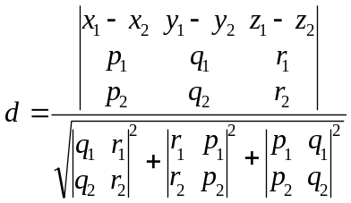

Planes in Space

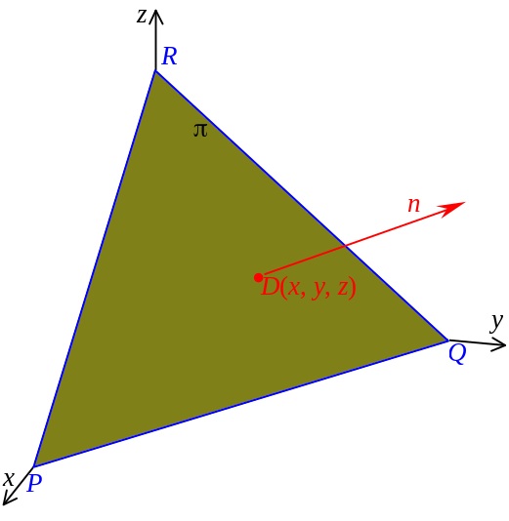Equation of a Plane:
- A plane π on the space and a line n normal to the plane
- The line n has direction angles α, β and γ
- Distance OD is p
- The eqn of π: xcos α + ycos β + zcos γ – p = 0
- Normal form equation of a plane
- Linear eqn in 3 variables represents a plane in the space
- General eqn of plane: Ax + By + Cz + D = 0
- [A:B:C] is a direction ratio of the normal
- If a plane’s general equation is Ax + By + Cz + D = 0
- Normal form: 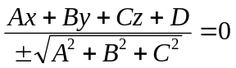
- The sign of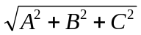is taken as:
- If D ≠ 0, it is opposite to D
- If D = 0, it is same as C
- If C=D=0, it is same as B
- If B=C=D=0, it is same as A

- Lets pts P₁(x₁, y₁, z₁), P₂(x₂, y₂, z₂) & P₃(x₃, y₃, z₃) are in the space
- The plane passing thou’ P₁, P₂, P₃ is given by: 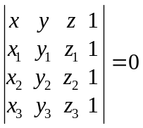
- Three-point form equation

- Let a plane π intersecting x-, y- and z-axis with intercepts P, Q, R respectively
- Equation of plane: 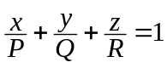
- Intercept form of a plane

- Let a point P(x₀, y₀, z₀) lies on a plane π, where π has a normal w/direction ratio [A:B:C]
- Equation of π: A(x–x₀) + B(y–y₀) + C(z–z₀) = 0

Angle btw 2 Planes:
- If two planes intersect, a pair of diedral angle formed
- The angle btw two plane = Angle btw the two normals of the planes
- Planes 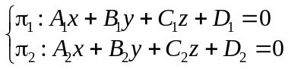 in the space, angle θ btw π₁ & π₂ is given by:
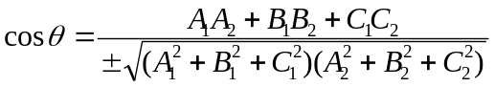
- Condition for π₁ // π₂: 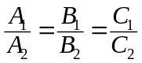
- Condition for π₁ coincide with π₂: 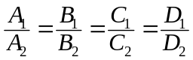
- Condition for π₁ ⊥ π₂: A₁A₂ + B₁B₂ + C₁C₂ = 0

Family of Planes:
- Let a plane π: Ax + By + Cz + D = 0 on the space
- The family of plane parallel to π is Ax + By + Cz + k = 0 ∀k∈ℝ

- Let planes intersect at a line 
- The family of plane thou’ the intersection of π₁ & π₂ is:
m(A₁x + B₁y + C₁z + D₁) + n(A₂x + B₂y + C₂z + D₂) = 0 ∀m, n∈ℝ
- If the direction cosines of  are cos α, cos β, cos γ, then it satisfies:
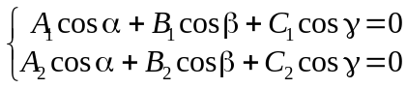
- Equation of : 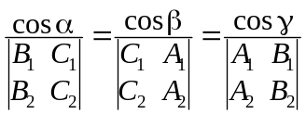

- Let point P(x₀, y₀, z₀) is on the space
- The family of planes thou’ P is A(x–x₀) + B(y–y₀) + C(z–z₀) = 0 ∀A, B, C∈ℝ

Relations about Planes:
- For planes: 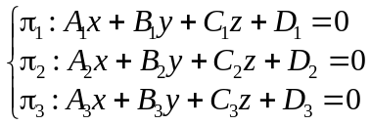 in the space
- If π₁, π₂, π₃ intersect at a point, 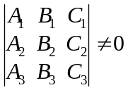
- If π₁, π₂, π₃ intersect at a line, 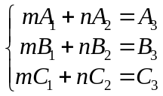 ∃m, n∈ℝ
- If the three planes are parallel, the coefficients of x, y & z are in proportion
- Let a line  w/direction ratio [a : b : c] & a plane π: Ax + By + Cz + D = 0 in the space
- The angle θ btw the  and π is given by: 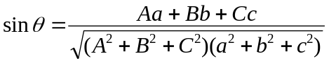
- 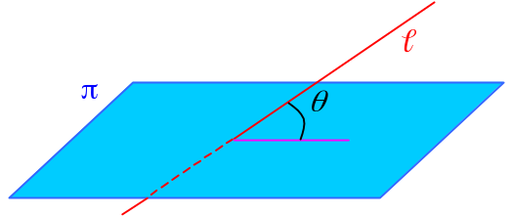If  // π, Aa + Bb + Cc = 0
- If  ⊥ π, 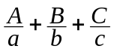
- Let a point P(x₀, y₀, z₀) and a plane π: xcos α + ycos β + zcos γ – p = 0 are in the space
- The distance btw P and π is: d = x₀cos α + y₀cos β + z₀cos γ – p
- If π is given in general form, 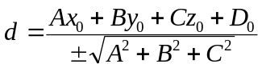

Direction ratio: [a : b : c] Direction number a, b, c
Standard form of a straight line is also called the Symmetric Form

