Pure Math – Vector Algebra

Vector operation

Vector:
- Geometrical vector is a directed line segment
- Represented by AB, where A is the initial point and B is the terminal point
- |AB| denotes the magnitude of the vector
- 0 is a null vector or zero vector whose magnitude is zero
- Two vector is equal iff their magnitude and direction is equal
- a=b ⇔ |a| = |b| ∧ a // b

Addition:
- + : V × V  V
- Addition of two vector a and b is the translation so that the terminal point of b coincides the initial point of b and the resultant vector has the initial point same as a and the terminal point is same as b
- Denoted by a + b
- Parallelogram low of addition
- Properties of vector addition:
- Commutative: a + b = b + a
- Associative: a + ( b + c ) = ( a + b ) + c

Scalar multiplication:
- × : ℝ × V  V
- A scalar k multiplies a vector a gives a new vector ka such that | ka | = | k | | a |
- 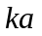 has the same direction as a if k is pos.; ka has the opposite direction as a if k is neg.
- If k > 1, the transformation is a dilation or stretch
- If 0 < k < 1, the transformation is a contraction
- The subtraction of vector is defined as: a – b = a + (–1)b
- Negative vector is defined as: –a = (–1)a
- Two non-zero vectors a and b are parallel iff a = kb ∃k∈ℝ
- A vector a whose magnitude | a | = 1 is called a unit vector
- Let be a non-zero vector, 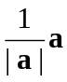 is a unit vector in same direction as a, denoted by
- Properties of scalar multiplication:
- Distributive: m(a + b) = ma + mb
- Distributive: (m + n)a = ma + na
- m(na) = (mn)a
- | a + b | ≤ | a | + | b |
- | a | – | b | ≤ | a – b |
- (1)a = a (0)a = 0
- k0 = 0

Scalar product:
- ⋅ : V × V  ℝ
- The scalar product of vectors a and b is the product of their magnitudes and the cosine of the angle btw them
- a ⋅ b = | a | | b | cosθ where θ ≤ π
- Angle θ btw two vectors a and b is given by: 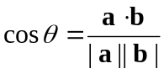
- Properties of scalar product:
- Commutative: a ⋅ b = b ⋅ a
- Associative: (λa) ⋅ b = λ(a ⋅ b) = a ⋅ (λb)
- Distributive: a ⋅ (b + c) = a ⋅ b + a ⋅ c
- Distributive: (a + b) ⋅ c = a ⋅ c + b ⋅ c
- a ⋅ a = | a |²
- a⊥b iff a ⋅ b = 0

Vector Product:
- × : V × V  V
- The vector product of vectors a and b has the magnitude of the product of their magnitudes and the sine of the angle btw them, where the direction follows the right-hand screw rule
- Magnitude: |a × b| = | a | | b | sinθ
- Direction: 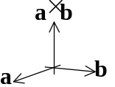
- Properties of vector product:
- 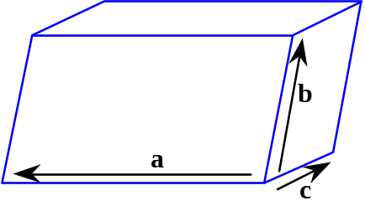a × b = – ( b × a )
- (λa) × b = λ(a × b) = a × (λb)
- (a + b) × c = a × c + b × c
- a × (b + c) = a × b + a × c
- a//b iff a × b = 0

Scalar Triple Product:
- Scalar triple product of three vectors a, b, c is defined to be (a × b) ⋅ c
- Geometrically, it represents the volume of the parallelepiped with sides a, b, c
- (a × b) ⋅ c = a ⋅ (b × c) = b ⋅ (c × a) = c ⋅ (a × b)
- The scalar triple product can be written as (a b c) as only one interpretation is possible
- a ⋅ (b × c) = –b ⋅ (a × c) = –c ⋅ (b × a) = –a ⋅ (c × b)
- If 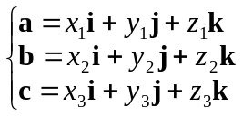, then the scalar triple product a ⋅ (b × c) =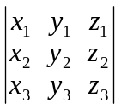
- Vectors a, b, c are coplanar iff the triple product is degenerated, i.e. a ⋅ (b × c) = 0

Vector Triple Product:
- Vector triple product of a, b, c is a × (b × c)
- a × (b × c) = (a ⋅ c)b – (a ⋅ b)c
- (a × b) × c = (a ⋅ c)b – (b ⋅ c)a
- Vector triple product a × (b × c) is a linear combination of b and c
- Triple product = (Outer ⋅ Remote) Adjacent – (Outer ⋅ Adjacent) Remote

Linear Dependency of Vectors:
- The expression k₁a₁ + k₂a₂ + ☹ + k_{n}a_{n} is called a linear combination of n vectors
- The set of vectors a₁, a₂, ☹, a_{n} are said to be linearly independent iff
k₁a₁ + k₂a₂ + ☹ + k_{n}a_{n} = 0 ⇒ k₁ = k₂ = ☹ = k_{n} = 0
- The set of vectors a₁, a₂, ☹, a_{n} are said to be linearly dependent iff there exists scalars k₁, k₂, ☹, k_{n}, who are not all zero, such that k₁a₁ + k₂a₂ + ☹ + k_{n}a_{n} = 0
- One of the vector can be written as a linear combination of other n–1 vectors
- Any vectors a & b are linearly dependent iff they are parallel
- Any vectors a, b & c are linearly dependent iff they are coplanar
- For three linearly independent vectors a, b, c in the 3D space, then any vector can be expressed uniquely as a linear combination of a, b, c
- Any four vectors in 3D space must be linearly dependent

Geometrical Application of Vectors

Position vectors:
- Position vectors are vectors in the 3D Cartesian rectangular coordinate system whose initial point is at the origin
- Basis vectors i, j, k are defined to be unit & position vectors parallel to the x-, y-, z-axis respectively
- Any point P(x, y, z) in the space can be represented by position vector P = xi + yj + zk
- xi, yj, zk are called components of P along the coordinate axes
- The vector P = xi + yj + zk is equivalent to the ordered triple (x, y, z)
- Let position vectors: a = x₁i + y₁j + z₁k & b = x₂i + y₂j + z₂k in the space
- a = b iff x₁=x₂ ∧ y₁=y₂ ∧ z₁=z₂
- a±b = (x₁ ± x₂)i + (y₁ ± y₂)j + (z₁ ± z₂)k
- ma = (mx₁)i + (my₁)j + (mz₁)k ∀m∈ℝ
- a ⋅ b=x₁x₂ + y₁y₂ + z₁z₂
- 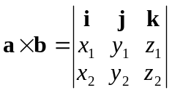

Points in Space:
- For points a = x₁i + y₁j + z₁k & b = x₂i + y₂j + z₂k in the space, if a vector c divides ab into the ratio m:n, then 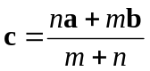
- Three distinct points a, b, c are collinear iff there exists non-zero real numbers α, β, γ such that
αa + βb + γc = 0 ∧ α + β + γ = 0
- Four non-collinear pts a, b, c, d are coplanar iff ∃ non-zero α, β, γ, δ∈ℝ such that
αa + βb + γc + δd = 0 ∧ α + β + γ + δ = 0

Vector Equation of Straight lines:
- 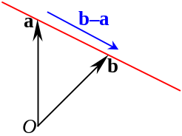Vectors a & b in ℝ³
- Any points r on the straight line passing thou’ points a & b satisfies:
r = a + λ(b–a) ∀λ∈ℝ
- Any points r on the straight line passing thou’ the point a and parallel to the vector c satisfies:
r = a + λc ∀λ∈ℝ
- 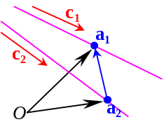Let two straight lines ₁:r = a₁ + λc₁ & ₂:r = a₂ + λc₂ in ℝ³
- ₁ & ₂ are coplanar iff a₁–a₂, c₁, c₂ are coplanar
- Criteria for ₁ & ₂ coplanar: (a₁–a₂) ⋅ c₁×c₂ = 0
- Criteria for ₁ & ₂ are skew lines: (a₁–a₂) ⋅ c₁×c₂ ≠ 0
- ₁ & ₂ are parallel iff c₁=kc₂ ∃k∈ℝ but not (a₁–a₂)⊥c₁
- Criteria for ₁ & ₂ parallel: c₁×c₂=0 ∧ (a₁–a₂) × c₁≠0
- Criteria for ₁ & ₂ coincide: c₁×c₂=0 ∧ (a₁–a₂) × c₁=0
- Criteria for ₁ & ₂ intersecting: c₁×c₂ ≠ 0
- If ₁ & ₂ are skew lines, the shortest distance btw ₁ & ₂ is: 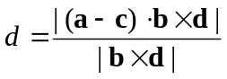
- Let straight line :r = a + λc & point P in ℝ³
- The projection of P to the line  is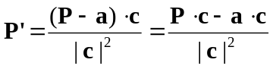 where (P'–P)⊥c
- The distance from P to  is 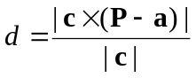

Vector Equation of Planes:
- Any points r on the plane passing thou’ the point a and with a normal unit vector n satisfies:
(r – a) ⋅ n = 0
- Alternatively, it can be written as r ⋅ n = p where p is the distance from the origin to the plane
or simply r ⋅ n = a ⋅ n
- 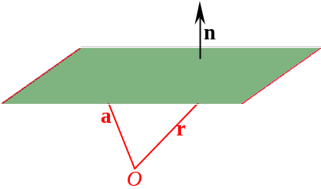The distance d from any point P to the plane r ⋅ n = p is given by P ⋅ n – p

- Any points r on the plane passing thou’ pts a, b, c satisfies:
r = αa + βb + (1–α–β)c ∀α, β∈ℝ or
r = αa + βb + γc where α, β, γ∈ℝ; α + β + γ = 1
- The equation can also be written as: (r – a) ⋅ [(b – a)×(c – a)] = 0

- 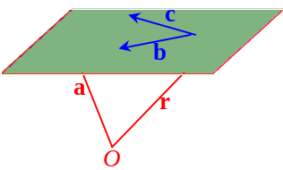Any points r on the plane that passing thou’ pt a and parallel to non-parallel and non-zero vectors b, c satisfies:
r = a + αb + βc ∀α, β∈ℝ
- Parametric equation of a plane: 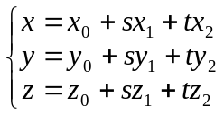 ∀s, t∈ℝ
- (x₀, y₀, z₀) is on the plane
- x₁i + y₁j + z₁k & x₂i + y₂j + z₂k are two vectors parallel to the plane
- For three distinct points (x₀, y₀, z₀), (x₁, y₁, z₁) & (x₂, y₂, z₂) on the plane,
The parametric equation of the plane is: 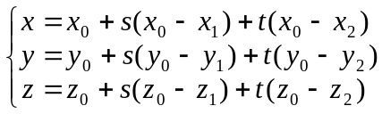 ∀s, t∈ℝ
- Let straight line : r = a + λc and plane π: r ⋅ n = p in ℝ³
-  parallel to π iff the line  ⊥ normal or π
- Criteria for  intersects with π: c ⋅ n ≠ 0
- Criteria for  lies on π: c ⋅ n = 0 ∧ a ⋅ n = p
- Criteria for  parallel to π: c ⋅ n = 0 ∧ a ⋅ n ≠ p
- The projection of  on π: r = a + λc + [(a + λc) ⋅ n – p]n
- Let planes π₁: r ⋅ n₁ = p₁ & π₂: r ⋅ n₂ = p₂ in ℝ³
- π₁ is parallel to π₂ iff the normals are parallel
- Criteria for π₁ intersects with π₂: n₁ × n₂ ≠ 0
- Criteria for π₁ coincides with π₂: n₁ × n₂ = 0 ∧ p₁n₂ = p₂n₁
- Criteria for π₁ parallel to π₂: n₁ × n₂ = 0 ∧ p₁n₂ ≠ p₂n₁
- If planes π₁ & π₂ are intersect, the angle θ btw planes is given by: 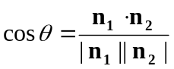

Scalar product = Dot product = Inner product
Vector product = Cross product

