Pure Math – Polar Coordinate System

Polar Coordinate System

Polar Coordinates:
- Polar coordinate system consists of a pole O and a polar axis OX
- 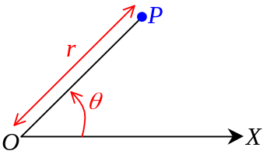O is a fixed point and OX is a fixed ray
- Any point P in the polar coordinate system has the coordinate (r, θ)
- Polar coordinates of point P
- The line OP is a radius vector of length r
- θ is the vectorial angle measured counter-clockwisely
- Polar coordinate of a point is not unique
- (r, θ) = (r, 2nπ+θ) = (r, –(2nπ–θ))
(r, θ) = (–r, θ–π) = (–r, (2n+1)π+θ)

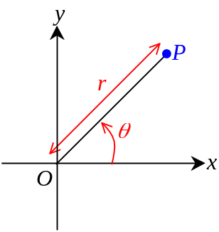Transformation btw Polar & Cartesian coordinate system:
- When P(r, θ) is transformed to Cartesian rectangular coordinate system,
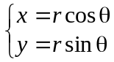
- When P(x, y) is transformed to polar coordinate system,
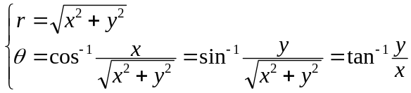

Polar equation

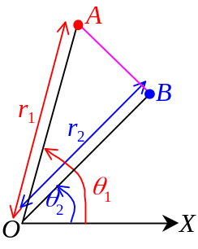Distance formula:
- Let two points A(r₁, θ₁) & B(r₂, θ₂) in a polar coordinate system
- The distance d of the line segment AB is: 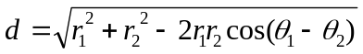

Behavior of polar equation curve:
- Polar equation: Equation written in the form r = f(θ) or f(r, θ) = 0
- Put θ = 0 and θ = π into the polar equation, the values obtained for r is the
intercepts of the curve on the initial line
- 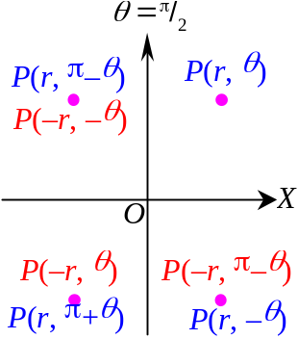The curve is symmetric about the initial line if the equation of the curve remains unaltered when:
- θ is replaced by –θ or
- r, θ is replaced by –r, π–θ
- If the curve passes the point (r, θ),
it also passes the point (r, –θ) or (–r, π–θ)
- The curve is symmetric about the pole if the eqn of curve unaltered when:
- r is replaced by –r or
- θ is replaced by π+θ
- If the curve passes the point (r, θ),
it also passes the point (–r, θ) or (r, π+θ)
- The curve is symmetric about the ray θ = ^{π}/₂ if the eqn of curve unaltered when:
- θ is replaced by π–θ or
- r is replaced by –r and θ is replaced by –θ
- If the curve passes the point (r, θ),
it also passes the point (r, π–θ) or (–r, –θ)
- If ∀θ∈ℝ, r∈ℝ, then the equation has no restriction in θ
- If ∃θ₀, 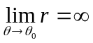, the curve extends infinitely at θ = θ₀

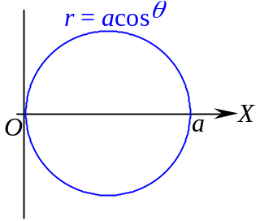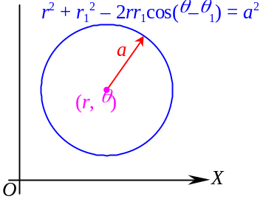Common Polar Curves:
- Circle:
- r = a cos θ
- General case:
r² + r₁² – 2rr₁cos(θ–θ₁) = a²
- 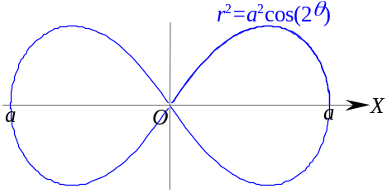Lemniscate:
- 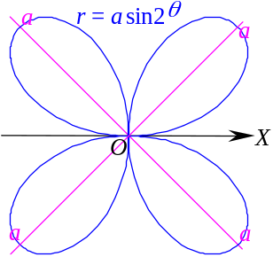r² = a²cos(2θ)
- 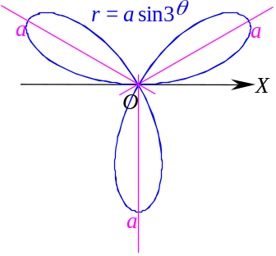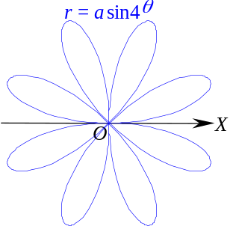Rose:
- Three-leaved: r = a sin3θ
- Four-leaved: r = a sin2θ
- Eight-leaved: r = a sin4θ
- 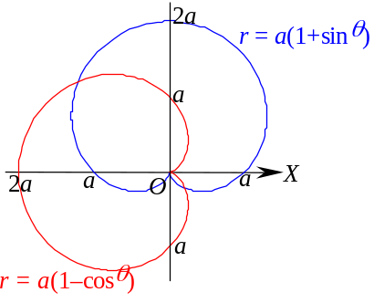Cardioid:
- r = a(1–cosθ)
- r = a(1+sinθ)
- 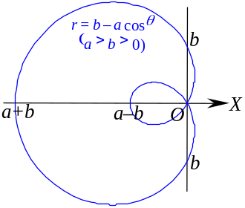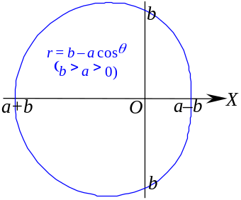Limacon:
- r = b – a cosθ where a > b > 0
- r = b – a cosθ where b > a > 0
- 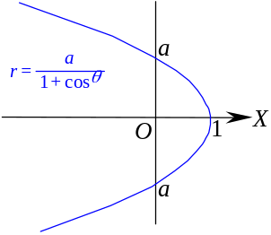Parabola:
- 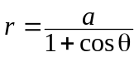
- 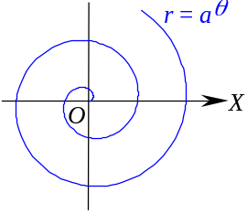Spiral of Archimedes
- r = aθ where a > 0
- 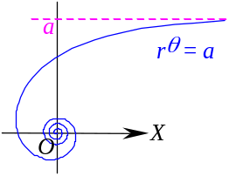Reciprocal spiral
- rθ = a where r, θ, a > 0
- 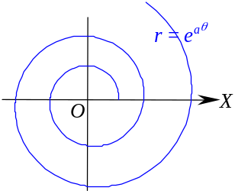Logarithmic spiral
- r = e^{aθ} where a > 0

Angle btw Radius vector & Tangent vector:
- 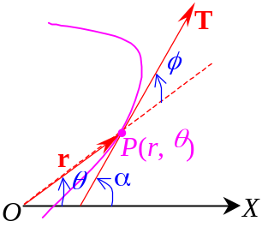Any point P(r, θ) on the polar curve, r = OP is the radius vector
- Vector T is the tangent vector
- If the polar curve is r = f(θ), than in Cartesian coordinate system,
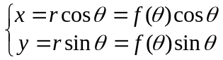
- 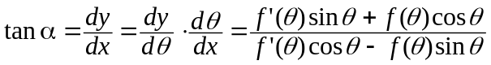
- 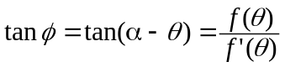

Polar axis = Initial line
Polar equation = Polar form equation = Equation in polar coordinate form

