Pure Math – Geometric Applications of Definite Integrals

Area of Plane Figures

Cartesian coordinate system:
- The area under the equation y = f(x) in the region x∈[a, b] is given by: 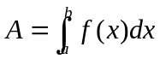
- The area under the x-axis is negative whereas above the axis is positive
- The area bounded by the equations y = f(x) and y = g(x) in the region x∈[a, b] is given by: 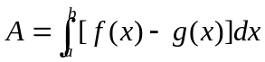
- The area under the equation x = f(y) in the region y∈[a, b] is given by: 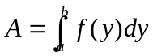
- The area at right-hand side of the y-axis is positive whereas at left-hand side of the axis is negative
- 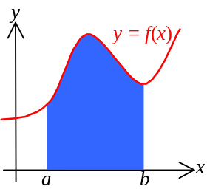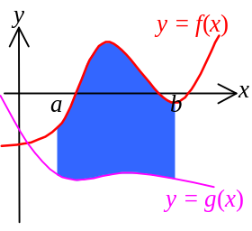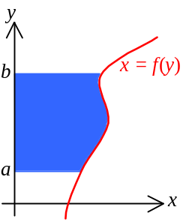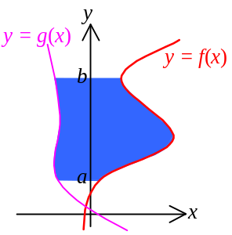The area bounded by the equations x = f(y) and x = g(y) in the region y∈[a, b] is given by: 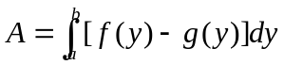

Parametric equations:
- When a curve is given by parametric equation: 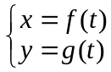 ∀t∈ℝ
- The area at the range x∈[a, b] is: 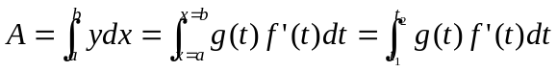
- a = f(t₁) i.e. x = a when t = t₁
- b = f(t₂) i.e. x = b when t = t₂
- The absolute area at the range x∈[a, b] is: 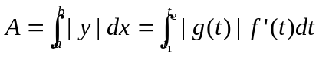

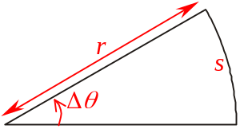Polar equations:
- Definite integrals can be used to find the area bounded by r = f(θ) and radius vectors θ =θ₁, θ =θ₂
- For a sector with angle Δθ and radius r has the area 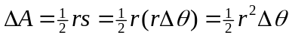
- 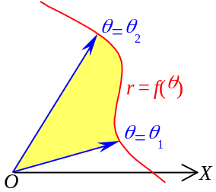The total area of r = f(θ) from θ =θ₁ to θ =θ₂ is: 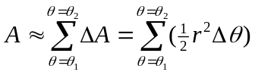
- When taking the limit Δθ → 0,
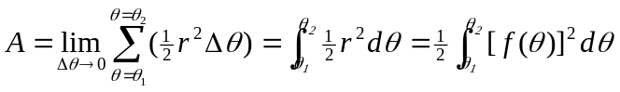

- 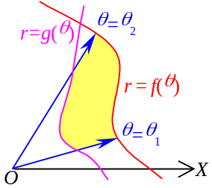The area enclosed by r = f(θ), r = g(θ) and the radius vectors θ =θ₁, θ =θ₂:
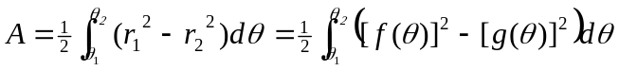

Arc Length

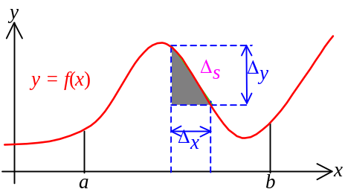Cartesian coordinate system:
- In the curve y = f(x), the length of the curve in x∈[a, b] is s
- In any partition of line ab, whose width is Δx and difference in f(x) is Δy, the portion of the curve is approximately equal to: 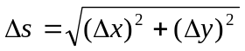
- The total length of curve: 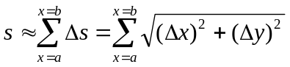
- By taking the limit Δx→0,
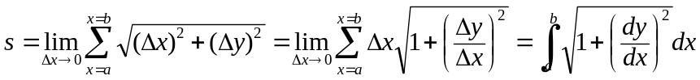
- Length of curve: 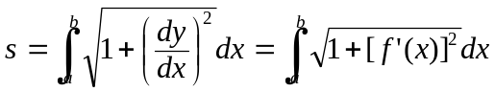

Parametric equations:
- When a curve is given by parametric equation: ∀t∈ℝ
- The length of curve at the range x∈[a, b] is:
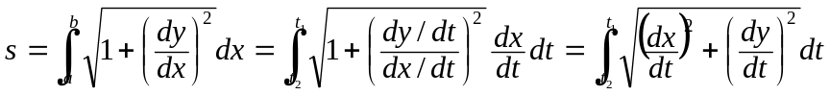
- Length of curve: 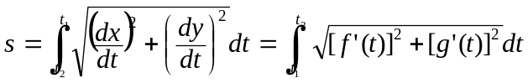
- a = f(t₁) i.e. x = a when t = t₁
- b = f(t₂) i.e. x = b when t = t₂

Polar equations:
- The length of curve of the equation r = f(θ) from θ =θ₁ to θ =θ₂:
- Transformed to Cartesian coordinate: 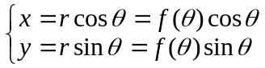
- Length of curve: 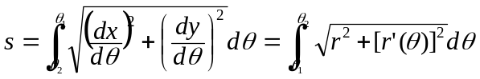

Volume of Solids of Revolution

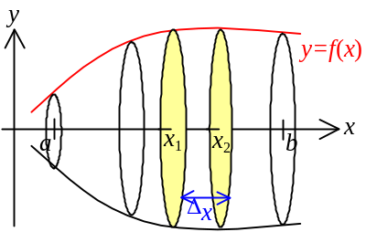Disc method:
- Let y = f(x) be a cts function defined on [a, b] and the curve is revolved about the x-axis
- At any partition [x₁, x₂] in [a, b] which has the width Δx, the volume of revolution of the curve in this partition is like a disc
- Volume of a disc: ΔV = πr²h = πy²(Δx) = π[f(x₁)]²Δx
- Total volume of revolution: 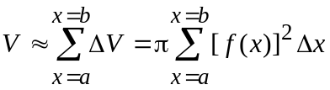
- When taking the limit Δx→0,
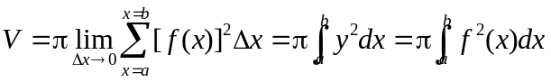
- 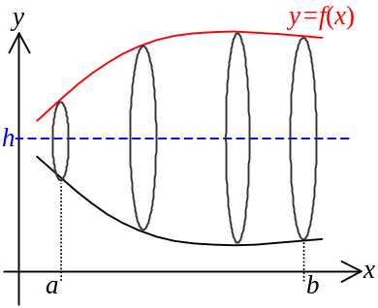The volume of revolution of y = f(x) about the line y = h in the region x∈[a, b] is:
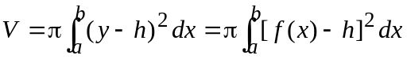
- The volume of revolution of x = f(y) about the y-axis in the region y∈[a, b] is:
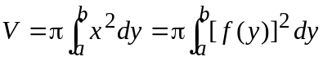

- 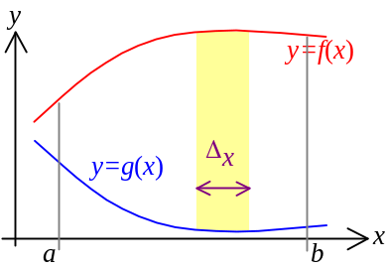The volume of revolution of x = f(y) about the line x = k in the region y∈[a, b] is:
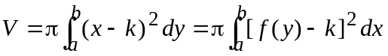

Shell method:
- Let y = f(x) and y = g(x) be cts functions defined on [a, b]
- The area bounded by y = f(x), y = g(x), x = a, x = b is on the xy-plane
- The area is revolved about the y-axis
- At any partition in [a, b] of the x-axis, which has the width Δx, the strip revolved is like a hollow cylinder
- Volume of the cylinder: ΔV = (2πx)[ f(x) – g(x)](Δx)
- Total volume is: 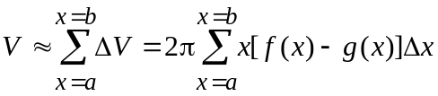
- By taking the limit Δx → 0, 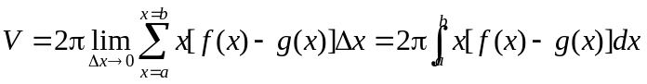
- Volume of revolution: 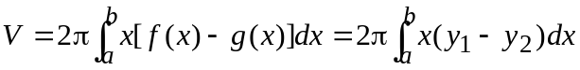
- y₁ = f(x) y₂ = g(x)
- y₁ ≥ y₂
- Let y = f(x) and y = g(x) be cts functions defined on [a, b]
- The area bounded by y = f(x), y = g(x), x = a, x = b is on the xy-plane
- Area bounded by curves x = f(y) and x = g(y) in the region y∈[a, b] is revolved about the x-axis
- Volume of revolution: 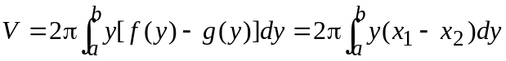

Solids w/known parallel cross section:
- For a solid which the cross-sectional area perpendicular to the x-axis is known
- The area at any position x₀ on the x-axis is A(x₀)
- The volume of the solid between positions x = a and x = b is: 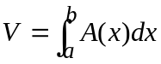

Area of Surface of Revolution

Area of surface of revolution:
- A curve y = f(x) in the region x∈[a, b] is revolved about the x-axis
- In any partition in [a, b] on the x-axis, whose width is Δx, the curve is:
- When revolved, the area of the surface is ΔA = 2πyΔs = 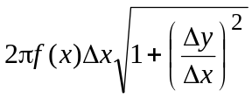
- Total area: 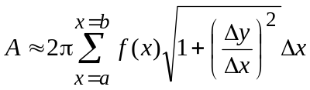
- By taking the limit Δx → 0
Total area: 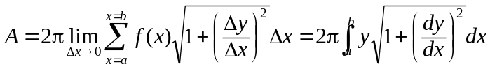
- Area of the surface of revolution: 