Pure Math – Complex Numbers

Definition

Complex Set:
- The set ℂ is defined to be the set of all complex numbers:
ℂ = { a+bi: a, b∈ℝ ∧ i ² = –1 }
- Any two complex numbers z₁ = a₁+b₁i and z₂ = a₂+b₂i are equal iff a₁=a₂ ∧ b₁=b₂
- A complex number z=a+bi is said to be purely imaginary iff a=0 ∧ b≠0
- Let z=a+bi be a complex number,
- Function Re(z) returns the real part of z, i.e. Re(z) = a
- Function Im(z) returns the imaginary part of z, i.e. Im(z) = b
- Complex number: z = Re(z) + Im(z) i

Conjugate & Modulus:
- Conjugate of a complex number is defined as: 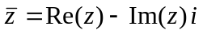
- 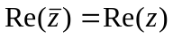; 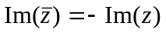
- 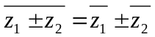
- 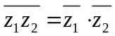
- 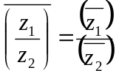
- Modulus of a complex number is defined as: 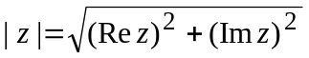
- 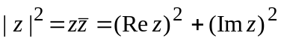
- 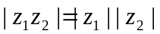
- 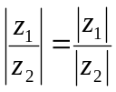
- 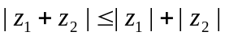

Complex Arithmetic

Real multiplication:
- ⋅ : ℝ × ℂ → ℂ
- z∈ℂ k∈ℝ kz = kRe(z) + kIm(z) i
- Negative complex number is defined as: –z = (–1)z

Addition operation:
- + : ℂ × ℂ → ℂ
- z₁, z₂∈ℂ z₁ + z₂ = Re(z₁)+Re(z₂) + [Im(z₁)+Im(z₂)] i
- Properties of addition:
- z₁ + z₂ = z₂ + z₁
- z₁ + (z₂ + z₃) = (z₁ + z₂) + z₃
- z + 0 = 0 + z = z
- z + (–z) = 0
- Subtraction is defined as: z₁ – z₂ = z₁ + (–z₂)

Multiplication & division operation:
- × : ℂ × ℂ → ℂ
- ÷ : ℂ × ℂ → ℂ
- z₁, z₂∈ℂ z₁ × z₂ = z₁z₂ = [Re(z₁)Re(z₂)–Im(z₁)Im(z₂)] + [Re(z₁)Im(z₂)+Re(z₂)Im(z₁)] i
- z₁, z₂∈ℂ 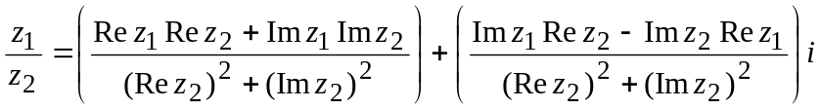

Polar Form Representation

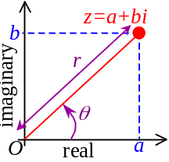Polar form:
- z = a + bi : Standard form representation of a complex number
- When z is presented on the Argand diagram, it is a point with real coordinate a and imaginary coordinate b
- z is a position vector where length = r and makes an angle θ w/real axis
- 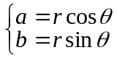
- Polar form of complex number: z = r(cosθ + isinθ)
- Argument has the principle value: –π < θ ≤ π
- Arg(z) = θ =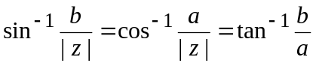
- r = | z | = Modulus of z
- When z₁ = r₁ (cosθ₁+ isinθ₁) and z₂ = r₂ (cosθ₂+ isinθ₂),
- z₁z₂ = r₁r₂[cos(θ₁+θ₂) + isin(θ₁+θ₂)]
- By induction, 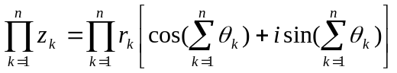
- 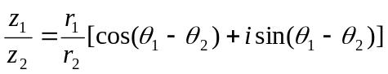
- Arg(z₁z₂) = Arg(z₁) + Arg(z₂) + 2nπ ∃n∈ℕ
- 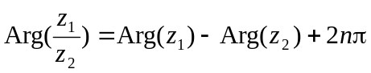 ∃n∈ℕ

Exponential form:
- exp : ℂ → ℂ
- exp(z) = e^{z} = e^{a+bi} = eª e^{ib}
- By Taylor’s theorem, 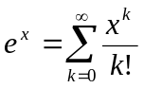; 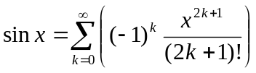; 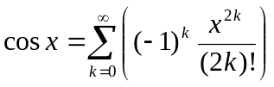
- 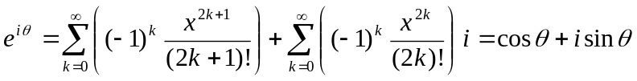
- cosθ + i sinθ = e^{iθ}
- r (cosθ + i sinθ) = re^{iθ} = rexp(iθ)

Some important formulae:
- Re(z₁ + z₂) = Re(z₁) + Re(z₂)
- Re(z₁z₂) ≤ | z₁z₂ |
- Re(z) ≤ | z |; Im(z) ≤ | z |
- 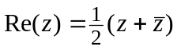; 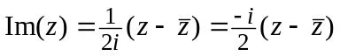
- 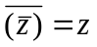
- 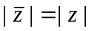; 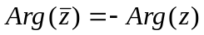
- 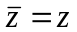 ⇔ z∈ℝ
- | z^{n} | = | z |^{n}; 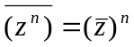

Geometric representation of Complex Numbers

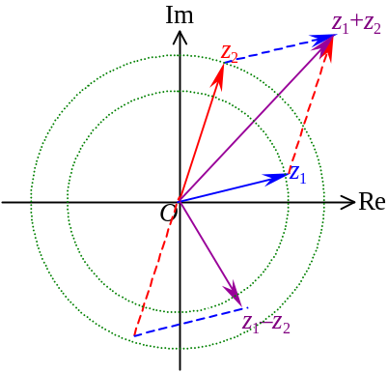Argand Diagram:
- Any complex number in Argand diagram is a vector in ℝ²
- A complex number z = a + bi can be represented by row vector z = [a b]
- Addition: [a₁ b₁] + [a₂ b₂] = [a₁+a₂ b₁+b₂]
- Triangle inequality: | z₁ + z₂ | ≤ | z₁ | + | z₂ |
- | | z₁ | – | z₂ | | ≤ | z₁ + z₂ |
- | | z₁ | – | z₂ | | ≤ | z₁ – z₂ |
- 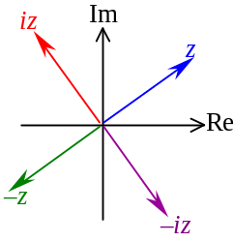Multiplication: Arg(z₁z₂) = Arg(z₁) + Arg(z₂);
- Multiply i to z rotate it for 90° counterclockwise in the Argand diagram
- 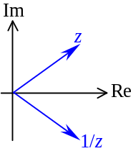Division: 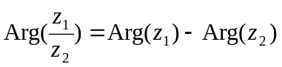; 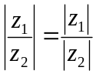
- If | z | = 1, 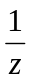 is the reflection of z about the real axis

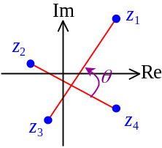Angle btw Complex Numbers:
- Let complex numbers z₁, z₂, z₃, z₄ on the Argand diagram
- The angle θ between vectors z₁z₃ and z₂z₄ is: 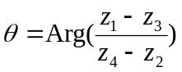
- If z₁z₃ ⊥ z₂z₄, 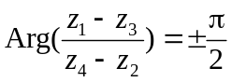 or 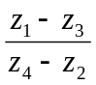 is pure imaginary
- 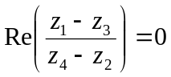 or 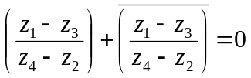 or 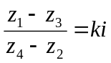 ∃k∈ℝ
- If z₁z₃ // z₂z₄, 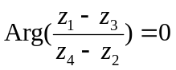or π, i.e. is real
- 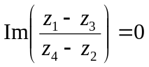 or 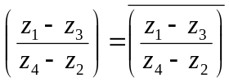 or ∈ℝ
- 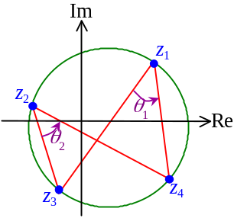Complex numbers z₁, z₂, z₃ are collinear on the Argand diagram iff 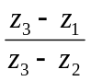∈ℝ
- z₁, z₂, z₃ are collinear iff z₃z₁ // z₃z₂
- Alternatively, ∃λ₁, λ₂, λ₃∈ℝ s.t. λ₁+λ₂+λ₃=0 ∧ λ₁z₁+λ₂z₂+λ₃z₃=0
- If complex numbers z₁, z₂, z₃, z₄ are concyclic,
- 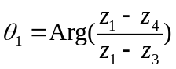 and 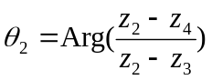 are equal
- 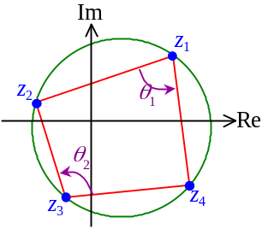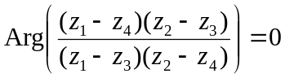 or 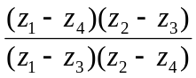 is a non-zero real no.
- On the other hand, 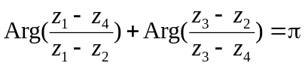
- 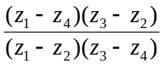∈ℝ or 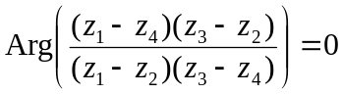
- Conversely, if ∈ℝ, z₁, z₂, z₃, z₄ are either concyclic or collinear

Transformation:
- Complex-valued function is a function whose range is the set ℂ
- f: ℂ → ℂ
- Let a fixed complex number z on the Argand diagram,
- f(z) = z + a will do translation to z
- f(z) = bz will do enlargement to z
- | f(z) | = | b || z |
- Arg f(z) = Arg b + Arg z
- 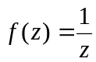 will do reflection about real axis
- f(z) = αz + β will do linear transformation to z
- 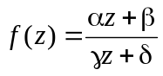 will do bilinear transformation to z

Locus

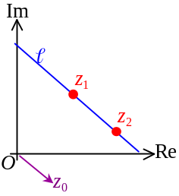Straight line:
- A point z₁ is on line  and a vector z₀ is parallel to 
- Equation of : z = z₁ + kz₀ ∀z∈ℝ
- Parametric form equation
- Line  joining pts z₁ and z₂, ∴: z = z₁ + k(z₁–z₂)
- After transformation, the equation z = z₁ + kz₀ would becomes
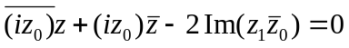
- General form of a straight line: 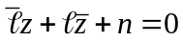 ∃∈ℂ, ∃n∈ℝ
- Straight line Ax + By + C = 0 on Cartesian plane transformed to complex form would become:
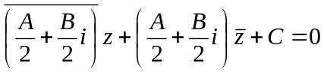

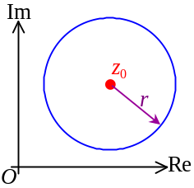Circle:
- General form: | z – z₀ | = r or | z – z₀ |² = r²
- Center: z₀
- Radius: r
- A circle x² + y² + Dx + Ey + F = 0 on Cartesian plane transformed to complex form would become:
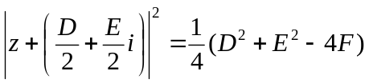

De Moivre’s Theorem

De Moivre’s Theorem:
- If z = r(cosθ + i sinθ) = re^{iθ},
z^{n} = r^{n} e^{i(nθ)} = r^{n}(cos nθ + i sin nθ) ∀n∈ℝ
- When applying the De Moivre’s Theorem,
- 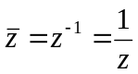
- 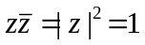 if z = e^{iθ}
- 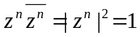 if z = e^{iθ}

Application in Trigonometry:
- Let z = cosθ + i sinθ = e^{iθ}
- 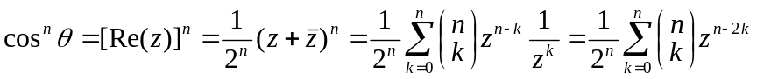
- When n is odd, 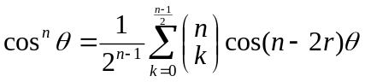
- When n is even, 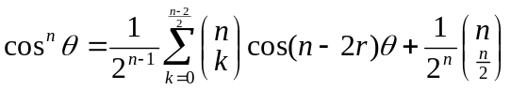
- When n is odd, 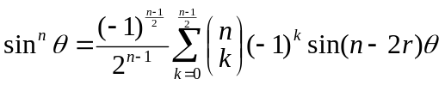
- When n is even, 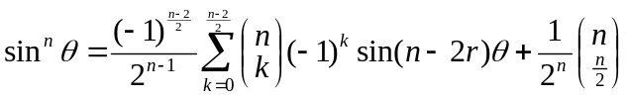
- 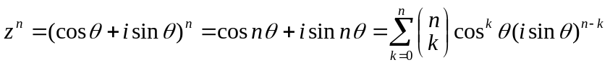
- 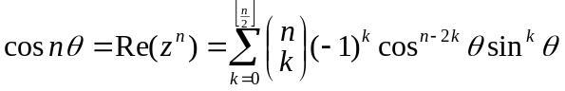
- When n is odd, 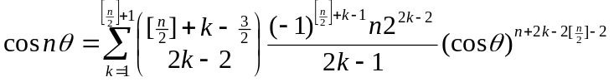
- When n is even, 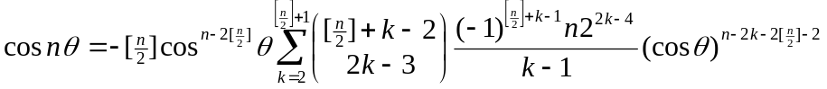
- 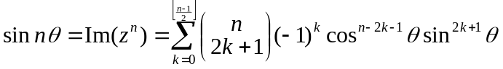
- 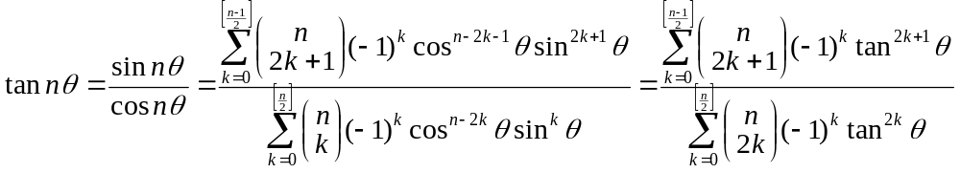

n^{th} Root of a Complex Number:
- Any complex number z = r(cosθ + i sinθ) has exactly n distinct n^{th} roots
- If ω^{n} = z = r(cosθ + i sinθ),
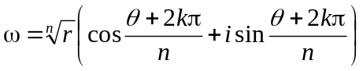 k = 0, 1, 2, …, (n–1); r > 0
- 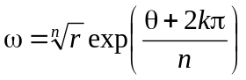

Factorization

Roots of Unity:
- 1 = cos 0 + i sin 0 = e^{i0} = e^{i(2kπ)} ∀k∈ℤ
- Since ω^{n} = cosθ + i sinθ ⇒ 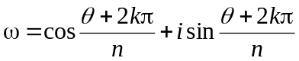,
- If let 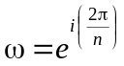, 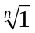 are ω^{k} k = 0, 1, 2, …, (n–1)
- 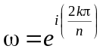 k = 0, 1, 2, …, (n–1)
- n^{th} roots of unity
- Properties of n^{th} roots of unity:
- If 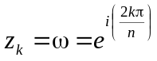, 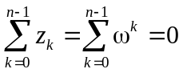
- If z^{n} = Z, 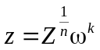 k = 0, 1, 2, …, (n–1)
- a³ + b³ = (a + b)(a + bω)(a + bω²)
- a³ – b³ = (a – b)(a – bω)(a – bω²)
- a² + b² + c² – ab – bc – ca = (a + bω + cω²)(a + bω² + cω)
- a³ + b³ + c³ – 3abc = (a + b + c)(a + bω + cω²)(a + bω² + cω)

Factorization:
- 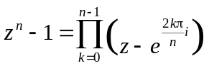
- If n is even, 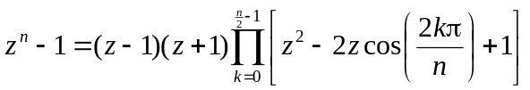
- If n is odd, 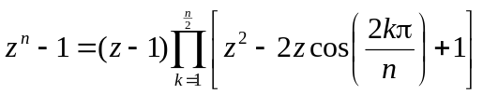
- 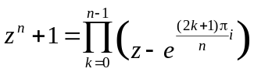
- If n is even, 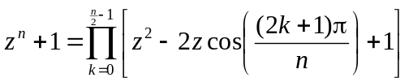
- If n is odd, 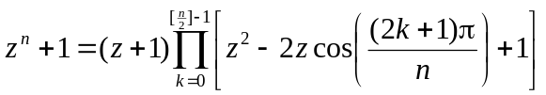
- 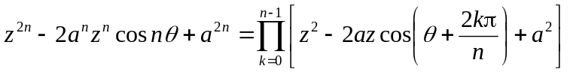
- a∈ℝ
- n∈ℕ

Standard form = Rectangular form = Algebraic form
Argand diagram = Argand plane = Complex plane
Polar form = Trigonometric form
Argument = Amplitude
Modulus = Absolute value

