Trigonometry Formula

Relations among Trigo functions:
sin²θ + cos²θ = 1
sec²θ – tan²θ = 1
csc²θ – cot²θ = 1
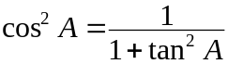
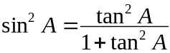

Inverse Trigo. functions:
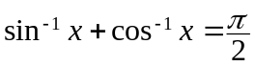
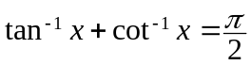
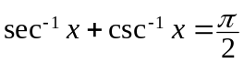
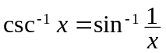
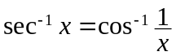
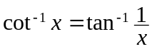
sin^{–1}(–x) = – sin^{–1}x
cos^{–1}(–x) = π – sin^{–1}x
tan^{–1}(–x) = – tan^{–1}x
cot^{–1}(–x) = π – cot^{–1}x
sec^{–1}(–x) = π – sec^{–1}x
csc^{–1}(–x) = – csc^{–1}x

Compound angle formulae:
sin(A+B) = sinA cosB + cosA sinB
cos(A+B) = cosA cosB – sinA sinB
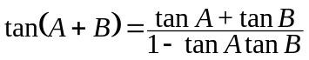
sin(A–B) = sinA cosB – cosA sinB
cos(A–B) = cosA cosB + sinA sinB
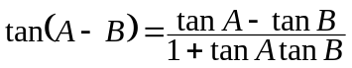

Subsidiary angle form:
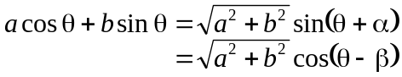
where 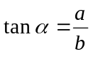, 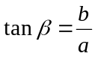

Multiple angle formulae:
sin2A = 2 sinA cosA
cos2A = cos²A – sin²A
= 2 cos²A – 1 = 1 – 2 sin²A
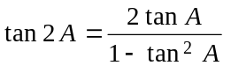
sin3A = 3sinA – 4sin³A
cos3A = 4cos³A – 3cosA
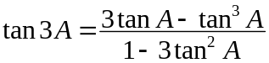

Half angle formulae:
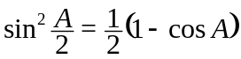
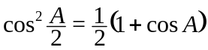
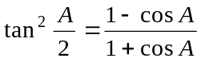
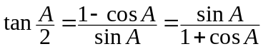
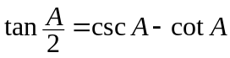
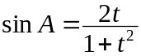
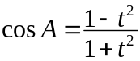
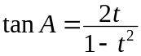

Transformation of Sum & Product:
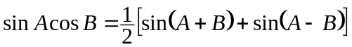
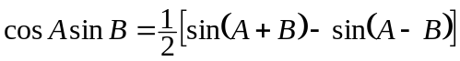
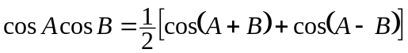
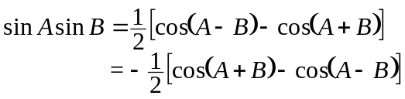
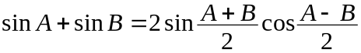
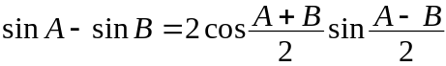
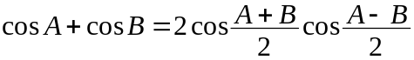
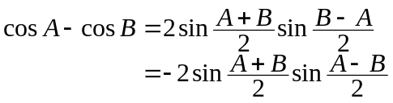

Differentiation Formula

Algebraic Function:
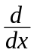c = 0
x = 1
x ^{n} = n x ^{n–1}
(u ± v) =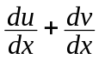
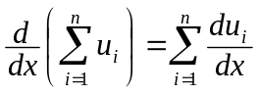
(uv) =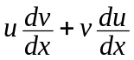
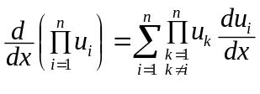
k u = k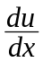
u ^{n} = n u ^{n–1}
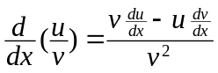
If y = F(x) = f (u) = f (g(x)),
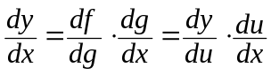

Logarithmic Function:
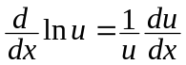
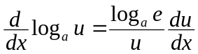

Exponential Function:
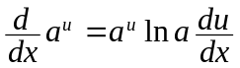
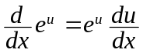
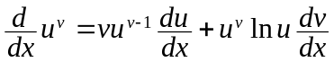

Trigonometric Function:
sin u = cos u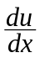
cos u = – sin u
tan u = sec²u
cot u = – csc²u
sec u = sec u tan u
csc u = – csc u cot u
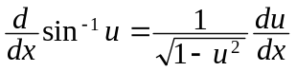
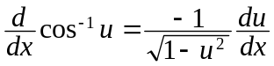
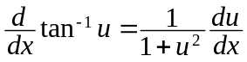
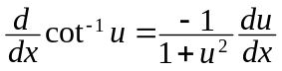
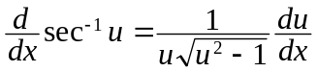
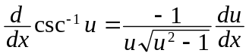

Integration

Polynomial & Functions:
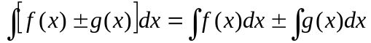
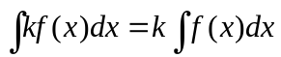 ∀k∈R
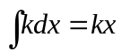
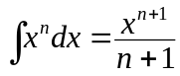

Trigonometric Functions:
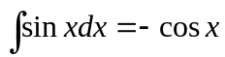
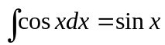
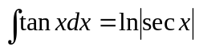
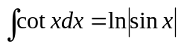
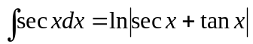
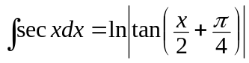
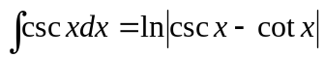
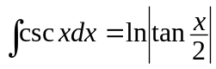



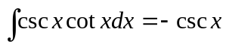
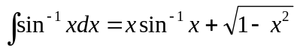
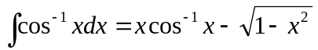
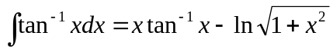
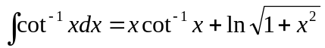
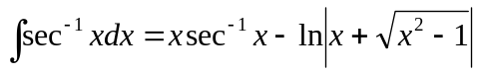
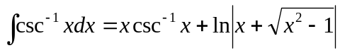

Exponential & Logarithmic Function:
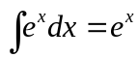
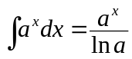
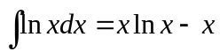

Integrals involving Reciprocals:
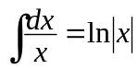
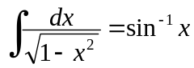
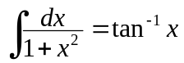
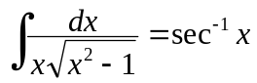
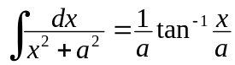
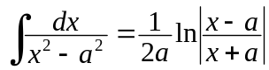
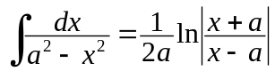
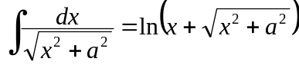
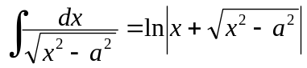
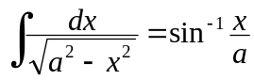

Square Roots:
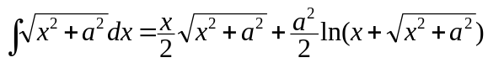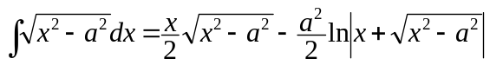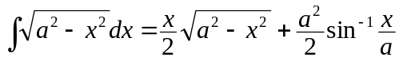

Common reduction formulae:
