Pure Math – Precise

Algebra

Binomial:
- _{n}C_{r} = _{n}C_{n–r}
- _{n}C_{r} + _{n}C_{r+1} = _{n+1}C_{r+1}
- 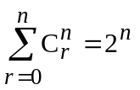
- 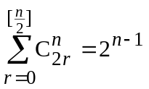
- 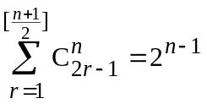

Polynomial:
- Euclidean Algo.: f, g, q, r∈ℝ[x] ∧ f=qg+r, ∃d∈ℝ[x] s.t. ( f, g) = (g, r) = d
- In the cubic equation, x³ + px² + qx + r = 0 :
p = –(α + β + γ )
q = αβ + βγ + αγ
r = –αβγ
- Newton’s formula of power of roots: 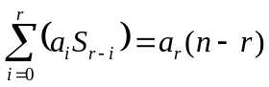 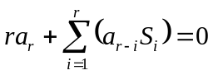
Where 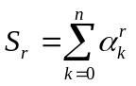 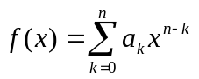 a_{i} are zeros of f(x)
- If 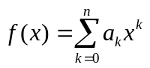, then 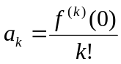 and 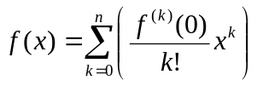
- 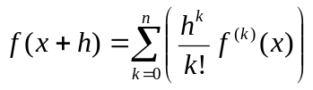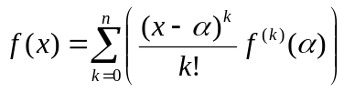

Inequalities:
- 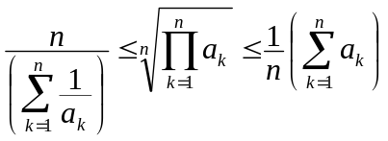
- 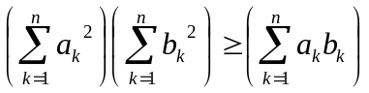

Determinants:
- Any two rows/columns interchanged, the sign of the determinant changed.
- The rows and columns of the determinant interchanged, value remains unchanged.
- Any two rows/columns of the determinant is identical, the determinant vanishes.
- Any row/column of the determinant multiplied by k, the value also multiplied by k.
- Any row/column is added by any multiple of another row/column, the value is unchanged.
- Any row/column is a sum or difference of two elements, the determinant can be broken into two determinants.
- Crammer’s Rule: 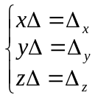
- Non-trivial soln. of 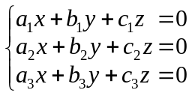 satisfies: 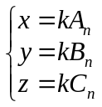

Matrix:
- λA = Aλ = [λa_{ij}]_{m×n}
- det AB = (det A)(det B)
- 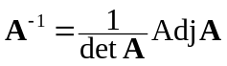

Sequence & Series:
- 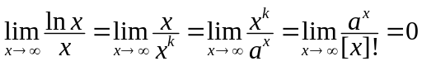
- 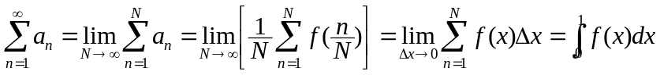
where 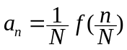

Complex number:
- z₁z₂ = r₁r₂[cos(θ₁+θ₂) + isin(θ₁+θ₂)]
- 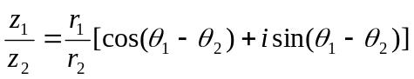
- 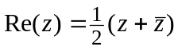; 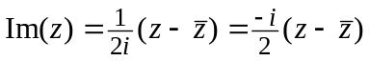
- 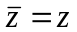 ⇔ z∈ℝ
- | z^{n} | = | z |^{n}; 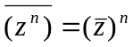
- z^{n} = r^{n} e^{i(nθ)}

Calculus

Limit:
- 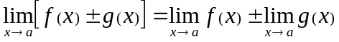
- 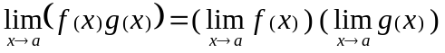
- 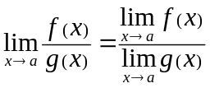 (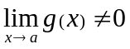)
- 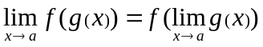
- 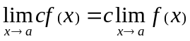
- 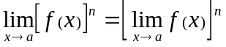

Differentiation:
- 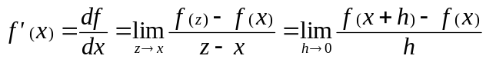
- 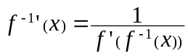 and 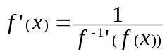
- Mean Value Th: f is cts on [a, b] & diffble on (a, b)  x_{o}(a, b) s.t.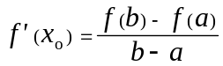
- Leibniz formula: 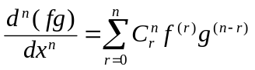

Indefinite integral:
- 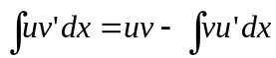
- 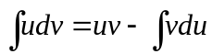
- 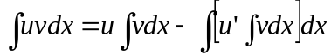

Definite integral:
- First Fundamental Th: 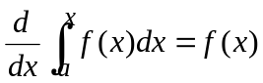
- Second Fundamental Th: 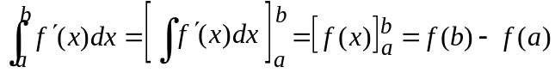
- 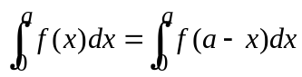
- 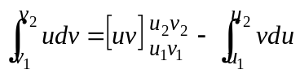
- Geometric Application:
 | y= f(x) | 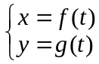 | r = f(θ)
Area | 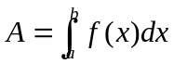 | 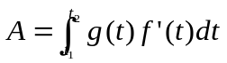 | 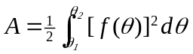
Arc length | 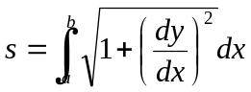 | 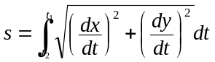 | 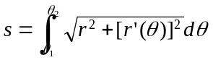
- Disc method: 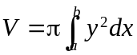
- Shell method: 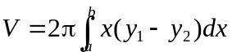
- Known cross-section: 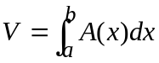
- Surface of revolution: 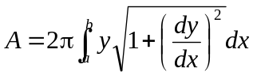

Coordinate Geometry

2D Coordinate Geometry:
- Angle btw 2 st. line: 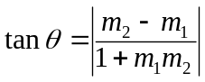

3D Coordinate Geometry:
- 