Grade 6: Power Practice Quiz, Week 19
Post Unit 4 Assessment: Dividing Fractions

Q | Correct Answer | Standard | YOY | Point Value | Distractors / Scoring Guidance
1 | C | 6.NS.A.1 | New! Adapted from NYS 2025 #6 | 1 | - Did not flip second fraction  - Added  - Correct  - Rounded up instead of down
2 | A | 6.NS.A.1 | 24-25 Week 19 PPQ #2 | 1 | - Correct  - Wrong order for division  - Divided numerators and kept the denominator  - Did not flip second fraction
3 | B | 6.NS.A.1 | 24-25 Week 19 PPQ #3 | 1 | - Did not flip second fraction  - Correct  - Divided by both numerator and denominator (15$÷9÷2)$  - Flipped first fraction
4 | B | 6.NS.A.1 | 24-25 Week 19 PPQ #4 | 1 | - Subtracted  - Correct  - Multiplied  - Multiplied
5 | C | 6.NS.A.1 | 24-25 Week 19 PPQ #5 | 1 | - Reversed the order of division  - Thinking of the greatest integer number of cups that will fit in each container  - Correct  - Incorrectly interpreted as a multiplication problem
6 | C | 6.NS.A.1 | 24-25 Week 19 PPQ #6 | 1 | - Just the whole  - Wrong remainder  - Correct  - Number of original wholes

*Exemplar below.

1 | 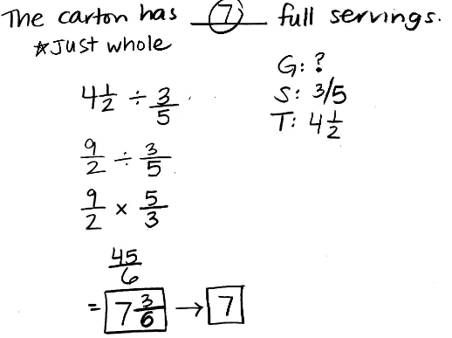  A carton contains $4\frac{1}{2}$ cups of ice cream. One full serving is $\frac{3}{5}$ cup. What is the total number of full servings of ice cream in the carton?  - $2\frac{7}{10}$  - $5\frac{1}{10}$  - $7$  - $8$
2 | 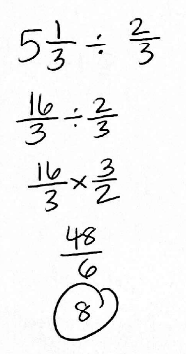  A recipe for cookies calls for $\frac{2}{3}$ of a cup of sugar per batch. Elena used $5\frac{1}{3}$ cups of sugar to make multiple batches of cookies. How many batches did she make?  - $8$  - $\frac{1}{8}$  - $\frac{8}{3}$  - $\frac{32}{9}$
3 | 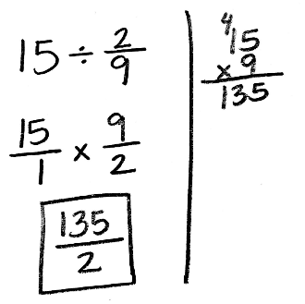  Find the quotient: $15÷\frac{2}{9}$  - $\frac{30}{9}$  - $\frac{135}{2}$  - $\frac{15}{18}$  - $\frac{2}{135}$
4 | 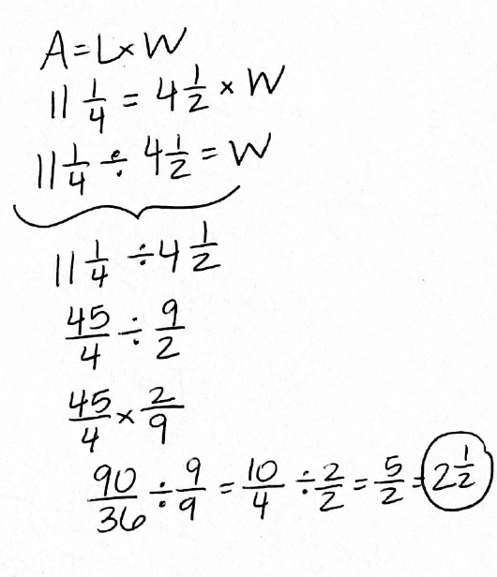  Lin has a rectangular baking pan. She lines the bottom of the pan with aluminum foil. The area of the rectangular piece of foil is $11\frac{1}{4}$ square inches. Its length is $4\frac{1}{2}$ inches. What is the width of the foil?  - $6\frac{3}{4}$ inches  - $2\frac{1}{2}$ inches  - $50\frac{5}{8}$ inches  - $\frac{405}{8}$ inches
5 | 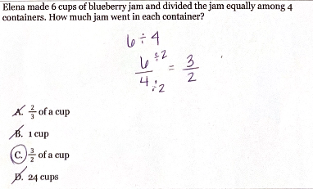
6 | 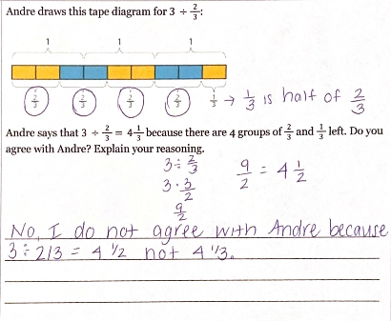  What is the quotient?  - $4$  - $4\frac{1}{3}$  - $4\frac{1}{2}$  - $3$

