Grade 8 Algebra: Power Practice Quiz, Week 15
Q | Correct Answer | Standard | YOY | Distractors
1 | C | A.REI.12 |  | - On the dotted line, does not satisfy the inequality  - Results in false inequality, not in solution set. Potentially switched x and y values when substituting.  - Correct  - Results in a false inequality, not in the solution set
2 | D | A.REI.3 |  | - Didn’t distribute correctly and wrong sign  - Wrong sign  - Didn’t distribute correctly  - Correct
3 | A | A.REI.3 |  | - Correct  - Did not flip inequality sign  - Computation error when isolating $x$  - Computation error when isolating $x$ and did not flip inequality sign.
4 | C | A.REI.12 |  | - Correct inequality symbol, swapped the slope and $y$-intercept  - Incorrect inequality symbol, swapped slope, and $y$-intercept  - Correct  - Incorrect inequality symbol, graph is shaded above the line.
5 | B | A.REI.12 |  | - Error using properties of equality when converting into slope intercept form, resulting in a negative slope  - Correct  - Did not divide by the coefficient of y term when converting into slope-intercept form before identifying slope and y-intercept  - Correctly converted inequality into slope-intercept form, but graphed $≤$ with a solid line
6 | A | G.GPE.5 | N.A | - Correct  - Gives equation for Line K  - Finds reciprocal for slope but not OPPOSITE  - Finds OPPOSITE for slope but not reciprocal

*Exemplar on the next page.
1 | 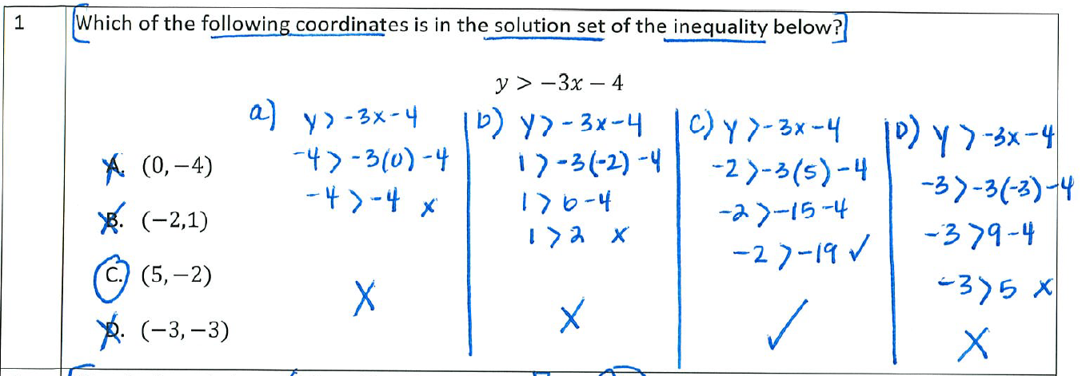
2 | 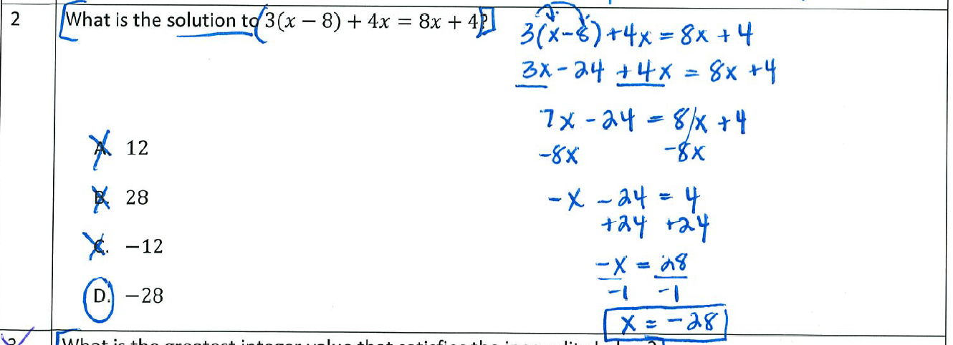
3 | 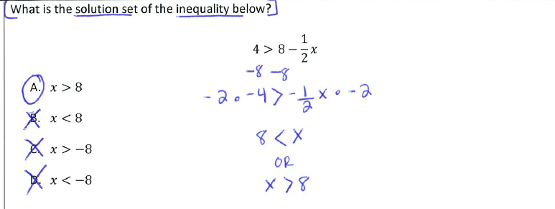
4 | 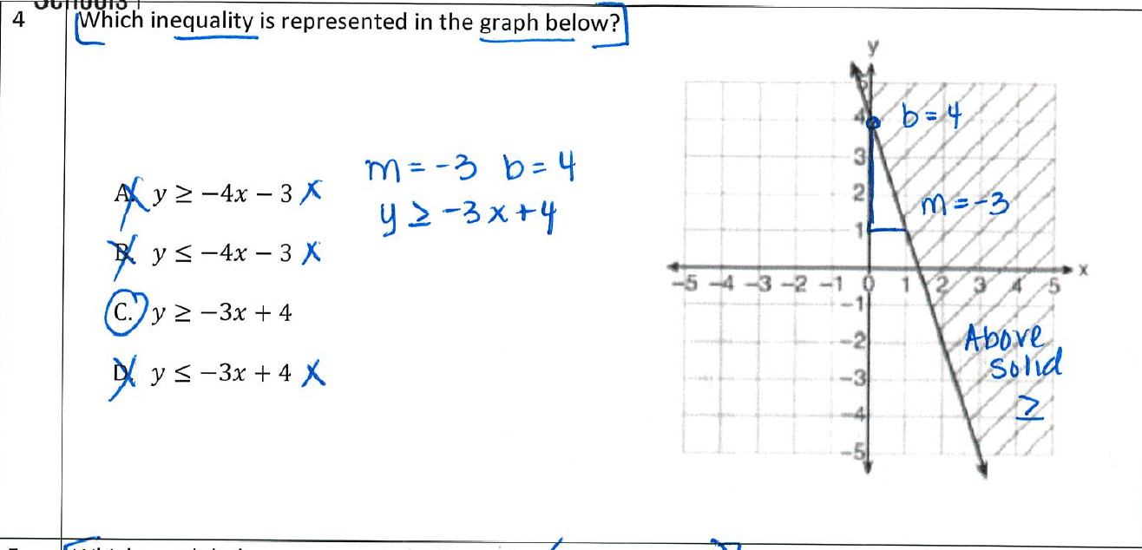
5 | 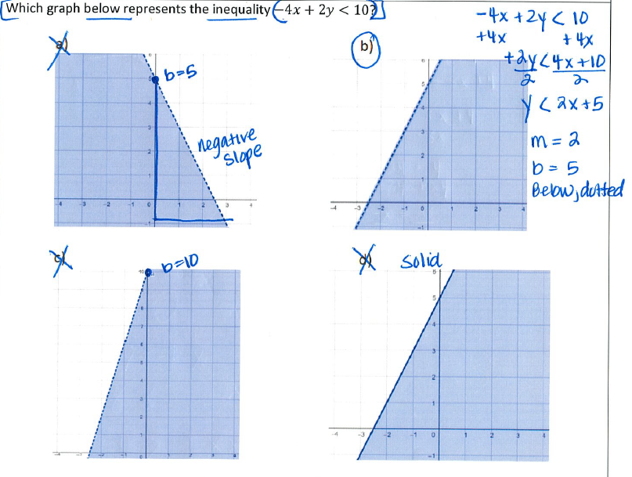
6 | 