6th Grade Math LP – U6, L6: Write Expressions with Variables

Lesson Overview
Planner | Erin Carmody
Objective | SWBAT use expressions with variables to describe situations
Standard | 6.EE.A.32, 6.EE.A.2.a, 6.EE.B.6
Lesson Stamp | To solve for a missing value in a situation, we can:  - Draw diagrams (tape, hanger, or their own creations) that describe the relationships.  - Think about values of the variable that would make the equation true and would make sense in the situation.  - Do the same operation to each side of an equation.
 | Purpose | Mini-Stamp
Warm-Up:  IM Task 6.7.2  Guided Practice | In this activity, students encounter two situations in which performing the same calculation with different values of one quantity gives the values of another quantity. Students interpret a situation with the support of tables. Through repeated reasoning, students see that they can summarize the calculations they performed with an algebraic expression (MP8) and use these expressions to answer questions about specific values. As students relate quantities in situations to numerical and variable expressions, they practice reasoning quantitatively and abstractly (MP2). | An expression with a variable can represent a situation with an unknown value.
Task 1:  IM Task 6.7.3 | This activity prompts students to write expressions to find unknown values in a situation and to describe the calculation process more generally. Then students use the expression with a variable to write and solve an equation involving the same situation.  The activity is structured in a way that allows students to progress gradually from concrete reasoning toward abstraction and to notice regularity. For the first three questions, students reason about numbers repeatedly before they write an expression that uses a variable (MP8). | To solve for a missing value in a situation, we can:  - Draw diagrams (tape, hanger, or their own creations) that describe the relationships.  - Think about values of the variable that would make the equation true and would make sense in the situation.  - Do the same operation to each side of an equation.
Prepare
Lesson Narrative | In this lesson, students write expressions with one variable to represent situations in which a calculation can be carried out repeatedly with different numbers. Students build on their work in prior grades and units with writing expressions to represent operations, situations, and relationships. In the previous section, students identified equations with variables that represented diagrams and situations. They also wrote equations in percent situations where the equation structure was clearly stated (____% of equals ____%). Now, students practice interpreting situations, writing expressions with a variable, and explaining how the parts of the expression match the situation. Students complete tables and write both numerical and algebraic expressions.  Throughout the lesson, as students perform the same calculations and generalize relationships with algebraic expressions, they practice expressing regularity through repeated reasoning (MP8). They are also encouraged to attend to precision when describing how their expressions relate to situations, using the vocabulary they developed in previous lessons (MP6).
Materials & Calculators | None
Exit Ticket  5-10 min | 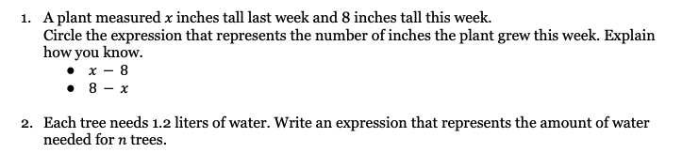  Solution:  - $8-x$. Since the plant grew taller this week, 8 is greater than $x$. The difference of 8 and $x$ is the amount that the plant grew.  - $1.2n$
Word Wall | Before discourse: equation, tape diagram, variable, factor, commutative property, fact family, multiplicative relationship, additive relationship, inverse relationships, substitution, solution, variable, “next to notation,” coefficient, inverse operations  During discourse: expression
Warm-Up: Scores and Stickers (15 minutes)
Guided Practice | Launch - Yesterday, we worked with writing equations that represent a situation. Today, we are going to write expressions to represent situations. What is the difference between an expression and an equation? - An equation has a solution and an expression does not.  We Do Question 1a: - T or S reads question. - How can we determine the score for each student? - We can subtract each number from 473 Question 1b: - T or S reads question. - To think about what expression we can use, let’s think back to part a. How did we find each student’s score? - We subtracted from 473 - So if a student scored $p$ points fewer than Priya, how could we find that score? - We could subtract $p$ from 473 - What expression can we write to show that? - $473-p$ - T&T: Turn to your partner and explain why this expression will work? - Earlier, we subtracted the 101, 53, and 18 from 473, so subtracting $p$ from 473 would also give this player’s score. Question 2a: - T or S reads question. - How can we determine the money collected for each amount of students? - We can multiply the number of stickers by $0.50 - Hm, what do we do with $s$ amount of stickers? - We can multiply $s$by $0.50 - How can we write that as an expression? - $0.50s$ Question 2b: - T or S reads question. - To think about how we can solve this, let’s look back at the expression we used for $s$ stickers, $0.50s$. If we want to know how many stickers he sold for 127.50, what can we do with that expression? - We can make it an equation and set it equal to 127.50 - Let’s write that down on our paper. $0.50s=127.50$ - Now let’s solve. I think I would like to rewrite this equation as $0.5s=127.5$. Can I do that? - Yes, because we did not change the value of the numbers. 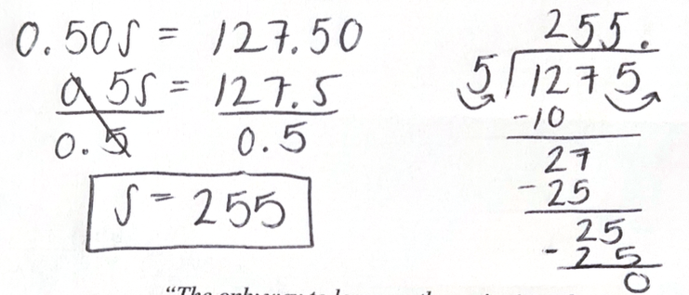  Mini-Stamp An expression with a variable can represent a situation with an unknown value.
Task 1: Building Expressions: Guided Practice (20 minutes)
Launch | - In this task, we are going to continue using tables to help us think about how we can represent an expression. We will do the first one together and then you will work independently.
We Do | Question 1a:  - T or S reads question  - Is Clare younger or older than her cousin?  - Clare is older  - Ok, so if Clare’s cousin in 10, what do we have to do to find Clare’s age?  - We can add 5  - Great, how can we write that as an expression?  - $10+5$  Question 1b:  - T or S reads question  - This problem is asking us to write expressions, not find the actual age. What expression can we write for the cousin that is 8 years old and the cousin that is 2 years old?  - $8+5$ and $2+5$  - What can we write for a cousins age that is unknow, $x$?  - $x+5$  Question 1c:  - T or S reads question  - Do you think that Clare’s equation is right? And if so, why?  - Yes because if Clare is 12 and she is 5 years older than her cousin, we can add 5 to how old her cousin is and we will get 12.  - How old is her cousin?  - 7  Question 2-4  - independent work: 10 minutes
Mini-Stamp | To solve for a missing value in a situation, we can:  - Draw diagrams (tape, hanger, or their own creations) that describe the relationships.  - Think about values of the variable that would make the equation true and would make sense in the situation.  - Do the same operation to each side of an equation.
Lesson Synthesis | - What do all the situations in this activity have in common?  - They are about two quantities, how they are related, and how to find one quantity when we know the other.  - In each situation, we know the relationship of the quantities. When we have the value of one quantity, we are able to calculate the other. What if we don’t have the value of that first quantity? Can we still describe how to find the other?  - Yes by using a variable and writing an expression
Independent Practice (20 minutes)
Monitor & Discuss | Anticipated Error #1 Students may write expressions that match the situation, but make errors when solving the second part of each problem. Then ask what they need to do to answer the last part of each problem.  Monitoring Prompts - Can you explain what your expression represents? - If you are stuck, let’s draw a tape diagram.  Mini-Stamp When writing an expression to match a situation it is helpful to: - Draw diagrams (tape, hanger, or their own creations) that describe the relationships. - Think about values of the variable that would make the equation true and would make sense in the situation. - Do the same operation to each side of an equation.
Exit Ticket: Growth (5-10 minutes)

Name Date
6th Grade Math Team

U6, L6: Write Expressions with Variables

Do Now

Directions: Show all work.
1 | 6.NS.B.3 | Tom had $25.80. He bought a book for $13.65. How much money does he have left?  - $12.15  - $12.05  - $12.25  - $11.85
2 | 6.NS.1 | Ava has $\frac{3}{4}$​ of a pound of clay. Each small sculpture requires $\frac{1}{6}$​ of a pound. How many complete sculptures can she make?  - $3$  - $4$  - $4\frac{1}{2}$  - $2$
3 | 6.NS.1 | A triangle has an area of $\frac{1}{5}$ yd² and a height of $\frac{4}{5}$ yd. What is its base?  - $\frac{1}{4}$ yd  - $\frac{1}{2}$ yd  - $\frac{1}{8}$ yd  - $1$ yd
4 | RTD (teacher-created) | Find the value of $x$.  $$5.7x=17.1$$  - $97.47$  - $3$  - $22.8$  - $11.4$

Excellence

Directions: Find the solution. Show your work.
- $8.004+0.96$ | - $19.75+0.008$ | - $5.203-1.8$ | - $40.07-0.984$
- $0.825∙0.3$ | - $14.2∙0.06$ | - $0.72÷0.009$ | - $4.006÷0.2$
Name Date
6th Grade Math Team

U6, L6: Write Expressions with Variables

Warm-Up: Scores and Stickers: Guided Practice (IM 6.7.2)

- Priya scored 473 points in an esport match.
  - The table shows how Noah, Elena, and Clare scored compared to Priya. Complete the table.
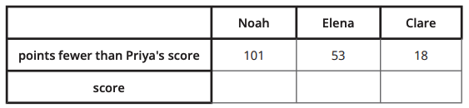
  - Another esport player scored $p$ fewer points than Priya. Write an expression that can be used to find their score. Explain your reasoning.

- Noah made stickers that show his team’s logo. He sells them for $0.50 per sticker.
  - Complete the table to show how much money Noah would collect if he sold each number of stickers.
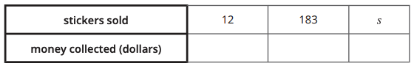
  - How many stickers did Noah sell if he collected $127.50? Be prepared to explain your reasoning.

Task 1: Building Expressions (IM 6.7.3)

- Clare is 5 years older than her cousin.
  - Suppose Clare’s cousin is 10 years old. How can you find Clare’s age?

  - Write expressions to show Clare’s age when her cousin is at different ages. Then record the answer.
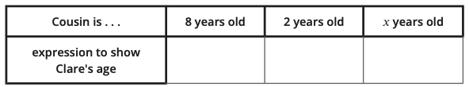

  - Clare is 12 years old. She said this equation, $x+5=12$, can be used to find out how old her cousin is. Do you agree? Explain your reasoning.
____________________________________________________________
____________________________________________________________
____________________________________________________________

- Diego has 3 times as many comic books as Han does.
  - Suppose Han has 10 comic books. How can you find the number of comic books Diego has?

  - Write expressions that can show how many comic books Diego has for different numbers of comic books that Han has. Then record the answer.
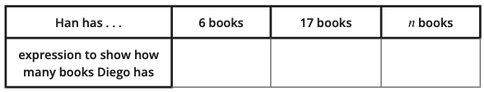

  - Diego has 27 comic books. How many comic books does Han have? Write an equation that represents the question and use it to find the answer.
____________________________________________________________
____________________________________________________________
____________________________________________________________

- A school paid $31.25 for each calculator.
  - If the school bought $c$ calculators, how much did they pay?

  - The school spent $500 on calculators. How many did the school buy?

Independent Practice
- Instructions for a craft project say that the length of the red ribbon should be 7 inches less than the length of the blue ribbon.
  - How long is the red ribbon if the length of the blue ribbon is:
10 inches? 27 inches? $x$ inches?

  - How long is the blue ribbon if the red ribbon is 12 inches?

- Tyler has 3 times as many pens as Mai does.
  - How many pens does Mai have if Tyler has:
15 pens? 21 pens? $x$ pens?

  - Tyler has 18 pens. How many pens does Mai have?

- A bottle holds 24 ounces of water. It has $x$ ounces of water in it.
  - What does $24-x$ represent in this situation?
____________________________________________________________
____________________________________________________________
  - Write a question about this situation that has $24-x$ for the answer.
____________________________________________________________
____________________________________________________________
- For each situation:
- Choose an equation that represents it.
- Solve the equation.
- Explain what the variable and solution mean in the situation.

- Jada’s dog was $5\frac{1}{2}$ inches tall when it was a puppy. Now her dog is $14\frac{1}{2}$ inches tall. How much did Jada’s dog grow? | 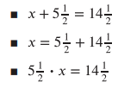
- Lin picked $9\frac{3}{4}$ pounds of apples, which was 3 times the weight of the apples Andre picked. How many pounds of apples did Andre pick? | 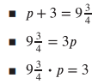

- Kiran’s aunt is 17 years older than Kiran.
  - How old will Kiran’s aunt be when Kiran is:
15 years old? 30 years old? $x$ years old?

  - How old will Kiran be when his aunt is 60 years old?

Lesson Summary

Suppose you were born on the same day as your neighbor, but she is 3 years older than you. When you were 1, she was 4. When you were 9, she was 12. When you are 42, she will be 45.
If we let $a$ represent your age at any time, your neighbor’s age can be expressed $a+3$.
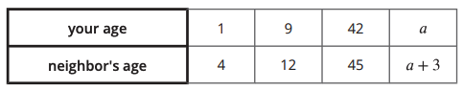
We often use a variable, such as $x$ or $a$, as a placeholder for a number in expressions. Variables make it possible to write expressions that represent a calculation even when we don't know all the numbers in the calculation.
How old will you be when your neighbor is 32? We know your neighbor is 32. We also know your neighbor’s age is your age plus 3, or $a+3$. We can write the equation $a+32$ to represent these relationships. When your neighbor is 32 you will be 29, because $a+3=32$ is true when $a$ is 29.

Name Date
6th Grade Math Team

U6, L6: Write Expressions with Variables
Exit Ticket: Growth

- A plant measured $x$ inches tall last week and 8 inches tall this week.
Circle the expression that represents the number of inches the plant grew this week. Explain how you know.
- $x-8$
- $8-x$

_________________________________________________________________
_________________________________________________________________
_________________________________________________________________

- Each tree needs 1.2 liters of water. Write an expression that represents the amount of water needed for $n$ trees.

Name Date
6th Grade Math Team

U6, L6: Write Expressions with Variables
Homework

  - What is the perimeter of a square with side length:
3 cm? 7 cm? $s$ cm?

  - If the perimeter of a square is 360 cm, what is its side length?

  - What is the area of a square with side length:
3 cm? 7 cm? $s$ cm?

  - If the area of a square is 121 cm2 , what is its side length?

Mixed Review

- Write an equation represented by this tape diagram using each of these operations.

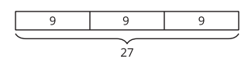
  - addition

  - subtraction

  - multiplication

  - division

- You had $30. You spent 70% of the money on books. How much money did you spend on books?

