7th Grade Math - Explore Lesson
Overview
Planner: | Shand/Armstrong/ S.Johnson
Unit: | Proportional Relationships
Day/Title: | IA3, Lesson 066 – Constant of Proportionality (Tables)
CCSS: | 7.RP.2.b  Identify the constant of proportionality (unit rate) in tables, graphs, equations, diagrams, and verbal descriptions of proportional relationships.
STAMP: | Previously, we knew that, if a table represents a proportional relationship, each pair of corresponding values makes a ratio equivalent to the same unit rate. We now know that the numerator of the unit rate, which we call the constant of proportionality, or $k$, is the number that can be multiplied by any x-value to generate the corresponding y-value. The value of $k$ is the number in the numerator of the unit rate.

Prepare
Objective: | - SWBAT determine the constant of proportionality in a given table.
An Explore Exemplar | 
An Exit Ticket Exemplar: | 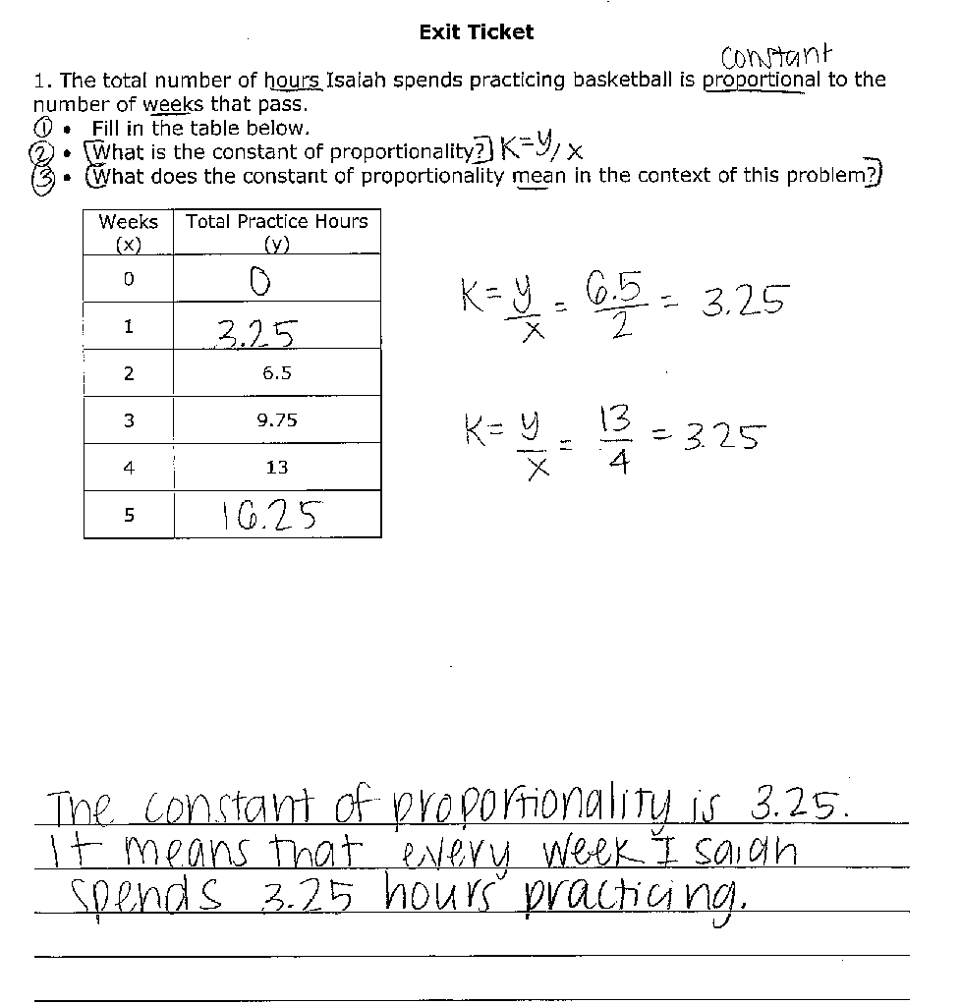
IA Alignment: | NJ and MA: NY:  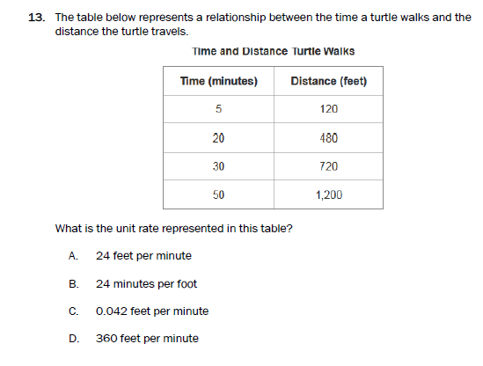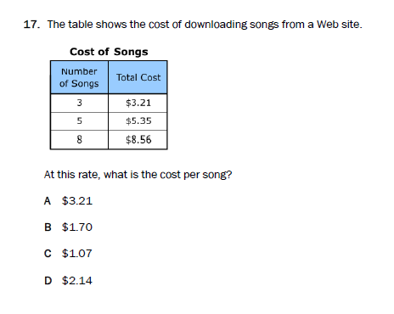
Materials: | LP, Handouts
Calculators: | No
Homework: | Constant of Proportionality (Tables), Mixed Review
Launch (1-5 minutes)
AFK (1-5 min): | - In our last lesson, we began talking about identifying proportional relationships in tables. Think back to that and take 90 seconds to answer the question on your handout.  - Which answer did you pick and why? B is the correct answer because each pair of values in the table shows a ratio of 3 to 1.  - Key Takeaway: A table shows a proportional relationship if each pair of values forms equivalent ratios.
Challenge (1 min): | - Let’s bring this key takeaway into our Explore today.
ID Parameters (1 min): | - Read the task for us please.  - You’ll have 5 minutes to work.
Monitor the Explore (5-10 minutes)
Affirmation Lap  Procedural Lap | Affirmation Lap ( 30 seconds)  - Teacher will affirm students who are on task, using habits, etc.  Procedural Lap (1-2 minutes)  - I’m coming around to check that you are creating proportions from the values in the table.
Conceptual Lap | Conceptual Lap (4-6 minutes)  - I am coming around to check that you determined the cost of a single box and 17 boxes.  Anticipated Error Prompts  - Extends table by finding constant change in y value, rather than using relationship with x value - What is the price per box? - So if the cost is $30, how many boxes would that be? - The table asks for the cost of 17 boxes. Use what you just found out to solve!  - Connection: determines that multiplication by unit rate can be used to find unknown y value - Good insight! - How is this related to the cost of 1 box?
Respond to Error
Stop the Show: 30 sec  Show-Call the Error:  2 min  Chart the Error: 6-8 min |  | Chart the Error  - Extends table by finding constant change in y value, rather than using relationship with x value  # of Cereal Boxes (x) Cost (y)  2 $6  4 $12  6 $18  8 $24  Error Correct Answer  +6 17 $30 17 x3 $30  Close the Gap: If one quantity in a proportional relationship does not increase by a constant amount, then the other value will also not increase by a constant amount.  Chart the Connection  - Connection: determines that multiplication by unit rate can be used to find unknown y value  # of Cereal Boxes (x) Cost (y)  2 x3 $6  4 x3 $12  6 x3 $18  8 x3 $24  Correct answer Correct Answer  17 x3 $51 $\frac{\$6}{2 boxes}=\frac{\$3}{1 box}$ $×17$ $\frac{\$3}{1 box}=\frac{\$x}{17 boxes}$ $×17$  Close the Gap: In a proportional relationship, there is a constant value that can be multiplied by one quantity to determine the other quantity. This constant value is the same as the value in the numerator of the unit rate.  - This constant we have determined, from the unit rate, is called the constant of proportionality. Let’s copy down the official definition into our notes: The constant of proportionality, or unit rate, (k) is the number that can be multiplied by any x value to generate the corresponding y-value. It is the amount of y per x, or the numerator of the unit rate.  - We can write the equation $k=\frac{y}{x}$ to help us calculate the constant.
Monitor the At-Bats (15-20 minutes)
Affirmation Lap  Procedural Lap | Affirmation Lap ( 30 seconds)  - Teacher will affirm students who are on task, using habits, etc.  Procedural Lap (1-2 minutes)  I’m coming around to check that you are writing $k=\frac{y}{x}$ and substituting to find the constant of proportionality
Conceptual Lap | Conceptual Lap (4-6 minutes)  - I am coming around to check that you determined the constant of proportionality correctly.  Anticipated Error Prompts  - Does not describe constant of proportionality in terms of unit rate - Check the definition. The c.o.p. is the same as what rate? - So, describe what the unit rate means.  - Uses $\frac{x}{y}$ for COP rather than $\frac{y}{x}$ - Look at the table. If we multiply ____ by ____, what do we get? - What should we have gotten?
Respond to Error
Stop the Show: 30 sec  Show-Call the Error:  2 min  Chart the Error: 6-8 min |  | Chart the Error  - Does not describe constant of proportionality in terms of unit rate  x Hours 1  y Price $6.50  What is the constant of proportionality? What does it represent in the context of the problem?  The constant of proportionality is 6.5.  Less sophisticated More sophisticated  This is the number we multiply x by to get y. This means that the unit rate is$6.50 for every 1 hour renting the bike.  Close the Gap: The constant of proportionality is a value that describes the unit rate. It represents how much of the y-quantity corresponds to 1 of the x-quantity.  Chart the Error  - Uses $\frac{x}{y}$ for COP rather than $\frac{y}{x}$  x Hours 0 4 8 12 16  y Miles 0 1 2 3 4  What is the constant of proportionality?  Error Correct Answer  $k=\frac{4}{1}=4$ $k=\frac{y}{x}=\frac{1 mi}{4 hr}=\frac{\frac{1}{4} mi}{1 hr}$  Close the Gap: The quantity represented by x is typically used for the denominator of the unit rate. To find $k$ we can use the equation $k=\frac{y}{x}$ and determine the amount of y for every 1 of x.
Monitor the IP (15-20 minutes)
Affirmation Lap  Procedural Lap | Affirmation Lap ( 30 seconds)  - Teacher will affirm students who are on task, using habits, etc.  Procedural Lap (1-2 minutes)  I’m coming around to check that you are writing $k=\frac{y}{x}$ and substituting to find the constant of proportionality.
Conceptual Lap | Conceptual Lap (4-6 minutes)  - I am coming around to check that you are determining the unit rate correctly.  Anticipated Error Prompts  - finds ratio of $\frac{x}{y}$ not $\frac{y}{x}$ - Should k be < or > 1? - Reread your definition for the constant of proportionality. - Is the COP multiplied by the x or the y-value? - What happens if you do that with your COP?  - Mathematical explanation lacks use of unit rate - What does this number mean in the context of the problem? - Add labels to your work – this will help you make meaning of the math.
Respond to Error
Stop the Show: 30 sec  Show-Call the Error:  2 min  Chart the Error: 6-8 min |  | Show-Call the Error  - Finds ratio of $\frac{x}{y}$ not $\frac{y}{x}$  x 5 10 20  y 4 8 16  Student Work to be Show-Called  $k=\frac{5}{4}$  Close the Gap: The quantity represented by x is typically used for the denominator of the unit rate. To find $k$ we can use the equation $k=\frac{y}{x}$ and calculate the unit rate.  Chart the Error  - Mathematical explanation lacks use of unit rate (Student calculates $k$ to refute claim, but does not connect it to unit rate, relying just on procedure)  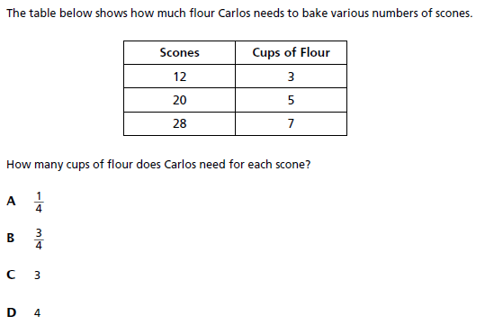  Carlos believes that he needs 4 cups of flour for each scone. Explain whether you agree or disagree and why.  I disagree with Carlos.  $k=\frac{y}{x}=\frac{3}{12}=\frac{1}{4}$  Less sophisticated More sophisticated  $k$is ¼, not 4. $k$ is $\frac{\frac{1}{4} cup}{1 scone}$, so Carlos needs ¼ cup for each scone, not 4.  Close the Gap: The value of $k$ represents the unit rate for a proportional relationship. We should include units when determining $k$ so that we can interpret it in terms of the unit rate.

Stamping the Understanding
Stamping the Understanding  (5 min): | Previously, we knew that, if a table represents a proportional relationship, each pair of corresponding values makes a ratio equivalent to the same unit rate. We now know that the numerator of the unit rate, which we call the constant of proportionality, or $k$, is the number that can be multiplied by any x-value to generate the corresponding y-value. The value of $k$ is the number in the numerator of the unit rate.

Exit Ticket (5-7 minutes)
Exit Ticket  (5-7 min) | TW give students 5-7 minutes to complete the Exit Ticket. Each day, they will review the ET data to update their Pathway to Understanding.

