For Teachers Only

LAUNCH
- Affirm the Success: “You are doing a great job with _____!”
- Invest Students in the Goal: “We are going to continue working on these Fraction Division problems – our goal is to grow by ____% today!”
- Name Current Data: “To reach that goal, we need to go from _____ to ______”. Let’s work towards that goal now!

CHART THE ERROR
- T or S reads the problem aloud.
- Who do you agree with – Student A or Student B? Think about it.
- Poll, T&T, Re-poll.
- Call on 1-2 students who agree with A.
  - “There are 4 equal groups and when I’m making equal groups I multiply.”
  - “I know that 24 is correct because 6 groups of 4 equals 24.”
- Call on 1-2 students who agree with B.
  - “6 is the total because that’s the amount being split. 4 is the groups because it’s the containers she’s splitting the jam into. I am solving for the size of each group so I need to divide.”
  - “Since I know the total (6), I can divide to find the unknown.”
  - “I am splitting a total into equal groups and I’m solving for how much is in each group so I need to divide.”
- Confirm that Student B is correct.
- Cross off Student A.
- CFU with originally incorrect student(s) – Why is A wrong?
- Key Takeaway:
  - To solve a division problem, identify the group, size, and total.
  - If the total is known, divide to find the missing group or size.

GUIDED PRACTICE
- Now, let’s review what your work should look like when solving a problem like this.
- GST Key
  - The first thing I need to do is create a GST key.
  - Take a minute with your partner to do that now. Go!
  - Stamp the GST key so each student has it on their paper.
    - G: 4
    - S: ?
    - T: 6
- Expression
  - Based on this, what would the expression be? Why? T&T.
    - The expression is $6÷4$ because we know the total, 6, and we are dividing it into 4 equal groups.
  - Stamp the correct expression so each student has it on their paper.
- Solve
  - Now, we are ready to solve!
  - Some of you remembered that in 5th grade we can rewrite a division statement as a fraction, so $6÷4=\frac{6}{4}$. Nice job.
  - Some of you used Keep-Switch-Flip.
  - How can we use Keep-Switch-Flip to solve $6÷4$?
  - How do I “Keep” the 6? (write it as 6/1)
  - What do I need to “Switch”? (division to multiplication)
  - How do I “Flip” the 4? (Since 4 is really 4/1, you can flip it to become ¼)
  - CFU: How do I “Flip” a whole number?
- Stamp: What do we want to keep in mind when solving problems like this?
- Key Takeaways:
  - To solve a division problem, we make a GST key, write our expression and then solve.
  - If we are using KSF to divide whole numbers, rewrite the whole numbers as fractions before solving.

Name Date
6th Grade Math Team

Week 19 RTD: Fraction Division

On the Week 19 PPQ, _____% answered question 5 correctly. Let’s raise that accuracy now!

Chart the Error
Elena made 6 cups of blueberry jam and divided the jam equally among 4 containers. How much jam went in each container?
Student A | Student B
$$6×4$$ | $$6÷4$$

Who do you agree with and why?
____________________________________________________________________________________________________________________________________________________________________________________
__________________________________________________________________________________________
Key Takeaways:

__________________________________________________________________________________________________________________________________________
__________________________________________________________________________________________________________________________________________

Guided Practice
Elena made 6 cups of blueberry jam and divided the jam equally among 4 containers. How much jam went in each container?
Step 1: Create GST Key | Step 2: Write Expression | Step 3: Solve

- $\frac{2}{3}$ of a cup
- $1$ cup
- $\frac{3}{2}$ of a cup
- $24$ cups

Key Takeaways:

__________________________________________________________________________________________________________________________________________
__________________________________________________________________________________________________________________________________________
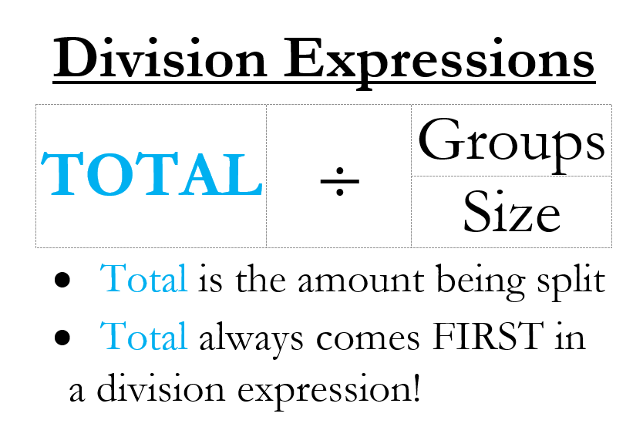

Independent Practice:

- Martha made 9 pounds of cake mix and split it evenly into 4 pans. How much cake went into each pan?

- $\frac{9}{4}$

- $36$

- $\frac{4}{9}$

- 13

- Julian had to separate his candy into 4 equal buckets. He had a total of 1 pound of candy. How much candy went into each bucket?

- Ms. Smith wants to share her 5 cups of hot chocolate among 9 students. How much hot chocolate does each student receive?

- $\frac{5}{9}$

- $\frac{9}{5}$

- 45

- 14

- Nancy has to feed her 6 cats. She went to the store and bought 10 pounds of cat food for her cats to share. How much food does each cat get?

- A cooking instructor has $11$ pounds of cheese and wants to divide it evenly amongst 5 students. How many pounds of cheese will each student get?

- BONUS: Kareem had $11\frac{1}{2}$ cups of Gatorade. He wants to pour the Gatorade into 3 equally-sized bottles. How much Gatorade goes into each bottle?

Name Date
6th Grade Math Team
MAT.06.W19.RTD.FractionDivision

RTD: Fraction Division
Exit Ticket

- Mr. Chen had 7 pounds of candy and wanted to split it evenly among his 8 students. How much candy did each student receive?

- $\frac{7}{8}$ of a pound

- $\frac{8}{7}$ of a pound

- $56$ pounds

- $1\frac{7}{8}$ pounds

