Final Project Planning: Video Store (Lesson 10 Additions)

Video Table datatypes:

* **video_id** integer UNSIGNED NOT NULL AUTO_INCREMENT
* **title** varchar(40)
* **production_date** date
* **star_actors** varchar(40)
* **producer** varchar(30)
* **director** varchar(30)

Customer Table datatypes:

* **customer_id** integer UNSIGNED NOT NULL AUTO_INCREMENT
* **last_name** varchar(30)
* **first_name** varchar(30)
* **address** varchar(40)
* **phone_number** varchar(10) [UPDATED FOR FINAL PROJECT]
* **email** varchar(40)

Rental Table datatypes:

* **video_id** KEYED to Video Table
* **customer_id** KEYED to Customer Table
* **rental_id** integer UNSIGNED NOT NULL AUTO_INCREMENT
* **checkout_date** date
* **due_date** date
* **checkInDate** date
* **late_status** ENUM(‘LATE’, ‘NOT LATE’)
* **rental_fees_accrued** integer(10)

Sample Movie Data:

|  |  |  |  |  |  |
| --- | --- | --- | --- | --- | --- |
| **Video_ID** | **Title** | **Production_Date** | **Star_Actors** | **Producer** | **Director** |
| 1 | Scorpion King | 2002-04-19 | Dwayne Johnson, Steven Brand | Sean Daniel | Chuck Russell |
| 2 | Harry Potter and the Sorcerer’s Stone | 2001-11-16 | Daniel Radcliffe, Rupert Grint | Michael Barnathan | Chris Columbus |
| 3 | Lord of the Rings: The Return of the King | 2003-12-17 | Elijah Wood, Viggo Mortensen | Michael Lynne | Peter Jackson |
| 4 | League of Extraordinary Gentleman | 2003-07-11 | Sean Connery, Stuart Townsend | Trevor Albert | Stephen Norrington |
| 5 | Waterworld | 1995-07-28 | Kevin Costner, Jeanne Tripplehorn | John Davis | Kevin Reynolds |
| 6 | The Matrix | 1999-03-31 | Keanu Reeves, Laurence Fishburne | Bruce Berman | Lana Wachowski, Lilly Wachowski |
| 7 | X-Men | 2000-07-14 | Patrick Stewart, Hugh Jackman | Avi Arad | Bryan Singer |
| 8 | Mulan | 1998-06-19 | Ming-Na Wen, Eddie Murphy | Pam Coats | Tony Bancroft, Barry Cook |
| 9 | The Chronicles of Riddick | 2004-06-11 | Vin Diesel, Judi Dench | Ted Field | David Twohy |
| 10 | Mortal Kombat | 1995-08-18 | Christopher Lambert, Robin Shou | Robert Engelman | Paul W.S. Anderson |

LESSON 6 ADDITION:

The Rental Table will be linking both the customer and video tables

See the datatypes and notes below

Rental Table datatypes:

* **video_id** KEYED to Video Table
  + This will serve as a foreign key that references the video table to ensure there is a link between each rental and the video associated
* **customer_id** KEYED to Customer Table
  + This will serve as a foreign key that references the customer table. This ensures there is a direct link between the rental and the customer that made the rental
* **rental_id** integer UNSIGNED NOT NULL AUTO_INCREMENT
  + This will be a unique ID specific to the rental table. The ID will individually identify each rental record
* **checkout_date** date
* **due_date** date
* **checkInDate** date
* **late_status** ENUM(‘LATE’, ‘NOT LATE’)
* **rental_fees_accrued** integer(10)

As I execute this project, I will be paying special attention to the key relationships in order to keep referential integrity and functionality.

See below for a sketch of the webpage with buttons/links

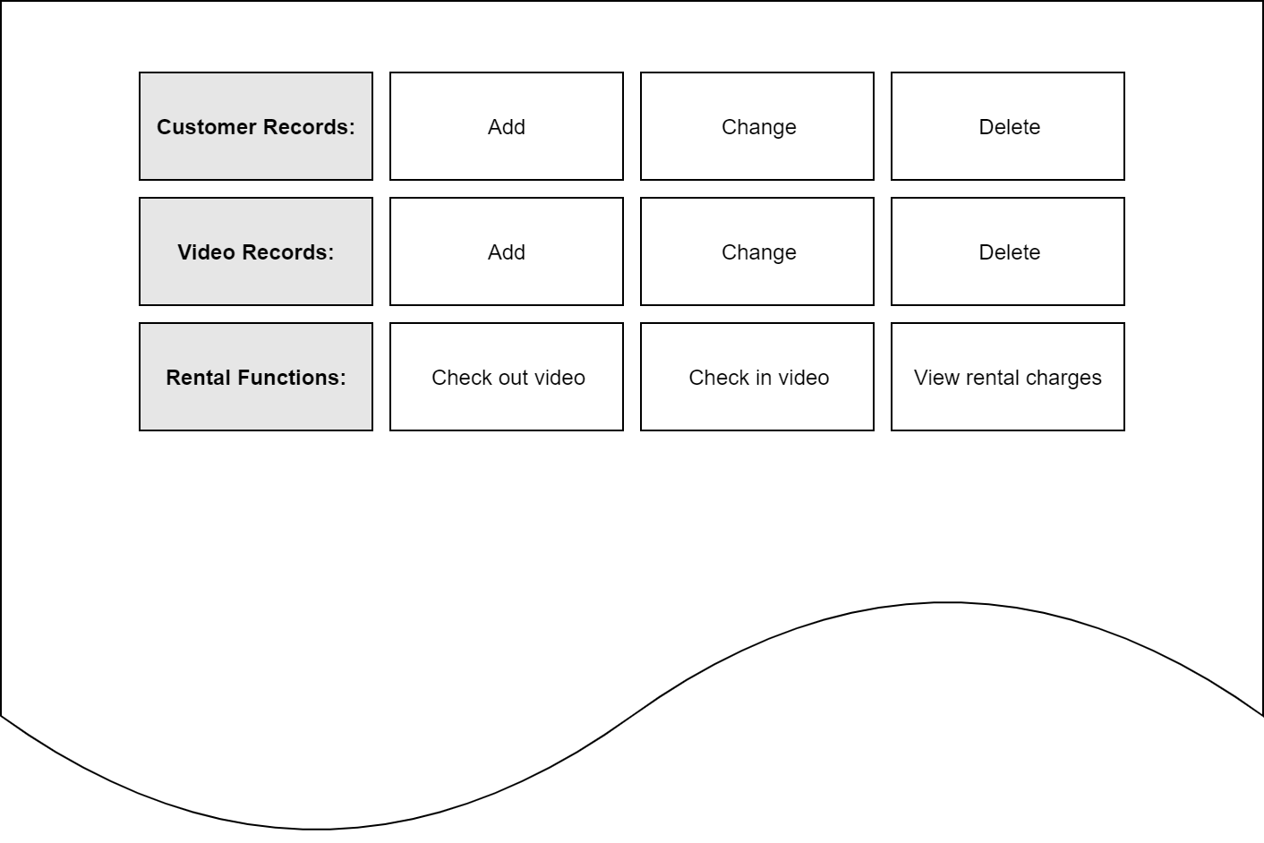

LESSON 8 ADDITIONS:

|  |  |
| --- | --- |
| **User ID’s** | **Privileges** |
| DBAdmin | SUPER, SHUTDOWN, SHOW DATABASES, CREATE USER, FILE, GRANT OPTION, (*include all lesser permissions below*) |
| StoreMgr | CREATE, CREATE VIEW, DELETE, LOCK TABLES, EXECUTE, (*include all lesser permissions below*) |
| Accountant | INSERT, CREATE VIEW, DELETE, SELECT, (*include all lesser permissions below*) |
| Clerk | SELECT, INSERT, DELETE |

*(Used info from section 13.2.2 pg. 660)*

LESSON 10 ADDITIONS:

