Rigoberto Quiroz

2/06/2019

Lab1 Report

CS 2302 1:30PM – 2:50OM MW

Description:

For this lab I had to draw certain figures multiple times using recursion. Affecting their position and size to construct the desired image. Some of the figures are squares, or circles as shown in the example below.

EX:

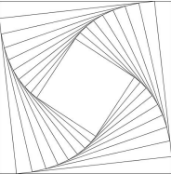

The way I was able or tried to solve this lab was by using a midpoint which I could reference. Then in each recursion call I would affect the coordinates of the following figures using my midpoint references, making my figures move to a desired direction or changing their size. In each recursion call I would update my midpoint to a new midpoint where a new figure would be drawn. For some of my methods (binaryTree(), draw_Squares()) I would affect their midpoints and size using addition or subtraction, meanwhile in others methods I would affect their midpoints and size using multiplication or division. For the first problem,