Rigoberto Quiroz

Assignment 1: Email Client

1. Sending Email through interacting with SMTP server from Terminal
   1. Make sure Telnet is enabled in your system.
   2. Establish a connection to the SMTP server, in this case UTEP’s SMTP server  
      hostname: smtp.utep.edu port: 25
      1. IMPORTANT: Make sure that either you are using UTEP’s Wi-Fi or VPN
   3. Once the handshake has been successful, enter ‘helo’ to introduce your system to the server.
      1. Helo utep.edu
   4. Enter the sender and recipient information.
      1. NOTE: Sender information should be your UTEP email address, recipient can be from any other email server (Gmail, yahoo, etc.) UTEP smtp server handles to transportation to recipient’s server

Mail from:<utep email>

Rctp to:<recipient email>

* 1. Once all that is done enter data. This will allow you to enter content of the email (Subject, body)
  2. When done enter ‘.’ This will indicate that the message is over, and the server can proceed to transport the message to recipient server.

Server Response

End User request

Email Content

When you we check the recipient email, we should see the following:

Using a recipient email from UTEP (Outlook)

Using a recipient email from Gmail



1. Writing socket program to automate telnet commands
   1. The first step to create a socket program in python is having the socket library imported
   2. Establish a TCP connection with UTEP’s server

serverName: smtp.utep.edu

serverPortNumber: 25



Note:

AF_INET = Your machines IPV4

SOCK_STREAM = TCP connection

* 1. Once the connection has been established make sure that your requests have ‘\r\n’ and are encoded in bytes.
     1. If the server receives a message without ‘\r\n’ then it will not recognize the message. This is mainly because of the socket in the server.

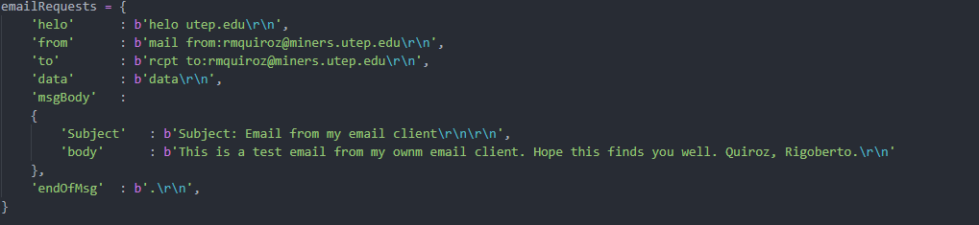

* 1. Once you have sent all the requests to the server and email content it will send that email to its recipient.

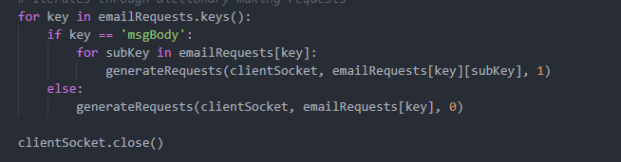

Once the loop is done it will close the TCP connection to the server.



Sample output from terminal:

