Rigoberto Quiroz
5/27/2019
Facial Recognition Lab
Description:
For this project I wanted to see how facial recognition worked. For this project I used random pictures of people’s faces from Google to see if my algorithm was able to detect the same across all faces. For this project I will only be detecting a person’s face and eyes.
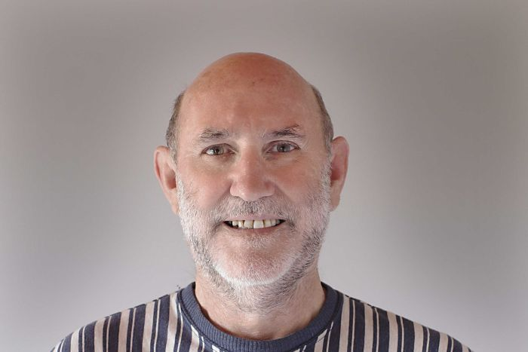
The way I was able to detect a person’s face and eyes was by using a premade machine learned facial features (Come standard with cv2 libraries). If the program can detect this kind of features, then we will draw a rectangle around that feature. What I noticed when making some test, the premade recognition features are not as functional, since certain face structure may affect the program detection. As shown below. Detects edge of mouth as eyes
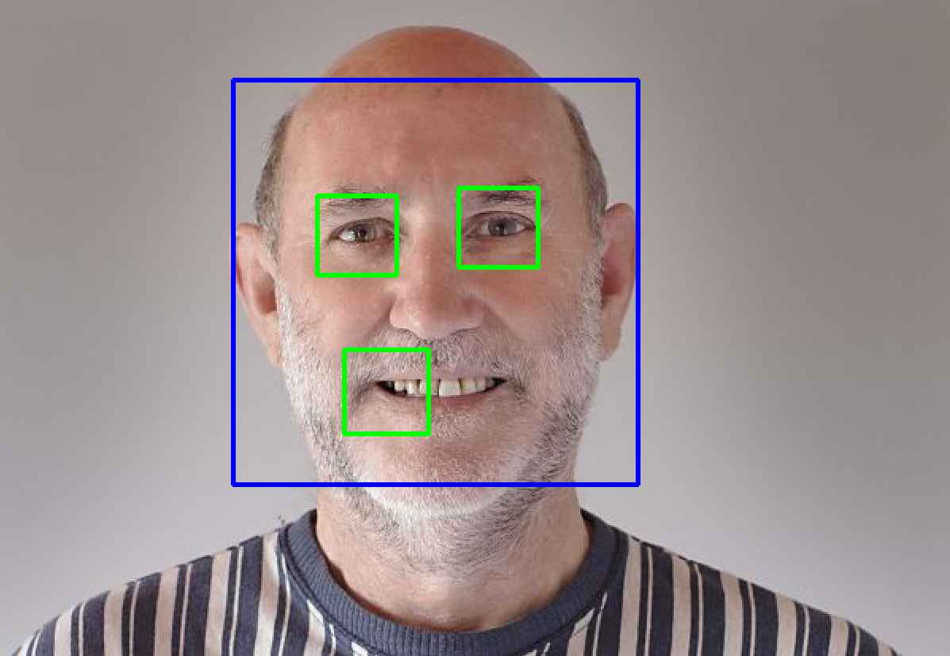
In other cases, the program was able to detect the correct features. Such as the image below.
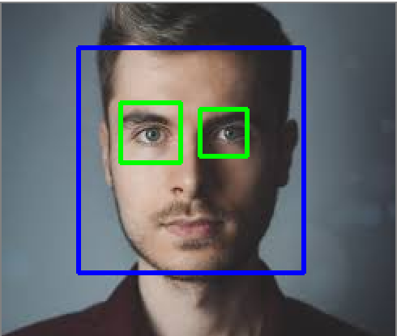
At certain picture qualities or color of images the program is not able to detect a person features, such in the image below.
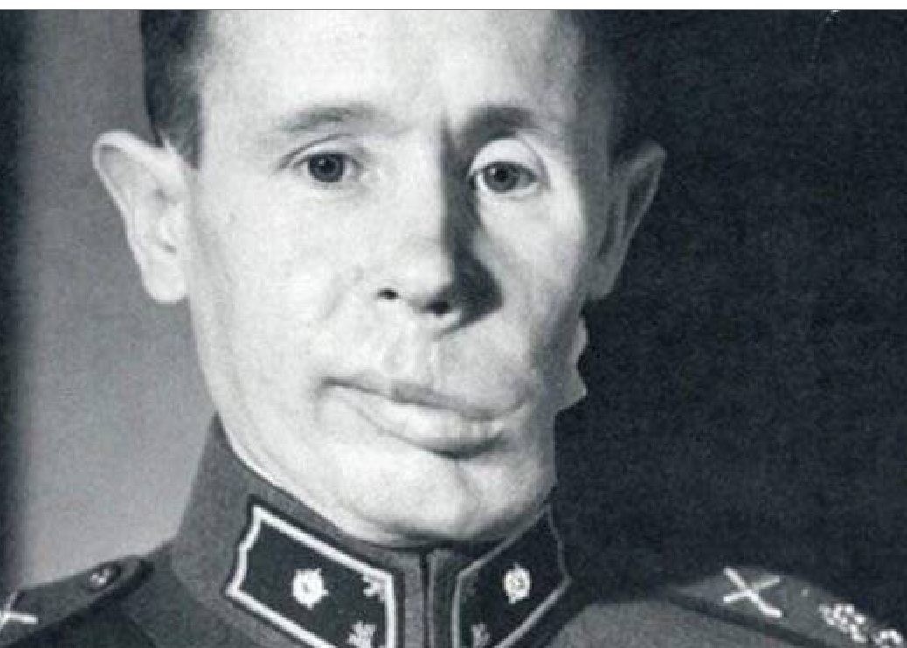
When used if a person’s face suffered deformity, at some cases, the program can detect these features.
