Receipt Scanner Feed Rig: Construction Guide
Oct 3, 2026 · @Rigved Epur

Overview
This rig answers one question before anything else gets built: can two pairs of rollers grab and move real household receipts without jamming? It also carries the camera, so the same rig later becomes the scanning prototype.
The paper path is vertical. Gravity helps the feed, and the receipt drops straight out of the bottom.
- Funnel (slot): you push a receipt in at the top. The 2 mm throat sits 9 mm above the first rollers, so the paper is grabbed before it can buckle.
- Nip 1 and nip 2: two roller pairs 36 mm apart, shorter than the shortest receipt (a 50 mm parking stub), so a receipt is always held by at least one pair.
- Driven rollers: O-rings grip the paper. One NEMA17 turns both through a single GT2 belt, so they always run at the same speed.
- Idler rollers: they press the paper against the driven rollers. Each spins on two 608 bearings around a fixed rod. Spring-loaded arms hold the rod and let the idler swing open up to 4 mm for creased paper.
- Camera: a Pi Camera Module 3 Wide, 55 mm from the paper, sees a 16 mm strip through the gap between the two driven rollers.
- Frame: two 157 × 167 mm side plates, 95 mm apart, tied by four spacers on M5 threaded rod.
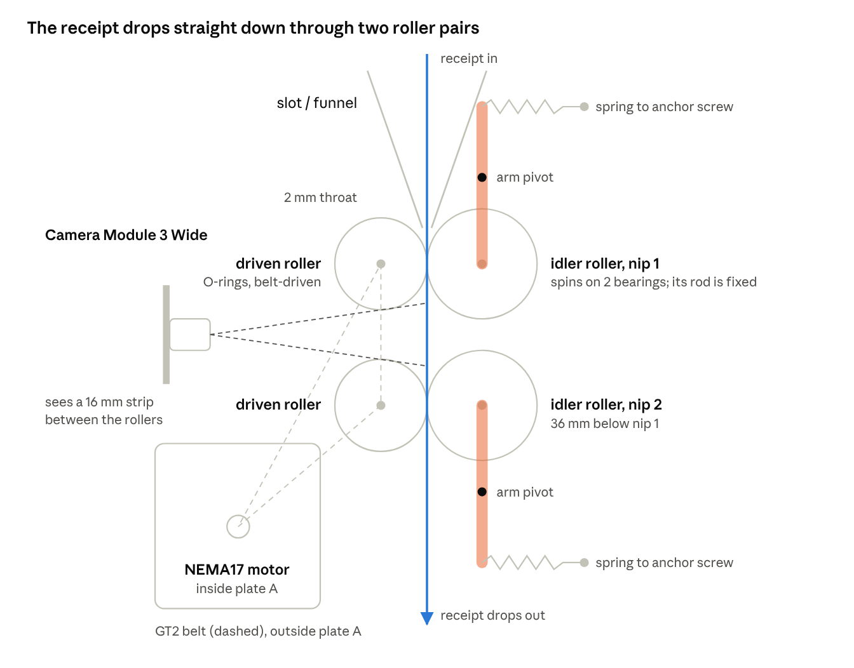
side view of the paper path, schematic, not to scale
The arms and springs sit outside the plates and the belt runs outside plate A; the side view overlaps them with the parts inside the frame.
All the source files are in ~/Documents/projects/receipt-scanner/feed-rig:
File | What it is
feed_rig.scad | Every part, parametric. It prints a design report and a FIT CHECK in the console.
stl/ | Exported parts, ready to print or cut
bom.csv | Parts list as a spreadsheet
feed_test/feed_test.ino | Stepper test sketch
test_log.csv | One row per receipt fed
drive_detail.scad, idler_detail.scad, idler_demos/ | Visual explainers only, nothing to print

Parts list
The rig costs about $90 in parts, plus about $100 for the camera setup if you buy the Pi and camera new. Prices are rough US estimates; the same list is in bom.csv.

Printed (PLA or PETG, about 250 g)
Part | File | Qty | Size
Driven roller | driven_roller.stl | 2 | Ø22 × 82 mm, 4 O-ring grooves
Idler roller | idler_roller.stl | 2 | Ø28 × 82 mm, bearing pocket each end
Idler arm | idler_arm.stl | 4 | 5 mm thick
Hub washer | hub_washer.stl | 8 | OD 12, ID 8.4, 6 mm thick
Pulley shim | pulley_shim.stl | 2 | OD 12, ID 8.4, 1 mm thick
Frame spacer | spacer.stl | 4 | OD 12, ID 5.5, 95 mm long
Funnel | funnel.stl | 1
Camera mount | camera_mount.stl | 1
Width shim (optional) | width_shim.stl | 2 | For 57/58 mm receipts

Cut from sheet
Part | File | Qty | Size
Side plate | side_plate_laser.svg | 2 | 157 × 167 mm from 6 mm plywood or 1/4 in MDF

Mechanical
Part | Spec | Qty | ~$
Ball bearing | 608ZZ, 8 × 22 × 7 mm | 8 | 6
Smooth rod | 8 mm steel, cut 2 × 129 mm + 2 × 123 mm | 600 mm | 10
GT2 pulley | 20T, 8 mm bore, 6 mm belt | 2 | 6
GT2 pulley | 20T, 5 mm bore, 6 mm belt | 1 | 3
GT2 closed belt loop | 200 mm × 6 mm | 1 | 4
O-ring | 18 × 2 mm, nitrile 70A | 8 | 8
Extension spring | about 5 mm diameter, 15–25 mm long, light | 4 | 5
M5 threaded rod | cut 4 × 120 mm | 1 m | 4

Fasteners (an M2/M3/M5 assortment covers all of these, about $15)
Part | Used for | Qty
M3 × 16 socket head + nylock nut + 2 washers | Arm pivots | 4 sets
M3 × 10 socket head | Motor 4, funnel 6, camera mount 4, spring anchors 4 | 18
M3 nut | Spring anchors | 4
M3 × 6 grub screw | Driven rollers | 4
M3 × 4 grub screw | Idler arms | 4
M2 × 6 screw | Camera board | 4
M5 nut + washer | Frame spacers | 8 + 8

Electronics
Part | Spec | Qty | ~$
NEMA17 stepper | 17HS15-1704S (already owned): 1.7 A, 5 mm D-shaft 20 mm long | 1 | 12
TMC2209 driver | standalone STEP/DIR module | 1 | 6
Capacitor | 100 µF, 25 V or higher | 1 | 1
Arduino Nano/Uno or ESP32 | runs feed_test.ino | 1 | 8
Power supply | 12 V 2 A + DC jack | 1 | 10
Jumper wires + breadboard |  | 1 | 6
Pi Camera Module 3 Wide |  | 1 | 35
Raspberry Pi 4 (2 GB or more) | Pi 5 needs a 22-to-15-pin camera cable | 1 | 45
Camera ribbon cable | 15-pin, 300 mm | 1 | 4
microSD card + Pi power supply | 32 GB; 5 V 3 A USB-C | 1 each | 18
Lighting is not designed yet.

Tools and before you start
Measure your sheet material first: every shaft length and pulley position depends on the plate thickness.
Tools: Snapmaker (printer + laser or CNC), calipers, hacksaw or rotary tool with a cut-off disc, metal file, M3 tap, 8 mm drill bit or reamer, 3.5 mm and 5.5 mm drill bits, hex keys (1.5, 2, 2.5 mm), small screwdriver, CA glue, wood glue (only if laminating 3 mm sheets).
- Measure the plate material with calipers in three places. "1/4 in" or "6 mm" sheet is often 5.2–6.4 mm.
- Open feed_rig.scad in OpenSCAD and set plate_t to the average you measured.
- Set the cutting mode: plate_mode = "laser" for the laser (the CNC uses its own side_plate_cnc_inner / side_plate_cnc_outline exports and ignores laser_kerf), or "print" to print the plates.
- Press F5 and read the console. Check that every line of the FIT CHECK says ok. If one says FAIL, the line names the clash and its size in mm.
- Note the report values you will use later: driven shaft length, idler rod length, belt loop length and steps/mm.
- Export the parts. OpenSCAD is not on your terminal path, so use the full path, from the project folder:
cd ~/Documents/projects/receipt-scanner/feed-rig && for p in driven_roller idler_roller idler_arm hub_washer pulley_shim spacer funnel width_shim camera_mount; do /Applications/OpenSCAD-2021.01.app/Contents/MacOS/OpenSCAD -D "part=\"$p\"" -o stl/$p.stl feed_rig.scad; done

/Applications/OpenSCAD-2021.01.app/Contents/MacOS/OpenSCAD -D 'part="side_plate_2d"' -o stl/side_plate_laser.svg feed_rig.scad
The files already in stl/ match the default settings (6 mm plates, laser). Re-export only if you change a parameter.

Fabrication
Make one test piece of each critical fit before cutting or printing the full set. It costs minutes and saves a second sheet.

1. Test fits first
- ☐ Bearing in plate: cut a small square with one bearing hole. A 608 should press in by hand or with a vise, not drop through. Too loose: raise bearing_press by 0.05 (the hole gets smaller). Too tight to press in: lower bearing_press by 0.05.
- ☐ Bearing in idler roller: print 10 mm of the idler roller end. A 608 should press in firmly. Adjust the + 0.15 in idler_roller().
- ☐ Roller bore on rod: the driven roller should slide onto the 8 mm rod snugly, with no wobble. Ream with an 8 mm bit if tight.
- ☐ Arm pivot: an M3 bolt should turn freely in the arm's 3.5 mm pivot hole.

2. Side plates (2)
- Laser: use basswood or poplar plywood, not hardware-store birch. Expect 2–3 passes for 6 mm with air assist on. Cut both plates in the same orientation.
- CNC (for MDF or hardware-store plywood): saw the panel into blanks of about 185 × 195 mm first. Use one 1/8 in (3.175 mm) flat end mill for everything, about 0.5–1 mm per pass, 300–500 mm/min. Import side_plate_cnc_inner.svg and side_plate_cnc_outline.svg at the same X/Y (they share a bounding box), set both to Luban's On the Path toolpath, cut the inner file first, then the outline with tabs. The paths are already offset for the bit, so every hole comes out at its true size, including the 3.4 mm M3 holes.
- MDF: coat the inside of each bearing hole with a thin layer of CA glue and let it harden before pressing bearings in.
- Printed plates: export with plate_mode="print". Use 4 walls and 25–30% infill.

3. Printed parts
Part | Qty | Orientation | Settings
Driven roller | 2 | Upright, as exported | 5 perimeters around the set-screw holes, slow outer wall (about 25 mm/s)
Idler roller | 2 | Upright | 4 perimeters, slow outer wall
Idler arm | 4 | Flat | 100% infill
Funnel | 1 | On its end cap, as exported | The top cap bridges about 30 mm; add support if your bridging is weak
Camera mount | 1 | Bar face down, as exported | Standoffs up
Hub washer, pulley shim, spacer, width shim | 8, 2, 4, 2 | As exported | Any
Common settings: 0.16–0.2 mm layers, 30–40% infill, elephant's foot compensation on. PLA is fine for this rig. Keep it out of hot cars and sunny windows.

4. Metal parts
Part | Qty | Length | Notes
Driven shaft (8 mm rod) | 2 | 129 mm | File a small flat where each set screw lands: 4 mm from each roller end and at the pulley
Idler rod (8 mm rod) | 2 | 123 mm | File a small flat where each arm's set screw lands
M5 threaded rod | 4 | 120 mm | File the cut ends so nuts thread on
Deburr and chamfer every rod end so it slides through bearings without scraping.

5. Prepare the printed parts
- ☐ Ream the driven roller bores with an 8 mm bit by hand.
- ☐ Tap the roller set-screw holes (2.7 mm) with the M3 tap, or thread a screw in once.
- ☐ Drill or ream each arm's rod hole to a snug fit on the 8 mm rod.
- ☐ Clean the M5 spacer bores with a 5.5 mm bit if the rod binds.

Assembly
Build everything onto plate B lying flat, then close the frame with plate A on top. Plate A is the motor side: the motor, pulleys and belt all go on it.
The idler rod never turns. The idler roller spins around it on two bearings, and the rod only swings a few millimetres with the arms. The idler_demos/ files animate this.

A. Bearings and rollers
- Press a 608 into each round bearing hole in both plates (4 total). Make each bearing flush with the plate's inner face. A 6 mm plate leaves about 1 mm sticking out on the outside; that is expected.
- Fit the O-rings: roll 4 O-rings into the grooves of each driven roller.
- Mount each driven roller on a 129 mm shaft. Center it so the long end sticks out about 32 mm on one side (the pulley side) and the short end about 15 mm on the other. Tighten its two M3 × 6 set screws onto the filed flats, snug only.
- Press a 608 into each end of both idler rollers (4 total), flush with the roller ends.

B. Build on plate B
- Lay plate B flat, inner face up. It is the plate without the pulleys, so either cut plate works.
- Driven rollers: slide a hub washer onto the short end of each driven shaft. Push that end into a plate B bearing, so the washer sits between the roller and the bearing's inner ring.
- Idler rollers: push an idler rod through each arc slot in plate B from the outside, leaving about 8 mm outside for the arm. Thread on a hub washer, the idler roller, then a second hub washer.
- Funnel: stand it on plate B over its 3 holes, wide mouth at the top edge. Fix it with three M3 × 10 screws from the outside of plate B.
- Spacers: push an M5 rod through each spacer hole in plate B with a washer and nut outside, and slide a 95 mm spacer onto each rod.
- Add the second hub washers on the long ends of the driven shafts.

C. Close the frame
- Lower plate A on top. Guide in order: both driven shafts into the plate A bearings, both idler rods through the arc slots, then the four M5 rods.
- Fasten: M5 washer and nut on each rod. Tighten the four nuts a little at a time in a diagonal pattern, like a car wheel. Then fix the funnel to plate A with three M3 × 10 screws.
- Check: both driven shafts should spin freely by hand. If they bind, the frame is twisted: loosen the M5 nuts, square the plates, and retighten.

D. Arms and springs
- Fit the arms on each idler rod outside both plates (4 arms). Bolt each arm's pivot hole to the matching plate hole with an M3 × 16, a washer each side, and a nylock nut. Tighten until there is no wobble but the arm still swings freely.
- Lock the rod: tighten each arm's M3 × 4 set screw onto the rod flat. Both arms on one rod must sit at the same angle, so the rod stays parallel to the driven roller.
- Spring anchors: put an M3 × 10 through the second anchor hole of each row from the outside, with a nut inside. This is the default nip force; holes further out press harder.
- Springs: hook each spring from the hole at the top of its arm (the tail) to its anchor screw. The lower arms point down, so their tails are at the bottom.
- Check: each idler should press against its driven roller. Push it away by hand: it should open about 4 mm and snap back.

E. Motor and belt
- Motor: hold the NEMA17 against the inside face of plate A, with its shaft through the large slotted hole. Fix it with four M3 × 10 through the slots, loosely.
- Pulleys: slide a 1 mm pulley shim, then an 8 mm-bore pulley, onto the long end of each driven shaft. Put the 5 mm-bore pulley on the motor shaft. Mount all three pulleys hub first, so the set-screw hub faces the plate and the toothed part faces out. The motor's 20 mm shaft is only long enough for the hub this way; its tip ends about 3 mm inside the toothed part, which is fine. Set the motor pulley's screw on the shaft's flat. Line up all three in one plane with a straightedge, then tighten the set screws onto the flats.
- Belt: loop the 200 mm belt around all three pulleys. Slide the motor along its slots until the belt is firm but not tight: it should twist about 90° by hand at the middle of its longest run. Tighten the four motor screws.
- Check: turning one driven shaft by hand turns the other and the motor.

F. Camera (after test 1)
- Plug in the ribbon cable to the Camera Module 3 Wide first, then fix the board to the mount's standoffs with four M2 × 6 screws, lens facing out, connector at the bottom.
- Mount it: slide the mount between the plates on the driven-roller side, behind the rollers. Fix it with four M3 × 10 through the camera slots into the bar ends.
- Set the distance: slide it along the slots until the lens front is about 55 mm from the paper plane, then tighten. Autofocus covers small errors.
- Route the ribbon: down from the connector, then bent back under the mount bar and out of the frame. The motor sits directly below, so keep the ribbon clear of it.

Electronics and first run
The stepper runs from a TMC2209 driver in standalone mode, controlled by feed_test.ino over USB serial. Wire everything with the 12 V supply unplugged.

Wiring
TMC2209 pin | Connects to | Note
STEP | Arduino pin 2
DIR | Arduino pin 3
EN | Arduino pin 4 | Active low; the sketch pulls it low
VIO (logic power) | Arduino 5 V (3.3 V on an ESP32)
GND (logic side) | Arduino GND | Shares ground with the 12 V supply
VM | 12 V supply + | 100 µF capacitor across VM and GND, close to the driver, with correct polarity
GND (motor side) | 12 V supply −
A1, A2 / B1, B2 | Motor coil 1 / coil 2 | Find the pairs with a multimeter: a few ohms between the two wires of one coil
MS1, MS2 | GND | 8 microsteps on most boards; check yours
Driver current: set it with the driver's potentiometer before connecting the motor, using your module's Vref table. Start around 0.8 A RMS; the 17HS4401 is rated 1.5 A, and this rig needs little torque.
Never plug or unplug the motor while the 12 V supply is on. It can destroy the driver.

Flash and run
- Open feed_test/feed_test.ino. Check that ROLLER_R_MM matches "Effective roller radius: driven" in the OpenSCAD report (11.6 with the defaults).
- Upload it, open the serial monitor at 115200 baud, then switch on the 12 V supply.
- Send v 30, then r. The rollers should turn smoothly. Send x to stop.
- Direction: the paper must travel down. If the nip surfaces move up, send d to reverse, or swap one coil's two wires.
- Speed check: send f 100. A pencil mark on the O-ring should travel about 100 mm (about 1.4 turns of the roller).
Command | Action
v <mm/s> | Set paper speed (default 60)
r | Run continuously
f <mm> | Feed a fixed distance, then stop
x | Stop
d | Reverse direction, to back out a jam

Camera check (Raspberry Pi)
With the ribbon in the Pi's camera connector and Raspberry Pi OS installed, run rpicam-hello --list-cameras. It should list an IMX708 wide sensor. Then rpicam-hello shows a live preview: hold a receipt in the nip and check that the text is sharp.

Testing and tuning
Test 1 passes when the rig feeds fewer than 1 in 50 flat, curled and creased receipts wrongly, and handles both short and long ones. Crumpled receipts are logged for information only.

Receipt set (50 real receipts)
Category | Count | Notes
Flat | 15 | The baseline
Curled | 10 | Fresh off the roll, not flattened
Creased | 10 | Folded once or twice, from a wallet or pocket
Crumpled | 5 | Lightly crumpled, then smoothed by hand
Short | 5 | Under 80 mm
Long | 5 | Over 300 mm
Number each receipt (R001…R050) so you can repeat runs with the same set.

Protocol
- Run the motor continuously at the test speed (start at 60 mm/s).
- Insert a receipt into the slot, print side toward the camera side, until nip 1 grabs it. Let go.
- Log one result per receipt in test_log.csv: ok, skew (with an estimated angle), stall, jam, no_grab or double.
- Change one setting at a time and note it in the config_note column.
- Sweep the three main variables: nip force (anchor holes 1–4), speed (30, 60, 100 mm/s) and driven surface (O-rings or silicone tube).

Tuning
Symptom | Try
no_grab | More nip force (anchor further out); lower throat_h; grippier driven surface (tube)
Buckling above nip 1 | Smaller throat_gap (1.5 mm); lower throat_h; slower speed
skew | Width shims for narrow receipts; equal spring force on both arms; more O-rings
Short receipts stall | Shorter nip_pitch (the FIT CHECK confirms the rollers still fit)
Curl catches the funnel lip | Wider funnel_mouth
Creases jam | More idler_travel; softer springs with more speed
Uneven speed or slip | Ignore unless the paper stops: the camera software will measure real paper motion

Reference
All values below are the feed_rig.scad defaults, with 6 mm plates cut on the laser.

Key dimensions
Item | Value
Plate size | 157 × 167 mm, 6 mm thick
Plate inner gap | 95 mm
Roller length | 82 mm
Driven roller grip diameter | 23.2 mm (22 mm core + O-rings 0.6 mm proud)
Idler roller diameter | 28 mm
Nip 1 to nip 2 | 36 mm
Funnel throat | 2 mm wide, 9 mm above nip 1
Idler travel | 4 mm open, 1 mm overtravel
Nip force per arm | spring force × 0.82
Belt loop | 200 mm (motor slot covers 196–204 mm)
Steps per mm | 21.95 at 8 microsteps
Camera | 55 mm from paper; 136 mm wide field; 16 mm visible strip
Camera resolution | 287 dpi at 1536 × 864, 120 fps; 431 dpi at 2304 × 1296, 56 fps

Holes as drawn in the plate file (laser mode)
Hole | Drawn | Cuts to about | For
Bearing | 21.75 mm | 21.9 mm | 608 press fit, 0.1 mm interference
M3 | 3.25 mm | 3.4 mm | Clearance
M5 | 5.35 mm | 5.5 mm | Clearance
Motor boss | 22.85 mm, slotted ±3 mm | 23 mm | NEMA17 boss (22 mm)
Idler rod slot | 8.85 mm wide arc | 9 mm | 8 mm rod, 4 mm travel

Fit check (verified on the current design)
Check | Clearance
Funnel screw heads vs nip 1 arm, closed and open | 2.2 mm
Spring anchor screw heads vs arms | 9.4 mm
Wood between bearing hole and idler slot | 9.1 mm
Funnel cap material above its screw holes | 1.65 mm
Motor pulley hub on the motor shaft | 5 mm to spare for the hub, teeth overhang 3 mm (20 mm shaft, hubs toward the plate)
Camera mount above motor body | 20 mm
Roller end play between hub washers | 1 mm
Gap between the two idler rollers | 8 mm

Troubleshooting
Problem | Likely cause | Fix
Driven shafts bind after closing the frame | Plates twisted or not parallel | Loosen the M5 nuts, square the frame, retighten diagonally
Bearing loose in the plate | Hole cut too big | CA glue around it, or recut with a higher bearing_press
Arm doesn't swing freely | Pivot nut too tight, or pivot hole too small | Back off the nylock; drill the arm to 3.5 mm
Idler doesn't touch the driven roller | Arms locked at different angles | Loosen one arm's set screw, let the spring seat the rod, retighten
Belt jumps teeth | Belt too loose or pulleys out of line | Retension; realign the pulleys with a straightedge
Motor buzzes but doesn't turn | Coil pair swapped, or current too low | Recheck the coil pairs; raise Vref a little
Rollers slip on paper | Too little nip force | Move the springs to an outer anchor hole
Camera image blurry | Distance or motion blur | Check 55 mm lens-to-paper; shorten exposure or slow the paper

