**RAQASH GALLERY**

Web Applications Development

**12 April 2020**

|  |  |
| --- | --- |
| **Student name** | **Student ID** |
| Riham AlKhudiadi | 438200371 |
| Renad AlMusaad | 438201773 |
| Mihaf AlJunaidel | 438201260 |
| Latifah AlOmar | 438202785 |

Section#

**L. Bayan AlArifi**

Table of Contents

Revision History | 2

Introduction | 3

Problem Domain Analysis | 3

Context View | 4

Functions & NFP of the System | 4

Functional requirement | 4

Non-Functional requirement | 4

Performance | 4

Reliability | 4

Usability | 5

Challenges | 5

Projection | 5

|  |  |
| --- | --- |
| **TEAM MEMBER** | **RESPONSBILITY** |
| Riham AlKhudiadi | * Front-end : Artist Studio page and Home page * Back-end : teamwork * Logo design |
| Mihaf AlJunaidel | * Front-end : Artist Studio page, Home page , manage art work page and add artwork. * Back-end : teamwork |
| Renad AlMusaad | * Login and logout pages and Admin page . * Back-end : teamwork |
| Latifah AlOmar | * Index page , comment and view artwork * Back-end : teamwork |

each member responsiblities

# INTRODCTION|

**RAQASH its an art gallery website based on the idea of line art.** the word **RAQASH** Means in Arabic (خط), Line art is any image that consists of distinct straight or curved lines placed against a (usually plain) background without gradations in shade (darkness) or hue (color) to represent two-dimensional or three-dimensional objects.  
**Our website is a great place for artists to represent their work and share it with others!**

We cared to follow standers on the design of the website pages to be consistent.

colors and font standars of RAQASH

# **configuration management |**

As it is teamwork and more than one developer may work on the same page at the same time, we managed the configuration by creating a **GitHub** repository as it is a good practice for software engineering to use an automated tool.

Direct link : <https://github.com/rihammastour/RAQASH>

# **Problem encounter|**

We faced many problems due to shortage of time and full schedule. Although, we used libraries to make the work easier but we faced a problem that we had to learn how to use them probably. For example, dealing with **Bootstrap** library makes the overriding on its classes a bit difficult. On the other hand, more problems occur at the back-end development time. first of all we tried use **AJAX** to pass information to front-end and we found it hard to learn and use. In addition to the fact that we had to develop the entire functionality in short-time.

# **Libraries :**

As software engineers , we apply a good practice of software engineering by using open source libraries instead of building from scratch .

1. **Bootstrap:** is an open source toolkit for developing with HTML, CSS, and JS. Quickly prototype the ideas or build entire app with the Sass variables.[1]
2. **jQuery:** jQuery is a fast, small, and feature-rich JavaScript library. It makes things like HTML document traversal and manipulation, event handling, animationwith an easy-to-use API that works across a multitude of browsers. With a combination of versatility and extensibility.**[2]**
3. **jQuery validation:** This jQuery plugin makes simple clientside form validation easy, whilst still offering plenty of customization options The plugin comes bundled with a useful set of validation methods, including URL and email validation, while providing an API to write your own methods. All bundled methods come with default error messages in english and translations into 37 other languages. [3]
4. **Glider:** Glider.js was born out of a frustration for carousels, especially on mobile devices. Inspired by the well-known Slick.js, Glider.js aims to be a fast, lightweight, responsive, unopinionated, dependency-free carousel alternative. Glider.js is not truly a carousel; it lacks the defining carousel feature, infinite looping. Without support for looping, Glider.js retains the ability to use native scrolling creating a natural feel on any touch enabled devices, while still providing the basic carousel aesthetic and functionality.[4]
5. **AJAX :** the word AJAX stands for Asynchronous JavaScript and XML. It is a set of web development techniques which allow web applications to work asynchronously – processing any requests to the server in the background.[5]

# **Sitemap |**A close up of a logo Description automatically generated

Sitemap of RAQASH represents the pages and how their linked

# ER diagram|

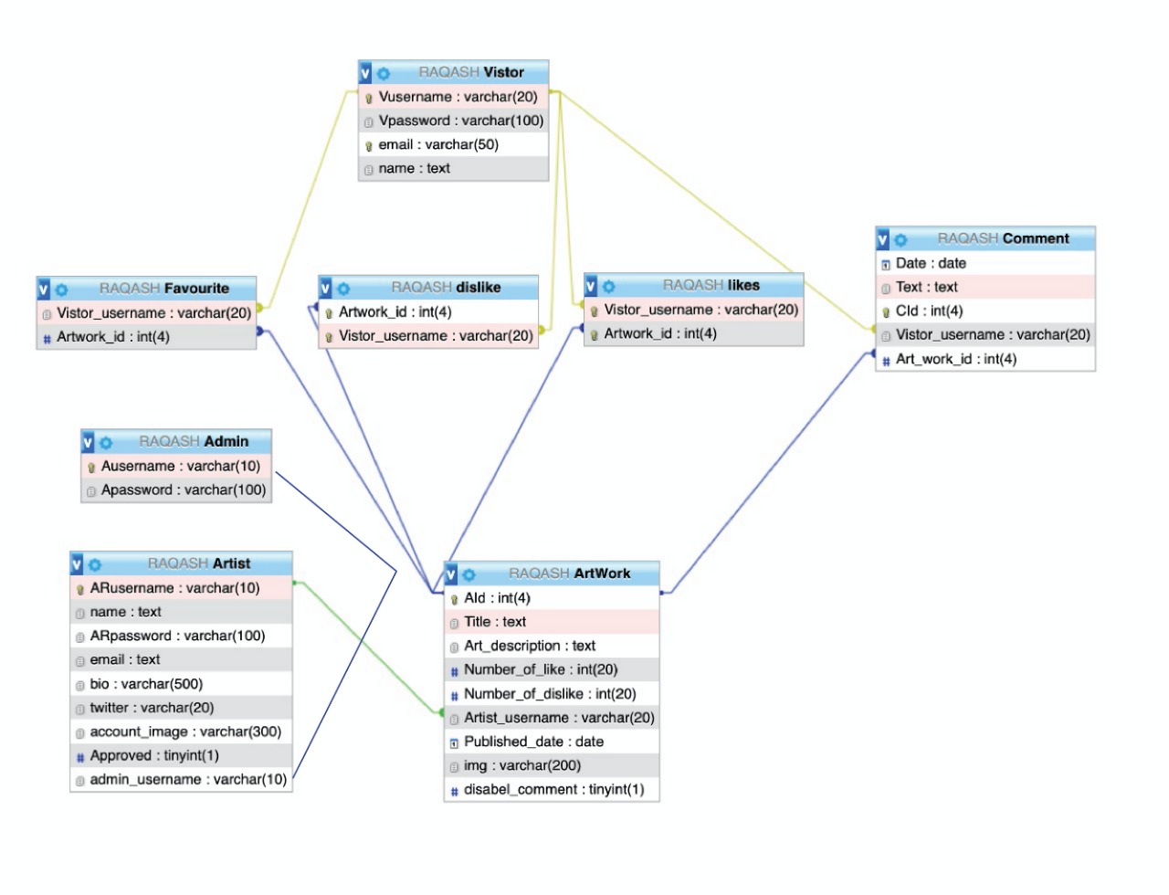

*An entity relationship diagram (ERD) shows the relationships of entity sets stored in RAQASH database.*

# project package/folder filenames |

|  |  |
| --- | --- |
| **File/Folder name** | **Purpose** |
| **Index.php file** | The index page of RAQASH which contain login and Signup options |
| **Validation.php** | Used to validate user input for login option and direct the user to appropriate page based on its roll |
| **Registration.php** | Used to validate user input for Signup option it is our database, check the username if exist and create an account and direct the user to appropriate page |
| **Adminepage.php** | Used to approve artist accounts by Admin |
| **ArtistStudioVisitor.php** | Used by Visitor to view all certain artist artworks, get access to the artwork information and contact information. |
| **ArtistStudio.php** | Used by Artist to view all its artworks , get access to edit their previous artwork and add new artwork. |
| **FAVOURITS.php** | Used by the visitor to view all of his/her favorites artworks. |
| **Manageartwork.php** | Used by Artist to manage artwork (edit title , description enable/disenable comment ) |
| **addToFav.php** | It is the back-end page for adding the artwork to visitor favorites. |
| **deleteArtwork.php** | It is the back-end page for removing the artwork. |
| **delete.php** | It is the back-end page for removing the artwork from visitor favorite list. |
| **Updateprofileimage.php** | This page allows the artist to update his/here profile image. |
| **updateArtwork.php** | The purpose of this page is to handle “update the artwork” functionality. |
| **AddArtwork.php** | The purpose of this page is to handle “add artwork” functionality . |
| **VistorHomePage.php** | It’s the home page of website and it is structure |
| **HomePage.php** | It is the backend of the home page |
| **Comment.php** | It handles the backend of add comment functionality |
| **viewArtwork1.php** | The purpose of this page is to show the artwork and its information and it’s associated comments. |
| **JS folder** | Contain java script files . |
| **onClickButtons.js** | This file handles many “on click “ functionality. |
| **viewArtwork.js** | The aim of this file is to show the art work and its associated comments. |
| **ArtistStudio.js** | The aim of this file is to show the related information of the artist and his/here artworks. |
| **welcomPage.js** | It links the login and signup windows to the index page (welcome page). |
| **CSS folder** | Contain CSS files. |
| **HomePage.css** | This file purpose is to style home pages (visitor home page). |
| **Style.css** | This file purpose is to style add artwork, update artwork windows |
| **viewArtwork1.css** | the purpose of this file is to style the view artwork page |
| **welcomePage.css** | the purpose of this file is to style the index page (welcome page) |
| **adminpage.css** | the purpose of this file is to style the admin page. |
| **Sudio.css** | the purpose of this file is to style the Artist studio, Artist Studio Visitor. |
| **ManageArtwork.css** | the purpose of this file is to style manage artwork functionality |
| **RAQASH.sql** | it contains RAQASH website information, Artist and visitor information |

# Reference |

[1] <https://getbootstrap.com/>

[2] <https://jquery.com/>

[3] <https://jqueryvalidation.org/>

[4] https://nickpiscitelli.github.io/Glider.js/

[5] <https://www.hostinger.com/tutorials/what-is-ajax>