**How to Submit Homework via Git Hub**

1. Create a new repository (aka a “repo”) to house your homework. It’s best practice to create the repo before you start your homework. Then you can save the starter files from the class repo into your homework repo See below for screenshots of the steps:

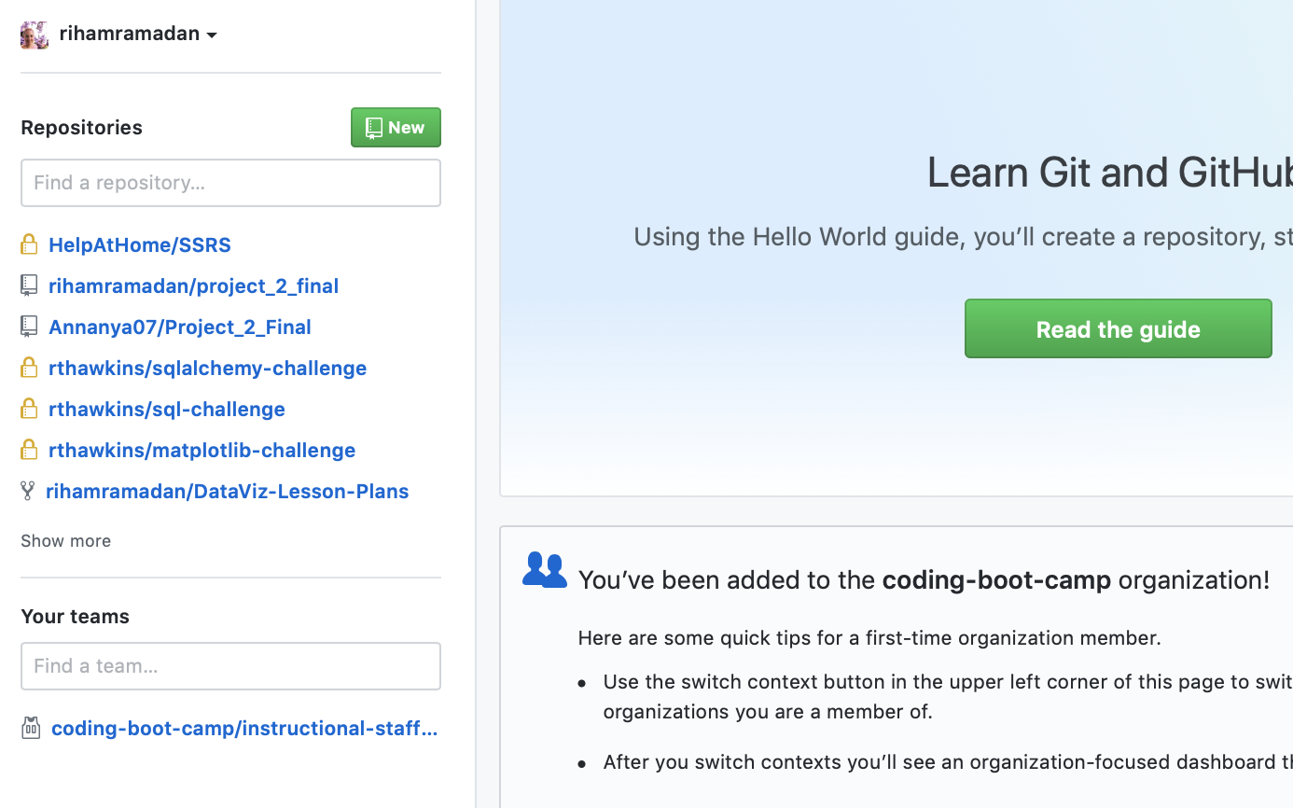

Name your repo and click “Create respository”

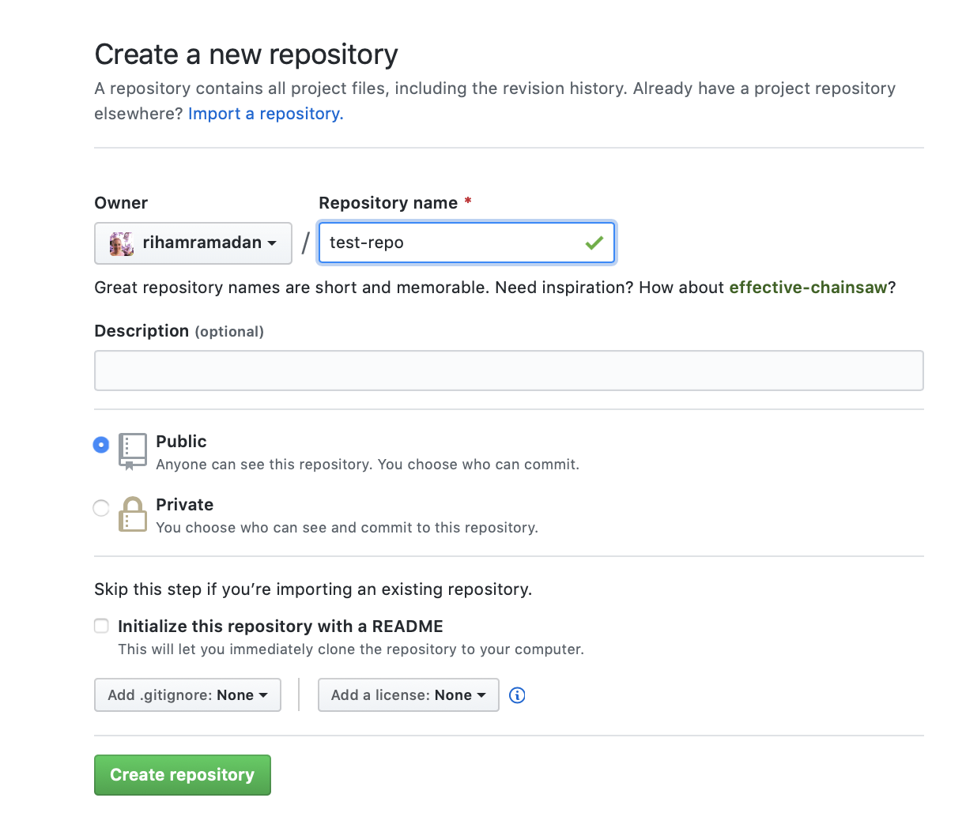

1. Now that you have a new repo, you need to clone it to your local machine. The screenshots below is an example of cloning it to your desktop by you can clone it anywhere in your machine. See below for the screenshots of steps.

Copy the link the link to your repo.

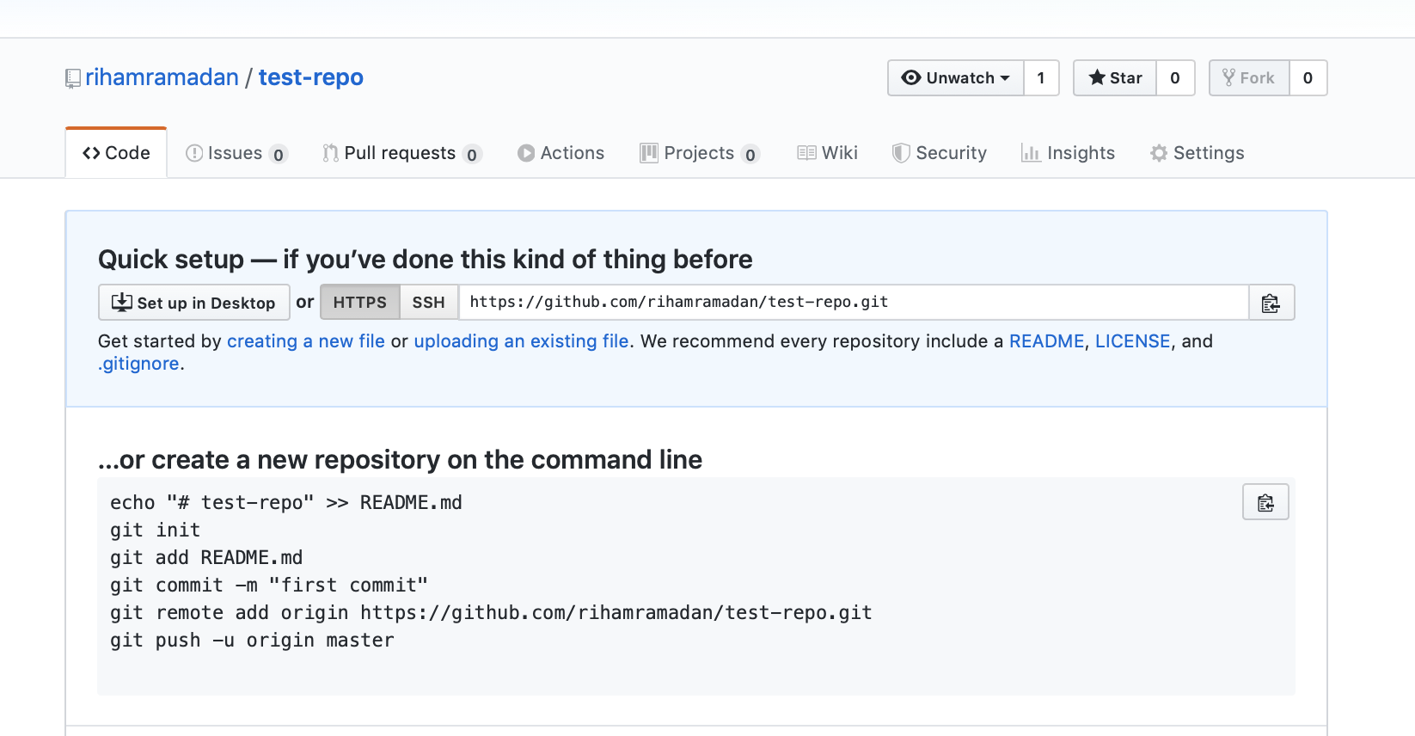

Using GitBash or Terminal, CD to your desktop or where ever you want to save your homework.

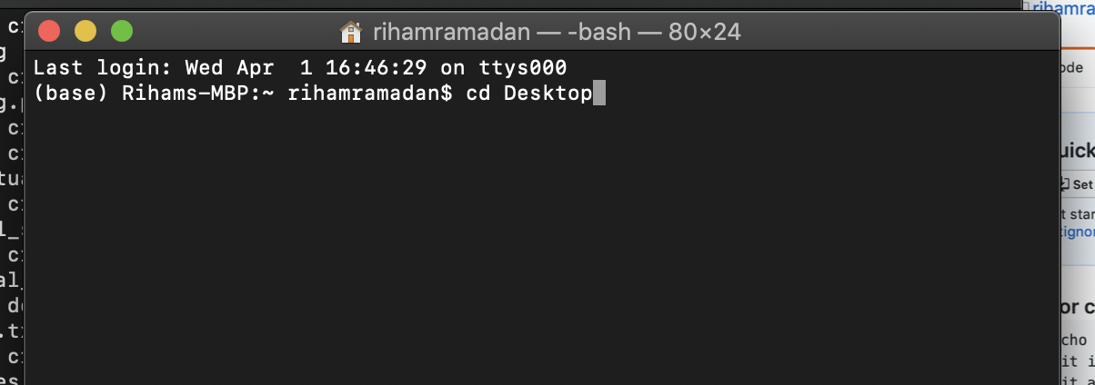

Then clone your repo by typing Git Clone and pasting your repo link.

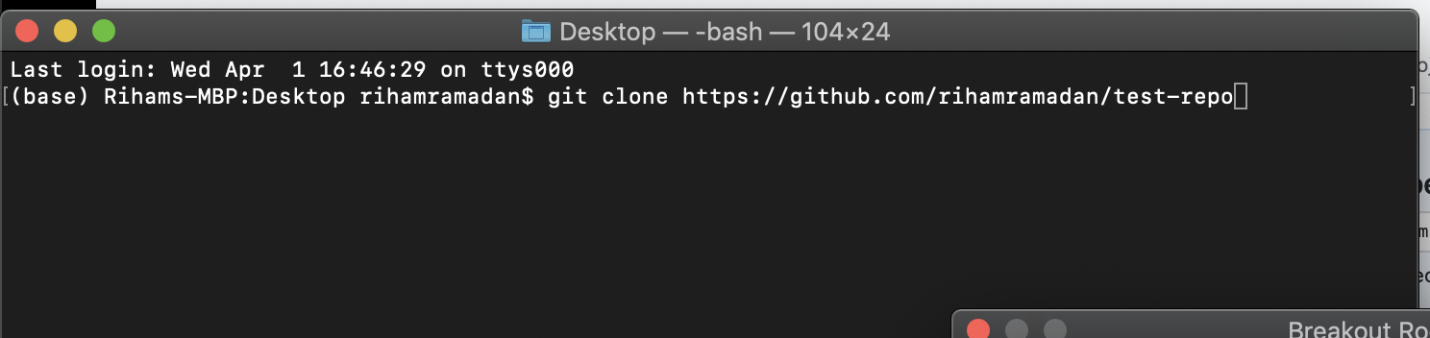

You may get a note stating you have cloned an empty repository. That’s fine!

3) Now that have cloned you repository. As previously mentioned, I recommend you move the starter files into your new repo (with the required resource files) and then you can begin completing your homework. All you need to do is copy the homework files in the class repo and paste it into the homework repo. Copying and pasting varies by machines so reach out to a TA if you have a question.

4) Now you completed parts or all of your homework and you want to push it so it’s GitHub. This is a 3 step process so see the screenshots below: