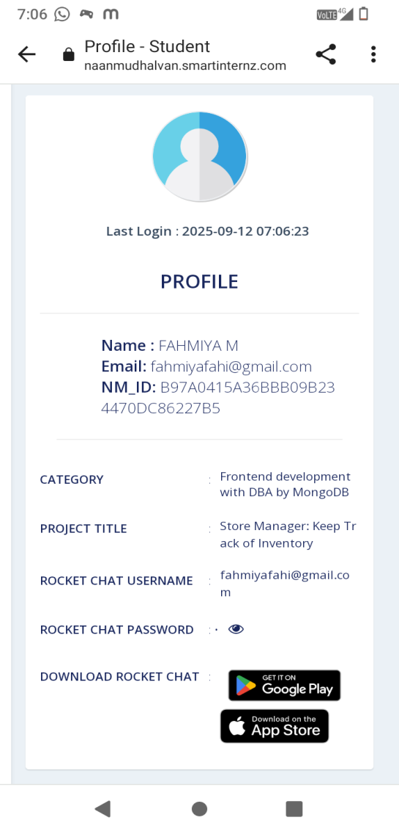
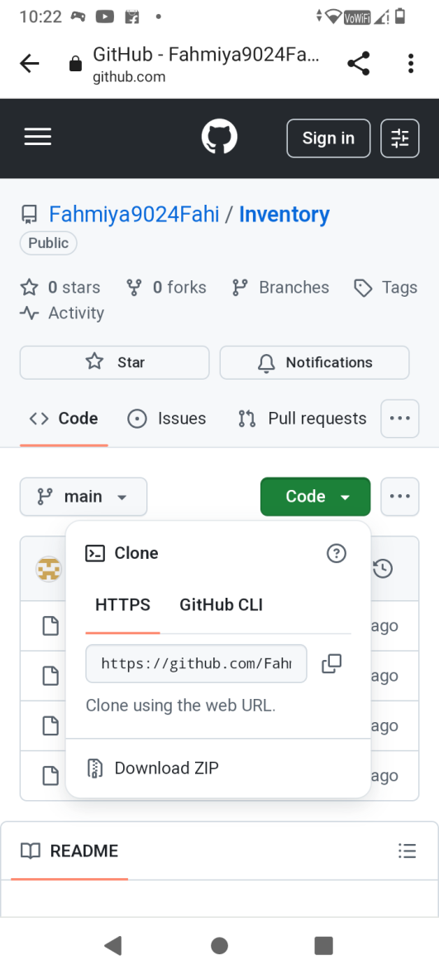
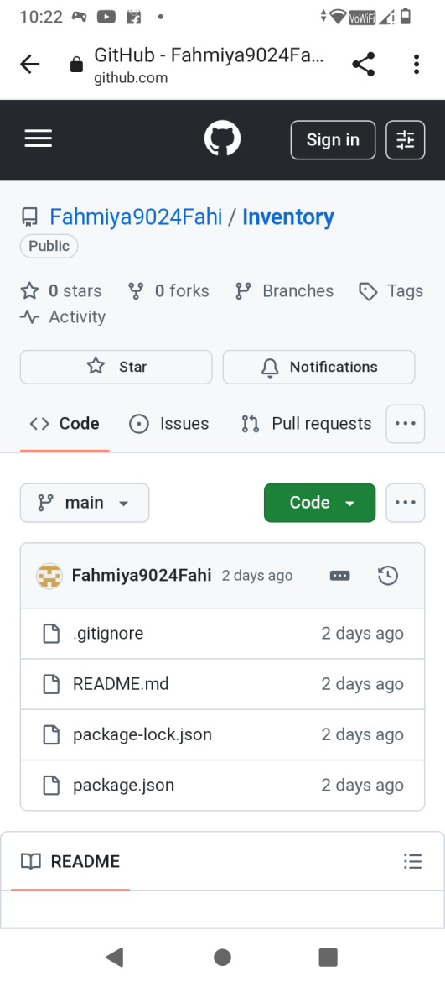
Introduction:
Project Title: Store Manager-Keep track of inventory
Team Leader:Rihana T
Team Member:Risvana Rositha M
Team Member:Sakthi Harishni T
Team Member:Rohini M
Project overview:
Purpose: The purpose of this project is to help store managers efficiently track inventory, monitor stock levels, and manage product details through an easy-to-use web application.
Features:
1. Product Management
- Add, edit, and delete product details (name, SKU, price, quantity, supplier).
- Bulk upload and bulk edit for faster updates.
- Image support for better product identification.
2. Inventory Tracking
- Real-time stock level updates.
- Batch/lot tracking with expiration date (useful for perishable goods).
- Stock adjustment logs for audit trails.
3. Alerts & Notifications
- Low-stock and out-of-stock alerts (real-time popups & email integration).
- Custom threshold settings for each product.
- Expiry date alerts for time-sensitive inventory.
4. Search & Filtering
- Full-text search across products, suppliers, and categories.
- Advanced filters (price range, availability, category, supplier).
5. Dashboard & Reports
- Interactive dashboard with charts (stock trends, sales vs. restock).
- Exportable reports (CSV, PDF).
- Historical inventory analysis for demand forecasting.
6. User Management & Roles
- Role-based access control (Admin, Manager, Staff).
- Authentication with JWT/Session tokens.
- Audit logs of user activities.
7. Integration & Extensibility
- API endpoints for third-party integrations.
- Future compatibility with barcode scanners and supplier APIs.
- Mobile-first design for tablets and smartphones.
Architecture:
Component Structure:
- App.js – Root component with routing
- Navbar – Navigation bar for app pages
- Dashboard – Overview of inventory stats
- ProductList – Displays all products in a table format
- ProductForm – Add/Edit product details
- InventoryAlerts – Low-stock notifications
- Reports – Basic inventory reports
State Management:
- Redux Toolkit for global state (inventory, users, alerts)
- Local state with useState for component-level interactions
Routing:
- Implemented with React Router v6
- /dashboard – Summary view
- /products – Inventory listing
- /products/add – Add new product
- /products/edit/:id – Edit product
Setup Instructions:
Prerequisites:
- Node.js (v18+)
- npm or yarn
Installation:
git clone <repository-url>
cd store-manager-frontend
npm install
npm start
Folder Structure
client/
├── src/
│ ├── components/
│ │ ├── Navbar.js
│ │ ├── ProductList.js
│ │ ├── ProductForm.js
│ │ ├── InventoryAlerts.js
│ │ └── Dashboard.js
│ ├── pages/
│ │ ├── ProductsPage.js
│ │ ├── DashboardPage.js
│ │ └── ReportsPage.js
│ ├── redux/
│ │ ├── store.js
│ │ ├── productSlice.js
│ │ └── alertSlice.js
│ ├── assets/
│ │ ├── styles/
│ │ └── images/
│ ├── App.js
│ └── index.js
Running the Application
npm start
Component Documentation
Key Components:
- ProductList: Displays products in a sortable, filterable table. Props: products, onDelete, onEdit.
- ProductForm: Used for adding and editing products. Props: onSubmit, initialValues.
- InventoryAlerts: Shows notifications for low-stock products. Props: alerts.
Reusable Components:
- Button (custom styled)
- Modal (confirmation dialogs)
- InputField (form input component)
State Management
Global State (Redux):
- products – stores all product details
- alerts – stores low-stock warning messages
- user – authentication and roles
Local State:
- Form input handling in ProductForm
- UI states like modal open/close
User Interface
Dashboard: Cards showing total products, low stock count, and recent activity
Inventory List: Searchable, filterable product table
Add/Edit Product: Form with validation
Alerts: Red-highlighted items for low stock
Styling
Framework: Tailwind CSS for responsive UI
Custom Theming: Store branding with color palette
Testing
Strategy:
- Unit tests with Jest & React Testing Library
- Integration tests for Redux store
- E2E tests with Cypress (future enhancement)
Code Coverage:
- Achieved with Jest coverage reports
Screenshots or Demo:

Future Enhancements
• Barcode scanner support
• Export reports (CSV/PDF)
• Multi-store inventory support
• Dark mode UI
• Mobile app version for store managers
• Integration with suppliers (auto re-order)
• Analytics (top-selling products, seasonal demand)

