

**Case Study Report**

Data Analytics with Power BI

**“360-degree Business Analysis of Online Delivery Apps”**

**WAVOO WAJEEHA WOMEN’S COLLEGE OF ARTS AND SCIENCE, KAYALPATNAM**

|  |  |
| --- | --- |
| **NM ID** | **NAME** |
| E334EA807297A6093B34DC385844991B | A.FATHIMA RIHANA |

Master name: R. Uma Maheshwari

Trainer name: R. Uma Maheshwari

**ABSTRACT**

Startups in India become a talk of the town in world business scenario. Youngsters are coming up with innovative concepts to counterpart untouched concerned area of consumers. Currently Indian Online food market is$350billion.Food technology in broad area, online food delivery apps are just part of it. The proposed project,”360-degree Business Analysis of Online Delivery Apps” aims to leverage Power BI , a leading business intelligence tool, to analyze and visualize real-time customer data. This conceptual study will give more insight about emerging innovative technologies in restaurant industry and strategies followed by online food Startups ZOMATO .Different services given by application that makes consumers happy and satisfied .Comfort and Convenience which makes consumer more inclined towards online food ordering. The real time analysis will help us to get the survey of the ZOMATO food products selling in different countries and online delivery applications is growing like a flying colors. Future of online food ordering website is bright. Facilities, Comfort, User friendliness are the key features of online websites success.

.

**INDEX**

|  |  |  |
| --- | --- | --- |
| **Sr. No.** | **Table of Contents** | **Page No.** |
| 1 | Chapter 1: Introduction | 1 |
| 2 | Chapter 2: Services and Tools Required | 4 |
| 3 | Chapter 3: Project Architecture | 7 |
| 4 | Chapter 4: Modeling and Result | 9 |
| 5 | Conclusion | 13 |
| 6 | Future Scope | 15 |
| 7 | References | 16 |
| 8 | Links | 18 |

**CHAPTER 1**

**INTRODUCTION**

* 1. **Problem Statement**

In today’s competitive world people rely on their hectic schedule and they often rely on online delivery apps for the food consumption. People usually prefer on serving a specific dish and it would be best if they find specific place that serves the dish. It also face spam problems while using the apps and lower server latency for our geographically widespread traffic .The lack of online delivery apps usually face this problem so to overcome this we need an additional feature to reduce this issue. User also prefers re-ordering their orders. So once the orders are placed, the order history must be saved in the app.

* 1. **Proposed Solution**

The proposed solution is to develop a Power BI dashboard that can analyze and visual the serving of specific dishes and help to track the location of many restaurants. The dashboard can help to show us the country code, city, restaurant name, address, locality, locality verbose, longitude, latitude, cuisines Using the 360-degree business analysis of Online Delivery Apps by this dashboard it will Make us enables to locate and give specification of these food that has availability in a specific place and the location and availability can be surveyed under this ‘

dashboard and their order history can be saved in this data.

* 1. **Feature**
* **360-degree Business Analysis of Online Delivery Apps**: The dashboard will provide analysis of the ZOMATO app food location and delivery data.
* **Menu optimization**: To optimize the menus of restaurants based on the popularity of dishes and local tastes.
* **Admin dashboard**: Offers functionalities related to the business side of the app, such as route management, driver and delivery stats, restaurant profiles, marketing section, and campaign.
* **Inventory Management**: It gives the data analytics to manage the inventory of ingredients and supplies needed for each restaurant, ensuring the time delivery and reducing food waste.

* 1. **Advantages**
* **Convenience**: You can order your favorite food from your preferred restaurant and it will be delivered at food step.
* **Improved operational efficiency**: Data analysis can help businesses get in touch with emerging market trends.
* **Flexibility for customers**: ZOMATO’S review system provides valuable feedback to restaurants, enabling them to improve their services and attract more customers.
  1. **Scope**

The scope of this project is to diversify into the catering business by leveraging its network of restaurant partners to service large orders. It is designed for users to find nearby restaurants and is perfect for those who prefer doorstep delivery. It’s also significant for restaurants owners who want to promote their business. By offering part-time or full-time services,

delivery provides can generate a decent revenue source income. It promotes restaurants based on their customers engagement, review ratings, and overall experience. It runs promotional campaigns for its exclusive restaurant members. It uses digital, traditional, word-of-mouth marketing. It also provides online payment facilities like Pay Through mobile [Paytm] , Google Pay, or card payments and provides information about restaurants, order food, and get it delivered.

**CHAPTER 2**

**SERVICES AND TOOLS REQUIRED**

**2.1 Services Used**

* **Data Collection and Storage Services**: Online delivery apps need to collect and store data in real-time. This could be achieved by data scraper from ZOMATO websites and using ZOMATO API and their data can be stored in Amazon Dynamo DB, Postgres DB and AWS Gravion2 instances.
* **Data Processing Services**: Services like X-Byte Enterprise Crawling, ZOMATO Food Trends, 3i Data Scraping and Actowiz Solutions can be used to process the real-time data.
* **Machine Learning Services**: Convolutional Neutrals Networks (CNNs) can be used to build predictive models based on historical data.

**2.2 Tools and Software used**

**Tools**:

* **Power BI**: The main tool for this project is Power BI, which will be used to create interactive dashboards for real-time data visualization.
* **Power Query**: This is a data connection technology that enables you to discover, connect, combine, and refine data across a wide variety of sources.

**Software Requirements**:

* **Power BI Desktop**: This is a Windows application that you can use to create reports and publish them to Power BI.
* **Business Model**: Assess how the app generates revenue (e.g., delivery fees, subscription models, commissions from partner businesses).
* **Target Market**: Identify the demographics and preferences of the app's users, including their geographic location, age, income level, and purchasing behavior.
* **Competition:** Analyze the competitive landscape, including major competitors, their strengths, weaknesses, and market share.
* **Technology Infrastructure**: Evaluate the app's technology stack, scalability, security measures, and user interface to ensure optimal performance and user experience.
* **Marketing Strategies**: Examine how the app attracts and retains customers through various marketing channels such as social media, email campaigns, referral programs, and partnerships.
* **Operational Efficiency:** Assess the efficiency of the app's operations, including order fulfillment, inventory management, delivery logistics, and customer support.
* **Customer Experience**: Analyze user feedback, ratings, and reviews to gauge customer satisfaction and identify areas for improvement in user interface, service quality, and responsiveness.

**CHAPTER 3**

**PROJECT ARCHITECTURE**

**3.1 Architecture**

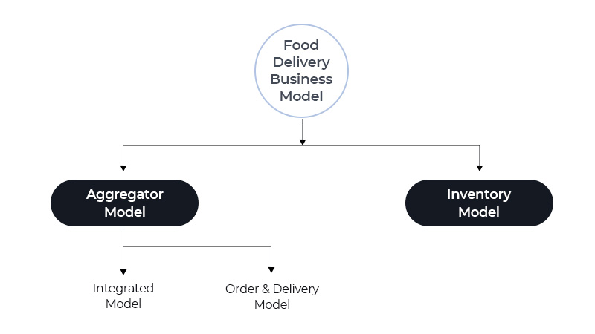

**Data Collection**: Real-time customer data is collected from various sources like data scraper from ZOMATO website and using ZOMATO API.

**Data Storage**: The collected data is stored in a database for processing. Amazon Dynamo DB, Postgres DB and AWS Gravion2 instances.

**Data Processing**: The stored data is processed in real-time using services like X- Byte Enterprise Crawling, ZOMATO Food Trends, 3i Data Scraping and Actowiz solutions.

**Machine Learning**: Predictive models are built based on processed data using Convolutional Neutrals Networks (CNNs). These models can help in accurately recognize menu images even in low- light or low- resolution images and make dining recommendations based on user preferences and behavior etc.

**Data Visualization**: The processed data and the results from the predictive models are visualized in real-time using Power BI. Power BI allows you to create interactive dashboards that can provide valuable insights into the data.

**Data Access**: The dashboards created in Power BI can be accessed through Power BI Desktop. This architecture provides a comprehensive solution for real-time analysis of Online Delivery Apps.

**User Interface Layer:** Web interface for desktop and mobile devices Native mobile applications for iOS and Android platforms.

**Presentation Layer:** Frontend technologies like HTML, CSS, and JavaScript frameworks (e.g., React, Angular, Vue.js) for user interaction.

**Application Layer:** Business logic implemented using backend technologies like Node.js, Python, or Java.

**Integration Layer:** Integration with third-party services for functionalities like payment gateways (e.g., PayPal, Stripe), geolocation services (e.g., Google Maps), and push notifications (e.g., Firebase Cloud Messaging).

**CHAPTER 4**

**MODELING AND RESULT**

**Manage relationship**

The “disp” file will be used as the main connector as it contains most key identifier (account id, client id and disp id) which can be use to relates the 8 data files together. The “district” file is use to link the client profile geographically with “district id”

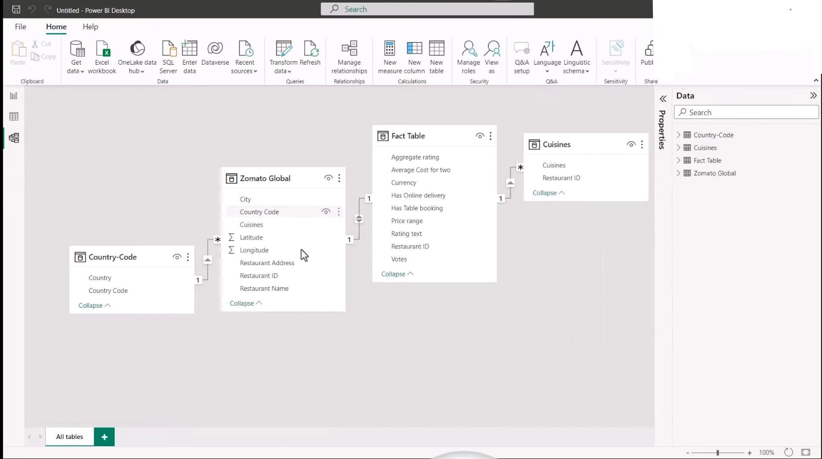

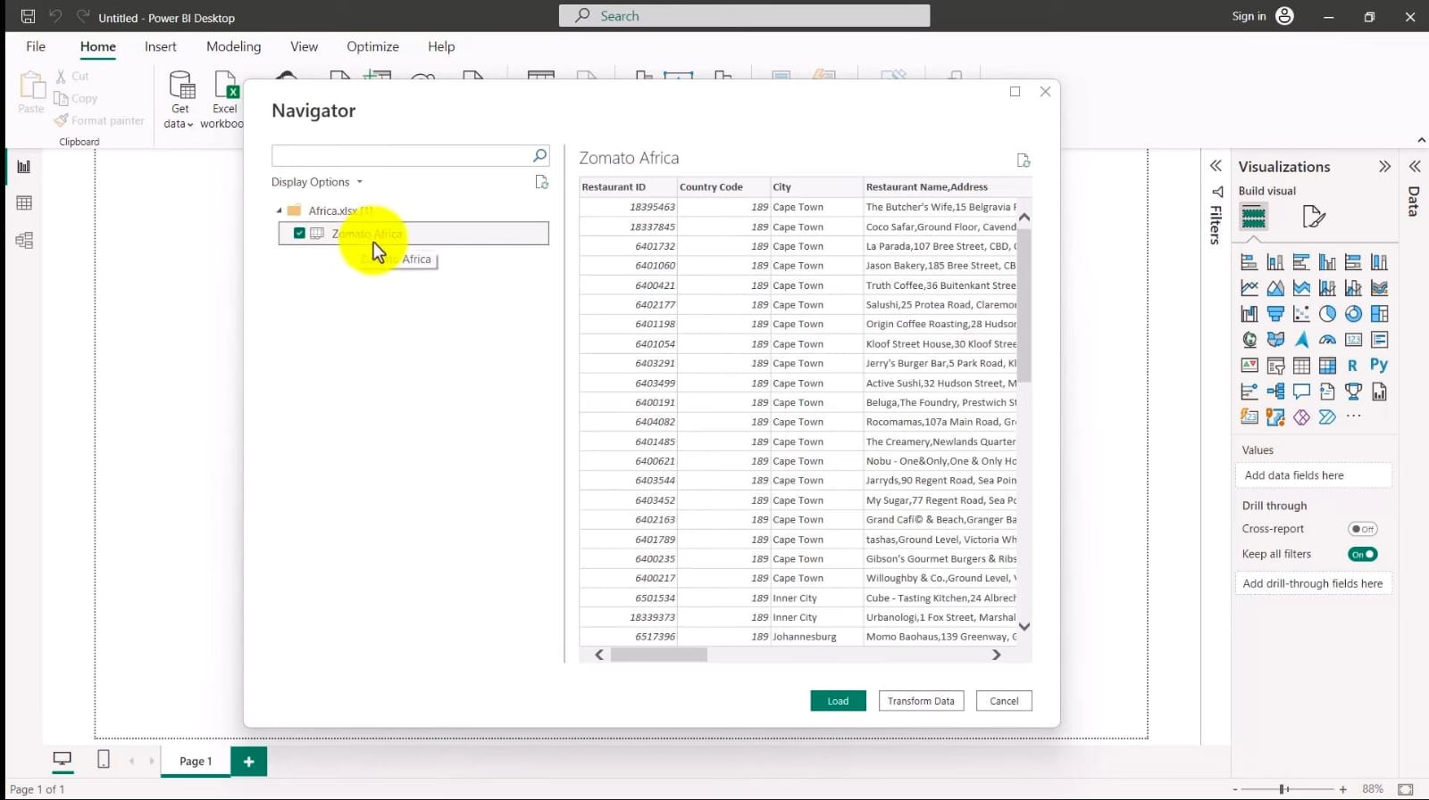

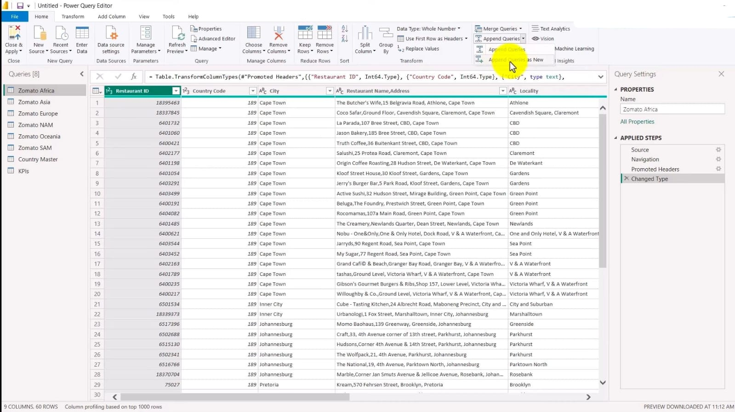

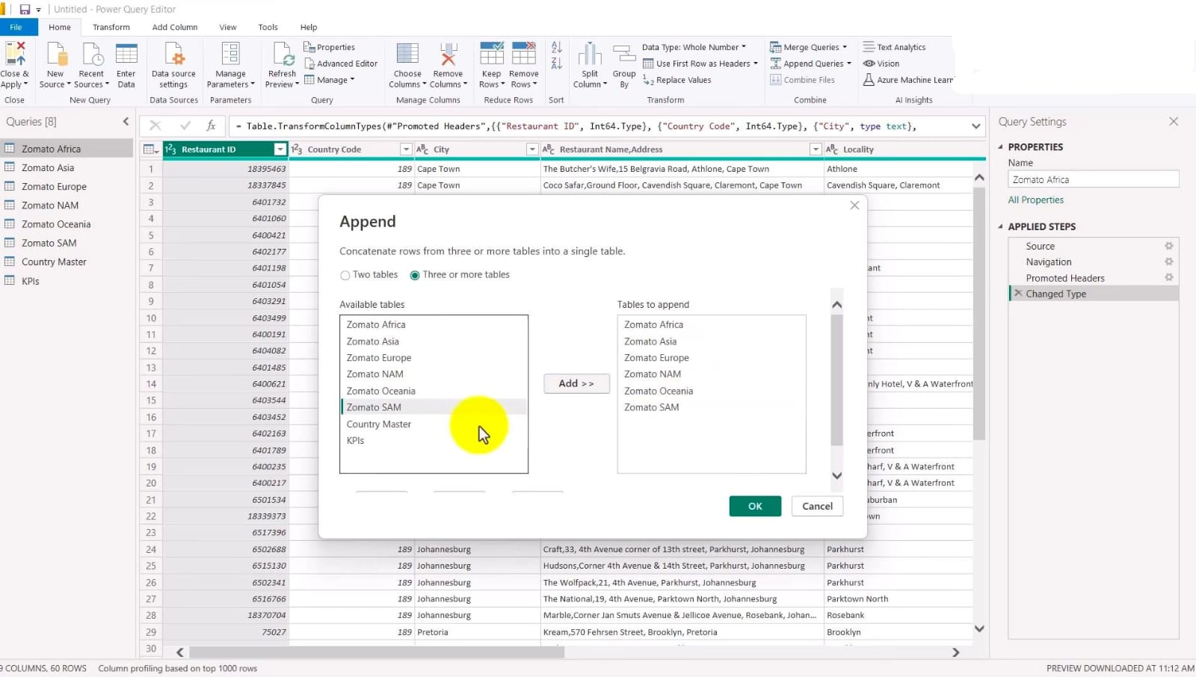

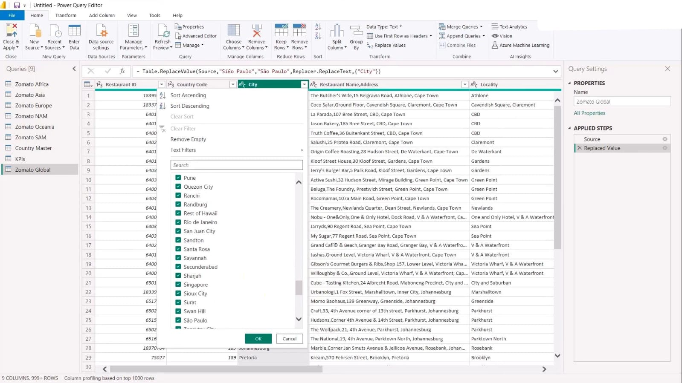

**DASHBOARD:**

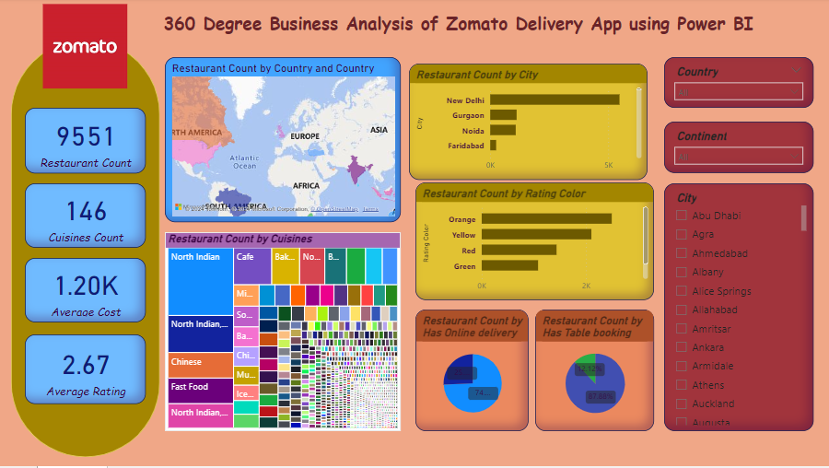

**CONCLUSION**

ZOMATO’S success can be attributed to its innovative business model, its focus on customer experience, and its ability to adapt to changing market conditions. As the food delivery industry continues to grow and evolve, ZOMATO is well-positioned to continue its success and expand its reach into new markets. ZOMATO’S offering the list of all restaurants, the type of food detailed analysis of restaurants, working hours, location of eatery, most importantly, reviews from other users which are mostly from the datasets collected all users. ZOMATO’S brilliant marketing strategies have helped them position themselves top within the industry. Marketing develops with time and changes based on the demands and the preferences of the modern population.

**FUTURE SCOPE**

The scope of this problem is significant for ZOMATO as it directly impacts the company’s revenue and market share. The drop in orders during the peak period of the festive season in India indicates that ZOMATO may not have been able to capture the surge in demand effectively, leading to a loss of potential revenue. Moreover, the problem could also lead to a loss of customer trust and loyalty, which can further harm the company’s reputation and long-term prospects. The problem also has a broader impact on the food delivery industry in India, which is highly competitive. The drop in orders during the festive season may have allowed ZOMATO’S competitors to gain an advantage, which could impact the company’s market share in the future. Therefore, addressing this problem effectively is critical for ZOMATO’S competitiveness and growth in the long term.

**REFERENCES**

<https://www.novypro.com/project/na-12>

<https://www.icoderzsolutions.com/blog/zomato-business-model/>

<https://www.youtube.com/live/x1ge5UM2ypE?si=yisCJCz-r13HTCKb>

**LINK**

<https://github.com/rihanafathima299/PowerBIProjectRihana.git>